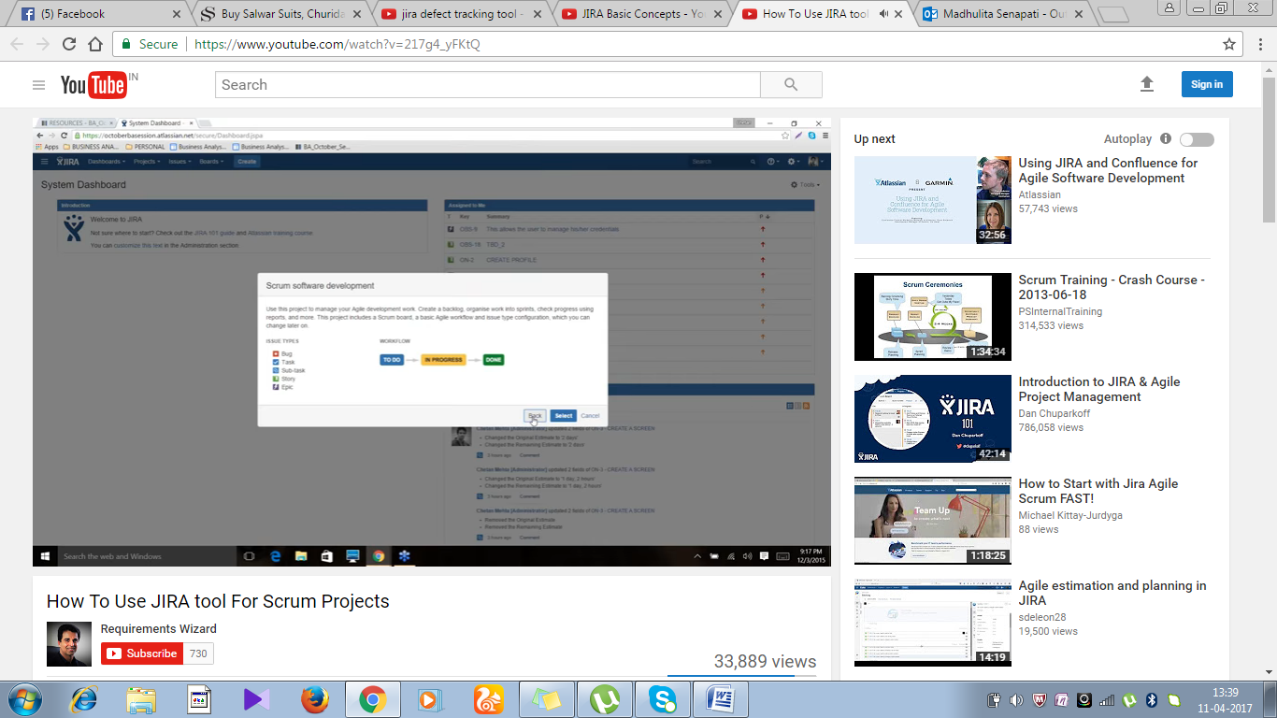

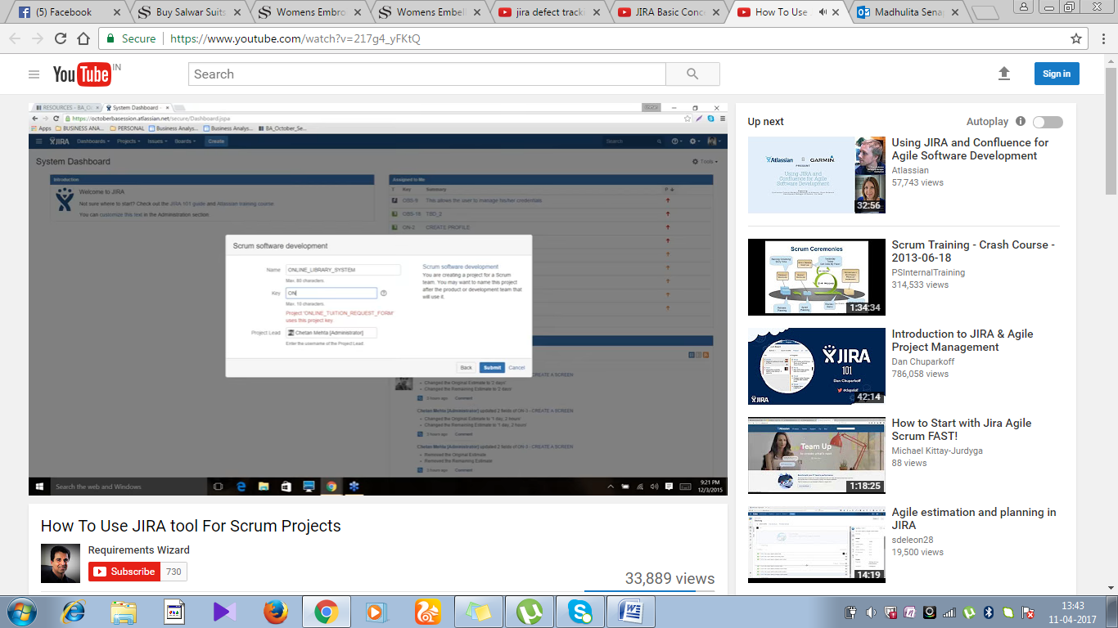

In product backlog:user stories

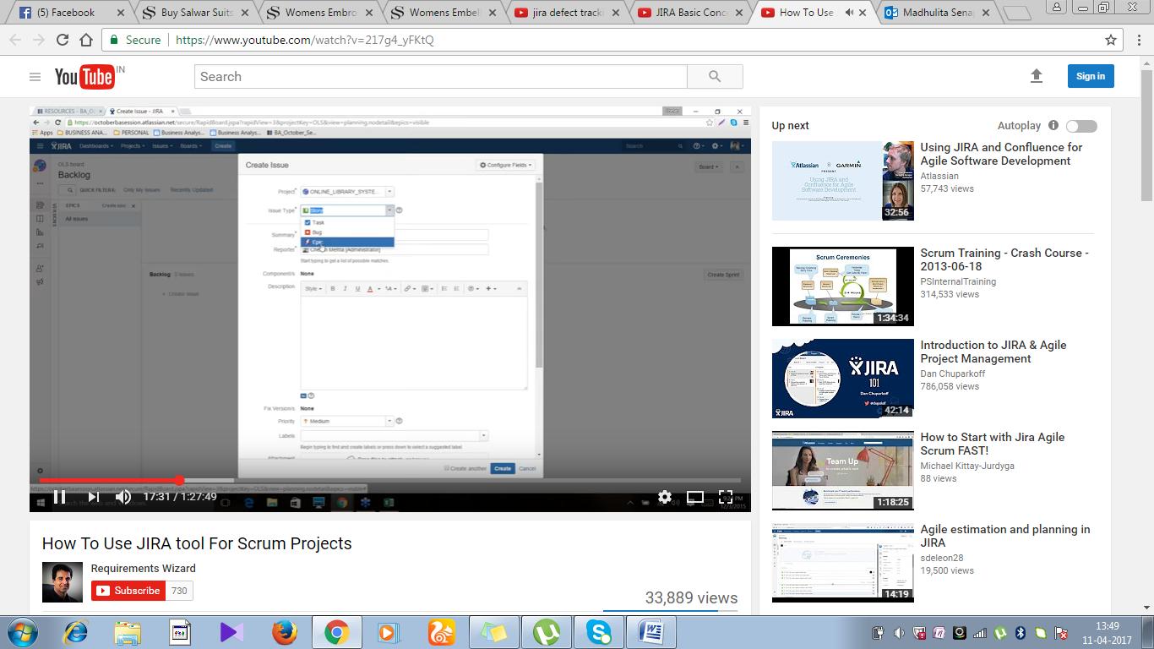

Create epic;

Then create the user stories with acceptace criteria:

Then link to epic:that is called tracebility

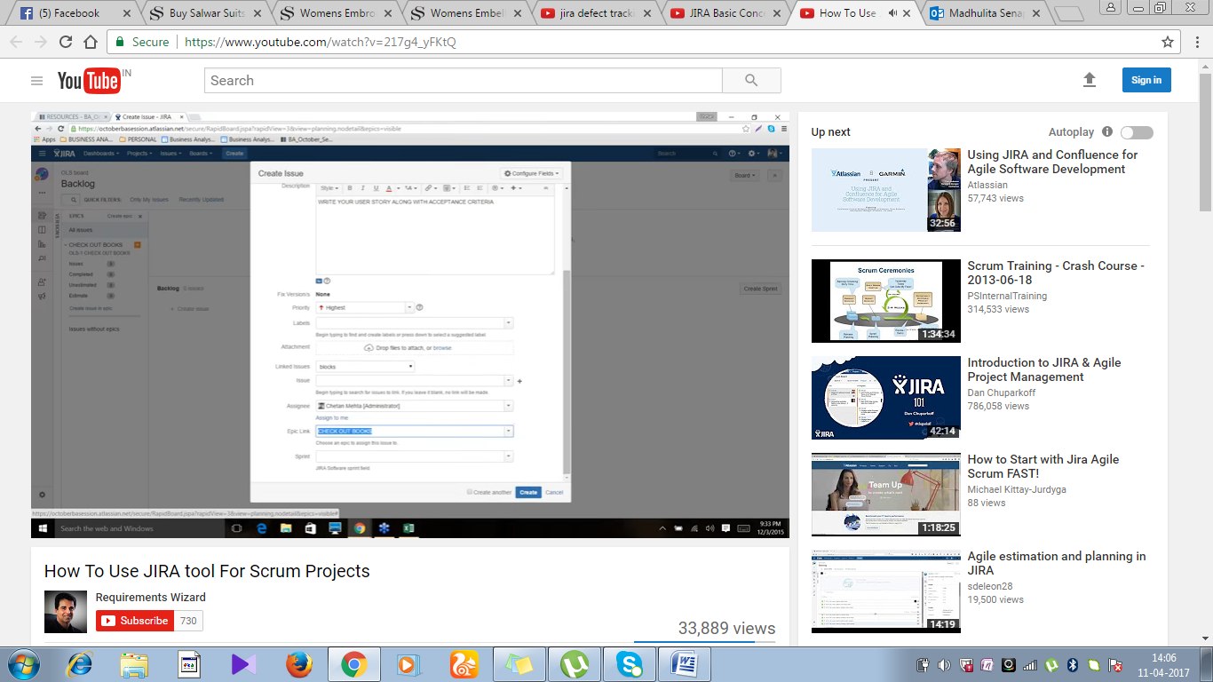

User stories is added Then backlog box

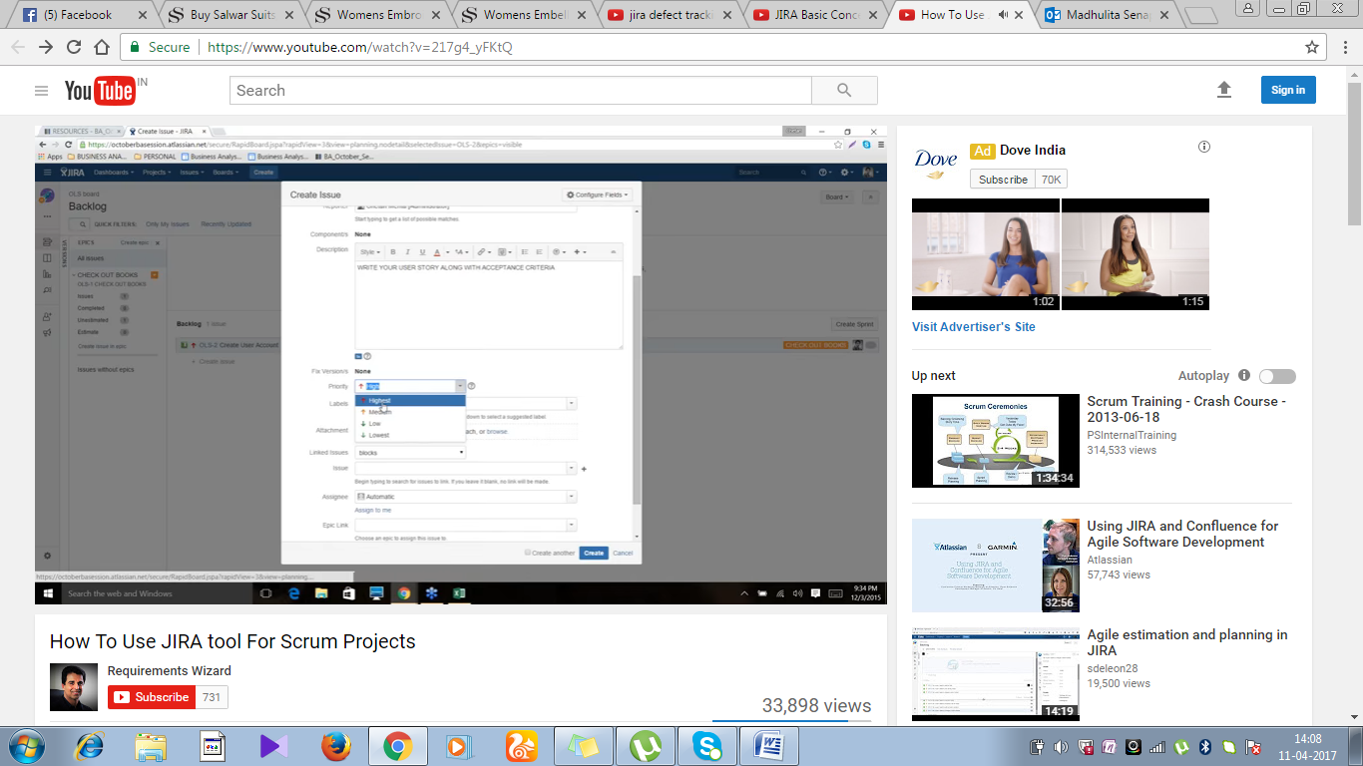

Based onn the crticallty of user stories , ranking done.

Estimate the user stories:

Weightage calculation based on story points ,how much criticality that point

Febanchi numbers:

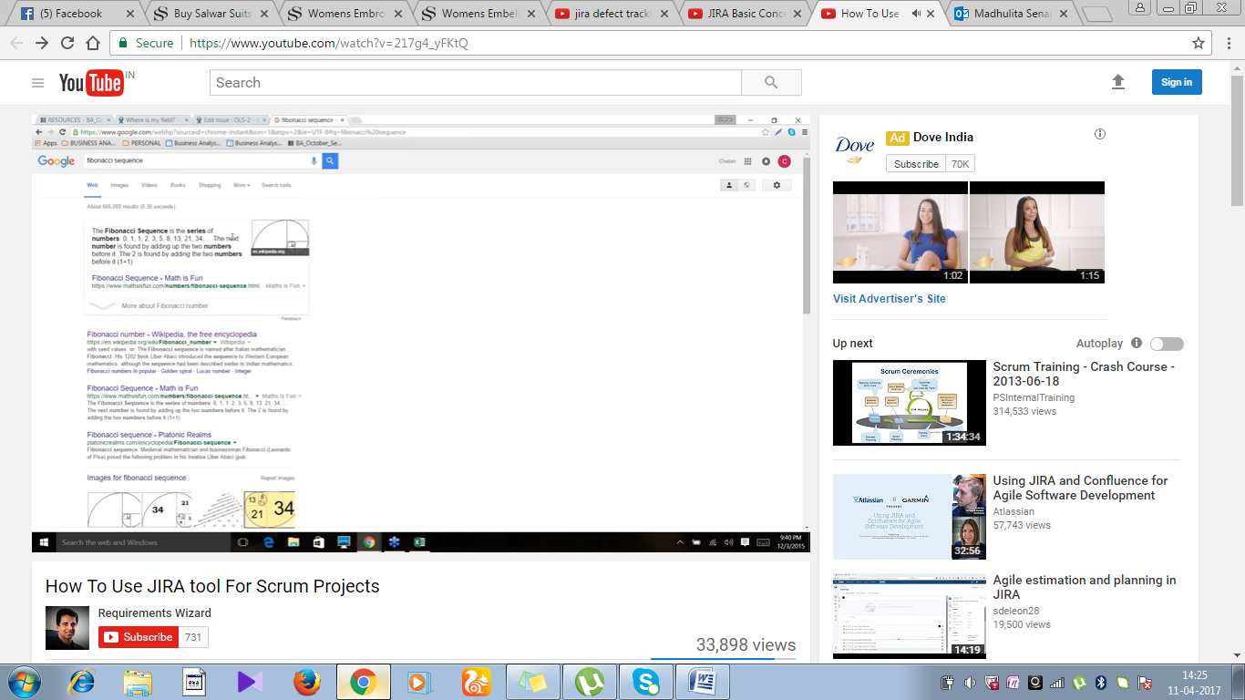

Story point represents the complexicity

Take a baseline of story point which is standard.

Create sub task under task

Then move the story to sprint and ten fill the duration of the sprint

U can update the story as by logging the hour…



<https://www.youtube.com/watch?v=v9smOrwr888&index=5&list=PL3kQlyGFE4GfjHgpv0oc_7Qcl1Qwy6PdG>