BRUSH-UP PROJECT: “TOPICS”

Part I: Software Design

1. The 3 use cases:

* Book a speaker: booking a date and time, fee calculation and an extra booking access for the speaker himself
* Manage speakers: enter new speaker including field of expertise and other contact information, update speaker’s information.
* Search speaker by field of expertise

1. Identify the actor:

* All the above use cases: administrator is the actor.
* The speaker himself is the actor of the sub-use case “booking access”

1. Use case diagram:

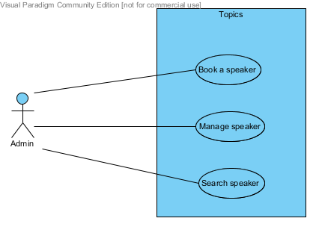

1. Identify conceptual class and develop a domain model:

* Speaker
* Presentation
* Field of expertise
* Commission
* Honorarium (speaker type – rate)

Domain model:

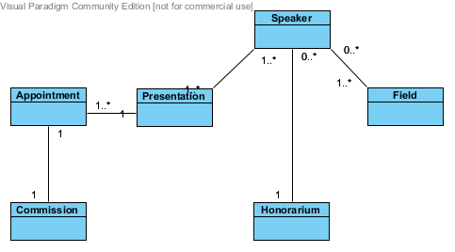

1. Create an SSD: use case “Book a speaker”

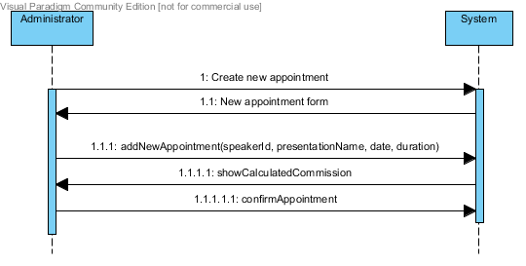

1. Interaction diagram:

