Combined Breeding Analysis: Atlas and DES Backlog
Contribution of the combined eBird and DES team (Shakiful Alam Oyon, Shivam Kapoor, Sanjay Singh Tamata, Yash Parmar) to the group progress report, under the template's four headings. Scope: the Atlassers/Access dataset and the DES backlog, analysed together. The eBird dataset is excluded, as agreed with the client on 11 October 2026.

1. Progress & Achievements

Combined dataset
The Atlas (the approved accepted Atlas file, checked against the client's original tables and found complete: every collection and survey with observations is present, apart from documented cleaning) and the DES backlog (the team's verified cleaned export) were merged into one dataset of species sightings, with a source label kept on every record. Both use the client's master species list, so species align without a separate mapping. Doubtful records (placeholder or invalid dates, a mis-read duplicate DES sheet, duplicate DES copies) are flagged and set aside, never deleted. The two sources barely overlap: only one DES sheet matches an Atlas survey, and the sources run end to end in time.
Source | Records | Sheets | Surveys / collections | Dates | Species | Breeding records | Species breeding
Atlas | 6,531,324 | 573,198 | 309,625 / 263,573 | 1900 – Mar 2020 | 631 | 339,953 | 435
DES | 102,701 | 2,552 | 2,434 / 118 | 1976 – Mar 2026 | 415 | 2,297 | 195

Coverage
Together the sources span 1900 to March 2026, with the Atlas providing the long baseline (busiest in 1984–2001) and DES the years after the Atlas ends. 2020 (Atlas, to 31 March) and 2026 (DES, to 11 March) are partial years and are labelled as such.
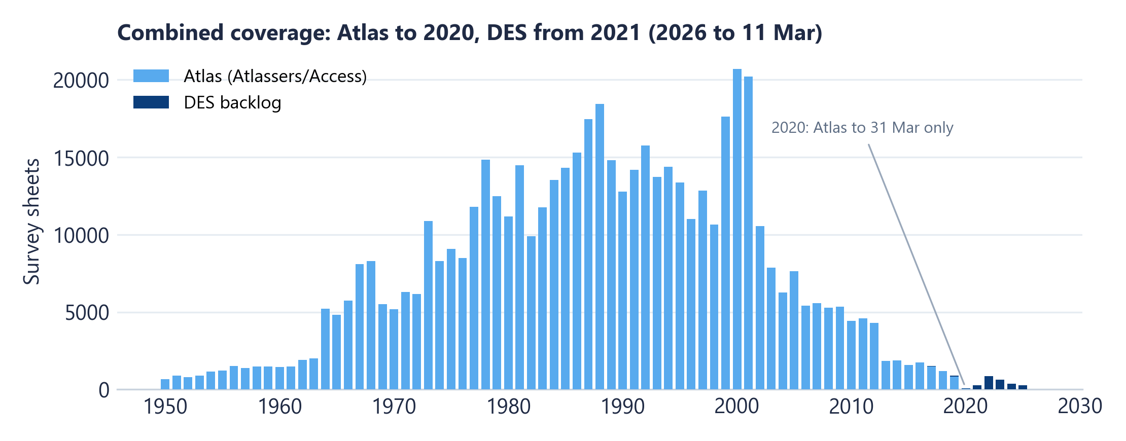
Figure 1. Survey sheets per year by source. [figures/comb_coverage_by_year.png]

The breeding season, then and now
Using surveys only (collections excluded from both the count of sightings and the count of breeding records, as agreed for reporting rates), the share of sightings marked as breeding follows the same spring–summer curve in every period: it rises from August, peaks in October–December and falls away after February. The levels differ between the two sources because they recorded breeding differently, so only the shape and timing are compared.
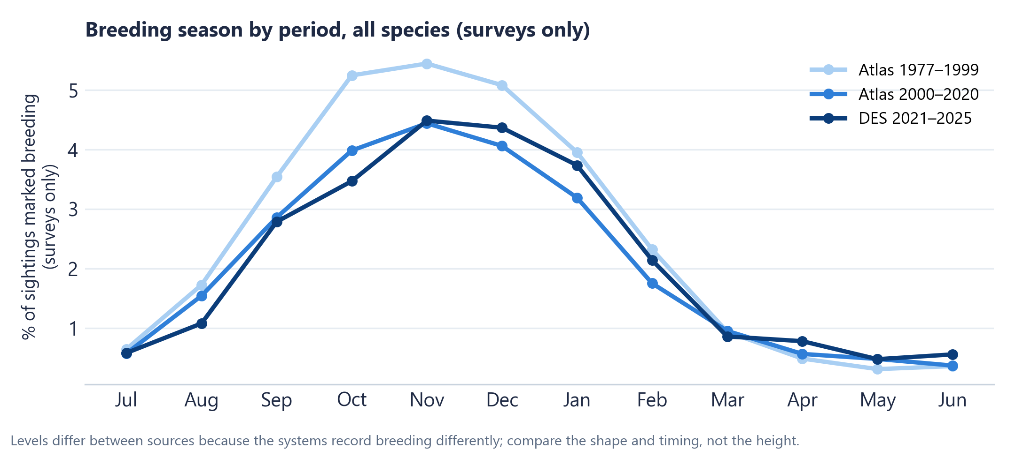
Figure 2. Breeding reporting rate by month (surveys only), Atlas 1977–1999, Atlas 2000–2020 and DES 2021–2025. [figures/comb_season_by_period.png]

Breeding-species shortlist and selection criteria
A species is included in the study cohort if it has at least 20 survey sheets with breeding evidence in both the historical period (Atlas 1977–1999) and the recent period (Atlas 2000–2020 plus DES 2021–2025); breeding evidence from collections is kept for this count. 236 species qualify, within the client's target of 200–300. The thresholds below show how the cohort size responds:
Breeding sheets needed in both periods | Species qualifying | …with ≥ 10 breeding sheets in DES
>= 10 | 273 | 60
>= 20 | 236 | 60
>= 50 | 161 | 60
>= 100 | 111 | 60

Within the cohort, a core shortlist of 32 species (at least 100 breeding sheets in both periods, at least 20 in DES, breeding recorded in five or more regions) gives the strongest evidence for species-level work, with 28 supporting species (at least 50 in both periods and 10 in DES). Core shortlist: Willie Wagtail, Welcome Swallow, Australian Magpie, Magpie-lark, Superb Fairy-wren, Australian Wood Duck, Masked Lapwing, Crested Pigeon, Grey Fantail, Red-browed Finch, Noisy Miner, Black Swan, Pacific Black Duck, Pied Currawong, Australasian Grebe, Noisy Friarbird, Galah, Dusky Moorhen, Laughing Kookaburra, Tawny Frogmouth, Eastern Rosella, Grey Butcherbird, Fairy Martin, Purple Swamphen, Grey Teal, Red-rumped Parrot, Australian White Ibis, Chestnut Teal, Common Myna, Rainbow Lorikeet, Yellow-tailed Black-Cockatoo, Australian Brush-turkey.

Has breeding timing changed?
For each cohort species the centre of its breeding season was estimated from monthly surveys-only reporting rates (which adjusts for how much surveying happened each month), on a July–June axis, with a 95% uncertainty range. A change counts as clear only when the historical and recent ranges do not overlap. Of 197 species with a clear breeding season, 175 show no clear change, 18 breed later (Australian Wood Duck, Magpie-lark, Purple Swamphen, Australasian Grebe, Jacky Winter, Pacific Black Duck, Galah, Crimson Rosella, Striped Honeyeater, Olive-backed Oriole, White-winged Triller, Grey Teal, European Goldfinch, White-necked Heron, White-bellied Cuckoo-shrike, Straw-necked Ibis, Little Crow, Chestnut-crowned Babbler) and 4 breed earlier (Powerful Owl, White-eared Honeyeater, White-naped Honeyeater, Red Wattlebird). The median shift is about zero days.
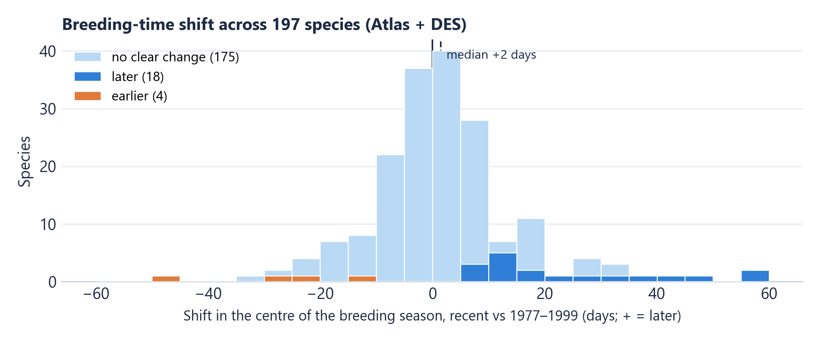
Figure 3. Shift in the centre of the breeding season, 2000–2025 versus 1977–1999, across all clearly seasonal cohort species. [figures/comb_shift_distribution.png]
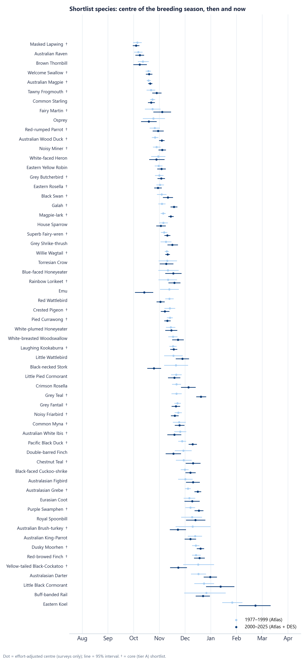
Figure 4. Centre of the breeding season for core and supporting shortlist species, 1977–1999 versus 2000–2025. [figures/comb_shortlist_timing.png]
- Collections check. Reporting rates follow the agreed method and use surveys only. Re-estimating with collections included as well gives more apparent changes (135 no clear change, 52 later, 10 earlier), with 156 of 197 species shifting in the same direction. Collections make up 58% of Atlas sheets in 1977–1999 but under 3% after 2000, so including them would mix different kinds of record between the two periods; they are kept for breeding evidence but not used in rates.
- What DES adds. The recent period is dominated by Atlas 2000–2020. DES on its own supports the comparison for 31 species (28 no clear change, 3 later), which is indicative only because DES is a different recording system.

Location and bird traits
Estimating each species' shift separately within the coast, tablelands and inland zones gives the same picture in every zone (median shifts of Coast +3, Tablelands +1, Inland +3 days). Linking the cohort to the project's species-trait table (by IOC code and exact scientific name), no trait group (diet, habitat, nest type, mobility, body size) differs in its shift once the many comparisons are accounted for (smallest adjusted p = 0.73). These are associations only; no cause is implied.

2. Obstacles
- Atlas export completeness. The first cleaned Atlas export omitted about three-quarters of collections, 13 species without IOC codes, and the date and collection-flag columns. It was replaced by an accepted file that was checked against the client's original tables before the analysis was run; the results here use the complete file only.
- eBird. The client confirmed that eBird is not a coherent dataset (files for several longitude strips were never processed), so it is excluded.
- Different recording systems. The Atlas and DES record breeding at different rates, so overall rates cannot be compared or pooled; only timing is compared.
- DES size and observer concentration. DES is small, almost entirely from the 2020s and concentrated among a few observers; it extends the series but carries little weight.
- Missing reference data. The trait table's breeding-season fields are empty and no weather or rainfall series has been supplied, so DES and Atlas calendars cannot yet be compared with published seasons or environmental conditions.

3. Deviation to Timeline
The proposal planned a validated inventory and a proposed 200–300-species cohort by Week 8. Validation took longer than planned, and in Week 9 the client removed eBird and the team consolidated the work into a single combined Atlas and DES analysis. The cohort (236 species) and a first timing comparison are now in place on the complete accepted data.

4. Milestones & Reporting
Suggested rows for the group milestone table:
Milestone | Tasks | Reporting
Week 9 | Combined Atlas + DES dataset on the complete accepted Atlas file, coverage review, species cohort and shortlist, first timing comparison | Client meeting: review results
Week 10 | Regional and range change (expanding/declining species), trait and environmental associations, using the same accepted release | Client meeting
Week 10–11 | Confirm shortlist and criteria with the client; refine timing analysis; add environmental data if supplied | Client meeting
Week 12–13 | Final presentation and final report | Final presentation / report

Files supplied with this section
- figures/comb_coverage_by_year.png
- figures/comb_season_by_period.png
- figures/comb_shift_distribution.png
- figures/comb_shortlist_timing.png
- tables/CS-13_Week9_Combined_Breeding_Analysis.xlsx

