MINISTRY OF EDUCATION AND SCIENCE OF UKRAINE
NATIONAL TECHNICAL UNIVERSITY
"KHARKIV POLYTECHNIC INSTITUTE"
DEPARTMENT OF SOFTWARE ENGINEERING AND MANAGEMENT
INFORMATION TECHNOLOGIES"

Report of laboratory work № 1
Discipline <<Basics of Software Engineering>>>

Executed by: Student of group Kn-226e
Klemeshov D.
Checked by:
Associate professor
Melnyk K. V.
Kharkiv
2026
THEME:
Laboratory work number 1
Goal: To learn how to make UML and Use-case diagrams in Visual Paradigm.
Tasks:
1. Get the individual task and look through work materials.
2. Develop the UML diagram.
3. Develop the Use-case diagram.
4. Prepare the report of the work.
Progress of work
1. UML diagram (here)
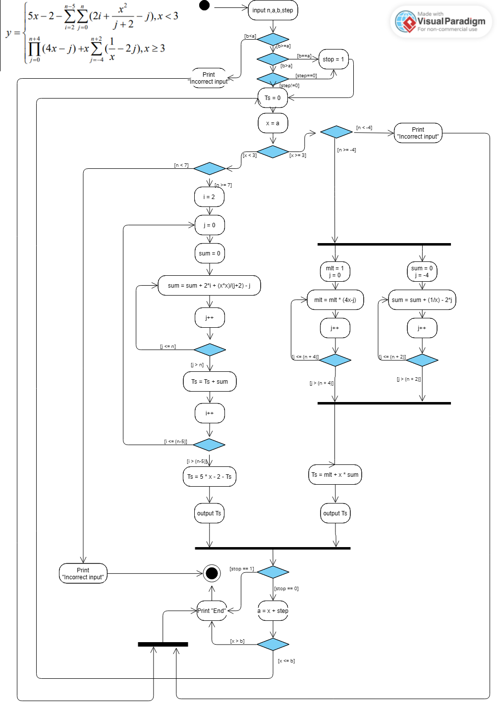
The diagram takes input n, a, b and step.
For x cordinates inside a-b segment it calculate y of funktion cordinate according to rule x1=a,x2=a+step*1,x3=a+step*2…. Untill a+step*smth > b.
Funktion mentioned below.
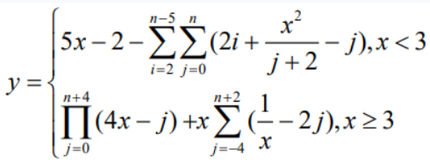
Before start of calculations programm checks if a,b is correct.
Also if a==b program calculates only one y coordinate.
We have 2 main segments
1. If x<3
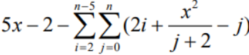
For this segment input n<7 is incorrect and lead to “Incorrect input" error message.
We allocate i and j as counters and Ts as the result of nested loops. After programm calculated Ts, calculate 5 * x - 2 – Ts and print the result.
2. If x>=3
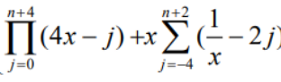
For this segment input n<-4 is incorrect and lead to “Incorrect input" error message.
We have two independent loops where the result of first loop is multiplied and assigned to mlt and the result of second loop is accumulated and assigned to sum. Calculate mit + x * sum and print the result.
1. Use-case diagram (here)
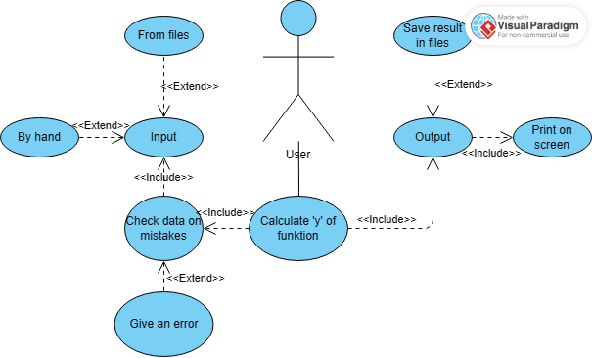
The diagram represents the interaction between the User and the system for calculating coordinate y. The user can choose to input data By hand or From files.
Before starting the calculations, the system performs Check data on mistakes to validate the input. If the input is invalid, the system will Give an error.
When the input is valid, the system will Calculate 'y' of funktion. The process includes Print on screen to display the result, and the user can optionally choose to Save result in files.
Conclusions
During this laboratory training I got skills and knowledge about designing algorithms and creating UML or Use-case diagrams. I described the system of expressions and analyzed its input constraints for x and n.
I created a UML diagram that shows step-by-step calculations with loops and branching. I also developed a Use-case diagram to show how the user inputs data, checks for errors, and gets results on the screen or in a file.

