MINISTRY OF EDUCATION AND SCIENCE OF UKRAINE
NATIONAL TECHNICAL UNIVERSITY
"KHARKIV POLYTECHNIC INSTITUTE"
DEPARTMENT OF SOFTWARE ENGINEERING AND MANAGEMENT
INFORMATION TECHNOLOGIES"

Report of laboratory work № 2
Discipline <<Basics of Software Engineering>>

Executed by: Student of group Kn-226e
Klemeshov D.
Checked by:
Associate professor
Melnyk K. V.
Kharkiv
2026
THEME:
Laboratory work number 2
Goal: Learning basic principles of C++
Tasks:
1. Write a program that takes a predefined range and step as input, calculates the function from previous lab for each value in the range, and displays the results on the screen.
2. Enhance interface and user experience of console application. Create wireframe to visualize your idea.
3. Prepare the report of the work with wireframe, code and several examples.

Progress of the lab.
1.Write a program based on the task from previous lab.
Before start of calculations programm checks if a,b is correct.
Also if a==b program calculates only one y coordinate.
The main part of code, which calculates y for each value in the range starts with for loop.
It takes left bound: a, right bound: b, and step: step. The variable x starts at a and increases by step after each iteration. The loop continues while x is less than or equal to b.
The program iterates x from a to b with a given step. For each x, it initializes Ts = 0 and checks whether x < 3 or x >= 3.
If x < 3, the program checks if n < 7. If true, it prints "Skipped for all x < 3" and skips the calculations. If false, it uses nested loops where i goes from 2 to n - 5 and j goes from 0 to n. Inside the inner loop, it accumulates sum = sum + 2 * i + (double)(x * x) / (j + 2) - j, adds sum to Ts, and then calculates the final result as Ts = 5 * x - 2 - Ts before printing it.
If x >= 3, the program checks if n < -4. If true, it prints "Skipped for all x >= 3"
and skips the calculations. If false, it calculates two separate loops. The first loop calculates product mlt with j from 0 to n + 4 using mlt = mlt * (4 * x - j). The second loop calculates accumulator sum with j from -4 to n + 2 using sum = sum + (1.0 / x) - 2 * j. It then computes Ts = mlt + x * sum and prints the result.
At the end of iteration, if step == 0, the program breaks out of the loop using break to prevent an infinite loop.
We can choose to enter data from keyboard or file. In both cases, we have the same input constraints, which are checked by the program.
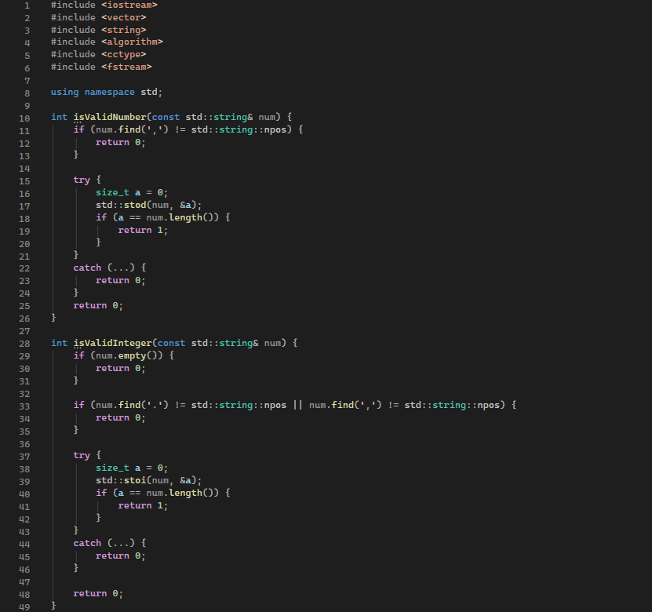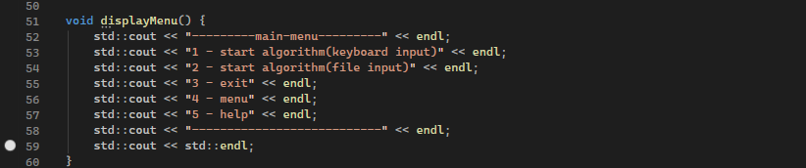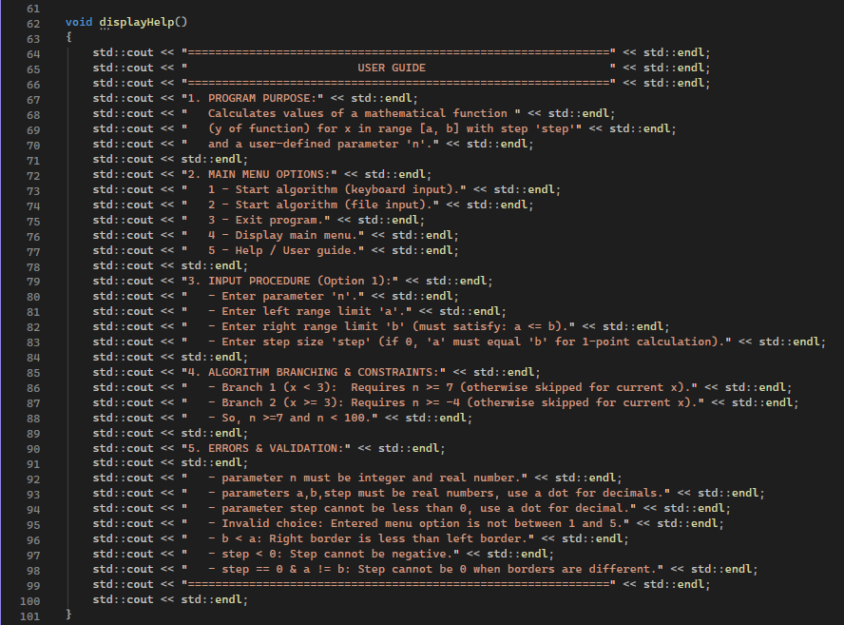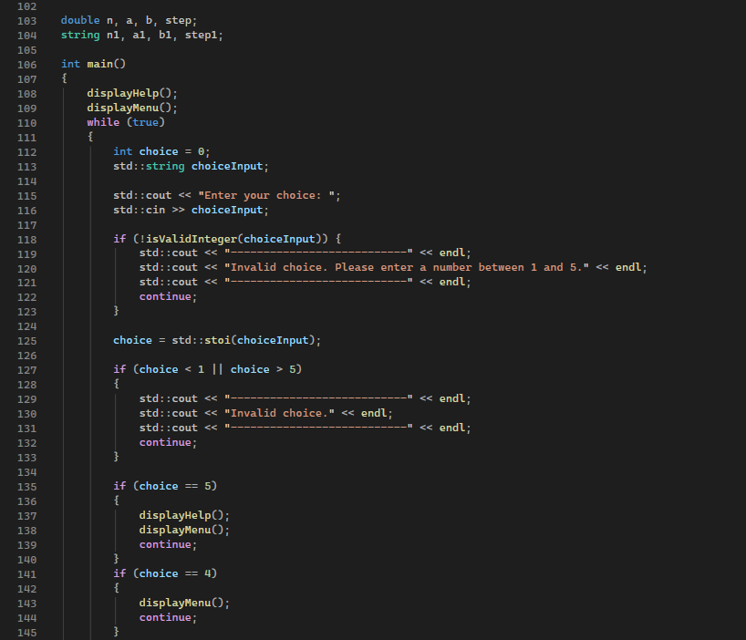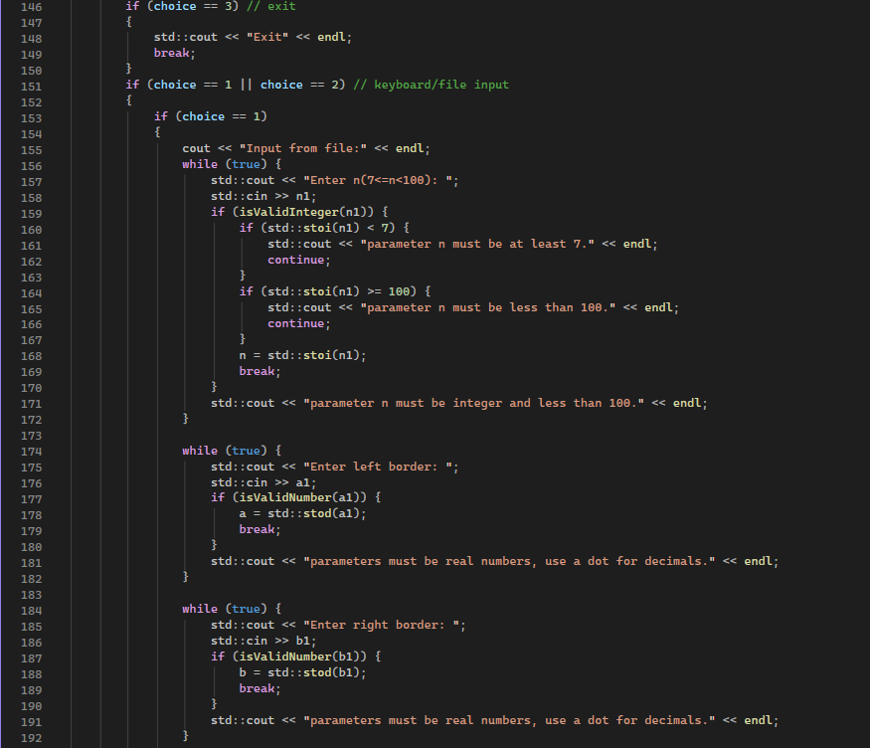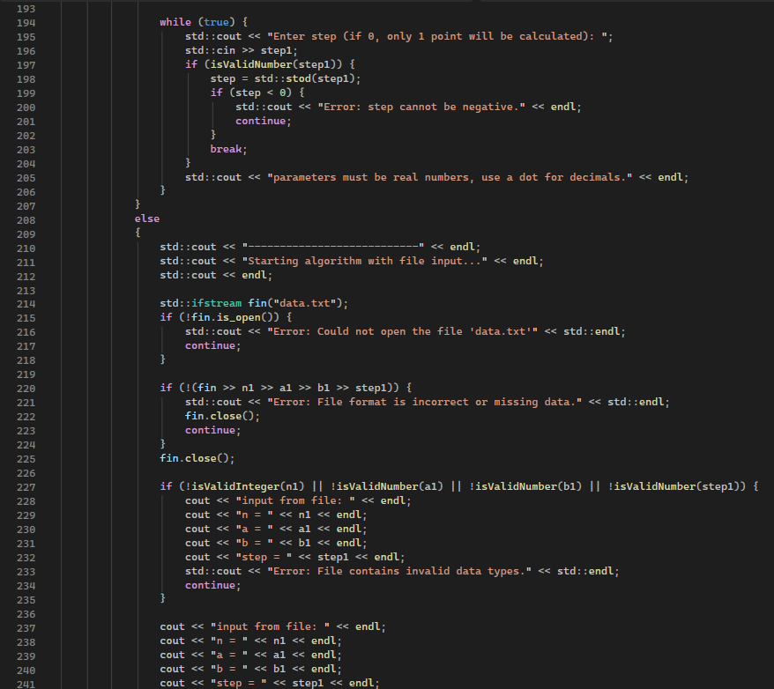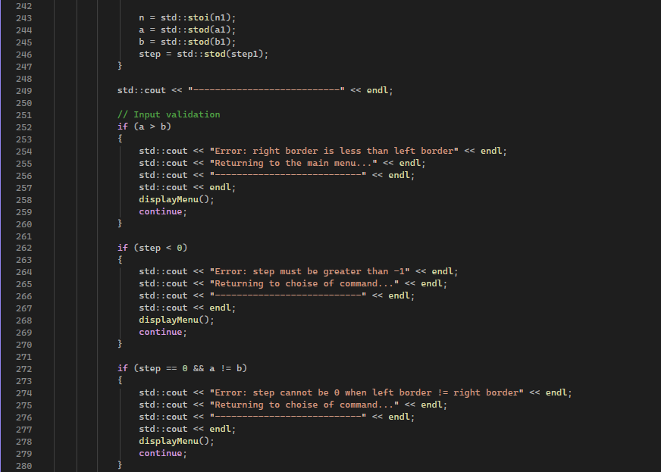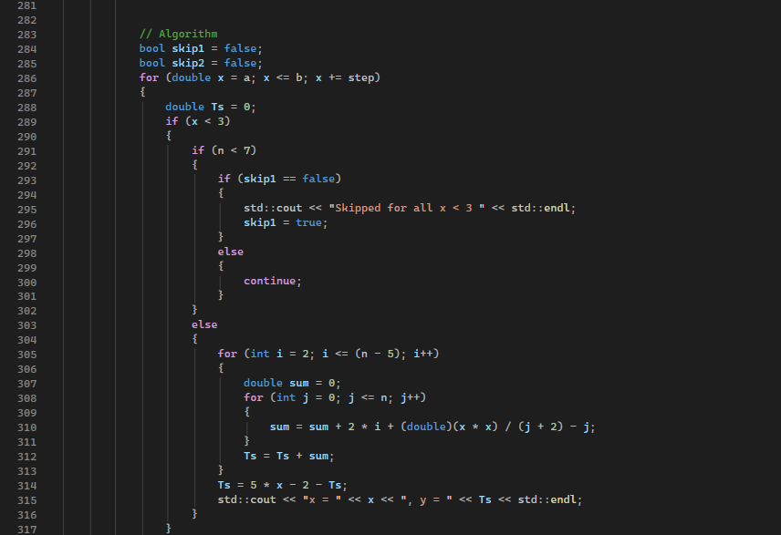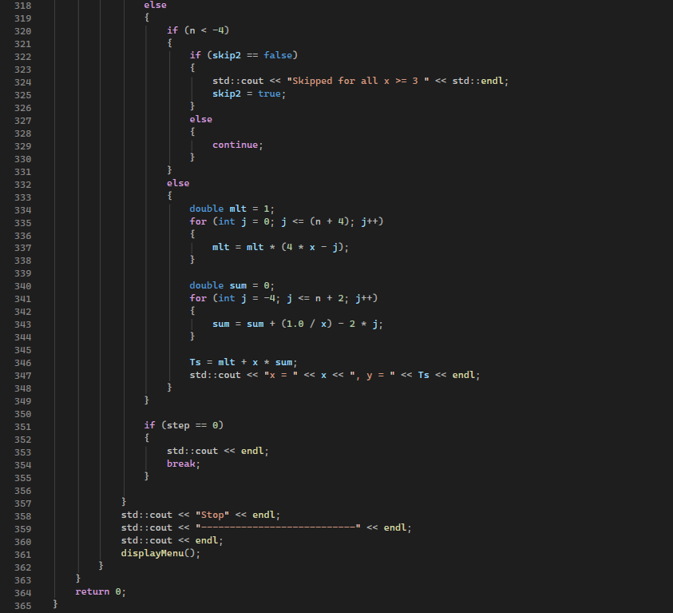

2. Enhance interface and user experience of console application. Create Wireframe to visualize your idea.
Wireframe was created according to diogram:
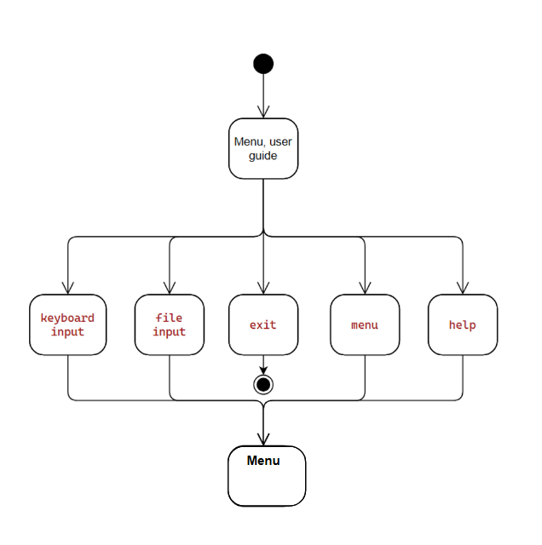
For user, programm starts with guide and main menu.
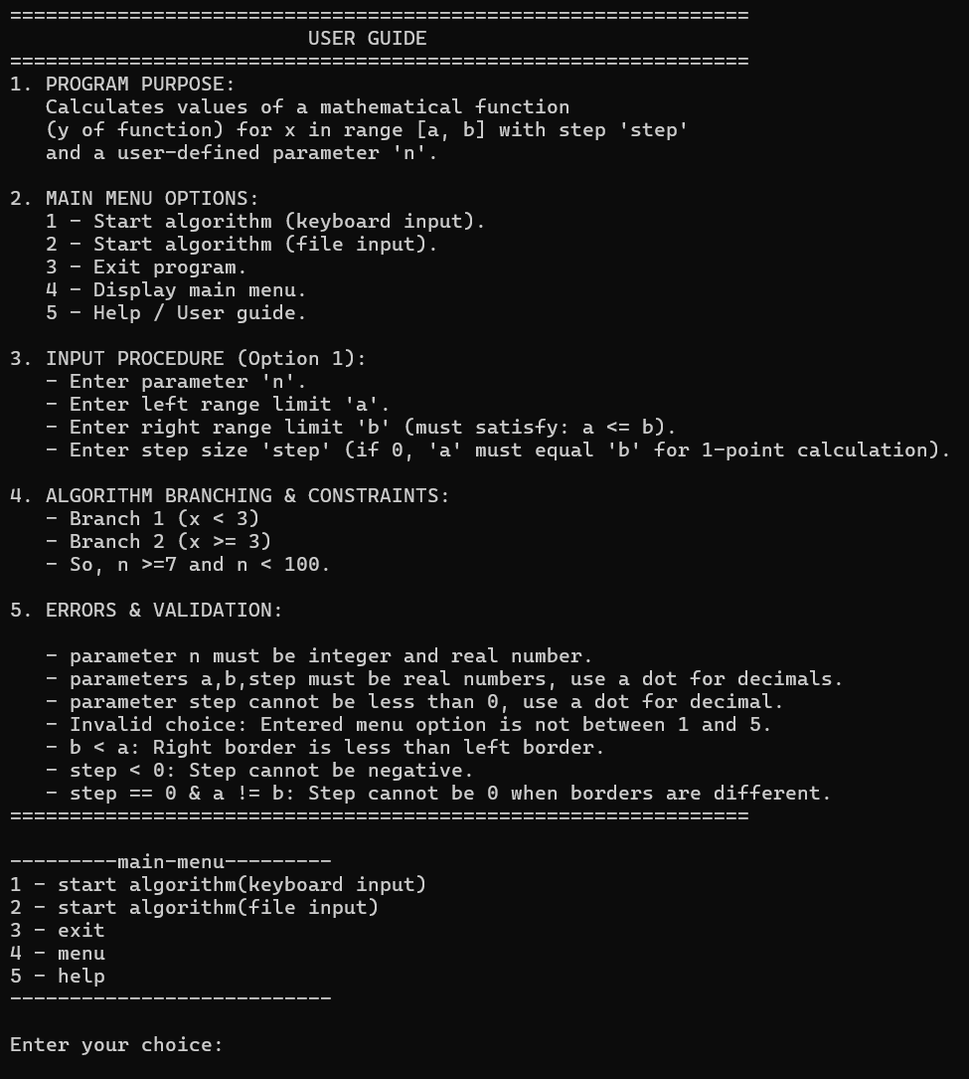
As we can see, user have 5 commands to choose of.
If we choose 5. Programm prints guide.
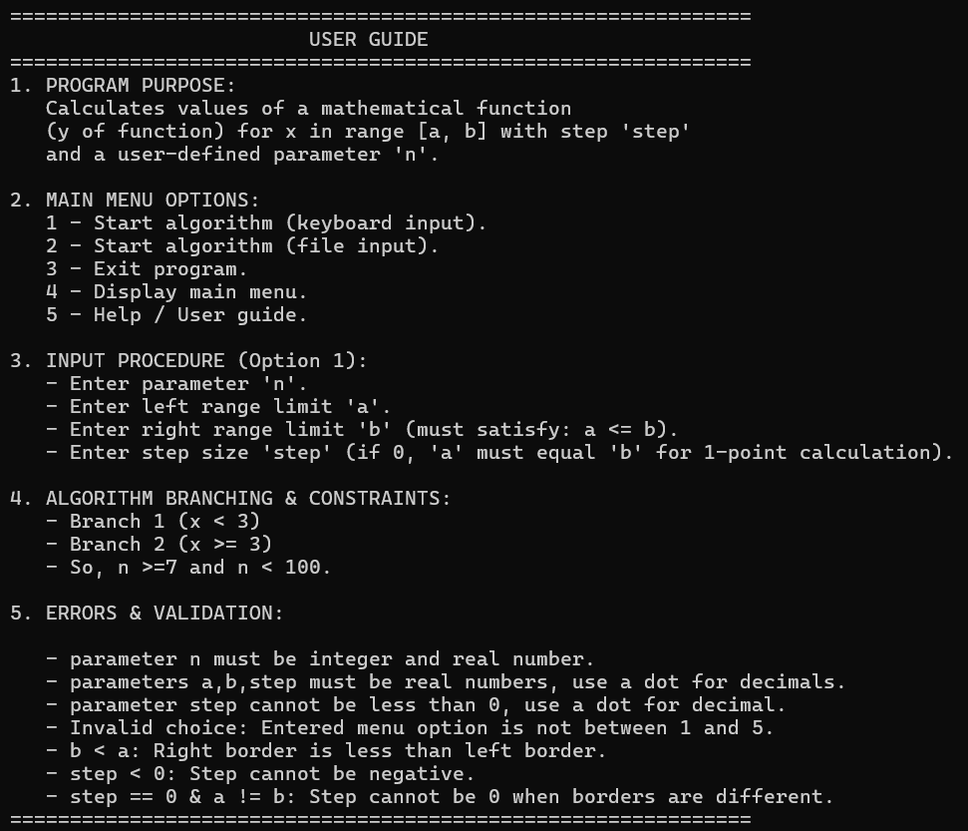
If we choose 4. Programm prints menu.
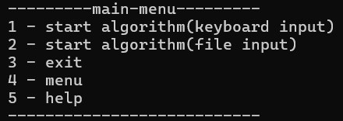
If we choose 3. Programm stops.
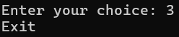
If we choose 2. Programm starts from data.txt input.
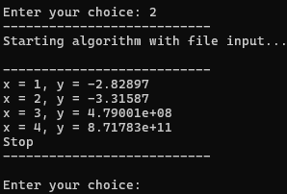
If we choose 1. Programm starts from keyboard input.
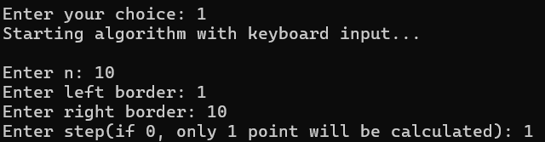
Result of this input:
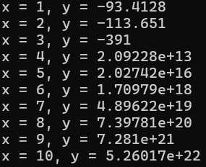
And after that we can chose another option again.
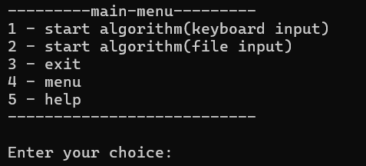
ERROR REPORTS
if (choice != 1 && choice != 2 && choice != 3); Invalid choice. Please try again.
if (b < a); Error: right border is less than left border
if (step < 0); Error: step must be greater than -1
if (step == 0 && a != b); Error: step cannot be 0 when left border != right border

CONCLUSION
During this laboratory work, I gained practical skills in C++ programming. I created a program to calculate a function over a given range, improved the console interface, designed a wireframe, and implemented input validation and error messages.

