Assignment 0.4
2022021003 Junho Uh

This experiment was conducted with the objective of identifying web servers within the Hanyang University network range, not merely through simple port scanning, but by designing an exploration strategy that accounts for network constraints and attempts to overcome them.
Initially, the experiment was performed in a local network environment to understand the behavior of scanning tools. In a cafe Wi-Fi environment, the current IP address was identified using the command ipconfig getifaddr en0, and hosts connected to the same network were discovered using sudo arp-scan --interface=en0 --localnet. While multiple hosts were successfully identified through ARP-based discovery, subsequent port scanning using nmap -p 80,443,8080 172.30.1.0/24 failed to detect most hosts.
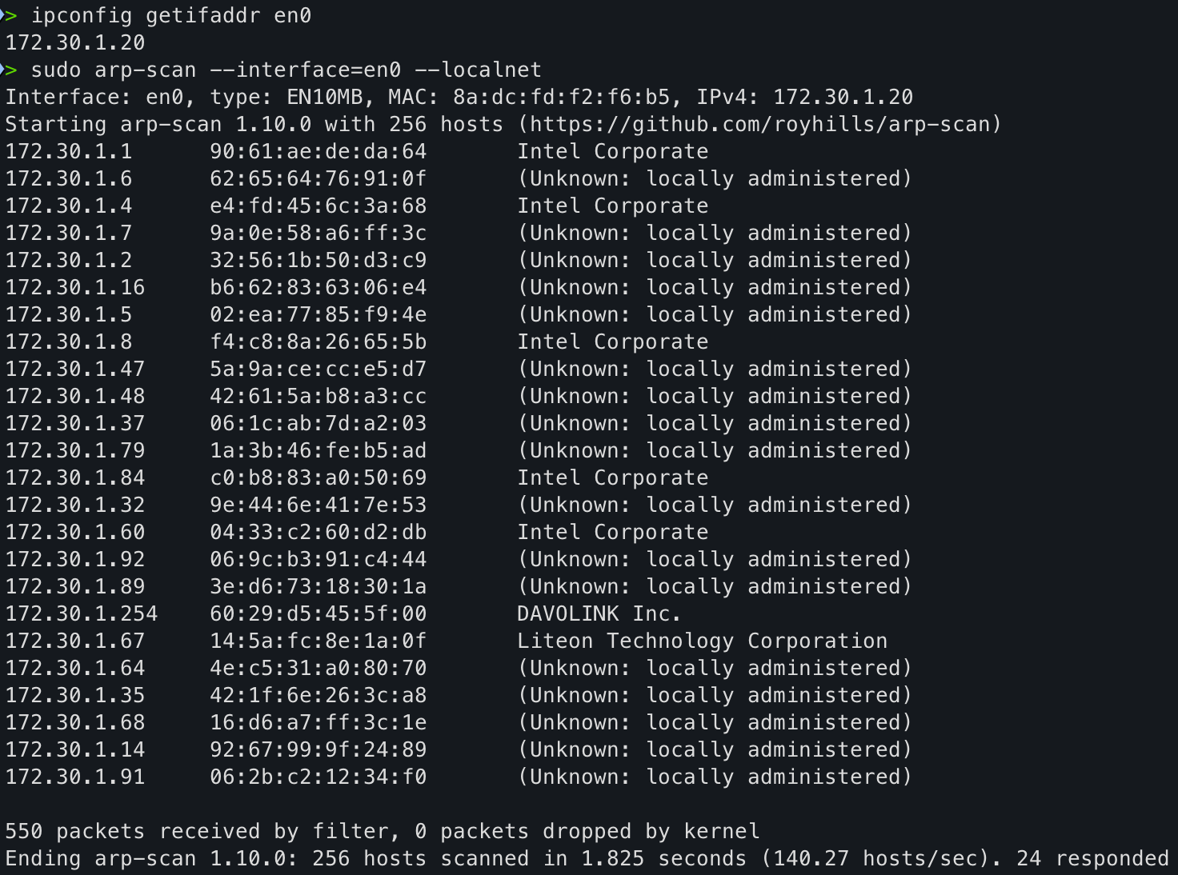
To address this issue, the command nmap -Pn -p 80,443,8080 172.30.1.0/24 was used to skip the host discovery phase and directly scan all IP addresses. However, the results still showed most targets as “filtered.” This indicated that in public Wi-Fi environments, client isolation and firewall policies restrict inter-client communication and port scanning. Through this process, it was recognized that results obtained in a local network environment cannot be directly applied to external network exploration.

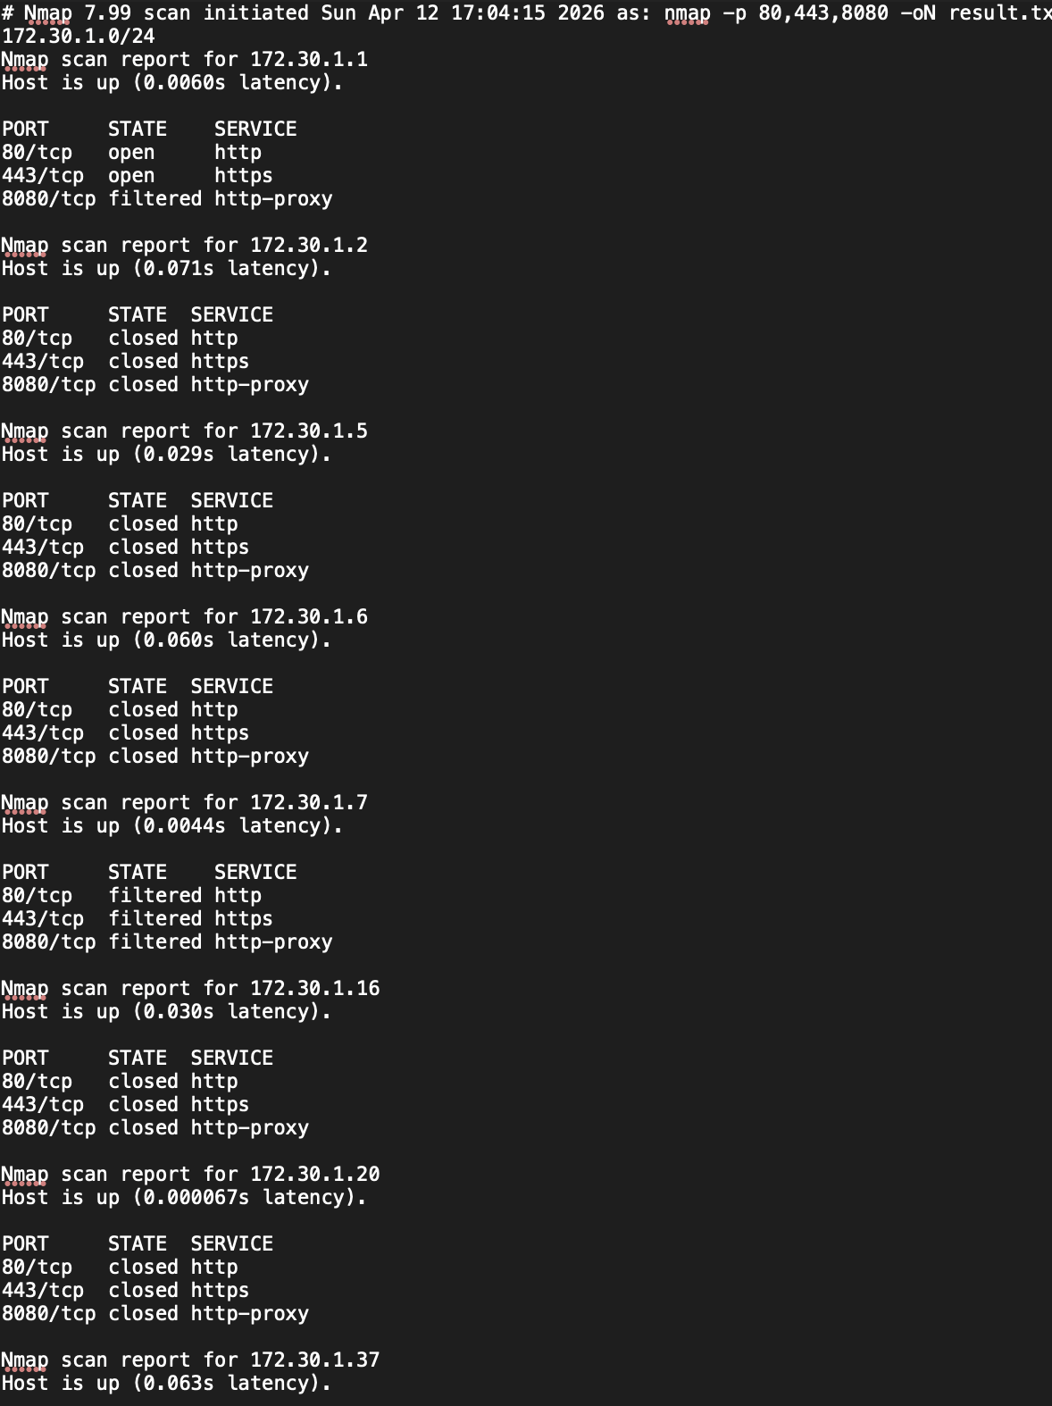
The experiment scope was then expanded to the public IP range of Hanyang University, 166.104.0.0/16. Although scanning the entire range at once was initially considered, this approach was deemed inefficient due to potential firewall blocking and excessive time consumption. Therefore, a strategy of incremental exploration using /24 subnet segmentation was adopted. Commands of the form
nmap -p 80,443,8080 -T3 --open -oN scan_166.104.X.0_24.txt 166.104.X.0/24
were used to perform sampling-based scans across multiple subnets.
During this process, most subnets responded with active hosts, but no hosts with open web-related ports were identified. In particular, subnets such as 166.104.30.0/24, 40.0/24, 80.0/24, 115.0/24, 130.0/24, 190.0/24, and 200.0/24 showed host availability but no open ports.
Additionally, some subnet scans took over 200 seconds to complete. This was due to Nmap waiting for timeouts on non-responsive hosts, significantly increasing the overall scanning time. To improve efficiency, an automated scanning approach with time limits was implemented. Specifically, the following loop was used:
for i in 1 10 20 30 50 100 150 200;
do gtimeout 160s nmap -p 80,443,8080 --open -T3 166.104.$i.0/24 -oN result_$i.txt;
done
This allowed the scanning process to skip unresponsive segments quickly and improve overall efficiency.
However, the issue of failing to identify web servers persisted under the random subnet sampling approach. To resolve this, the strategy was shifted to domain-based exploration. Web domains associated with Hanyang University were collected, and DNS resolution was performed to identify their corresponding IP addresses. The results showed that many domains were concentrated on a single IP address, 166.104.177.20.
For example, domains such as hanyang.ac.kr, academic.hanyang.ac.kr, it.hanyang.ac.kr, and biz.hanyang.ac.kr were all mapped to this IP. Additionally, some services were found to use different IPs, such as 166.104.177.130, 166.104.110.250, and 166.104.115.154.
Based on these findings, a focused scan was conducted on the 166.104.177.0/24 subnet. This scan successfully identified multiple web servers. Specifically, IP addresses 166.104.177.20, 166.104.177.155, 166.104.177.170 (portal.hanyang.ac.kr), and 166.104.177.180 were found to have ports 80 and 443 open. In contrast, neighboring subnets such as 166.104.176.0/24, 178.0/24, and 179.0/24 showed little to no host activity or open ports. This indicates that web services are concentrated within specific subnets rather than being uniformly distributed across adjacent ranges.
Further analysis using nmap -p 80,443,8080 -sV 166.104.177.20 revealed that this IP address was not a typical web server but an F5 BIG-IP load balancer. This explains why multiple domains are mapped to a single IP address, indicating that actual web servers are located internally and accessed externally through the load balancer. In other words, the number of externally observable web servers does not necessarily correspond to the actual number of backend servers, as a single IP can represent multiple services.
In conclusion, this experiment demonstrates that web servers within the Hanyang University network are not evenly distributed across the entire IP range but are instead concentrated in specific subnets and accessed externally via load balancers. Furthermore, random subnet scanning was found to be inefficient, while a domain-based analysis combined with targeted scanning proved to be significantly more effective. The experiment also confirmed that network conditions, firewall policies, and scanning methodologies can significantly influence the results.
Specific scan results can be viewed on following Github link.

