
A DBMS Project Report on

Connore Student Networking Platform
Database Management Systems Lab
Semester III | Batch B2
Submitted by
Purab Bubna (25070122145)
Rikisha Bhattacharya (25070122155)
Riddhima Wadhane (25070122154)
Rashmi Hore (25070122153)
Under the guidance of
Dr Jitendra Rajpurohit
Department of Computer Science and Engineering
Symbiosis Institute of Technology Pune
Symbiosis International Deemed University
Academic Year 2026–2027

Index
Section | Contents | Page
1 | Introduction and problem statement | 3
2 | System architecture and modules | 4
3 | Functional requirements | 5
4 | Entities relationships and attributes | 6
5 | ER and EER diagrams | 7–8
6 | Relational schema | 9
7 | Anomalies and functional dependencies | 10
8 | Normalization | 11
9 | Application of Codd rules | 12
10 | MySQL table implementation | 13–16
11 | SQL queries | 17
12 | Function procedure and trigger | 18
13 | Application and verification | 19
14 | Conclusion contributions and references | 20

1 Introduction and problem statement

Introduction
Connore assists students in college to connect with others who share their interests. A student creates a profile, chooses interests and joins communities of interest. Connection requests give both students a choice before social handles are shared. The site is available in two versions: Classic and Motion, running on the same Java back end and MySQL database.

Problem statement
Student interests and contact information may be distributed among different groups and profiles. Connore compiles these records and provides students with control over what others can see. The database should not allow for duplicate selections or repeated pairs of students. It must store profiles, interests, memberships and connection states.

Objectives
The project offers college domain registration, profile editing, interest based suggestions and community membership. It also handles request acceptance, rejection, expiration and blocking. These features illustrate keys, relationships, normalization, joins and transactions in the database design.

Project scope
Included | Outside the current implementation
Profiles and privacy settings | Mailbox verification and password recovery
Interest suggestions and communities | Internal messaging
Connection requests and shared social handles | A web interface for catalog administration
Classic and Motion frontend editions | Public production hosting

2 System architecture and modules
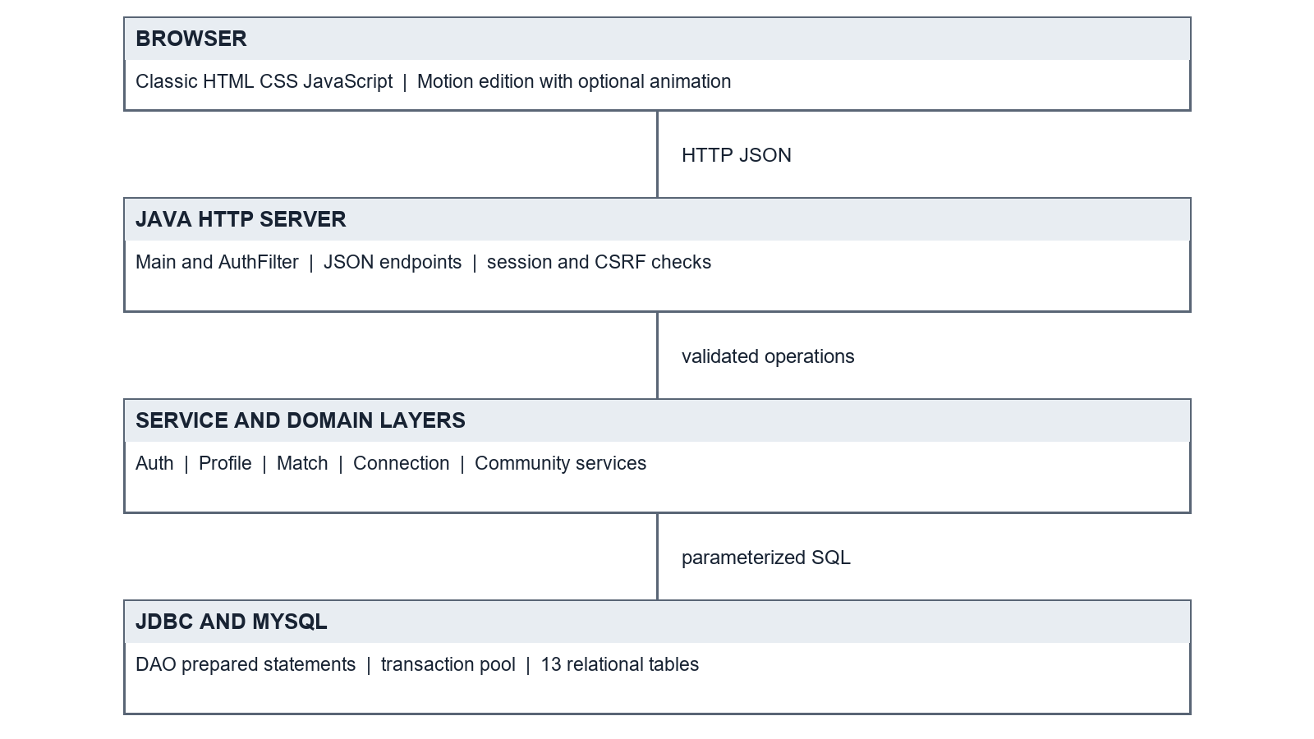
Figure 1 System architecture
The browser makes a JSON request to the Java HTTP server. Valid requests are passed to endpoint classes which then pass to services which apply rules and call DAO classes. The DAO classes use prepared JDBC statements to read and update MySQL. The application is deployed on the built-in HTTP server of Java without Tomcat or Maven.
Module | Purpose
Authentication | Registration, login, sessions and logout
Profile | Details, selected interests, privacy settings and social handles
Matching | Find eligible profiles and count shared interests
Connection | Request, accept, decline, expire, reopen and block
Community | List communities, join, leave and view members

3 Functional requirements
ID | Requirement
FR01 | Register with a unique college email and log in using a password.
FR02 | Create and edit a profile with a name, department, year and biography.
FR03 | Add or remove approved interests without duplicate selections.
FR04 | Control department and year visibility, and participation in suggestions.
FR05 | Suggest other students with shared interests, excluding active or blocked pairs.
FR06 | Send a connection request with an optional interest as context.
FR07 | Allow only the receiver to accept or decline a pending request.
FR08 | Expire pending requests after 48 hours and allow closed pairs to reopen.
FR09 | Accept an existing pair when the receiver sends a reverse request.
FR10 | Allow a participant to block a pending or accepted pair.
FR11 | List communities and support joining, leaving and viewing members.
FR12 | Show opted-in social handles only through accepted connections.
FR13 | Offer an optional Motion edition with pause and reduced-motion support.

Input validation
The maximum lengths of names, departments and biographies are 100, 60 and 500 characters. Year of study may be blank or 1-6. The password should be 8-200 characters long. College domain validation is performed on the domain part of the address, but there is no mailbox validation or password recovery.

4 Entities relationships and attributes
There are thirteen tables in the design. Account contains login information, student_profile contains student information. Many-to-many relationships are resolved by Student_interest and community_membership. Connection records the requester and receiver roles, and its subtype tables hold the information for each state. All attributes and keys are listed in the relational schema.
Entity | Key and main attributes | Relationship
account | account_id; email, password_hash | Parent of profile
student_profile | student_id; name, department, year, bio, privacy flags | One account; many interests and memberships
social_link | link_id; platform, handle, shared | Belongs to one profile
category | category_id; name | Groups interests
interest | interest_id; name, category_id, is_approved | Selected by many students
student_interest | student_id + interest_id; added_at | Student–interest junction
community | community_id; interest_id, description | At most one per interest
community_  membership | student_id + community_id; joined_at | Student–community junction
connection | connection_id; requester, receiver, status, context | One unordered student pair
pending_request | connection_id; expires_at | Pending subtype
accepted_connection | connection_id; connected_at | Accepted subtype
closed_request | connection_id; outcome, closed_at | Closed subtype
block | connection_id; blocked_by, blocked_at | Blocked subtype; blocker is a profile

5 ER diagram
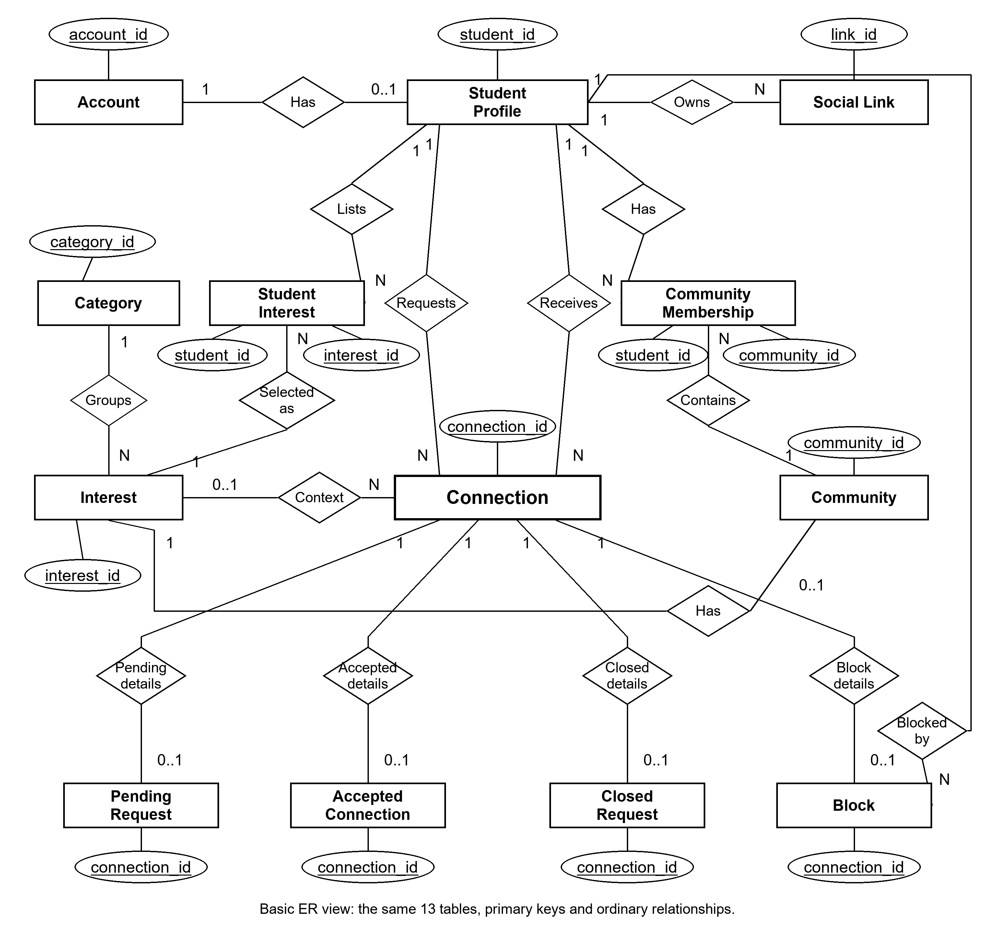
Figure 2 Simplified ER model centred on Connection
Both diagrams use the same 13 tables, with Connection at the centre. The ER shows primary keys and basic relationships. Rectangles represent tables, diamonds represent relationships and ovals represent attributes. Keys are underlined; N means many.
Student Interest and Community Membership link students with interests and communities. Both use the two underlined attributes as a composite key. A connection has a requester and a receiver, and may refer to an interest. The four state tables have ordinary links in this simpler ER view.

5 EER diagram
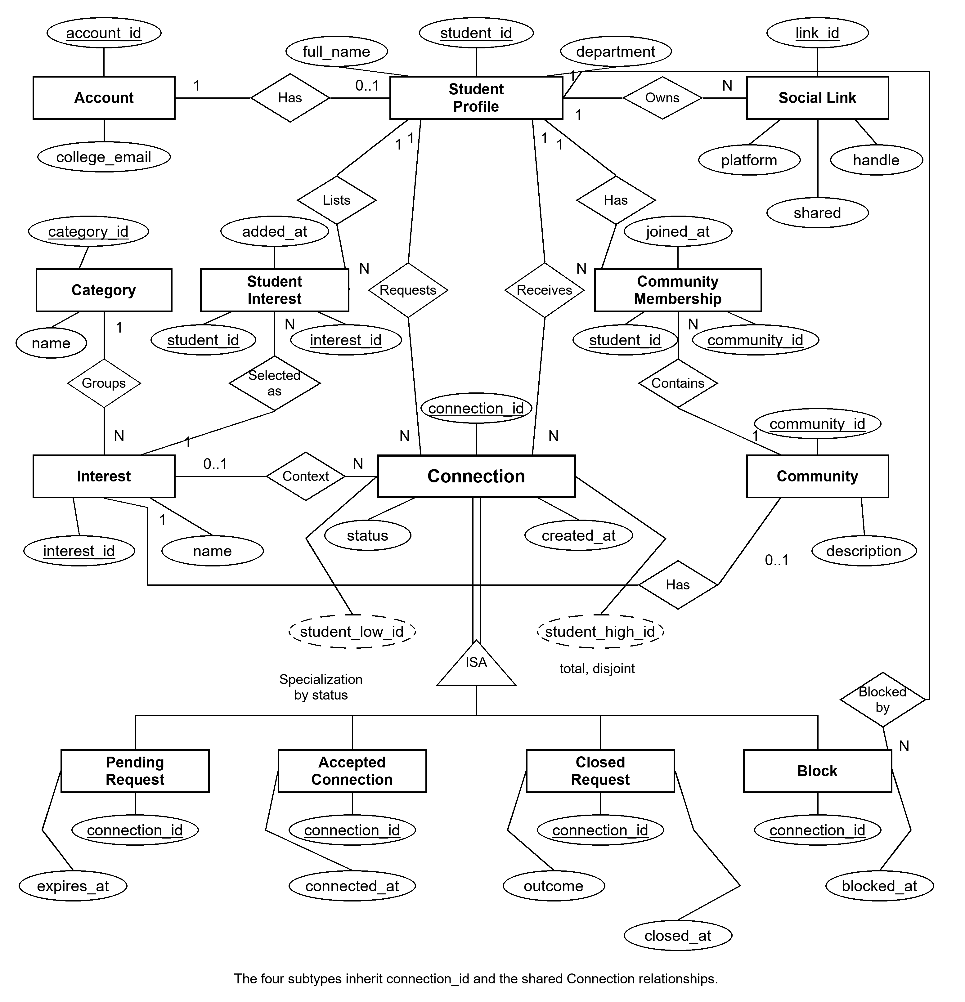
Figure 3 EER model with total disjoint specialization of Connection
The EER adds descriptive attributes to the same model. Connection is specialized by status into Pending Request, Accepted Connection, Closed Request and Block. The ISA triangle shows the hierarchy. The double line indicates total specialization; disjoint means a connection belongs to only one state. Reading upward gives the corresponding generalization.
Each subtype inherits connection_id and the shared Connection relationships. Dashed ovals show the generated student pair IDs. Java transactions maintain exactly one subtype matching status; foreign keys alone do not enforce this rule across the state tables.

6 Relational schema
PK marks a primary key, FK a foreign key, and UK a unique key. Two PK attributes in a junction table form one composite key.
ACCOUNT(account_id PK, college_email UK, password_hash, email_verified, created_at)
STUDENT_PROFILE(student_id PK FK→ACCOUNT, full_name, department, year_of_study, bio, show_department, show_year, suggestible)
SOCIAL_LINK(link_id PK, student_id FK→STUDENT_PROFILE, platform, handle, shared)
CATEGORY(category_id PK, name UK)
INTEREST(interest_id PK, name UK, category_id FK→CATEGORY, is_approved)
STUDENT_INTEREST(student_id PK FK→STUDENT_PROFILE, interest_id PK FK→INTEREST, added_at)
COMMUNITY(community_id PK, interest_id UK FK→INTEREST, description, created_at)
COMMUNITY_MEMBERSHIP(student_id PK FK→STUDENT_PROFILE, community_id PK FK→COMMUNITY, joined_at)
CONNECTION(connection_id PK, requester_id FK→STUDENT_PROFILE, receiver_id FK→STUDENT_PROFILE, context_interest_id FK→INTEREST, status, created_at, student_low_id, student_high_id; UK(student_low_id, student_high_id))
PENDING_REQUEST(connection_id PK FK→CONNECTION, expires_at)
ACCEPTED_CONNECTION(connection_id PK FK→CONNECTION, connected_at)
CLOSED_REQUEST(connection_id PK FK→CONNECTION, outcome, closed_at)
BLOCK(connection_id PK FK→CONNECTION, blocked_by FK→STUDENT_PROFILE, blocked_at)

7 Anomalies and functional dependencies
Anomaly in a combined record | Resolution in Connore
Update: a student or category name is repeated in many selections. | Keep the name in its profile or catalog table.
Insertion: a new interest needs a student selection before it can exist. | Store interests independently of student_interest.
Deletion: removing the last membership removes community details. | Separate community from community_membership.

A functional dependency is a relationship that shows which attributes determine others. Account ID and college email each identify one account. The two junction tables are dependent on their full composite keys. A connection can be found by its ID or by the unordered student pair generated. A requester ID is not sufficient to identify a single connection.
Relation | Determinant → dependent attributes
account | account_id or college_email → all other attributes
student_profile | student_id → name, department, year, bio, privacy flags
social_link | link_id → student_id, platform, handle, shared
category | category_id or name → other attribute
interest | interest_id or name → other attributes
student_interest | (student_id, interest_id) → added_at
community | community_id or interest_id → other attributes
community_membership | (student_id, community_id) → joined_at
connection | connection_id or (student_low_id, student_high_id) → other attributes
pending_request | connection_id → expires_at
accepted_connection | connection_id → connected_at
closed_request | connection_id → outcome, closed_at
block | connection_id → blocked_by, blocked_at

8 Normalization

First normal form
Only one value is stored in each field. A student who has multiple interests will have multiple student_interest rows, not a comma-separated list. Social handles and memberships are also kept as individual records.

Second normal form
The added_at field in student_interest is dependent on student_id and interest_id. The joined_at field in community_membership is dependent on student_id and community_id. Student names and catalog names should be in separate tables, and neither junction table should have attributes that depend on only some of its key.

Third normal form and BCNF
category_id is stored in interest, and category stores the name of the category. Community refers to an interest rather than its name and category. These separations eliminate transitive descriptive dependencies. Under the stated dependencies, every nontrivial determinant is a candidate key, so the logical relations also satisfy BCNF. Physical uniqueness enforcement is supported for generated pair columns.

Decomposition example
Selection(student_id, full_name, interest_id, interest_name,
category_id, category_name, added_at)
Decomposes into
Student_profile(student_id, full_name, ...)
Category(category_id, name)
Interest(interest_id, name, category_id, ...)
Student_interest(student_id, interest_id, added_at)
Joining a selection to student_profile on student_id and to interest on interest_id returns one record from each parent. This decomposition is lossless for selection rows, because of the referenced keys. Profile, catalog and selection dependencies continue to be valid in their relations. The application transaction is still needed for cross-table subtype consistency.

9 Application of Codd rules
Rule | Application to Connore
0 Relational foundation | Persistent facts are stored in relational tables and manipulated through SQL.
1 Information | Profiles, interests and relationships are represented as table values.
2 Guaranteed access | A table, key value and column identify a field.
3 Null treatment | Optional department, year, bio and context may be null.
4 Online catalog | information_schema describes tables, columns, constraints and indexes.
5 Comprehensive language | SQL provides DDL, queries, updates, grants and transaction control.
6 View updating | No views are defined; full view-update compliance is not claimed.
7 Set operations | Joins, aggregation, updates and deletes operate on sets of rows.
8 Physical independence | Indexes can change without changing the frontend API.
9 Logical independence | DAO classes limit coupling, but schema changes can require code changes.
10 Integrity independence | SQL enforces keys and checks; subtype consistency also relies on Java.
11 Distribution independence | The project uses one local database; distributed operation is not demonstrated.
12 Nonsubversion | The API enforces ownership, but privileged SQL can bypass application-only rules.

10 MySQL table implementation
The following table definitions are the same as the developer guide and application schema. MySQL 8.0.16 or later is required for enforced CHECK constraints. The schema is utf8mb4 and has no sample rows. Database credentials are saved in the local configuration file.
CREATE DATABASE IF NOT EXISTS connore CHARACTER SET utf8mb4;
USE connore;
CREATE TABLE account (
account_id INT AUTO_INCREMENT PRIMARY KEY,
college_email VARCHAR(100) NOT NULL UNIQUE,
password_hash VARCHAR(255) NOT NULL,
email_verified BOOLEAN NOT NULL DEFAULT FALSE,
created_at DATETIME NOT NULL DEFAULT CURRENT_TIMESTAMP
);
CREATE TABLE student_profile (
student_id INT PRIMARY KEY,
full_name VARCHAR(100) NOT NULL,
department VARCHAR(60),
year_of_study TINYINT,
bio VARCHAR(500),
show_department BOOLEAN NOT NULL DEFAULT FALSE,
show_year BOOLEAN NOT NULL DEFAULT FALSE,
suggestible BOOLEAN NOT NULL DEFAULT TRUE,
FOREIGN KEY (student_id) REFERENCES account(account_id) ON DELETE CASCADE
);
CREATE TABLE social_link (
link_id INT AUTO_INCREMENT PRIMARY KEY,
student_id INT NOT NULL,
platform VARCHAR(30) NOT NULL,
handle VARCHAR(100) NOT NULL,
shared BOOLEAN NOT NULL DEFAULT FALSE,
FOREIGN KEY (student_id) REFERENCES student_profile(student_id) ON DELETE
CASCADE
);
CREATE TABLE category (
category_id INT AUTO_INCREMENT PRIMARY KEY,
name VARCHAR(50) NOT NULL UNIQUE
);

10 Interest and community tables
CREATE TABLE interest (
interest_id INT AUTO_INCREMENT PRIMARY KEY,
name VARCHAR(80) NOT NULL UNIQUE,
category_id INT NOT NULL,
is_approved BOOLEAN NOT NULL DEFAULT TRUE,
FOREIGN KEY (category_id) REFERENCES category(category_id)
);
CREATE TABLE student_interest (
student_id INT NOT NULL,
interest_id INT NOT NULL,
added_at DATETIME NOT NULL DEFAULT CURRENT_TIMESTAMP,
PRIMARY KEY (student_id, interest_id),
INDEX idx_student_interest_interest (interest_id),
FOREIGN KEY (student_id) REFERENCES student_profile(student_id) ON DELETE
CASCADE,
FOREIGN KEY (interest_id) REFERENCES interest(interest_id)
);
CREATE TABLE community (
community_id INT AUTO_INCREMENT PRIMARY KEY,
interest_id INT NOT NULL UNIQUE,
description VARCHAR(300),
created_at DATETIME NOT NULL DEFAULT CURRENT_TIMESTAMP,
FOREIGN KEY (interest_id) REFERENCES interest(interest_id)
);
CREATE TABLE community_membership (
student_id INT NOT NULL,
community_id INT NOT NULL,
joined_at DATETIME NOT NULL DEFAULT CURRENT_TIMESTAMP,
PRIMARY KEY (student_id, community_id),
INDEX idx_membership_community (community_id),
FOREIGN KEY (student_id) REFERENCES student_profile(student_id) ON DELETE
CASCADE,
FOREIGN KEY (community_id) REFERENCES community(community_id) ON DELETE
CASCADE
);

10 Connection table
CREATE TABLE `connection` (
connection_id INT AUTO_INCREMENT PRIMARY KEY,
requester_id INT NOT NULL,
receiver_id INT NOT NULL,
context_interest_id INT NULL,
status VARCHAR(10) NOT NULL,
created_at DATETIME NOT NULL DEFAULT CURRENT_TIMESTAMP,
student_low_id INT GENERATED ALWAYS AS (LEAST(requester_id, receiver_id))
STORED,
student_high_id INT GENERATED ALWAYS AS (GREATEST(requester_id,
receiver_id)) STORED,
CONSTRAINT chk_connection_pair CHECK (requester_id <> receiver_id),
CONSTRAINT chk_connection_status CHECK (status IN
('PENDING','ACCEPTED','CLOSED','BLOCKED')),
UNIQUE KEY uq_connection_pair (student_low_id, student_high_id),
INDEX idx_connection_requester (requester_id),
INDEX idx_connection_receiver (receiver_id),
FOREIGN KEY (requester_id) REFERENCES student_profile(student_id),
FOREIGN KEY (receiver_id) REFERENCES student_profile(student_id),
FOREIGN KEY (context_interest_id) REFERENCES interest(interest_id)
);

Pair uniqueness
student_low_id = LEAST(requester_id, receiver_id)
student_high_id = GREATEST(requester_id, receiver_id)
UNIQUE(student_low_id, student_high_id)
Constraint | Purpose
requester_id <> receiver_id | Reject self connections.
Unique generated pair | Treat A→B and B→A as one relationship.
Status CHECK | Permit PENDING, ACCEPTED, CLOSED and BLOCKED.
Foreign keys | Require existing requester, receiver and optional interest.

10 Connection subtype tables
CREATE TABLE pending_request (
connection_id INT PRIMARY KEY,
expires_at DATETIME NOT NULL,
INDEX idx_pending_expires (expires_at),
FOREIGN KEY (connection_id) REFERENCES `connection`(connection_id) ON
DELETE CASCADE
);
CREATE TABLE accepted_connection (
connection_id INT PRIMARY KEY,
connected_at DATETIME NOT NULL DEFAULT CURRENT_TIMESTAMP,
FOREIGN KEY (connection_id) REFERENCES `connection`(connection_id) ON
DELETE CASCADE
);
CREATE TABLE closed_request (
connection_id INT PRIMARY KEY,
outcome VARCHAR(10) NOT NULL,
closed_at DATETIME NOT NULL DEFAULT CURRENT_TIMESTAMP,
CONSTRAINT chk_closed_outcome CHECK (outcome IN ('DECLINED','EXPIRED')),
FOREIGN KEY (connection_id) REFERENCES `connection`(connection_id) ON
DELETE CASCADE
);
CREATE TABLE `block` (
connection_id INT PRIMARY KEY,
blocked_by INT NOT NULL,
blocked_at DATETIME NOT NULL DEFAULT CURRENT_TIMESTAMP,
FOREIGN KEY (connection_id) REFERENCES `connection`(connection_id) ON
DELETE CASCADE,
FOREIGN KEY (blocked_by) REFERENCES student_profile(student_id)
);

11 SQL queries
The queries illustrate catalog joins, counts of memberships, shared-interest lookup and request expiry. Use real IDs from another demonstration database. These statements are not live output, but rather are examples of the expected result structure.

Selected interests and categories
SET @student_id = 1;
SELECT i.name AS interest_name, c.name AS category_name
FROM student_interest s
JOIN interest i ON i.interest_id = s.interest_id
JOIN category c ON c.category_id = i.category_id
WHERE s.student_id = @student_id;

Community member counts
SELECT c.community_id, i.name, COUNT(m.student_id) AS members
FROM community c JOIN interest i USING (interest_id)
LEFT JOIN community_membership m USING (community_id)
GROUP BY c.community_id, i.name;

Shared interests between two students
SELECT COUNT(*) AS shared_interests
FROM student_interest a JOIN student_interest b USING (interest_id)
WHERE a.student_id = 1 AND b.student_id = 2;

Incoming pending requests and time remaining
SELECT c.connection_id, p.expires_at,
TIMESTAMPDIFF(MINUTE, UTC_TIMESTAMP(), p.expires_at)
AS minutes_remaining
FROM `connection` c JOIN pending_request p USING (connection_id)
WHERE c.receiver_id = @student_id AND c.status = 'PENDING'
AND p.expires_at > UTC_TIMESTAMP();

12 Function procedure and trigger
The application handles its workflows in Java. The following function, procedure and trigger are additional examples of the lab and have not been run. The trigger validates year values on insertion; a similar update trigger is required to enforce the same rule for direct updates.

Function Count shared interests
DELIMITER $$
CREATE FUNCTION fn_shared_interests(a INT, b INT) RETURNS INT
READS SQL DATA SQL SECURITY INVOKER
BEGIN
DECLARE n INT;
SELECT COUNT(*) INTO n FROM student_interest x
JOIN student_interest y USING (interest_id)
WHERE x.student_id = a AND y.student_id = b;
RETURN n;
END$$
DELIMITER ;
SELECT fn_shared_interests(1, 2);

Procedure List joined communities
DELIMITER $$
CREATE PROCEDURE sp_student_communities(IN sid INT)
READS SQL DATA SQL SECURITY INVOKER
BEGIN
SELECT c.community_id, i.name, m.joined_at
FROM community_membership m JOIN community c USING (community_id)
JOIN interest i USING (interest_id) WHERE m.student_id = sid;
END$$
DELIMITER ;
CALL sp_student_communities(1);

Trigger Validate year on insertion
DELIMITER $$
CREATE TRIGGER trg_profile_year_insert
BEFORE INSERT ON student_profile FOR EACH ROW
BEGIN
IF NEW.year_of_study IS NOT NULL
AND NEW.year_of_study NOT BETWEEN 1 AND 6 THEN
SIGNAL SQLSTATE '45000' SET MESSAGE_TEXT = 'Invalid study year';
END IF;
END$$
DELIMITER ;

13 Application and verification
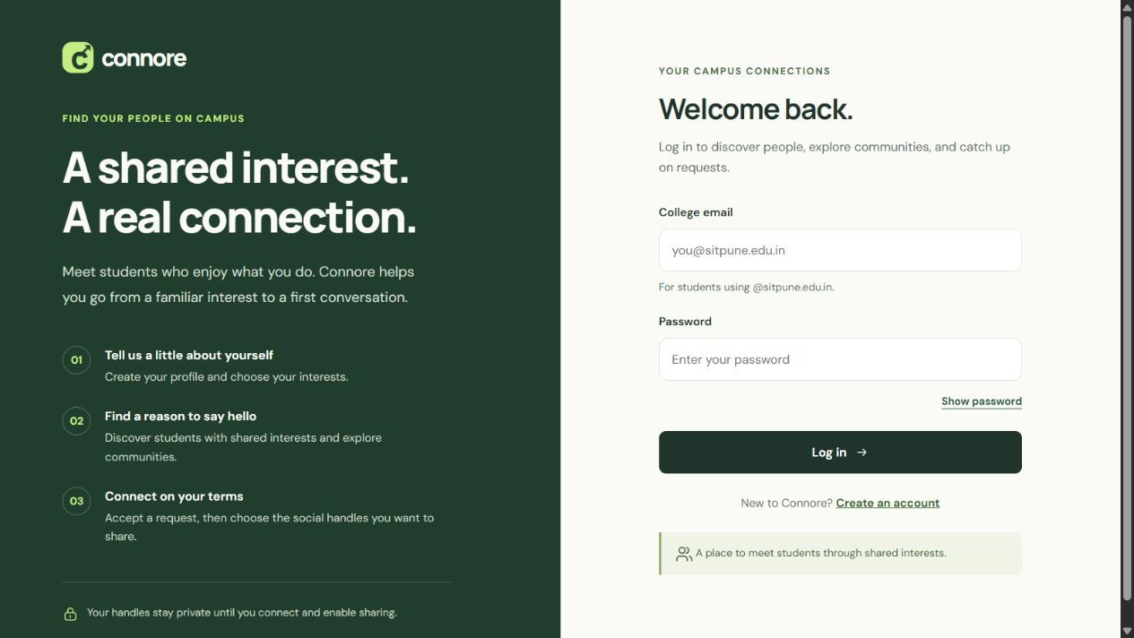
Figure 4 Connore local application login screen
The Java build, core checks and authorization checks were successful on 18 October 2026. The Classic and Motion editions each passed 16 UI checks, while the motion engine passed 8 checks. Stubs are used with the UI tests. The guarded JDBC integration suite has not been executed and needs an empty database with the suffix _test.
Check | Result
Java compilation and CoreTest | Passed
FilterTest session and authorization checks | Passed
Classic UI and Motion UI | 16 passed in each edition
Motion engine | 8 passed
MySQL IntegrationTest | Not run
Stored function procedure and trigger | Examples provided; execution pending

14 Conclusion contributions and references

Conclusion
Connore uses thirteen related tables to manage student discovery, communities and connection requests. Composite keys prevent duplicate selections and memberships. The unordered pair key prevents duplicate relationships when requests are reversed. Separate subtype tables hold each connection state, while transactions maintain consistency. The current project illustrates the database design with a working local web interface.

Individual contributions
Member | Main Responsibility
Purab Bubna | Database Design & ER/EER
Rikisha Bhattacharya | Normalization & DBMS Theory
Riddhima Wadhane | SQL Implementation & Queries
Rashmi Hore | Java Application & Testing

References
1. Connore developer guide, 14 October 2026. ER model, SQL schema and business rules.
2. Connore project source: sql/schema.sql, Java services and DAOs, dist, and test files.
3. Mini Project Guidelines 2023–27 and DBMS Project Notice dated 9 October 2026.
4. Supplied Sample.pdf, used for report structure and cover layout.

