## AMS Scope

IBM teams will be covering various modules under the AMS umbrella. Our breadth of applications will be encompassing Oracle Fusion Cloud modules across the functional domain HR, Procurement, Finance, Inventory Management, Order Management, Manufacturing. Technical scope will encompass Oracle Fusion cloud ERP, Eloqua, Oracle Fusion cloud HCM, Oracle CX cloud. Scope will also cover leveraging number of CEMLIs including 61 interfaces and 33 reports.

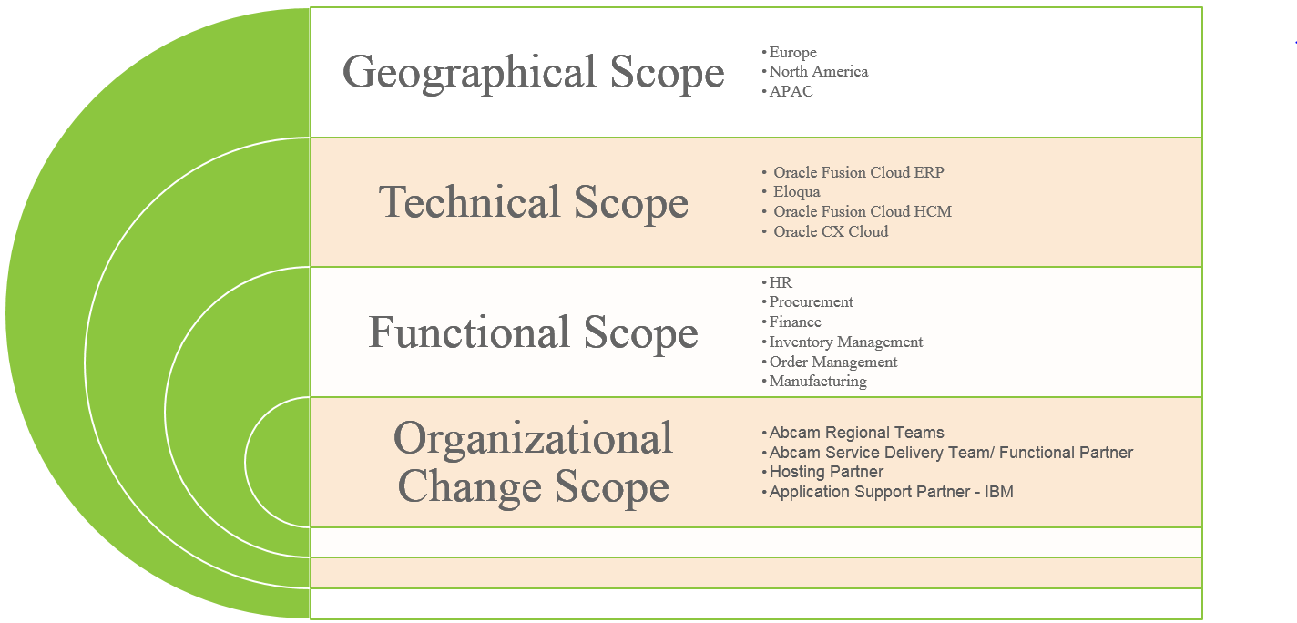

**Solution Scope:**

|  |  |
| --- | --- |
| **System Area** | **Oracle Application Name** |
| Procurement | Oracle Fusion Purchasing Cloud Service |
| Procurement | Oracle Fusion Supplier Portal Cloud Service |
| Procurement | Oracle Fusion Sourcing Cloud Service |
| Procurement | Oracle Fusion Procurement Contracts Cloud Service |
| Procurement | Oracle Fusion Self Service Procurement Cloud Service |
| Logistics | Oracle LogFire Warehouse Management Cloud |
| Logistics | Oracle Fusion Inventory Management Cloud Service |
| Products | Oracle Fusion Product Hub Cloud Service |
| Products | Oracle Fusion Product Hub Portal Cloud Service |
| Products | Oracle Fusion Product Development Cloud Service |
| Projects | Oracle Fusion Project Management Cloud Service |
| Projects | Oracle Fusion Project Billing |
| Projects | Oracle Fusion Project Financial Cloud Service |
| Projects | Oracle Fusion Time and Labour for Projects Cloud Service |
| Projects | Oracle Fusion Task Management Cloud Service |
| Manufacturing | Oracle Fusion Manufacturing Cloud Service |
| Manufacturing | Oracle Fusion Innovation Management Cloud Service |
| Manufacturing | Oracle Fusion Innovation Management Ideation Cloud Service |
| CX | Oracle RightNow Enterprise Dynamic Agent Desktop Cloud Service |
| CX | Oracle RightNow Universal Tier 1 Session Period Pool |
| CX | Oracle Sales Cloud |
| CX | Eloqua |
| CX | Oracle CPQ Cloud for Channel Partners |
| CX | Big Machines Enterprise Cloud service CPQ |
| BI | Oracle BICS |
| BI | Oracle BI Publisher |
| BI | Oracle ODI |
| Orders | Oracle Fusion Order Management Cloud Service |
| Orders | Oracle Fusion Order Management User Cloud Service |
| Orders | Oracle Fusion Global Order Promising Cloud Service |
| Orders | Oracle Fusion Global Order Promising User Cloud Service |
| Orders | Oracle Fusion Transactional Business Intelligence for Supply Chain Management Cloud |
| Orders | Oracle Fusion Global Trade Management Cloud Service |
| Orders | GTM Trade Compliance |
| Orders | GTM Customs |
| Orders | GTM Trade Intelligence |
| HCM | Oracle Fusion HCM Base Cloud Service |
| HCM | Oracle Fusion Performance Management Cloud Service |
| HCM | Oracle Fusion Talent Review and Succession Management Cloud Service |
| HCM | Oracle Fusion Talent Management Base Cloud Service |
| HCM | Oracle Fusion Workforce Compensation Cloud Service |
| HCM | Oracle Taleo Recruiting Cloud Service |
| HCM | Oracle Taleo Onboarding Cloud Service |
| EPM | Oracle Planning and Budgeting |
| EPM | Oracle Fusion Planning Central User Cloud Service |
| EPM | Oracle Fusion Planning Central Cloud Service |
| Financials | Oracle Fusion Financials Cloud Service (Payables Only) |
| Financials | Oracle Fusion Expenses Cloud Service |
| Financials | Oracle Fusion Financials Cloud Service |
| Financials | Oracle Fusion Financials Cloud Service |
| Financials | Oracle Fusion Financials Cloud Service |
| Financials | Oracle Fusion Advanced Collections Cloud Service |
| Financials | Oracle Fusion Financials Cloud Service (Receivables Only) |
| Financials | Oracle Fusion Automated Invoice Processing Cloud Service |
| Financials | Oracle Fusion WebCenter Forms Recognition Cloud Service |
| Financials | Oracle Risk and Compliance Cloud |

Application Development and Management Services (Level 2 and 3) scope will include:

* Systematised expertise delivered through knowledge management technology
* Defined, repeatable, and optimised processes to mitigate transition risk, ensure on-going success

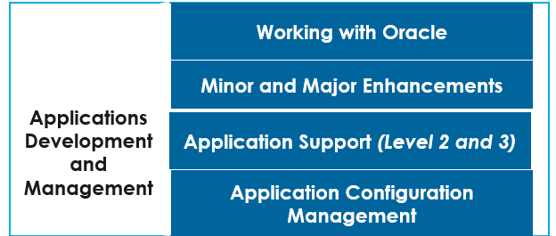

|  |  |  |
| --- | --- | --- |
| **Scope** | **Bound By** | **Numerical Boundary** |
| Day to day operations and monitoring | Hours | Nil hours per month |
| L2/L3 incident management | Tickets | Tickets per month, broken down by severity, with a 5% dead band |
| Minor Enhancements < 40 hours | Hours | 150 hours per month |
| Ad hoc business requests | Hours | Nil hours per month |
| Apply application patches from vendor | Nbr of patches and hours | Upgrade patches every 12 months and quarterly patches |
| Operational Responsibility | Nbr of Client Meeting/Reporting | Monthly SLA Reports/Meetings with the client in a month |

### Delivery Model and Support Locations

IBM will establish a worldwide delivery model for the provision of the services for all the in-scope applications. The IBM delivery model agrees with <<Client>> and is based on IBM providing Application support and delivery from multiple locations. Onsite resources will be needed for delivery ownership/accountability, Architecture and Business Analysis.

The AMS solution of IBM offers to <<Client>> a delivery model that helps to reduce costs and at the same time improves quality with clearly defined service levels and a strong model of governance.

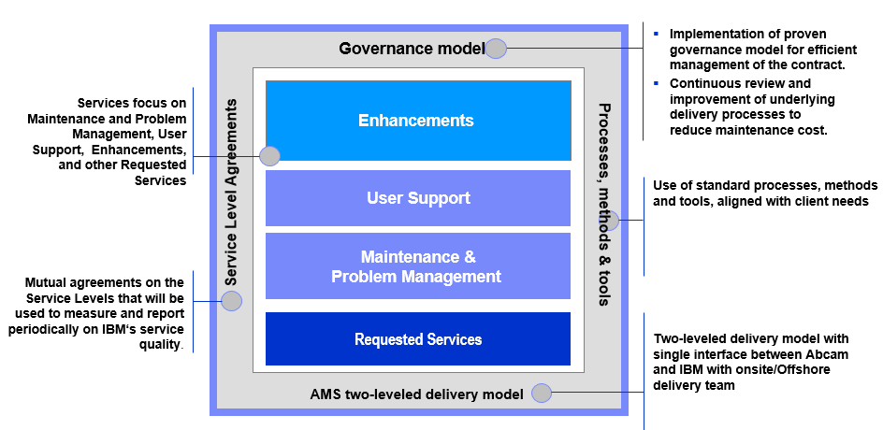

IBM offers a competitive delivery model with high quality Factory Based Services across all Delivery Centers. Global Integration achieves the optimum combination of quality, stability and savings, and enables us to serve both major and growth

We will be providing Locations Support for the listed sites. Delivery Locations to provide flexible and scalable model to get Right resource at Right time

* UK (2 locations)
* USA (5 locations)
* Asia Pacific (6 locations)

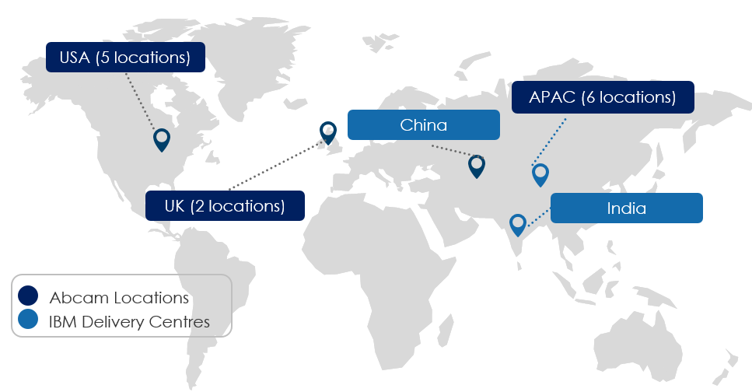

* Onshore team located at Cambridge, UK
* Primary offshore delivery team to be located in India and China
* On demand resourcing from Delivery Centers
* Cost effective and flexible model to support <<Client>>’s current & future requirements

We will provide Application support for <<Client>> using a blended on-shore / off-shore approach. In IBM’s solution, our on-shore teams will be the 1st point of contact for the users and will ensure that the requirement is understood, translated, conveyed and coordinated with offshore team in India/China to be delivered with quality and agreed SLA/SLO.

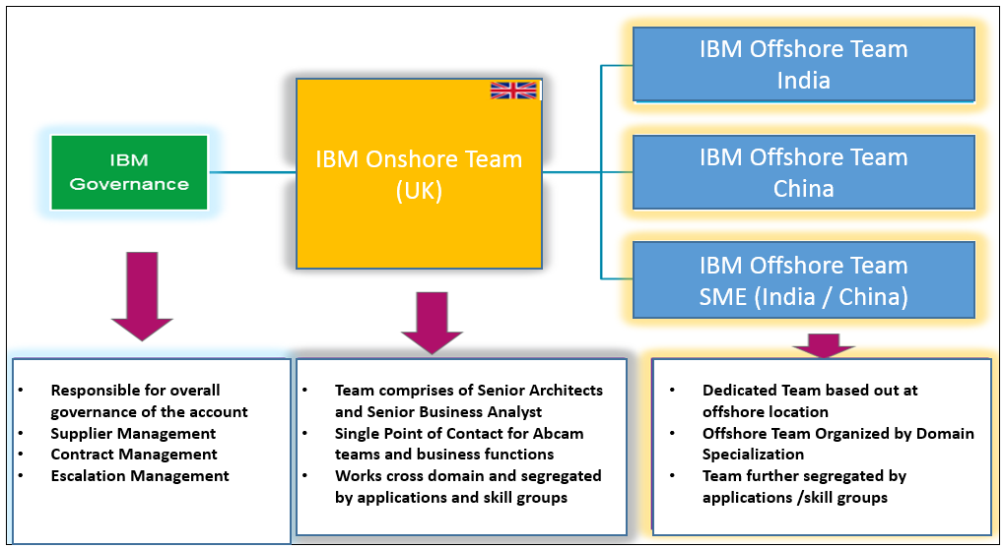

We understand that despite best plans and forecasts, the resource demand would fluctuate over a period, based on the varying business demands and priorities. To reflect the actual demand on ground, IBM proposes a **Core-Flex** model that is customized to the client’s needs.

Depending on client’s current and future needs, resources can be assigned to work either as part of the “IBM Core Team” to address client's core and critical project services, and/or to the “IBM Flex Team”. The flex team is primarily assigned for less critical projects, where the workload can be elastic and dynamic. IBM employs a management structure that provides timely scaling of resources based on demand. There is a joint demand forecast of resources between IBM and client to identify flexible resource requirements, which is crucial to success of this model. Monthly baseline reviews occur as part of the continuous planning cycle. These reviews address changes to business needs, forecast resource requirements, address capacity planning needs and suggest changes to the sourcing solution based on demand.

The Core team includes dedicated and persistent resources. This team ensures that the knowledge is retained while maintaining the minimum capacity required to provide application services. Core team may include specialized resources or resources that manage core activities (such as high and critical business process issues, tickets, service requests, enhancements etc.). Flex resources join the team for specific projects or during spike in demand.

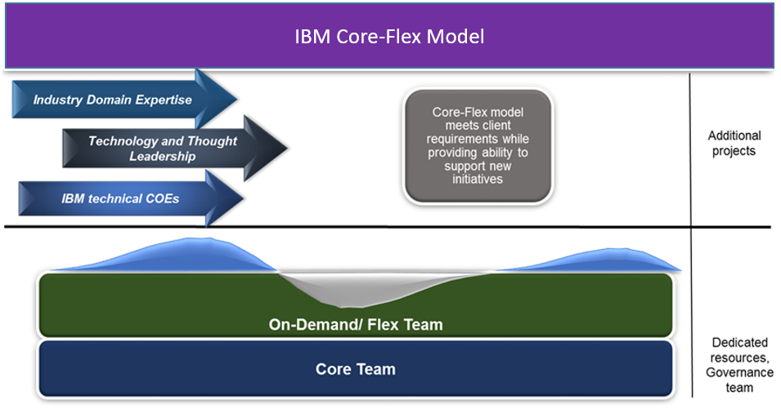

|  |  |
| --- | --- |
| **Functions of Core team** | **Functions of Flex team** |
| * provide stability and continuity to the project * acquire in-depth business process knowledge and become Subject Matter Experts * provide productivity gains with maturity | * quickly ramp up in peak periods * ramp down during lean periods * handle unplanned requirements |

The Core-Flex model can provide <<Client>> with following benefits:

* An optimal level of continuous improvement and SLA performance commitments over time, by enabling greater access to broader shared resource pool and industrialised delivery capabilities
* A service for which you are only charged for productive hours to ensure that you derive even greater value from every hour you pay for
* Greater service flexibility with seamless ramp-up and ramp-down
* Speed and accelerated timelines for project delivery with shortened transition time
* Pool of resources ensures knowledge retention across projects
* Optimal management of cost profile through structured forecasting based on business demand

### Description of Services

Our solution reflects <<Client>>’s desire to have a flexible delivery model so that the service can, on an ongoing basis, be easily adapted to provide on demand support from IBM’s extensive pool of local, regional and global resources.

**Incident and Problem Management:**

During the Transition Phase, IBM will hold a series of process development workshops that customise its Level 2 and Level 3 processes. IBM will document the outcomes in the Procedure Manual which will include hand-offs and a summary of roles and responsibilities for both <<Client>> and IBM.

IBM proposes the <<Client>> service desk remain the primary point of contact for call logging and that IBM be provided with access to <<Client>> Incident & Problem Management system for call tracking.

The following diagram illustrates the Level 2 and 3 application support process:

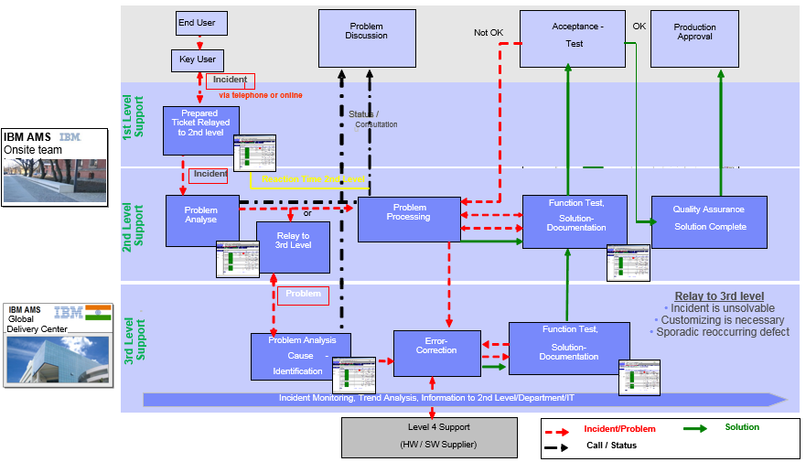

The process starts when a user contacts the <<Client>> Service Desk to report an incident or IBM monitoring team proactively identifies potential system issues and logs an incident in the service management tool. The service desk will log the call into the Incident & Problem Management system, including contact details of the end user to allow for clarification of the ticket, the priority and the date and time that the ticket was raised. Where the service desk is unable to resolve the problem, the service desk will assign the call to IBM Level 2 support, which includes calling or paging the dedicated support contact for high severity issues. The date and time that the ticket was assigned to IBM will be recorded in the Incident & Problem Management system to facilitate escalation and performance tracking.

The following table shows the high-level responsibilities of the various groups involved in the Application support process:

| Level | Activities |
| --- | --- |
| <<Client>> Service Desk | * Receive calls from <<Client>> users and log the reported incident into <<CLIENT>> Incident & Problem Management system. * Assign Incident or Problem severity. * Resolve incidents or problems where the Service Desk has appropriate knowledge (e.g. password resets for Oracle cloud applications). * Route calls to the Level 2 support team as required, including a call or page for high severity problems. * Own the Incident & Problem Report management through to resolution, providing feedback to the affected end user at agreed intervals (depending on severity). |
| Level 2 – IBM Support | * Monitor <<Client>> Incident & Problem Management system for new incidents assigned to IBM support. * Receive calls/ pages from the Service Desk for high severity incidents. * Initial investigation of the reported incident to attempt to identify likely cause. * Advise resolution to Service Desk (if straightforward) or route to Level 3 support. (Many end-users, infrastructure-related and some data problems are able to be resolved at Level 2; issues able to be resolved at Level 2 do not require code changes). * Provide status updates to the Service Desk at agreed intervals (depending on severity). * Record problem details/metrics for service level reporting. * Ensure high severity problems are escalated appropriately. |
| Level 3 – IBM Support | * Investigate the reported defect and attempt to further identify likely causes; and either: * Return to Service Desk with explanation for closure (if no issue); or * If application issue, refer to Level 4 support; or * Build and test a corrective fix as an emergency fix or for inclusion in a scheduled release. * Provide status updates to the Service Desk at agreed intervals. * For defects referred to Level 4 support, liaise with the support organisation and monitor progress. * Record Problem details/metrics for service level reporting. |
| Level 4 – Package Software Vendors (e.g. Oracle ) | * Investigate the reported defect and attempt to further identify likely causes; and either: * Return to Level 3 Support with explanation for closure (if no issue); or * Build and test a corrective fix and return to IBM for emergency release or inclusion in a scheduled release. * Provide status updates to IBM and to the Service Desk at agreed intervals. |

### Support Coverage

The support is primarily based on the Service Level of Applications and Severity of the Incidents as defined in the RFP document. IBM will provide the AMS support of the oracle fusion cloud applications and objects developed by IBM team / scoped for AMS.

* Support coverage: 0800 – 1800 hrs UK time, 24x7 Sev 1 & Sev 2 tickets capped at 15% of the ticket volume
* Sev 1 and Sev 2 24X7 support (Desk / On-Call)
* Sev 3 & 4 -8 to 6 UK Time Service Coverage and not all time zones.
* L2/L3 support for 51 Oracle Applications on Cloud
* Minor Enhancements of 150 hours per month
* All tickets and responses will be in English

India CIC – Morning Shift, General Shift and Afternoon Shift considered

### SLA Measurement and Reporting

IBM understands that a strong and meaningful set of measurements supports the perceived quality of service, aiming to provide objective data on the performance. To quantify and monitor the quality of operational activities, various measures will be calculated to know the deviation from the agreed service levels. IBM has the standard IBM‘s SLAs associated with the support.

Standard KPI will be used and reported on monthly basis for operational control and to assess the compliance. IBM will utilize the measurement and reporting Tools to measure and report on performance of the services against applicable target KPIs.

**Proposed Service Level -1**

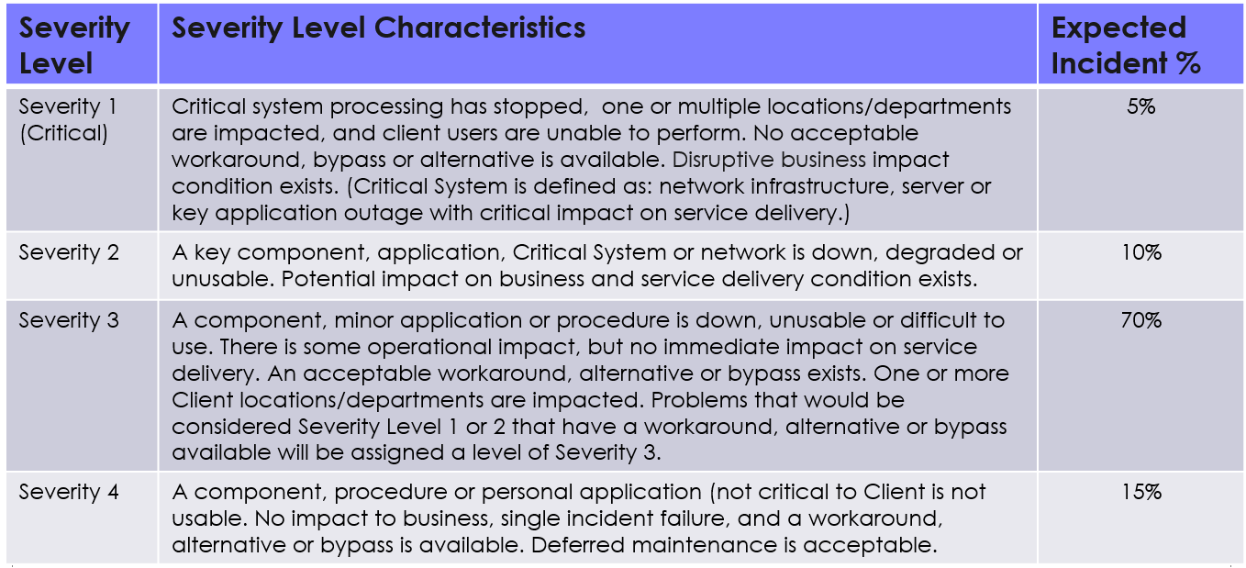

**Proposed service Level – 2**

Oracle Tickets - IBM will raise a Service Request (SR) with Oracle within the target Resolution Time based on Severity. However, Oracle Product related issues will follow Oracle’s Standard SLA with Customer.

Service desk. SLA for High, Medium and Low Business Criticality

|  |  |  |  |
| --- | --- | --- | --- |
| SLA’s by business Criticality | Service Hours | Response Time | Resolution Time |
| **Low** | | | |
| Severity 1 | 24 X 7 | 2 Hours | 1 Day |
| Severity 2 | 24 X 7 | 1 Day | 3 Days |
| Severity 3 | UK Hours 8.00 to 18.00 | 2 Days | 5 Days |
| Severity 4 | UK Hours 8.00 to 18.01 | 2 Days | 7 Days |
| **Medium** | | | |
| Severity 1 | 24 X 7 | 1 Hours | 6 Hours |
| Severity 2 | 24 X 7 | 2 Hours | 2 Days |
| Severity 3 | UK Hours 8.00 to 18.00 | 2 Days | 4 Days |
| Severity 4 | UK Hours 8.00 to 18.01 | 2 Days | 5 Days |
| **High** | | | |
| Severity 1 | 24 X 7 | 30 Minutes | 3 Hours |
| Severity 2 | 24 X 7 | 1 Hour | 8 Hours |
| Severity 3 | UK Hours 8.00 to 18.00 | 1 Day | 4 Days |
| Severity 4 | UK Hours 8.00 to 18.01 | 1 Day | 3 Days |

**Service Measurement and Reporting Processes –**A partial listing of information typically provided:

* SLA Reports (covering all components with required detail back-up supporting SLA attainments)
* Project / Enhancement Status Reports
* Open Work / Service Requests
* IBM Team Access Report for <<Client>> Systems (Security Reporting)
* Open / Closed Problem Tickets
* Problem Tickets by Severity (rolling totals)
* Problem Tickets by Application (rolling totals)
* Total Ticket Volume (rolling totals)
* Reporting to be provided to <<Client>> will be defined during contract negotiations and the transition period to ensure that <<Client>>’s requirements are met.

### AMS Assumptions

* Service Management Tools Implementation and Customization is not considered in scope.
* <<Client>> to provide support in understanding their current processes & tools.
* 24X7 support is considered only for Severity 1 tickets.
* It is assumed that Implementation team members will continue for AMS.
* IBM AMS team would only support L2 & L3 Support there would be no L1 in IBM scope.
* IBM AMS will provide application management services during the Business hours of 0900-1800 (UK, US, China, APAC and India), Monday to Friday with a round the clock support for Severity 1 issues.
* AMS Scope will be limited to support of Oracle Fusion cloud modules and application developed by IBM team / or Scoped for AMS.
* Service Levels, mentioned earlier, are for measurement and reporting purposes; no services credits/ penalties have been provided for.
* Since AMS team would be inducted from Implementation team therefore no Specific KT is required however additional KT session would be arranged in case of any Knowledge gaps.
* AMS team will use the infrastructure and connectivity created for implementation, thereby, avoiding any duplication of costs.
* Escalation procedure as Appendix B will be followed if resolution is required to a conflict arising during the project execution

### Out of Scope

Below mention are the list of areas/activities that will not be consider as part of the current scope:

* All DBA activities
* L1 help desk
* Network/ Infrastructure Support
* Live Batch Monitoring
* Any testing other than unit testing and System Testing within the boundary of Application being supported by IBM
* 24x7 Live Monitoring of batches/interfaces – batch failures to be reported as incidents (tickets)
* Basic product bugs – IBM will only coordinate with product vendors to resolve these issues, pertaining to the applications in-scope
* Application Support for any applications not listed in scope