## Governance Model

Effective governance is critical to maintaining agility and flexibility, aligning business requirements and <<Client>> priorities. The governance model will facilitate a continuous alignment of the delivered services with strategies and goals, and will support the overall relationship. It defines rules, processes and organizational constructs needed for effective planning and decision making. Effective governance is critical to maintaining agility and flexibility, aligning business requirements and <<Client>> priorities. The governance model will facilitate a continuous alignment of the delivered services with strategies and goals, and will support the overall relationship. It defines rules, processes and organizational constructs needed for effective planning and decision making.

The governance model also needs to recognize and build on current technology investments and provide for seamless integration into current organization and governance structure. IBM recognizes this requirement as an important ingredient in establishing an effective service model that will establish the delivery and relationship governance that links business and comprehensive technology strategy.

To achieve this, IBM proposes a three-tier governance model that will provide a management framework for partnership between <<Client>> and IBM. This framework is based on the concept that organizational relationships must be founded on trust, support rapid execution, drive change, and provide strategic value.

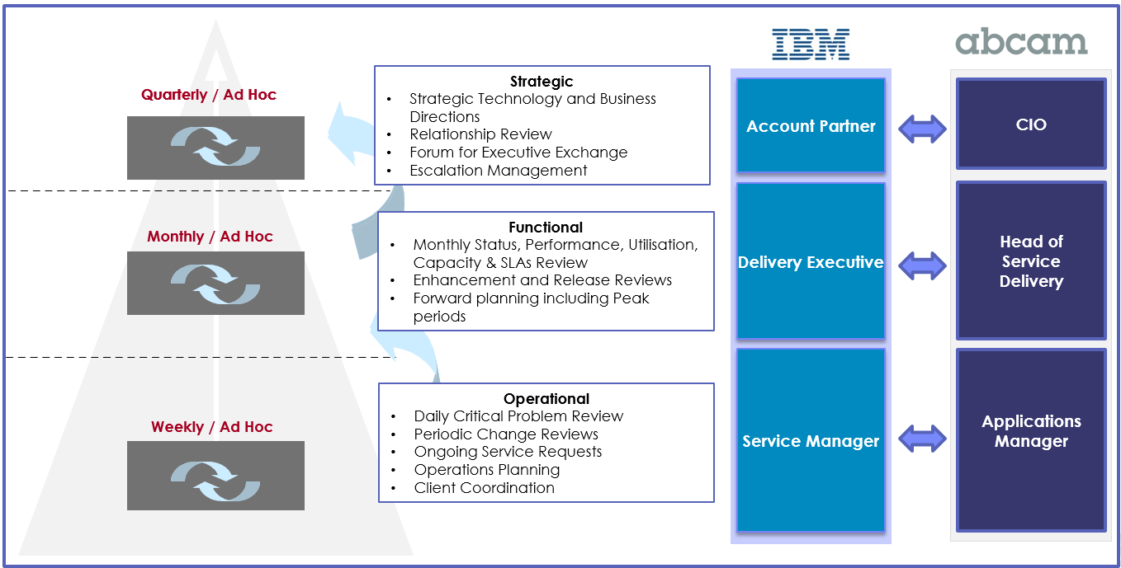

**Strategic-level governance:** Strategic layer of governance will be built up by bringing together <<Client>> Steering committee representative and IBM’s DPE and executive sponsor. Its overall objective is to set up strategy and direction for the effective relationship between IBM and <<Client>>, providing overall authority and measures performance against business objectives. Strategic governance layer will also be engaged in activities like review of risk/mitigation and resolving escalation reaching to this level, Ratify/recommend changes to the contract, oversee strategic technology and business direction, and discuss/resolve any issues pertaining to delivery of services

**Functional governance:** This layer of governance will have <<Client>> Director Committee and IBM DPE, Program manager and offshore delivery manager. It will provide the <<Client>> project the direction required to meet and manage overall performance efficiently. Activities like review quality goals and other pertinent milestones against target levels, Perform Management and Quality reviews, Scope change and contractual topics will also be looked by functional governance layer.

**Operational-level governance:** IBM will merge <<Client>> project team and IBM DPE, Delivery SME/ Architect, offshore delivery manager together to form operational layer. It will provide periodic project/stream status & overall contract performance necessary for the <<Client>> to easily track and control the project performance. Other activities like Discuss/resolve issues related to service and demand management, Track and verify resolution of any service issues and risks, managing priorities are primarily being looked by the operational governance layer.

### Delivery Organization

IBM is proposing the delivery organization as depicted in the below diagram.

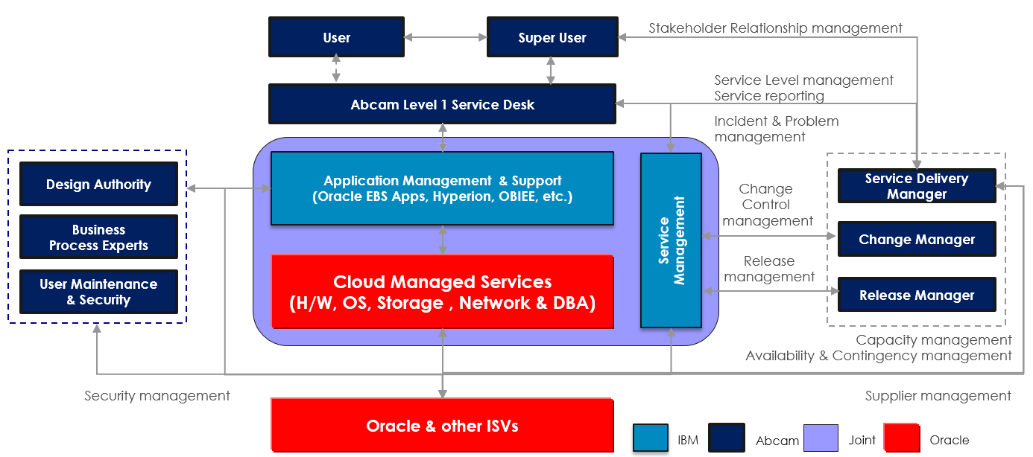

### Organization Structure

IBM is proposing the project organization, governance and key resources structure as depicted in the below diagram:

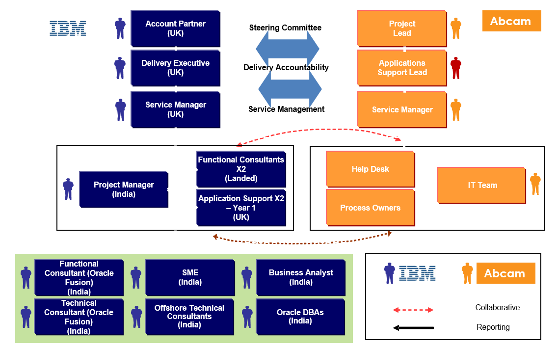

### Operational Model

Our Operational Model is comprised of five major components of services to be provided:

* Application Management Services,
* Application Development Services,
* Services Management,
* Change Management,
* Documentation and Reporting.

