## Transition

IBM’s proven transition approach will make transition smooth and risk-free. IBMs transition method has been used but customized to the <<Client>> requirements. Special care has been taken for the knowledge transfer of critical modules. IBM will solve Tickets during trainings to avoid ticket backlog and speeding up of training.

IBM Will leverage the transition model that would be ideal for repetitive processes to make the transition happen in smooth and less risky. We will request <<Client>> SMEs to be available throughout the transition period to ensure smooth transition. It will also ensure reduced risk for business critical applications. IBM will also provide its expertise to mitigate various conditions, e.g., longer wait for productivity gain, risk of missing important hands-on opportunity due to longer wait for perform phase, unavailability of key resources throughout the transition period.

### Agile Transition Methodology

IBM is proposing the agile methodology by blending Agile Scrum principles to define Transition plan suitable for iterative and incremental Agile scenarios.

IBM has considerable experience of transitioning of critical Applications from an ongoing support phases. IBM is proposing the option to follow IBM agile methodology for transition at <<Client>>. IBM Agile is an iterative, incremental framework hence, transition can be tailored with IBM's Agile Scrum method as a base.

All transition phases and activities will be planned as small sprints. Assessment inputs from previous phase are taken into consideration during the Sprint planning. Team will be exposed to hands on activities aligning with the Sprint / Iteration cycle.

IBM’s Agile Knowledge Transfer Method (by each application in an Epic or Feature)

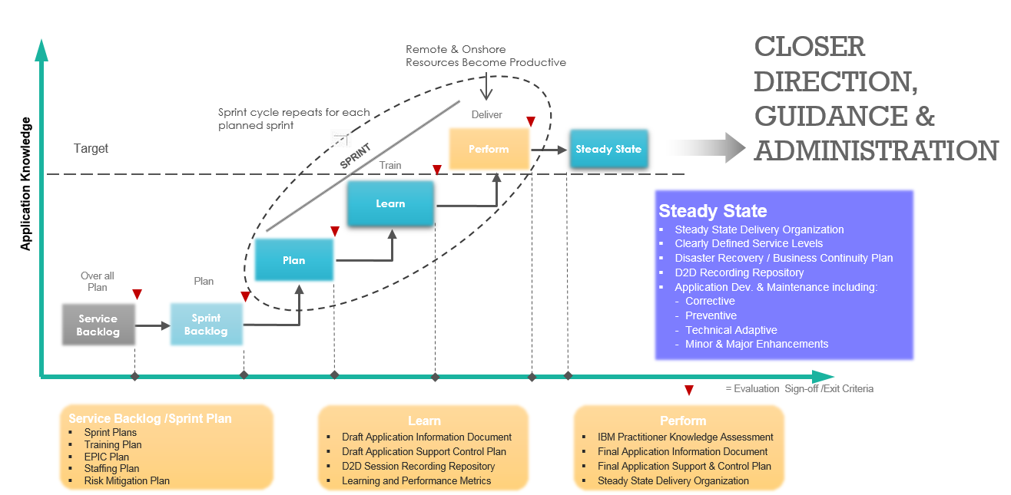

### Transition Plan and Approach

The entire transition will be executed using Agile Methodology in several sprints linked to Epics. This ensures early readiness of

* Few areas / modules which can be supported sooner than steady state from KT point of view
* Few services can be established (like Event Management) much earlier by absorbing the As-Is best practices from Service Transition point of view

This being a new implementation project, availability of historic ticket data is very minimal. Hence IBM is proposing to kick start the knowledge Transfer (KT) activities from the beginning of UAT Phase

* IBM resources are aligned to get engaged with incumbent team for learning & Shadowing in UAT & Hyper Care periods to get adequate exposure on real time issues
* As an entry criteria to kick start KT, IBM Management would engage <<Client>> Application owner to get formal sign off from incumbent implementation team on
  + All UAT test cases to confirm that all agreed functionalities are deployed & are working as per <<Client>>’s expectation
  + The Test summary report to ensure that all defects reported in UAT & Hyper phases are resolved by implementation team and validated by <<Client>> end users

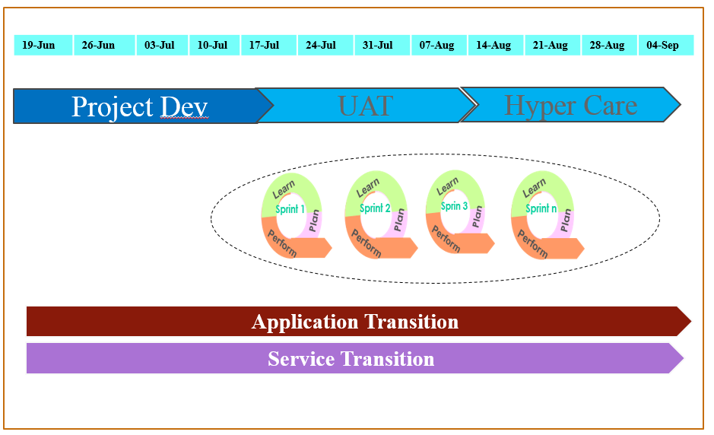

### Transition Activities

IBM will also leverage Agile Method which is an alternative to traditional model.

While implementing Agile Method, the “Plan” phase includes service backlog and sprint plans covering training Plan, EPIC Plan, staffing plan and risk mitigation plan. Phase “Learn” will be covering Draft Application Information Document, Draft Application Support Control Plan, D2D Session Recording Repository and Learning and Performance Metrics.Phase “Perform” will be including IBM Practitioner Knowledge Assessment, Final Application Information Document, Final Application Support & Control Plan and Steady State Delivery Organization.

Agile is a proven and flexible transition approach which provides the flexibility to choose the activities and then time-box those to have full control. Next Generation transition capabilities of Agile transformation approach ensures the benefits including quicker productivity gains, faster transition completion, reduced transition cost, maturing on customer confidence, quicker KT gap determination, reduced risks and observing transition effectiveness in quicker manner.

As availability of historic data is minimal, IBM is proposing to start the knowledge Transfer (KT) activities from the beginning of UAT Phase. Intent is to get engaged with incumbent team for learning & Shadowing in UAT & Hyper Care periods to get adequate exposure on real time issues. High level Transition Plan & Approach is as follows:

IBM’s Agile Knowledge Transfer Method (by each Module) is depicted in the below diagram:

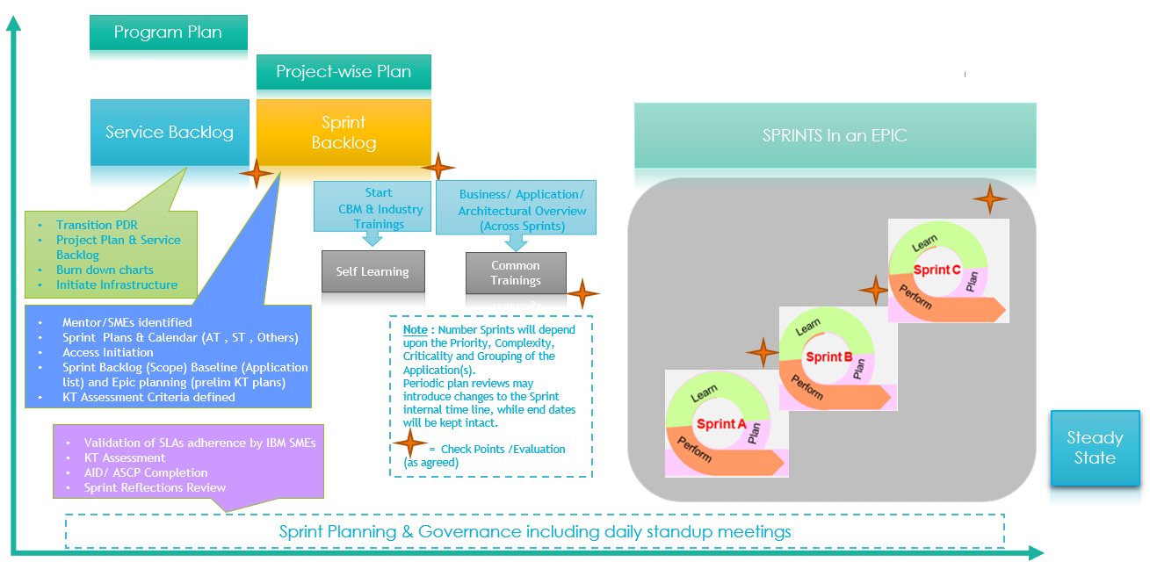

### Application Transition Plan

Application Transition Plan will be according to the timelines shown in the figure below:

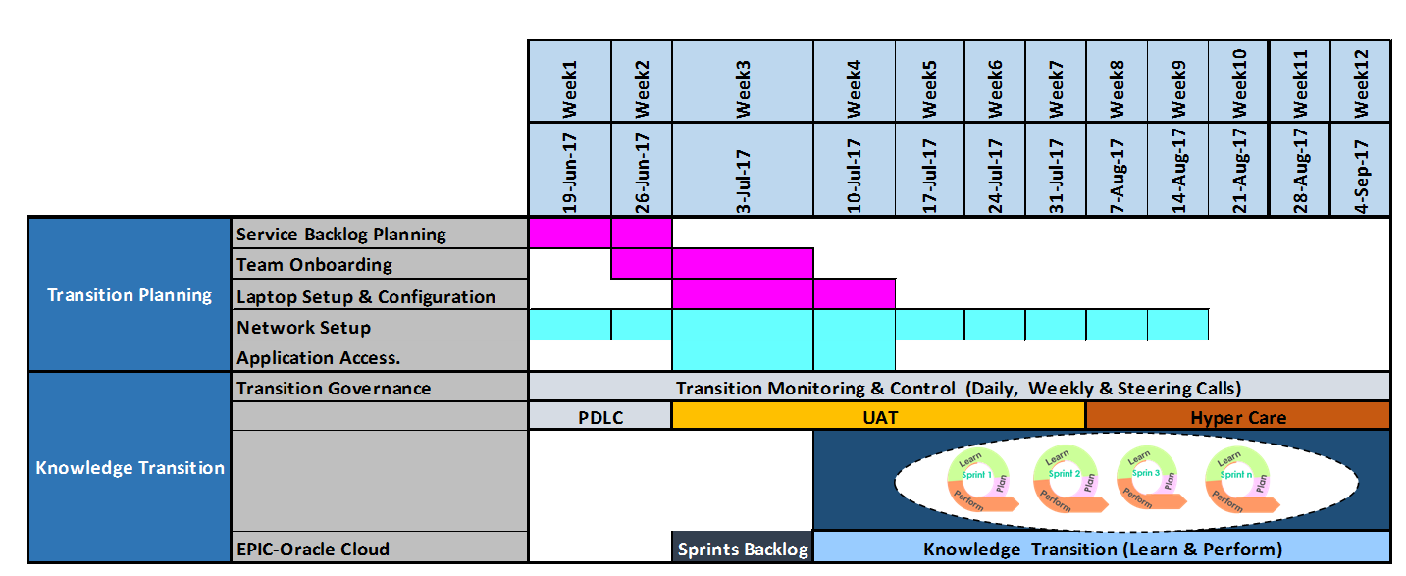



### Service Transition Plan

Service Transition will be carried out using Agile Methodology, in two sprints:

* Sprint 1 – Establishing <<Client>> AMS Processes likeIncident Management, Problem Management, Service Request fulfilment, Minor/Major Enhancement, Asset & Config., Availability and ITSM Processes
* Sprint 2 – Establishing <<Client>> CF & AO Processes likeEvent, Knowledge, Capacity, Change, Release & Service Level Management Processes

There will be four main phasesto follow, using Agile method;

* + MAW
  + Define & Document
  + Implement (Process)
  + Handover
* Each Process area is a story by itself and expected with defined outcomes.
* Some process area has common and dependent factor on another process and hence we can combine and form agile sprints, from its evaluation till implementation.
* An early assessment and evaluation is must against each process, if we would like “As-Is” readiness or “New State/To-Be” readiness

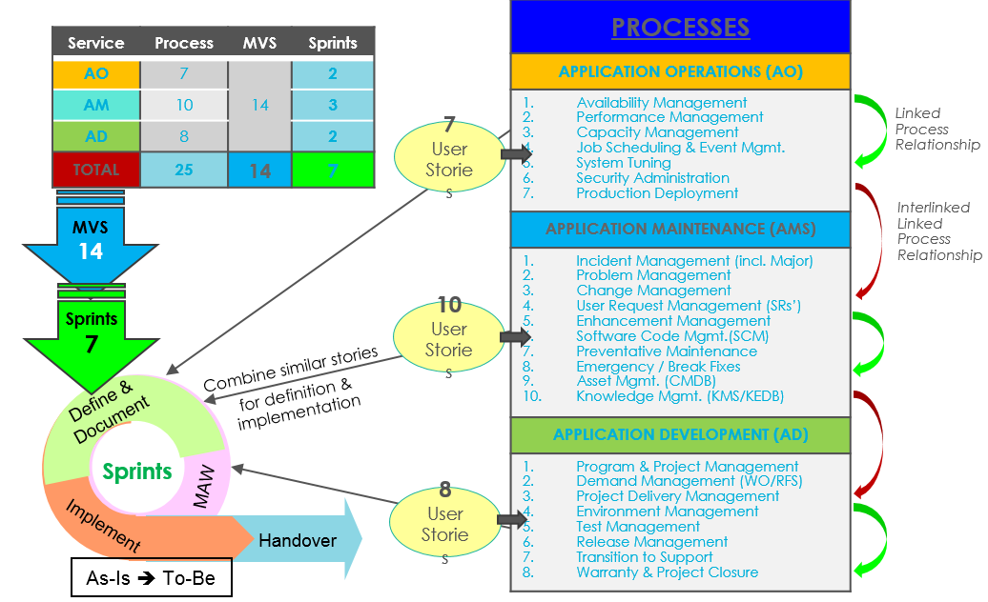

*Service Transition – In Agile Model*

**Tasks and Deliverables:**

|  |  |
| --- | --- |
| Tasks | Deliverables |
| **Method Adoption Workshop** | |
| * Process Framework * SLAs (if already configured) * Tools (if implemented and Operational) | * Gaps and Plan of Actions for delivering Standard Operational Processes (SOP) * Gaps and Plan of Actions for understanding pre-configured SLAs & Reporting formats (if available) * Gaps and action plans on tools for ticket handling |
| **Define and Document** | |
| Define and document SOPs, as per the scope identified | * PFDs & Process Description documents with associated artefacts * Documented As-Is SLA Framework * Report on tools (Gaps and Recommendations) |
| **Training Phase** | |
| Train the Delivery Teams on   * SOPs (Both AM & AD) * SLAs (As-Is) & Tool usage | Training the Delivery teams on   * Newly developed / refined Processes * As-Is SLA Framework / Tool Usage |
| **Implementation Phase** | |
| Implement and roll out the defined processes | Resources start working as defined |

**Timeline for the service transition will be as**:

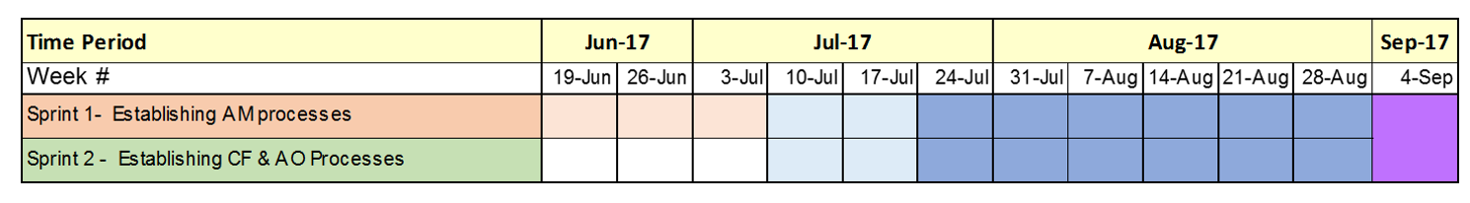

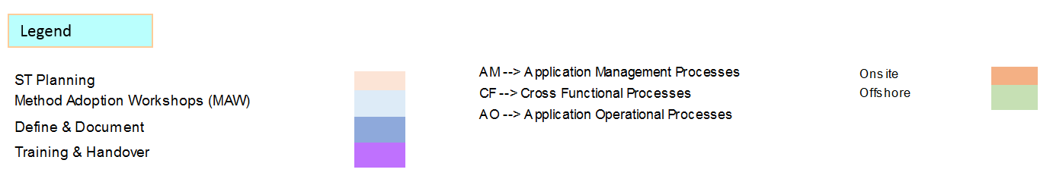

### Transition Assumptions and Risks

Transition Risks and Mitigations are outlined in the table below:

|  |  |  |
| --- | --- | --- |
| **Definition** | **Description** | **Risk Mitigation** |
| Process knowledge gaps | Incomplete and out of sync process documentation and reliance on people for such knowledge | Define transformation plan for updating and maintaining process knowledge |
| SMEs unavailability | Limited availability & access to SMEs, stakeholders and process owners | Reinforce with support from IBM SME’s, bringing in experience and best practices in this area. Bring in “Two in the Box” (Delivery lead and SME for each business area) concept for transition and transformation |
| Engagement | Limited Stakeholder Engagement | Define stakeholder map and develop engagement plan with approval milestones for each transition acceptance |
| Documentation | Lack of technical documentation of apps and processes | Support using documentation tools/Assets within IBM |
| Landscape | Limited Testing Landscape Availability | Introduction of Regression testing environment in the landscape & consider Testing as a service. |
| Planning | Lack / absence of suitable plan | Utilize IBM’s Transition Centre of Excellence Assets / Best practices |
| Governance | Lack of clear roles | Create Transition Governance board, Incumbent and IBM with well define RACI matrix for each phase |
| Knowledge transfer | Incumbent SMEs, contractors may not support the transition of work to IBM. This has the potential to delay transition and hinder current work commitments | Define exit criteria and governance structure with contractors and <<Client>> stakeholders with attachment of financial aspects of transition |
| Environment | Readiness for transition | Mapping of server, applications, network to be validated from ‘As is’ and ‘To be’ perspective. Specific risk mitigation plan will be worked out |