## Governance Model

Effective governance is critical to maintaining agility and flexibility, aligning business requirements and <<CLIENT>> priorities. The governance model will facilitate a continuous alignment of the delivered services with strategies and goals, and will support the overall relationship. It defines rules, processes and organizational constructs needed for effective planning and decision making.

To achieve this, IBM and <<CLIENT>> will implement a governance model that will provide a management framework for partnership between <<CLIENT>> and IBM. This framework is based on the concept that organizational relationships must be founded on trust, support rapid execution, drive change, and provide strategic value.

The picture below illustrates the governance model used for the provided services.

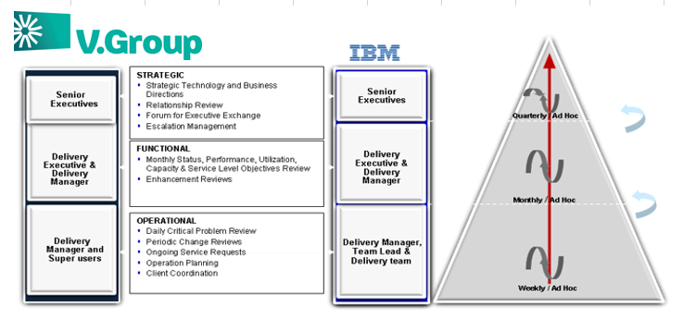

The governance model also needs to recognize and build on current technology investments and provide for seamless integration into current organization and governance structure. IBM recognizes this requirement as an important ingredient in establishing an effective service model that will establish the delivery and relationship governance that links business and comprehensive technology strategy.

To perform project management for the IBM responsibilities in this project, which include technical direction and control of IBM project personnel and to provide a framework for project planning, communications, reporting, procedural and contractual activities, the key activities and responsibilities are as follows:

| Task Name | Key Activities | Primary  Responsible | Secondary  Responsible |
| --- | --- | --- | --- |
| Execute project plan | Engage stakeholders; coordinate and manage the activities of the project in accordance with the project plan; monitor progress and review deviations; plan and implement corrective actions. | IBM | <<CLIENT>> |
| Produce status reports | Conduct regularly scheduled project status meetings; produce weekly status report comparing the plan to the actual progress; highlighting the issues and risks and their severities and statuses; request steering committee intervention for critical / complex issues. | IBM | <<CLIENT>> |
| Review project and deliverable and manage scope | Review project deliverables for consistency in quality; provide feedback where necessary; compare deliverables to project scope and manage deviation | IBM | <<CLIENT>> |

**The regular meetings to be held are as follows:**

| **Meeting Name** | **Purpose** | **Frequency** | **Attendees** |
| --- | --- | --- | --- |
| Steering Committee Meeting | Update on current project status, and resolve issues escalated to Steering Committee. | Monthly | Steering Committee, IBM and <<CLIENT>> Project Managers |
| Project Management Meeting | Update on project situation, determine status of project tasks, determine and resolve issues. | Weekly | <<CLIENT>> and IBM project managers, IBM project director |
| Project Team Meeting | Update on project situation, determine and resolve issues. | Weekly | IBM and <<CLIENT>> Project Manager/Team Members/Service Delivery Managers |
| Project Status Report | Weekly project status review meeting. Determine and resolve issues. Report to be sent to <<CLIENT>> by IBM Project Manager | Weekly | IBM Project Manager and Team Leads copied to IBM Management |
| Daily Operational Report | Individual Status Report. Sent by Team Leaders/ individuals To Project Manage | Daily | Sent by Team Leaders/ individuals To Project Manager |