# Transition approach

## Overall Transition Approach

IBM has considerable experience of transitioning of critical Applications from an ongoing support phases. This experience gives IBM a unique understanding of the challenges of transitioning not just the technology but also the user base and languages used.

This experience gives IBM a unique understanding of the challenges of transitioning not just the technology but also the user base and languages used. The scope would embrace the following deliverables:

* Transition Planning, Managing and Reporting
* Support Model refinement and agreement
  + Agree Support Model between <<CLIENT>> and Partner Organizations
  + Agree Service Governance
  + Agree Support Organization including Roles and Responsibilities
  + Agree Support Processes
* 4 Service level Agreements (SLA1, 2, 3 and Generic)
  + Reporting
  + Metrics
  + Service Reviews
* Knowledge Transfer
* Acceptance Criteria for Transition to Steady state Support
  + Development of a set of acceptance criteria, measures and reviewers
  + Ongoing Monitoring against acceptance criteria and corrective action
* Support Infrastructure
  + Agreement and set up on Support Tools
  + Security Access
  + Additional Support Infrastructure e.g. network connectivity

## Transition Organization

IBM will appoint two experienced Transition Project Managers (one on-shore and one offshore) who will provide overall planning, initiation, coordination and management of the transition process from initial planning through to Steady State Support. They will be accountable to <<CLIENT>> for the successful transition of the Applications service to steady state support.

IBM also proposes that the majority of the IBM team will be located at offshore centers in India during the transition period. The team will be oriented in the following way:

* IBM’s onsite Transition Manager will be located in <<UK>>. The transition manager will be responsible for the overall transition for <<CLIENT>> applications. The offshore transition manager travels to <<CLIENT>> locations for planning and execution of transition of <<CLIENT>> applications. Onsite Transition Manager will work with the <<CLIENT>> stakeholders and its vendors.
* The onsite Transition manager will facilitate face to face sessions with the local vendor for <<CLIENT>> resources.
* The offshore transition Manager (service Transition manager) will be co-located with offshore team in India. This transition manager will oversee the transition activities at offshore for <<CLIENT>> applications. The transition manager will be supported by Service Delivery Manager, responsible for setting up services for <<CLIENT>> applications.
* IBM transition team will prepare, validate and execute a detailed Transition Plan in consultation with <<CLIENT>> and vendors. The final plan will be shared with <<CLIENT>> and vendors. The plan will be signed off to start transition execution.
* The Offshore team will participate in transition via our web conferencing tool called 'IBM SmartCloud Meetings'. This is full-featured online meeting service that integrates Web and video conferencing. SmartCloud Meetings allows users to share their desktops, conduct demonstrations, and deliver presentations.

## Knowledge Transfer Process, Activities and Deliverables

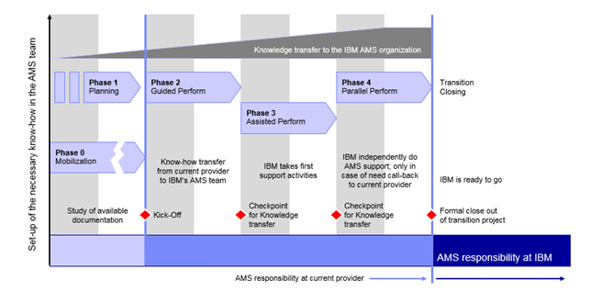

The Application Knowledge transfer will be carried out in well-defined stages with clear entry and exit criteria and clear reporting of progress. The main Application Knowledge Transfer phases will be:

* Application specific planning (ASP)
  + Detailed transition plan will be prepared
  + Entry and exit criteria will be agreed upon by IBM and <<CLIENT>>
  + Governance will be established.
  + Risks, Escalation Matrix, Reporting mechanism will be agreed upon
* Guided perform (GP) - Existing support team will be primary. IBM team will start understanding applications. The on-site Functional Support Team will ‘shadow’ existing support team and IBM implementation/interim support team in the resolution of L2/3 calls.
* Assisted perform (AP) -IBM team and existing support team will own joint responsibilities of defect fixing, monitoring and other tasks. Current support team will review all tasks done by IBM team. The on-site Functional Support Team will lead the resolution of L2/3 calls with the assistance of <<CLIENT>> and IBM implementation/interim support team. Problem analysis and problem solving will be a joint responsibility.
* Parallel perform (PP) – IBM team will primarily start support applications and existing team will monitor and review. This will demonstrate the knowledge gained during the Knowledge Transfer phases.
* Steady State (SS)- IBM team will begin AMS Support

## Transition Plan and Time Table

<<For all applications in scope, the overall transition will be carried out over period of 10 weeks for <<CLIENT>> applications starting <<DATE>. till <<DATE>>. The initial two weeks is reserved for a planning phase involving application specific planning. From week three, knowledge transfer commences.

Following is sample transition plan for the phases and applications used.

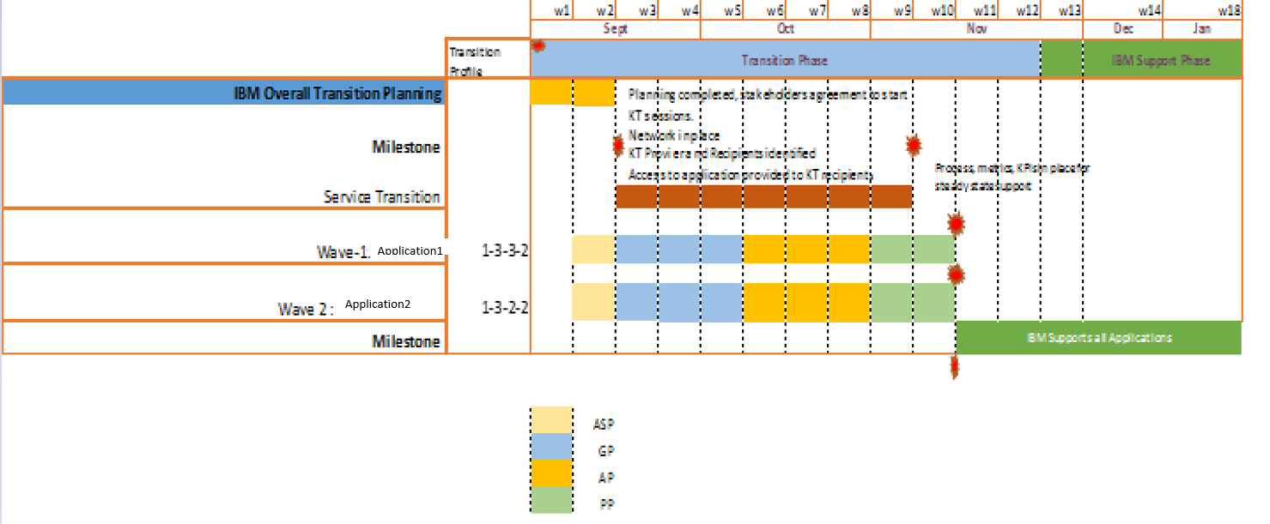

## Transition Assumptions, Risks and Mitigation

Following are the assumptions & dependencies envisaged by IBM for Managed Service and Applications:

* **<<Transition duration is of 10 weeks >>** for <<CLIENT>>’s Applications**, << two weeks >>**is considered for overall transition planning and Application Specific Planning. Key <<CLIENT>> application SMEs are required to be made available to IBM to agree on planning.
* KT requiring SMEs to share vacation plans while application specific planning is performed.
* <<CLIENT>> to allow usage of IBM SmartCloud to enable remote knowledge transfer sessions. Recording tool to be installed on the KT provider workstation to record the sessions for future use.
* Access to all applications is provided to KT recipients by <<CLIENT>> before completion of the planning Phase. Transition Manager Access to be raised much earlier to enable quicker knowledge information to be plan transition activities.
* <<CLIENT>> to arrange backup resources in case the KT providing resource is not available during transition, with no delays.
* All the key KT providing resources to be retained until the end of transition. Releasing resources will cause loss of knowledge and delayed transition
* Delays may occur due to translation activity; particularly in the case that documentation is large.
* IBM requests access to the documentation repository to be available before start of transition.
* <<CLIENT>> to identify SPOCs to help IBM with network connectivity between <<CLIENT>> Locations to IBM Offshore. Access to the network from IBM locations to be set up before start of GP Phase.
* <<CLIENT>> counterpart has bandwidth and time required to review and approve deliverables as well as attend workshops, to discuss and decide on structure and governance model, as outlined in contract documents.
* Process SME’s identified during the beginning of the work stream are retained until completion of transition. It is assumed that most of the SME reviews / approvals would not go into multiple iterations as SMEs are experienced and committed to the project.
* All available processes and documentation to be provided by <<CLIENT>> to IBM, in order to align documentation prior to the Support Service Commencement Dates.
* Measurements, reports of applied SL metrics performed by earlier suppliers or/and <<CLIENT>> required to check for measurements & validate baseline data, as per contractual targets.