**Link to access blog website:** <http://puyabrianblog.appspot.com>

The homepage of our blog website greets the user with a welcoming picture of Brian and Puya which provides an epic introduction to our website, titled “Puya and Brian’s Radical Blog.” Directly below the picture is an option button to create a new blog post and an option to sign in, if not already signed in. We utilized Google sign in services which allows for users to sign in with their Google accounts. Under the sign in option is the five most recent blog posts. Blog posts are presented with the title of the post in large bolded and underlined text. Under the title, the author and date of the post is presented in smaller italicized text with the text of the post under in larger, no formatted, text.

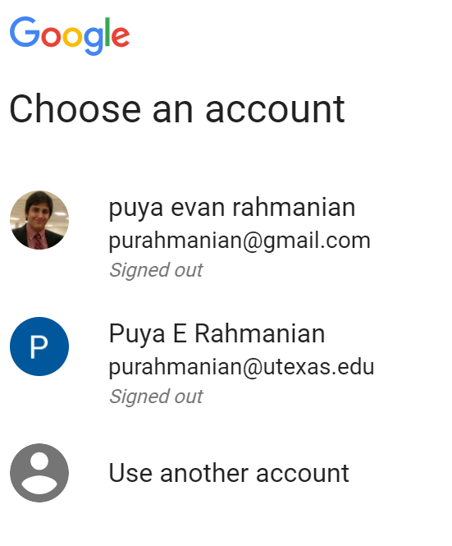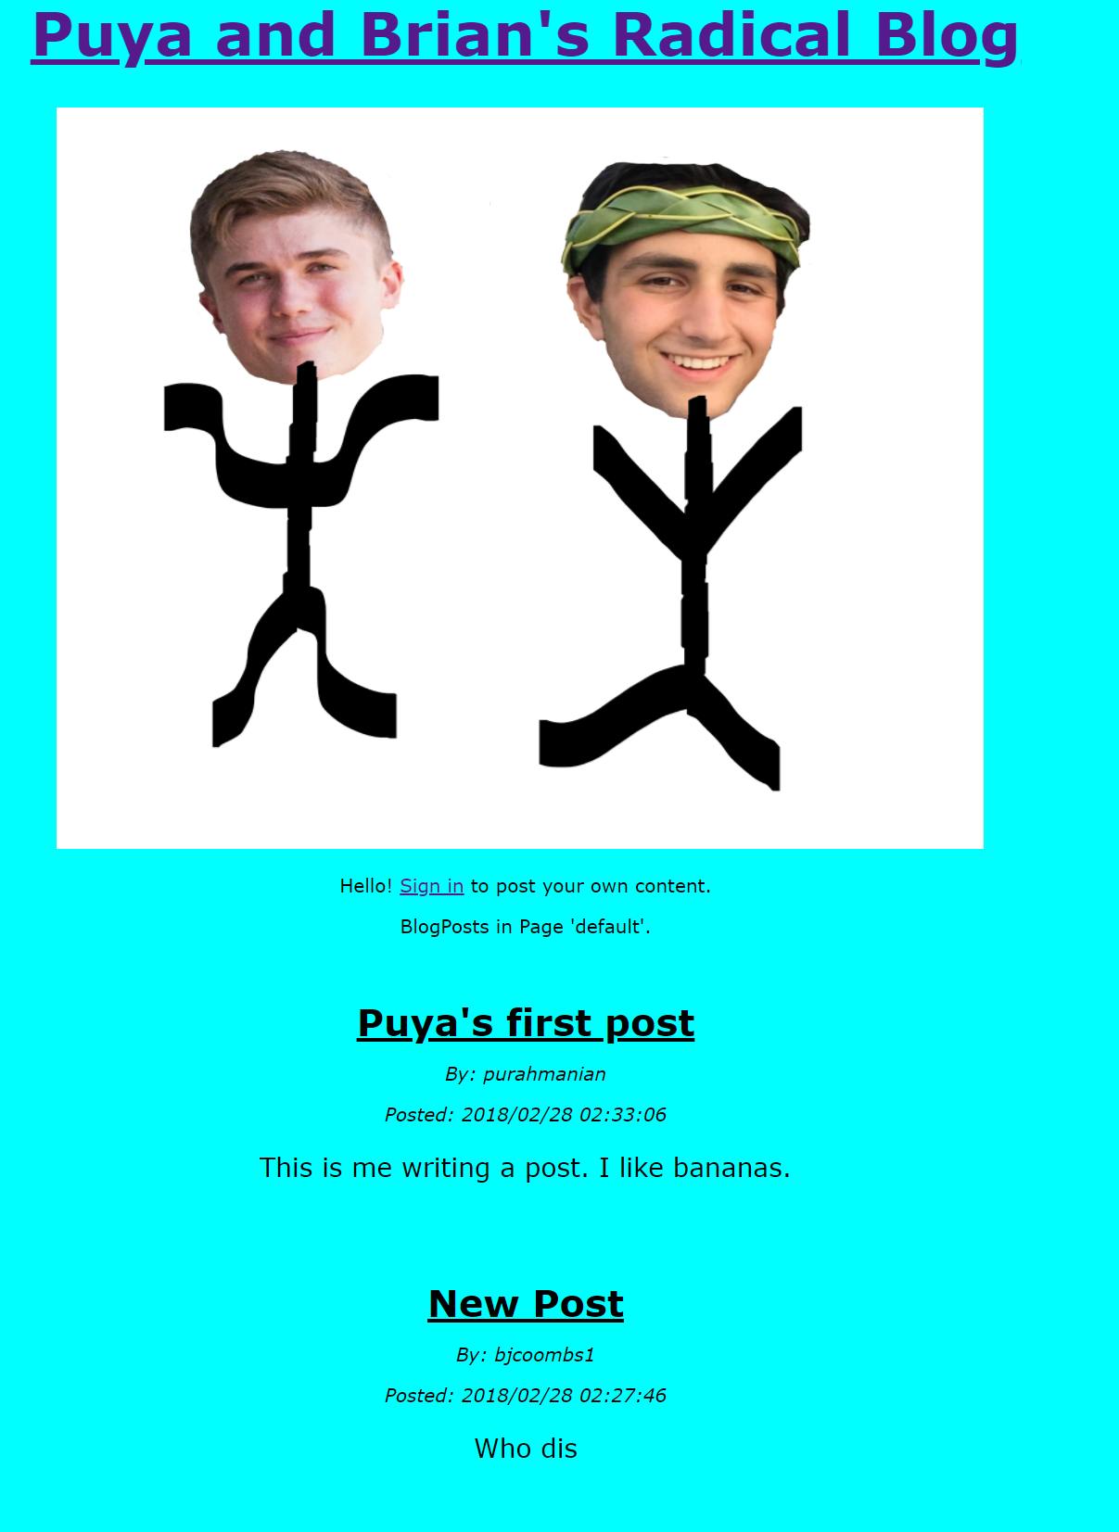

Under the final blog post on the home page of the blog, we have a search bar to filter blog posts by title, an option to see all blog posts, and an option to subscribe/unsubscribe to the blog daily newsletter update.

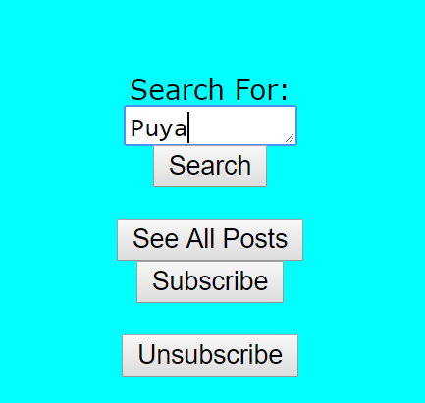

The search bar, our added functionality tool, allows the user to filter all blog posts by titles containing a string literal defined by the user in the text field pictured above. The screenshot below illustrates the results when the user searches for “puya.”

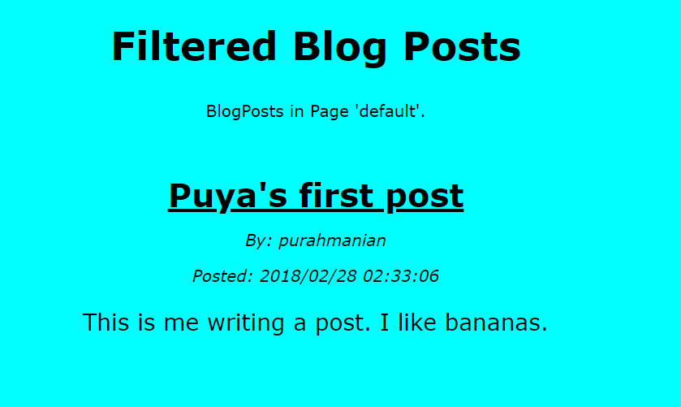

Once the user is done viewing the filtered posts, or the all posts page, the user can navigate back to the homepage by clicking the blog title, as pictured below.



The picture below shows our “all posts” page option.

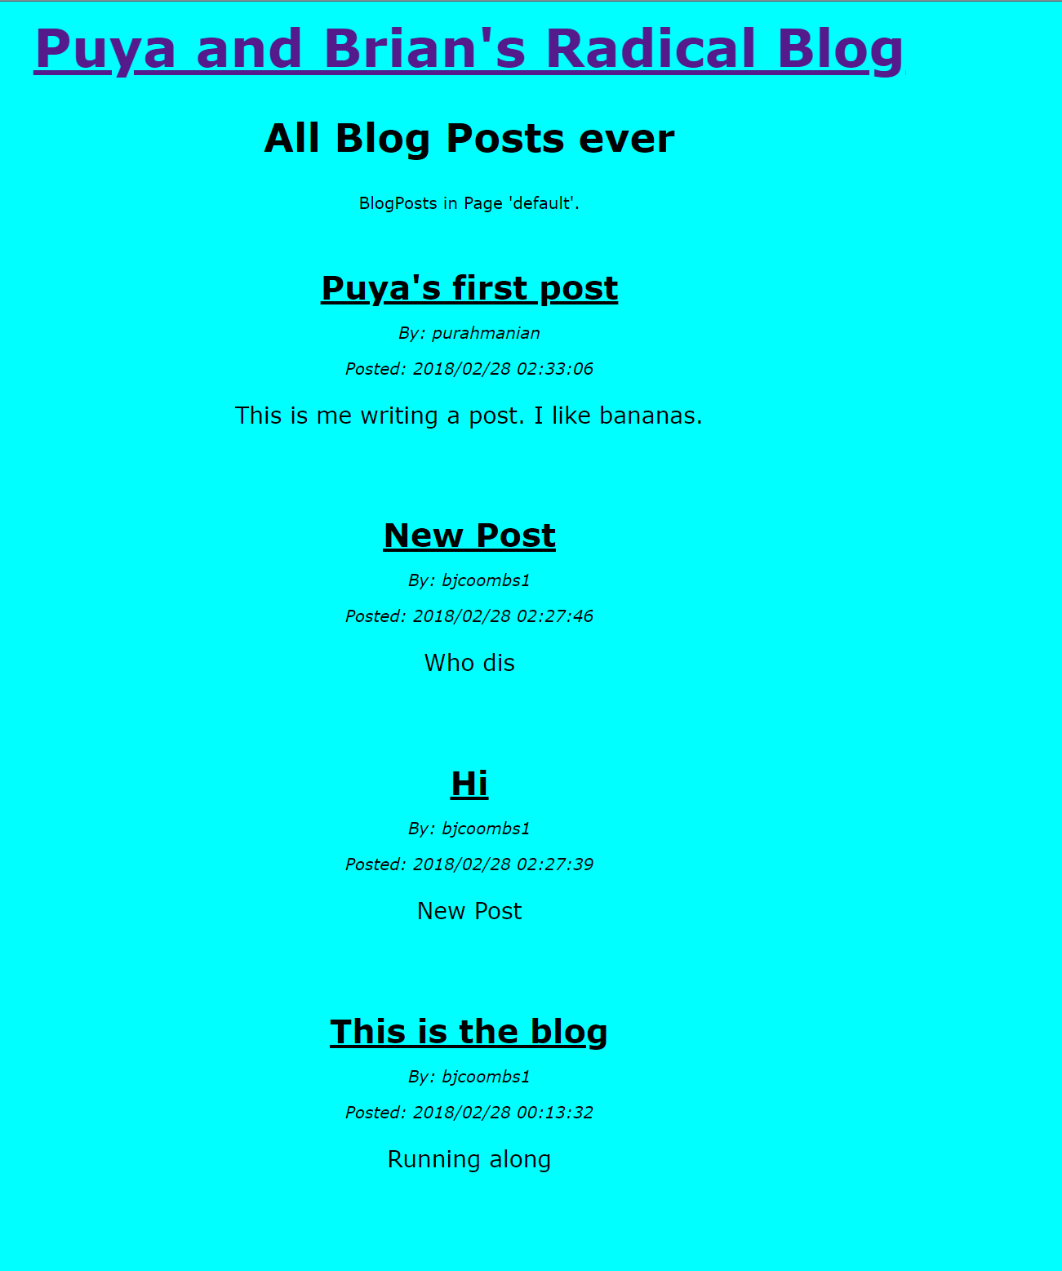

Pictured below is the “create a blog post” page. Here the user inputs their blog post title and content in the provided text boxes. If the user decides to cancel their post, they can click cancel and all the text fields will clear. If the user posts their blogpost, they will be redirected to the homepage which will now be updated with their blogpost at the top.

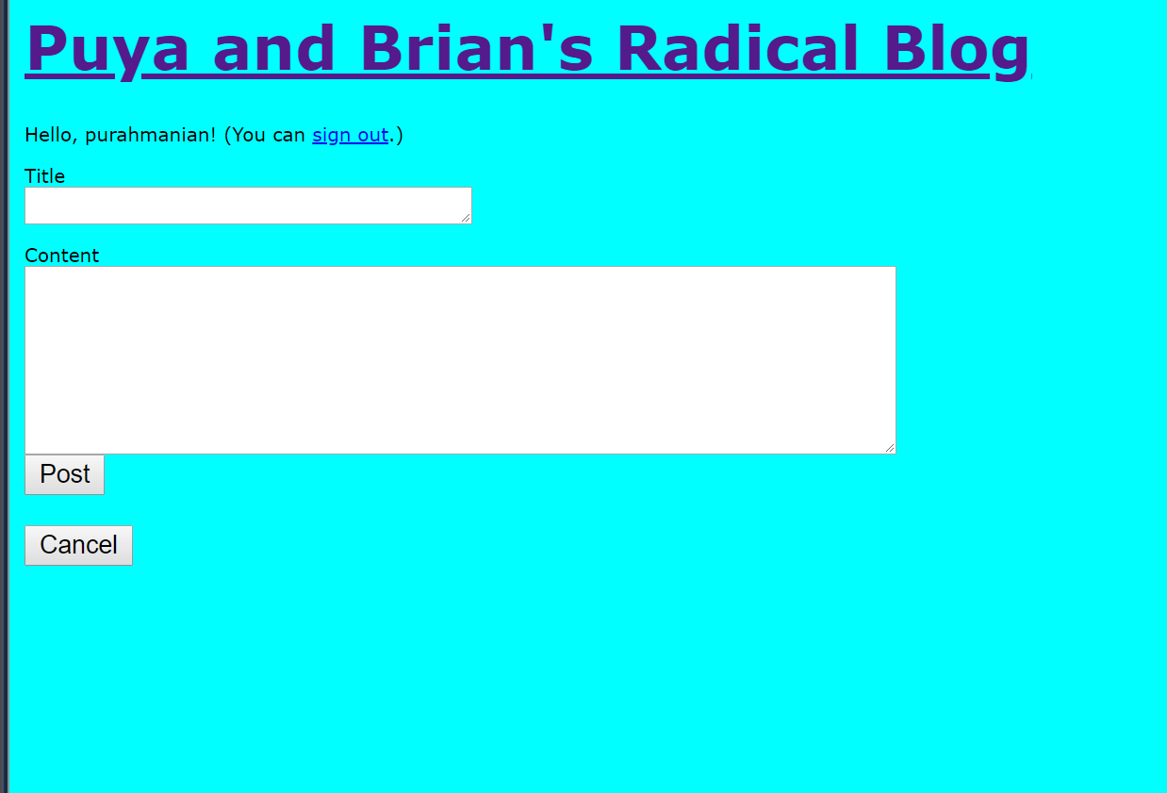

In spirit of pair programming, the majority of this assignment was done on Brian’s computer with both of us present. Both programmers gave input while Brian did the coding. Both of us benefitted from the refresher on the concepts covered in this assignment and expansion on these concepts introduced in the tutorials. We both covered the tutorial on the cron job, but Brian implemented the cron job. Because of this, Brian is more familiar with that concept. Both of us participated in all other aspects of the assignment and benefitted equally. Both of us feel like our grasp on JavaScript, html, and CSS have improved and strengthened by this assignment. We think that implementing a complete, functional website from scratch helped piece together our understanding of the tutorials. However, in all we feel like we need more time to learn how to correctly and modularly organize a project. It felt like we were slightly unorganized at times with project flow.