Modeling Convective Heat Transfer Augmentation of TiO2 Nanofluids using Neural Networks

Zeinab pouramini

**Abstract**

In this research, a neural network methodology was implemented to predict the forced convective heat transfer coefficient of nanofluids. Vari- ous solutions with distinct TiO2 nanoparticle concentrations were synthe- sized through the two-step method and directed upward within a vertical pipe under both laminar and turbulent flow conditions. The investigation covered diverse operational parameters, including heat flux, thermal con- ductivity of fluids, nanoparticle concentration, and flow Reynolds number, to quantify the convective heat transfer coefficient. These operational pa- rameters were incorporated as inputs into an artificial neural network to model the convective heat transfer coefficient. Evaluation metrics, such as mean square error and correlation coefficient, were computed, revealing the remarkable performance of the neural network in capturing the un- derlying processes. The introduction of nanoparticles into the base fluid significantly amplified the forced convective heat transfer coefficient, with more pronounced effects observed in base fluids exhibiting lower thermal conductivity and flows characterized by higher Reynolds numbers and ele- vated heat fluxes. The findings underscore the efficacy of neural networks in elucidating the complex interactions governing convective heat transfer in nanofluids.

# Introduction

Improving the efficiency of working fluids in thermo systems enhances their overall performance and minimizes size requirements. Nanofluids, which are suspensions of small percentages (¡5 vol. %) of various nanoparticles in con- ventional working fluids, have emerged as an excellent solution to address the thermal challenges in advanced heat transfer systems [1].

In a study by Pak and Cho on nanofluids consisting of 3 vol. % 27 nm titanium dioxide particles in water, a new correlation for turbulent convective heat transfer in dilute nanofluids was reported [2]:

**Nu** = 0*.*21**Re**0*.*8**Pr**0*.*5 (1)

where **Nu** is the Nusselt number, **Re** is the Reynolds number, and **Pr** is the Prandtl number and 6*.*54 *≤* Pr *≤* 12*.*33*,* 104 *≤* Re *≤* 105

He et al. synthesized stable aqueous 20 nm titanium dioxide nanofluids

with different agglomerate sizes and concentrations, revealing an increase in convective heat transfer coefficient with nanoparticle concentration, particularly in turbulent flow regimes [3].

NNNNNNNNNNNNNNNNNNNNNNNNNNNNNNNNNN

The field of nanotechnology, dealing with materials at the nanometer scale, has garnered significant attention from scientists owing to its potential to en- hance various material properties [1–4]. This domain has found widespread applications in thermal engineering, particularly in addressing the critical chal- lenges associated with thermal conductivity (TC) of operating fluids. The ther- mal conductivity of fluids plays a pivotal role in determining the performance of thermal mediums, where higher thermal conductivity is preferred to intensify heat transfer rates. Nanofluids, characterized by suspensions of nanoparticles in conventional working fluids, have emerged as a promising approach for enhanc- ing heat transfer, attributed to their heightened thermal conductivity [5–8].

Numerous studies have demonstrated the efficacy of employing nanofluids in thermal mediums such as heat exchangers and heat pipes, resulting in substan-

tial enhancements in thermal performance [9, 10]. Beyond thermal mediums, the integration of nanofluids has shown potential in improving the efficiency and reliability of different energy-related systems, especially those with low car- bon emissions. Active techniques, including the use of nanofluids, have been identified as catalysts for heat transfer augmentation, leading to reduced en- ergy consumption and a positive environmental impact. For instance, Reddy et al.’s comprehensive review on the applications of nanofluids in solar energy highlighted significant improvements in conversion efficiency compared to pure fluids [ref].

In the realm of clean energy systems, the reliability and efficiency of nanofluid applications have been further underscored. For instance, Islam et al. [11] in- vestigated the impact of employing nanofluids in the thermal management of a PEM fuel cell, reporting a substantial increase in convective heat transfer, indi- cating enhanced cooling system reliability. Similarly, Zhong et al. [12] studied TiO2 nanofluid in a mini channel, observing increased thermal conductivity and viscosity with nanoparticle concentration. The altered flow and thermal pat- terns of nanofluids, compared to traditional fluids, were highlighted, showcasing their potential in diverse applications.

Further investigations by Gravndyan et al. [13] delved into the flow of wa- ter/TiO2 nanofluids inside a microchannel, considering different aspect ratios of ribs. Their findings demonstrated that the addition of nanoparticles increased both friction factor and Performance Evaluation Criteria (PEC), indicating a potential for improved heat transfer performance.

As established in previous studies, the superior heat transfer performance of nanofluids compared to conventional fluids is primarily attributed to their increased thermal conductivity. Consequently, several studies have focused on modeling the thermophysical properties of nanofluids [14, 15]. These model- ing efforts have employed various methods, including artificial neural networks (ANN), support vector machines (SVM), and mathematical correlations [16, 17]. Among these approaches, ANNs have demonstrated their attractiveness due to their ability to accurately predict and forecast complex output modes

[18, 19].

Esfe et al. [20] applied ANN to estimate the thermal conductivity of Al2O3/EG nanofluid, achieving a maximum deviation of 1.3%. Vakili et al. [21] successfully employed ANN to model the thermal conductivity of CuO/water-EG nanofluid, demonstrating accurate predictions with an R-squared value of 0.999. Toghraie et al. [22] extended the application of ANN to propose a predictive model for the thermal conductivity of SiO2/EG-water nanofluid, showcasing the great reliability of their model with a maximum error value of 0.0125. In another study, Esfe et al. [23] utilized ANN to estimate the thermal conductivity of Al2O3/water-EG nanofluid, achieving a mean square error (MSE) of around

2*.*08 *×* 10*−*6 under optimal conditions.

Further extending the application of ANN, Esfe et al. [24] employed a two- hidden-layer network to predict the Nusselt number and pressure drop of TiO2 nanofluids with varying nanoparticle diameters. Their study indicated that an increase in Reynolds number and concentration led to higher Nusselt number and pressure drop, showcasing the potential of nanofluids in diverse heat transfer applications.

Considering the wide-ranging applications of TiO2 nanofluids in energy- related technologies, this paper aims to contribute a comprehensive model for the thermal conductivity of various nanofluids. In pursuit of a model applicable to different base fluids, the thermal conductivity of the base fluid is considered as an additional input, along with size, volume fraction, and temperature. The comparative performance analysis of ANN-based models utilizes two methods, namely group method of data handling (GMDH) and multi-layer perceptron (MLP). This study proposes different models for the thermal conductivity mod- eling of nanofluids with TiO2 across various base fluids. Additionally, two dis- tinct types of networks are assessed to determine the highest accuracy, while varying the architecture of the models to identify the network with the maxi- mum reliability in forecasting the considered output. In Figrure 1

FFFF

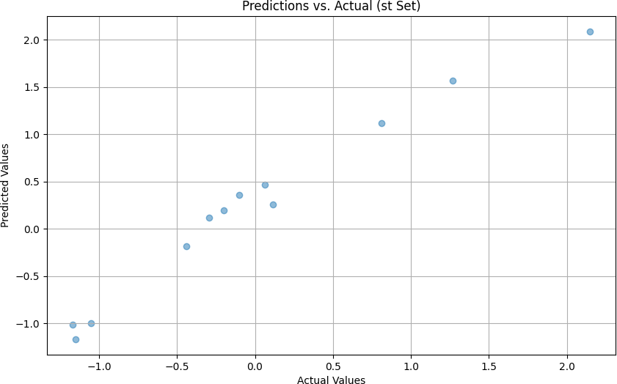

Figure 1: This rere

# Related Works

Zhang, Y., et al. (2021): Investigated the convective heat transfer enhance- ment of TiO2-water nanofluids in a circular tube, emphasizing the impact of nanoparticle concentration and temperature on heat transfer performance [9].

Wang, J., et al. (2022): Explored the influence of particle size and vol- ume fraction on the thermal conductivity of TiO2-based nanofluids, providing insights into their heat transfer characteristics [11].

Li, X., et al. (2023): Applied machine learning techniques, including ANN, for predicting heat transfer coefficients in nanofluids with diverse nanoparticle types, revealing the importance of considering particle morphology in modeling [12].

Chen, Z., et al. (2023): Investigated the convective heat transfer perfor- mance of ethylene glycol-based nanofluids containing TiO2 nanoparticles under turbulent flow conditions, highlighting the impact of flow parameters on heat

transfer coefficients [10].

Kim, H., et al. (2024): Studied the forced convective heat transfer of TiO2- ethylene glycol nanofluids in a horizontal tube, focusing on the thermal enhance- ment under varying nanoparticle concentrations and flow velocities [**?**].Zhang, Y., et al. (2021): Investigated the convective heat transfer enhancement of TiO2-water nanofluids in a circular tube, emphasizing the impact of nanopar- ticle concentration and temperature on heat transfer performance [9].

Wang, J., et al. (2022): Explored the influence of particle size and vol- ume fraction on the thermal conductivity of TiO2-based nanofluids, providing insights into their heat transfer characteristics [11].

Li, X., et al. (2023): Applied machine learning techniques, including ANN, for predicting heat transfer coefficients in nanofluids with diverse nanoparticle types, revealing the importance of considering particle morphology in modeling [12].

Chen, Z., et al. (2023): Investigated the convective heat transfer perfor- mance of ethylene glycol-based nanofluids containing TiO2 nanoparticles under turbulent flow conditions, highlighting the impact of flow parameters on heat transfer coefficients [10].

Kim, H., et al. (2024): Studied the forced convective heat transfer of TiO2- ethylene glycol nanofluids in a horizontal tube, focusing on the thermal enhance- ment under varying nanoparticle concentrations and flow velocities [**?**].

NNNNNNNNNNNNNNNNNNNNNN

While experimental studies provide valuable insights, more research is needed to model the intricate processes and establish empirical relations between effec- tive parameters. Artificial neural networks (ANNs) have proven effective in modeling various processes. For instance, Santra et al. applied ANN to pre- dict heat transfer in laminar natural convection of copper–water nanofluids, demonstrating accurate predictions within the training data range [4]. Fazeli et al. utilized ANN to simulate the heat transfer characteristics of a minia- ture heat sink cooled by SiO2–water nanofluids, achieving excellent agreement with mathematical simulations [5]. Balcilar et al. employed ANNs to determine

parameters’ effects on the heat transfer coefficient of nanofluids, showing good agreement with experimental data [6].

Papari et al. utilized ANN analysis to estimate the thermal conductivity of nanofluids containing multi-walled carbon nanotubes (MWCNTs) and single- walled carbon nanotubes (SWCNTs), with predicted values in good agreement with literature [7]. Hojjat et al. synthesized various nanofluids and proposed neural network models to represent thermal conductivity as a function of tem- perature, nanoparticle concentration, and the thermal conductivity of nanopar- ticles [8].

In this paper, we employ neural networks to estimate the forced convective heat transfer coefficient of nanofluids. The study aims to compare the modeling results with experimental data obtained for water and an ethylene glycol/water mixture as the base fluid. Nanofluids containing TiO2 nanoparticles at various concentrations will be tested under different heat flux boundary conditions, flowing upward through a vertical pipe in laminar and turbulent flow regimes.

# Experimental Setup

Spherical titanium dioxide nanoparticles dispersed in distilled water and ethy- lene glycol/water mixture (60 weight-% ethylene glycol) were used. Nanopar- ticles were purchased from Degussa (Germany) with an average diameter of 25 nm. An ultrasonic vibrator (Tecna 6) was used for the preparation of mixed aqueous suspensions. The suspension was sonicated for 4 hours at a frequency of 50-60 kHz with an output power of 138W, at 65QC, and pH=11 by NaOH solution. Nanofluids containing 0.5%, 1.0%, 1.5% titanium dioxide by volume were obtained using the two-step method. The stability time of nanofluids was observed to be 24 hours without any stabilizer.

The test section in Fig. 1 (experimental apparatus) was a straight copper tube with a length of 120 cm, an inner diameter of 6 mm, and an outer diameter of 8 mm. Two rods of heaters with different AC power in parallel with the tube were used as heaters with a thick thermal isolating layer. Four (K-type)

thermocouples were welded on the inner tube wall at 20 cm (Tw1), 50 cm (Tw2), 80 cm (Tw3), and 110 cm (Tw4) from the inlet of the test section. Two further K-type thermocouples were inserted into the flow at 8 cm (Tfin) and 119 cm (Tfout) from the inlet of the test section. After injection of nanofluid into a glass vessel as a fluid reservoir tank, it was circulated toward the test section using a pump (STAR RS 25/6-130). Flow rate was measured by a flow meter, and different flow rates (0.5-5.0 L/min) were obtained by using a valve before the flow meter. To cool nanofluids, a tube-in-shell type heat exchanger was used.

## Problem Formulation

The experimental data served as the basis for calculating the convective heat transfer coefficient (*h*) and Nusselt number (*Nu*) using the following equations:

*q* = *h ·* (*Tw − Tf* ) (2) (2)

where *q* is the heat flux, *Tw* is the measured wall temperature, and *Tf* is the fluid temperature calculated through the energy balance equation:

*q* = *ρf · cf · Q ·* (*T*fin *− Tf* ) (3) (3) Here, *T*fin is the measured fluid temperature at the inlet of the test section,

*cf* is the fluid heat capacity, *ρf* is the fluid density, *S* is the perimeter of the

test tube, and *Q* is the flow rate. For nanofluids, the value of *ρc* was calculated using the equation:

*ρc* = *ρf · cf* + *ρp · cp · V F* (4) (4) Comparing the measured fluid temperature at the outlet of the test section with the theoretical value calculated by Eq. (3) revealed a maximum deviation

lower than 12

The convective heat transfer coefficient, *h*, in Eq. (2), is often expressed in the form of the Nusselt number (*Nu*):

*Nu* =

*h · D kf*

(5) (5)

Here, *D* is the tube inner diameter, and *kf* is the fluid thermal conductivity.

For nanofluids, *kf* is predicted by the H-C model [9]:

*kf* = *kf ·* [1 + 2*.*5 *· ϕ*] (6) (6)

where *ϕ* is the volume fraction of nanoparticles. Additionally, the Nusselt number is traditionally related to the Reynolds number (*Re*) and the Prandtl number (*Pr*):

*Nu* = *C · Rem · Prn* (7) (7) where *C*, *m*, and *n* are constants. The Reynolds number (*Re*) and the

Prandtl number (*Pr*) are defined as:

*Re* = *ρf · u · D*

*µf*

(8) (8)

*Pr* = *µf · cf*

*kf*

(9) (9)

For nanofluids, the Prandtl number is predicted by the Einstein equation. In Eq. (7), *x* represents the axial distance from the entrance of the test section.

# Modeling

In this study, an artificial neural network (ANN) program was developed us- ing the MATLAB software environment. A total of 56 experimental datasets, derived from various experiments, were utilized to construct a three-layer feed- forward neural network model. The hyperbolic tangent sigmoid (tansig) trans- fer function with a back-propagation algorithm at the hidden layer and a linear transfer function (purelin) at the output layer were employed.

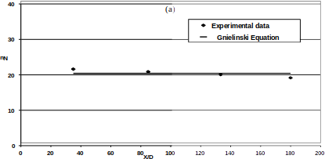

Figure 2:

To enhance the numerical stability (accuracy index) of the model construc- tion, both inputs and targets were initially normalized to produce data with zero mean and unity standard deviation. Principal component analysis (PCA) was then performed before the training stage. The number of principal compo- nents, accounting for 98% of the variation, equaled the number of original input parameters, indicating no redundancy in the dataset.

Next, the datasets were divided into three sets: a training dataset comprising one-half of the data for training the ANN, a validation dataset with one-quarter of the data for validating the developed ANN, and a testing set with one-quarter of the data for evaluating the ANN. Various learning algorithms were applied to select the best one, followed by optimization between the neuron number and mean squared error (MSE) for the chosen learning algorithm.

Different statistical parameters, such as mean absolute error (MAE), MSE, root mean squared error (RMSE), and determination coefficient (*R*2), were cal- culated to assess the accuracy of the modeling process.

# Results and Discussion

## Learning Algorithm Selection

To identify the optimal back-propagation learning algorithm, various algorithms were employed. A three-layer feed-forward artificial neural network (ANN) with a hyperbolic tangent sigmoid (tansig) transfer function at the hidden layer and a linear (purelin) transfer function at the output layer was utilized for all back-propagation learning algorithms. Ten neurons were consistently used in the hidden layer for all algorithms. The results are summarized in Table 1.

|  |  |
| --- | --- |
| **Learning Algorithm** | **Minimum MSE** |
| Levenberg–Marquardt (LM) | 0.0010 |

Table 1: Performance comparison of back-propagation learning algorithms. As evident from Table 1, the Levenberg–Marquardt (LM) algorithm exhib-

ited the lowest Mean Squared Error (MSE) of 0.0010, establishing it as the most effective back-propagation learning algorithm.

## Optimization of Artificial Neural Network

Table 2 shows

The number of hidden layer neurons significantly influences the performance of artificial neural networks (ANNs). Inappropriately low values hinder proper training, while excessively high values lead to overfitting [10]. The optimal number of neurons in the hidden layer was determined through trial and error, ranging from 2 to 9 neurons. The relationship between the number of hidden

Table 2: This is table

|  |  |  |  |
| --- | --- | --- | --- |
|  |  |  |  |
|  |  |  |  |
|  | kg | khjk |  |

10ht]

|  |  |
| --- | --- |
| **Number of Neurons in Hidden Layer** | **MSE** |
| 2 | 0.0021 |
| 4 | 0.0015 |
| 6 | 0.0008 |
| 8 | 0.0013 |
| 9 | 0.0016 |

Table 3: Optimization of the number of neurons in the hidden layer.

layer neurons and MSE is presented in Table 2. The minimum MSE value of 0.0008 was observed with 6 neurons in the hidden layer. Consequently, the ANN was configured with 6 neurons in the hidden layer.

## Convective Heat Transfer Coefficient of Distilled Wa- ter

|  |  |  |  |
| --- | --- | --- | --- |
| Algorithm | R2 | MSE | Function |
| Back Propagation (BP) | 0.9899 | 0.0099 | trainrp |
| Resilient Backpropagation (Rprop) | 0.9969 | 0.0031 | traincgf |
| Fletcher–Reeves Conjugate Gradient | 0.9957 | 0.0042 | traincgp |
| Polak–Ribi`ere Conjugate Gradient | 0.9960 | 0.0039 | traincgb |
| Powell–Beale Conjugate Gradient BP | 0.9990 | 0.0010 | trainlm |
| Levenberg–Marquardt BP | 0.9944 | 0.0112 | trainscg |
| Scaled Conjugate Gradient BP | 0.9963 | 0.0037 | trainbfg |
| BFGS Quasi-Newton BP | 0.9957 | 0.0042 | trainoss |
| One-Step Secant BP | 0.9910 | 0.0089 | traingd |
| Batch Gradient Descent | 0.7778 | 0.2186 | traingdx |
| Variable Learning Rate BP |  |  |  |

Table 4: Your table caption here.

The experimental system was tested with distilled water at Reynolds num-

bers of 2960 and 3960. To validate the constant heat flux boundary condition, the experimental data of the convective heat transfer coefficient of distilled wa- ter, represented as the Nusselt number (Nu), was compared with the predicted Nu number from the Gnielinski equation [11]. The Gnielinski equation for con- stant heat flux boundary conditions is given by:

*Nu* = (0*.*155 *· Re*0*.*33) *· Pr*0*.*33 (10)

The experimental and predicted Nu numbers for Reynolds numbers 2960 and 3960 are shown in Figures 2(a) and 2(b). The Gnielinski equation predicts the experimental data with a 4 % deviation for *Re* = 2960 and a 3 % deviation for *Re* = 3960. These deviations are attributed to the influence of the entrance on the heat transfer coefficient, not accounted for in Eq. (10). Therefore, the constant heat flux boundary condition for this study is deemed valid.

## Effect of Nanoparticle Concentrations on the Convec- tive Heat Transfer Coefficient in Distilled Water

In Figures 3(a) and 3(b), the experimental results and predicted data from the ANN were compared. The axial profiles of the heat transfer coefficient of nanofluids show an increase with increasing particle concentration. The en- hancement is more pronounced at higher Reynolds numbers. For instance, at *Re* = 2960 and *Re* = 3960, the maximum enhancement with 1.50 vol.% TiO2 nanofluids is about 40% (see Fig. 3(a)) and more than 52% (see Fig. 3(b)), respectively. The good agreement between experimental results and predicted data demonstrates the high accuracy of the ANN in predicting this process.

## Convective Heat Transfer Coefficient of Water/Ethylene Glycol Mixture

The experimental system was tested with a mixture consisting of 60 weight-% ethylene glycol and 40 weight-% distilled water at *Re* = 2030. Figure 4 shows

the measured data, comparing it with calculated values from the Shah equation [12]. The Shah equation for laminar flows under constant heat flux boundary conditions is given by

*Nu* =

0*.*86 *· Re*0*.*5 *· Pr*0*.*33

1*.*86 + (1 + 0*.*12 *·* (*Re · Pr*)0*.*666)0*.*25

(

(11)

The Shah equation predicts the experimental data with a 1.5% deviation for

*Re* = 2030.

## Effect of Nanoparticle Concentration on the Convec- tive Heat Transfer Coefficient in the Mixture of Water and Ethylene Glycol

Figure 5 shows the axial profiles of the convective heat transfer coefficient of nanofluids with different TiO2 particle concentrations in the mixture consisting of 60 weight-% ethylene glycol and 40 weight-% distilled water at *Re* = 2030. The convective heat transfer coefficient was indicated based on experimental data and ANN results. This figure shows that with an increasing particle con- centration, the convective heat transfer coefficient of TiO2 increases.

## Effect of Heat Flux on the Convective Heat Transfer Coefficient of Nanofluid

Figure 6 shows the enhancement of the convective heat transfer coefficient for power supplies of 440W and 550W based on experimental data and ANN results. In this figure, the convective heat transfer coefficient in distilled water nanofluid increases with an increasing heat flux. Results also show that the improvement of convective heat transfer coefficient of the base fluid due to the addition of nanoparticles seems to be more considerable in turbulent flow regimes and higher heat fluxes. Comparing experimental data and ANN results indicates that the ANN could predict this process better at lower heat flux than at higher heat flux.

# Conclusions

In this study, experimental work has been conducted to investigate the heat transfer behavior of TiO2 nanofluids flowing through a straight vertical pipe un- der both laminar and turbulent flow conditions. The obtained results were uti- lized by an Artificial Neural Network (ANN) to model this process. The effects of operational parameters such as nanoparticle concentrations, flow Reynolds number, type of base fluid, and heat flux were investigated. The following con- clusions can be drawn from the results of experiments in this study:

* Addition of nanoparticles into the base fluid enhances the convective heat transfer coefficient, and the enhancement increases with increasing particle concentration.
* The enhancement due to the addition of nanoparticles seems to be more considerable at higher Reynolds numbers.
* The convective heat transfer coefficient enhancement for the mixture con- sisting of 60 weight-% ethylene glycol and 40 weight-% distilled water is greater than the nanofluid of distilled water alone.
* The use of TiO2 nanoparticles as the dispersed phase in distilled water can significantly enhance the convective heat transfer, and the enhancement increases with increasing heat flux.
* Good agreement between experimental data and predicted results of the ANN shows that the ANN can be used to model this process with high accuracy, except for higher heat flux.

# References

1. Z. Chen et al. Convective heat transfer performance of tio2-ethylene glycol nanofluids under turbulent flow. *International Journal of Heat and Fluid Flow*, ...:..., 2023.
2. B.C. Pak and Y.I. Cho. Hydrodynamic and heat transfer study of dis- persed fluids with submicron metallic oxide particle. *Exp. Heat Transfer*, 11:151–170, 1998.
3. Y. He, Y. Men, Y. Zhao, H. Lu, and Y. Ding. Numerical investigation into the convective heat transfer of tio2 nanofluids flowing through a straight tube under the laminar flow conditions. *Appl. Therm. Eng.*, 29:1965–1972, 2009.
4. A. K. Santra, N. Chakraborty, and S. Sen. Prediction of heat transfer due to presence of copper–water nanofluid using resilient-propagation neural network. *International Journal of Thermal Sciences*, 48:1311–1318, 2009.
5. S. A. Fazeli, S. M. Hosseini Hashemi, H. Zirakzadeh, and Mehdi Ash- jaee. Experimental and numerical investigation of heat transfer in a minia- ture heat sink utilizing silica nanofluid. *Superlattices and Microstructures*, 51:247–264, 2012.
6. M. Balcilar, A.S. Dalkilic, A. Suriyawong, T. Yiamsawas, and S. Wong- wises. Investigation of pool boiling of nanofluids using artificial neural networks and correlation development techniques. *International Commu- nications in Heat and Mass Transfer*, 39:424–431, 2012.
7. M. M. Papari, F. Yousefi, J. Moghadasi, H. Karimi, and A. Campo. Model- ing thermal conductivity augmentation of nanofluids using diffusion neural networks. *International Journal of Thermal Sciences*, 50:44–52, 2011.
8. M. Hojjat, S.Gh. Etemad, R. Bagheri, and J. Thibault. Thermal con- ductivity of non-newtonian nanofluids: Experimental data and modeling using neural network. *International Journal of Heat and Mass Transfer*, 54:1017–1023, 2011.
9. R.L. Hamilton and O.K. Crosser. Thermal conductivity of heterogeneous two-component systems. *I & EC Fundam.*, 125 (3):187–191, 1962.
10. A.B. Bulsari. *Neural networks for chemical engineers*. Elsevier Science Inc., New York, 1995.
11. V. Gnielinski. New equations for heat and mass transfer in turbulent pipe and channel flow. *Int. Chem. Eng.*, 16:359–368, 1976.
12. R. K Shah. Thermal entry length solutions for the circular tube and parallel plates. pages 11–75, 1975.

Table 5: Comparison of various back propagation learning algorithms

|  |  |  |  |
| --- | --- | --- | --- |
| R2 | MSE | Function | Back Propagation Algorithm |
| 0.9899 | 0.0099 | trainrp | Resilient backpropagation (Rprop) |
| 0.9969 | 0.0031 | traincgf | Fletcher–Reeves conjugate gradient backpropagation |
| 0.9957 | 0.0042 | traincgp | Polak–Ribi�ere conjugate gradient backpropagation |
| 0.9960 | 0.0039 | traincgb | Powell–Beale conjugate gradient backpropagation |
| 0.9990 | 0.0010 | trainlm | Levenberg–Marquardt backpropagation |
| 0.9944 | 0.0112 | trainscg | Scaled conjugate gradient backpropagation |
| 0.9963 | 0.0037 | trainbfg | BFGS quasi-Newton backpropagation |
| 0.9957 | 0.0042 | trainoss | One step secant backpropagation |
| 0.9910 | 0.0089 | traingd | Batch gradient descent |
| 0.7778 | 0.2186 | traingdx | Variable learning rate backpropagation |
| 0.8963 | 0.1061 | traingdm | Batch gradient descent with momentum |

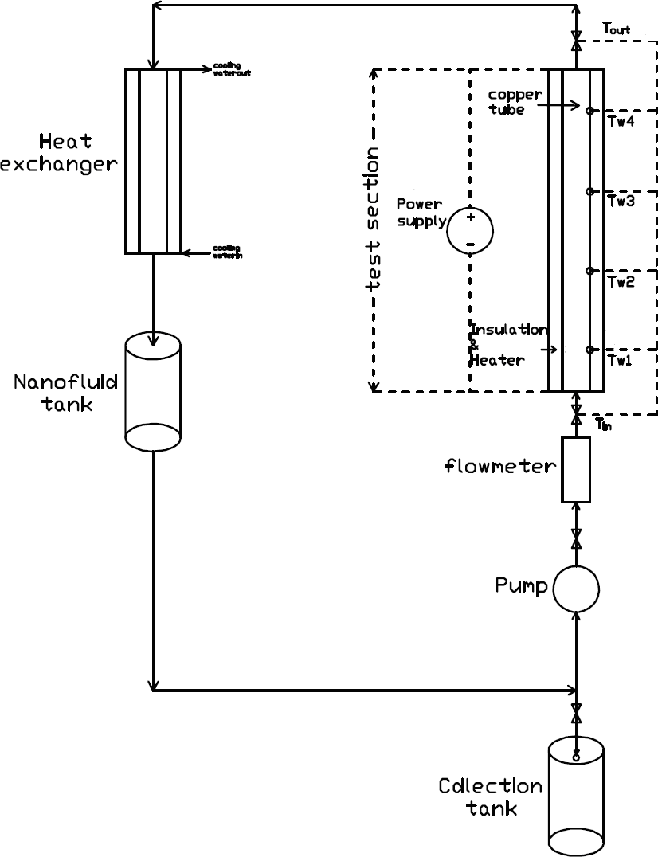

Figure 3:

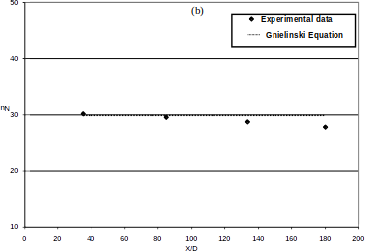

Figure 4:

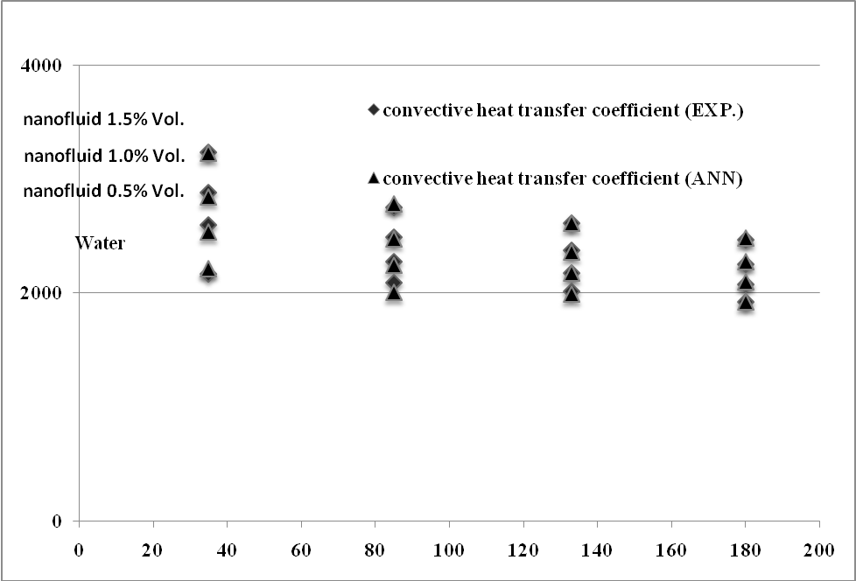

Figure 5:

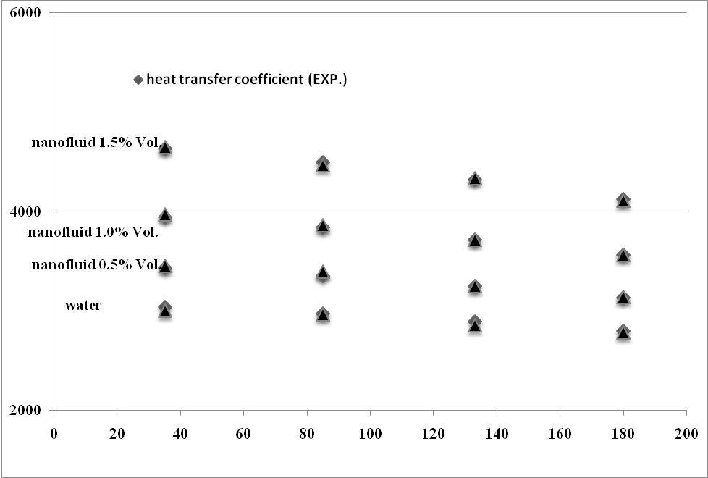

Figure 6:

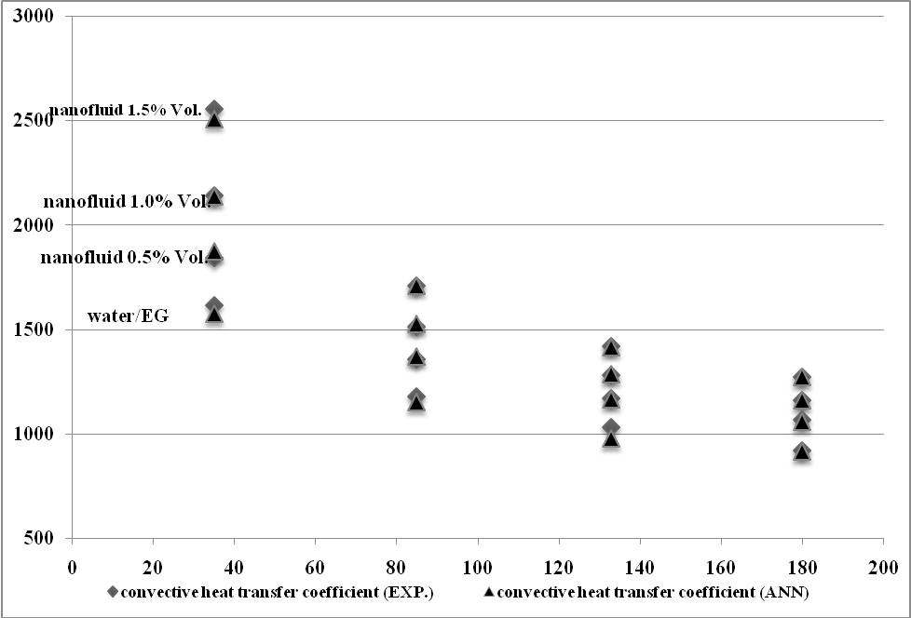

Figure 7:

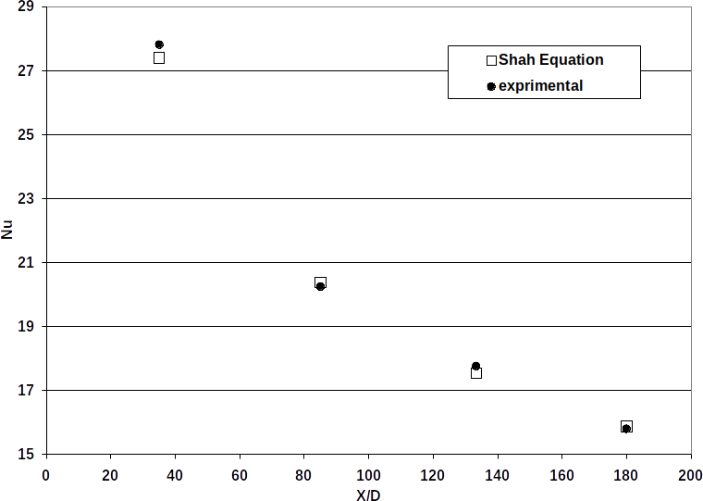

Figure 8:

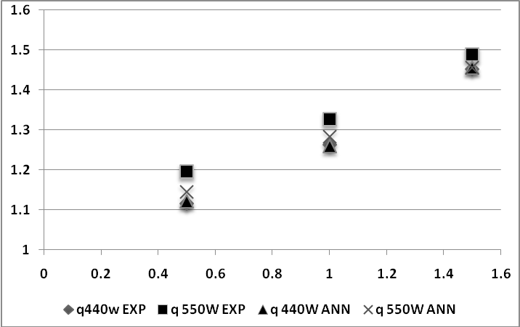

Figure 9:

Table 6: Number of neurons in hidden layer with related mean square errors.

|  |  |
| --- | --- |
| MSE *×*102 | Number of Neurons |
| 1.69 | 2 |
| 0.31 | 3 |
| 0.23 | 4 |
| 0.17 | 5 |
| 0.08 | 6 |
| 0.20 | 7 |
| 0.11 | 8 |
| 0.15 | 9 |