CREATE DATABASE:
CREATE DATABASE mysqllab1;

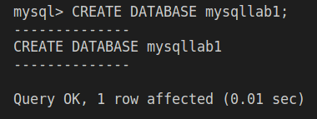

SHOW EXISTING DATABASES:
SHOW DATABASES;

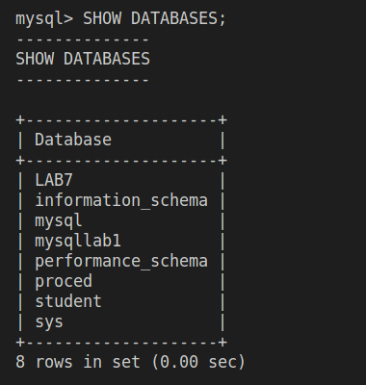

SELECTING A PARTICULAR DATABASE FOR FURTHER TRANSACTIONS:
USE mysqllab1;

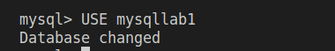

CREATING A TABLE IN THE DATABASE:
CREATE TABLE PRODUCT_MASTER (
PRODUCTNO Varchar(6),
DESCRIPTION Varchar(15),
PROFITPERCENT Float(4,2),
UNITMEASURE Varchar(10),
QTYONHOLD Int(8),
REORDERLVL Int(8),
SELLPRICE Float(8,2),
COSTPRICE Float(8,2)
);

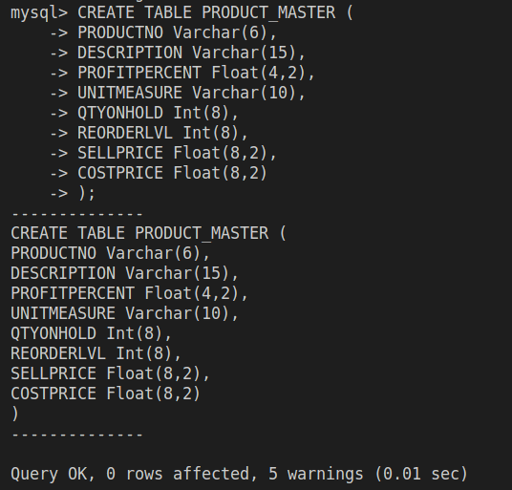

VIEWING THE CREATED TABLE:
desc PRODUCT_MASTER;

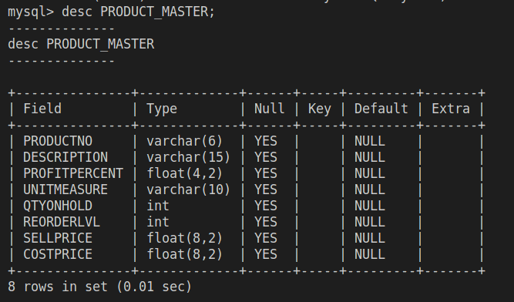

CREATING TABLE-2:
CREATE TABLE CLIENT_MASTER (
CLIENTNO Varchar(6),
NAME Varchar(20),
ADDRESS1 Varchar(30),
ADDRESS2 Varchar(30),
CITY Varchar(15),
PINCODE Int(8),
STATE Varchar(15),
BALDUE Float(10,2)
);

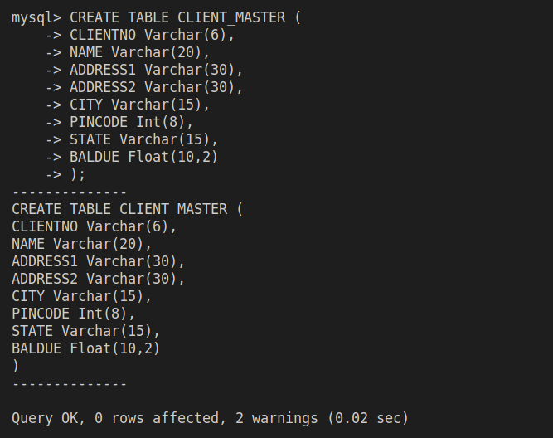

CREATING TABLE-3:
CREATE TABLE SALESMAN_MASTER (
SALESMANNO Varchar(6),
SALESMANNAME Varchar(20),
ADDRESS1 Varchar(30),
ADDRESS2 Varchar(30),
CITY Varchar(15),
PINCODE Int(8),
STATE Varchar(15)
);

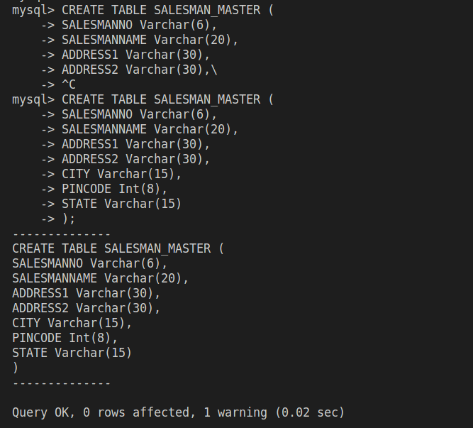

CREATING TABLE-4:
CREATE TABLE STUDENT (
SNO Int(5),
SNAME Varchar(20),
AGE Int(5),
SDOB Date,
SMARK1 Float(4,2),
SMARK2 Float(4,2),
SMARK3 Float(4,4)
);

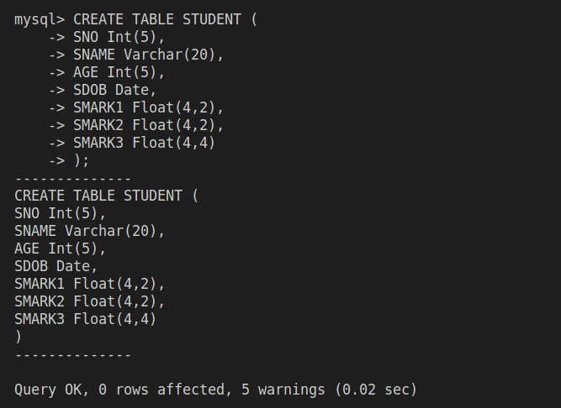

ADDING COLUMN TO EXISTING TABLE:
ALTER TABLE CLIENT_MASTER
ADD TELEPHONE Int(10);

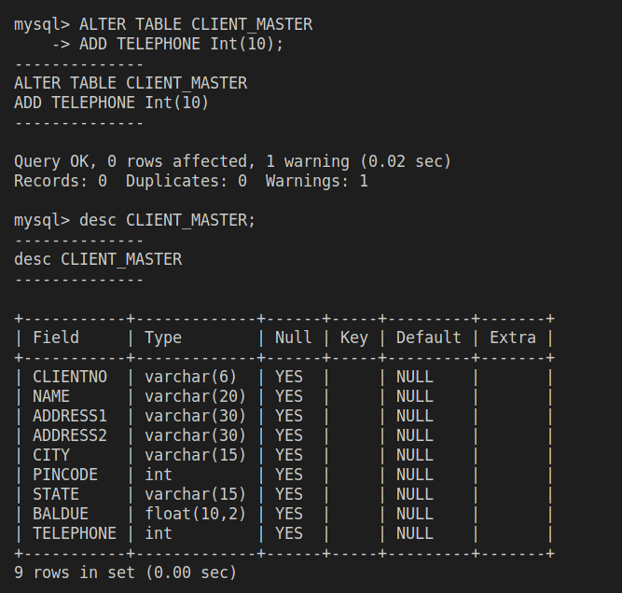

CHANGING THE DATATYPE SIZE OF EXISTING COLUMN OF A TABLE:
ALTER TABLE PRODUCT_MASTER
MODIFY COLUMN SELLPRICE Float(10,2);

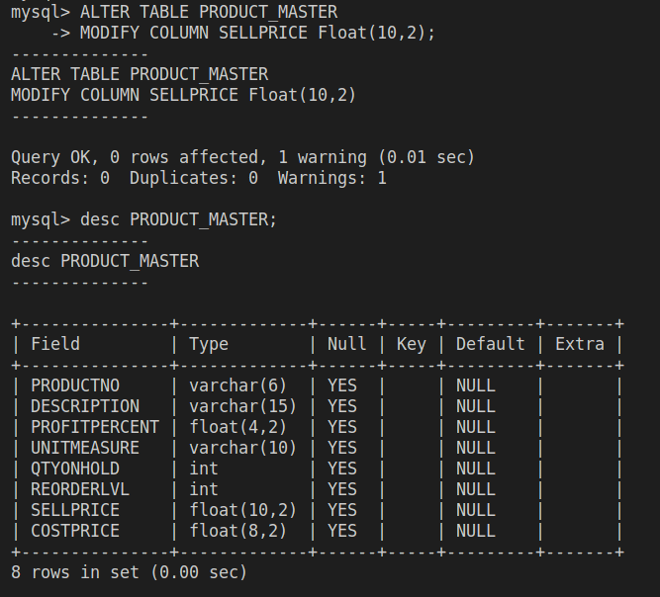

DELETING TABLE STRUCTURE ALONG WITH ITS DATA:
DROP TABLE CLIENT_MASTER;

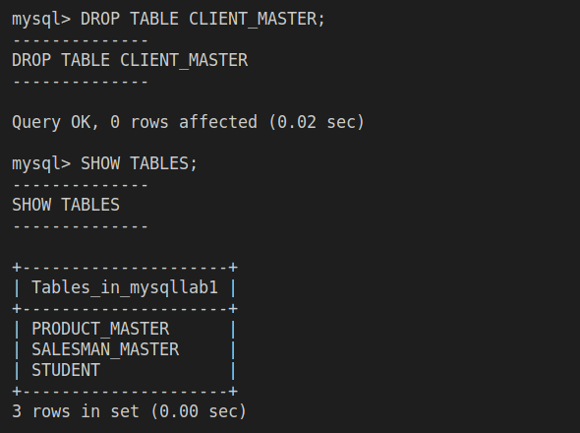

RENAMING AN EXISTING TABLE:
RENAME TABLE SALESMAN_MASTER TO SMAN_MAST;

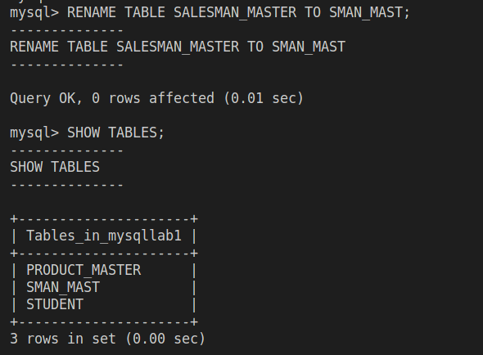

ADDING VALUES INTO A TABLE:
INSERT INTO PRODUCT_MASTER (PRODUCTNO, DESCRIPTION, PROFITPERCENT, UNITMEASURE, QTYONHOLD, REORDERLVL, SELLPRICE, COSTPRICE)
VALUES
(12, 'ABC', 52.32, 'KG', 8, 5, 25, 20.32),
(13, 'DEF', 25.35, 'G', 5, 8, 35.23, 26);

