**Document – Regression Analysis**

The dataset is the simulated dataset which representing 9-hour cycle for 100 experiment. For pH and weight are measured every one hour and the mean of whole 9 Hour cycle is taken for the analysis.

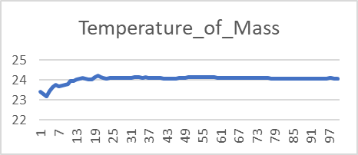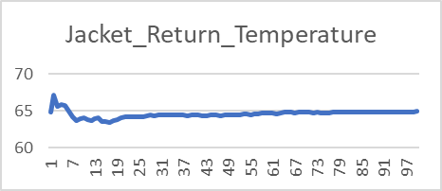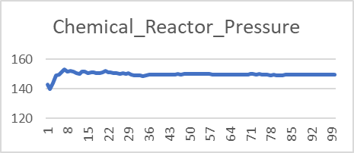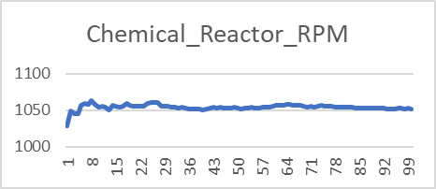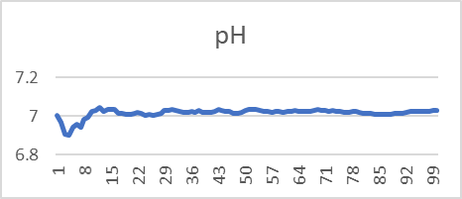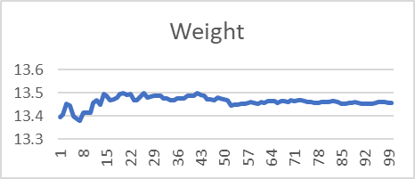

Regression Results –

|  |  |  |
| --- | --- | --- |
| Model | Test MAE | Test R2 |
| Random Forest | 0.009388 | 0.74071 |
| Gradient Boost | 0.012113 | 0.60092 |
| K-Nearest Neighbors | 0.019498 | -0.1658 |
| Linear Regression | 0.011642 | 0.77647 |
| Support Vector Machine | 0.034763 | -0.1478 |

For predicting pH

|  |  |  |
| --- | --- | --- |
| Model | Test MAE | Test R2 |
| Random Forest | 0.011946 | 0.1818 |
| Gradient Boost | 0.012263 | 0.1230 |
| K-Nearest Neighbors | 0.016572 | -0.0520 |
| Linear Regression | 0.020955 | -2.2683 |
| Support Vector Machine | 0.030609 | -1.7797 |

For predicting Weight

Among the models for predicting pH Linear Regression gave best result and for weight Random Forest