v
EDUCATION
Bachelor in Computer Engineering
June 2021 – April 2025
Pashchimanchal Campus, Tribhuvan University, IOE
+2 in Science
April 2018 – July 2020
Pokhara Secondary School, Gandaki

INTERESTS
- Web Development
- App Development
- UI/UX Design
HOBBIES
- Video Games
- Music
LANGUAGES
- English: Proficient
- Nepali: Proficient
SKILLS
- Python
- Javascript
- HTML & CSS
- Git
- NodeJS
CONTACT
+977 9845533201
 glacticoanish@gmail.com
 Milanchowk, Pokhara-25, Kaski

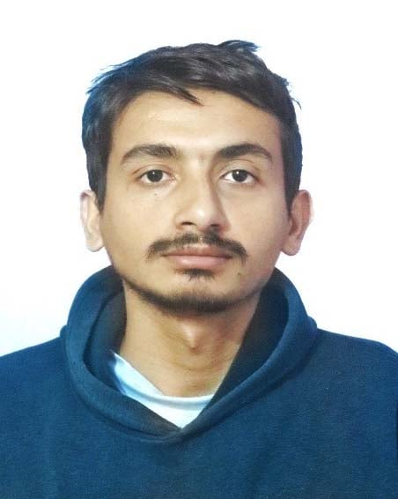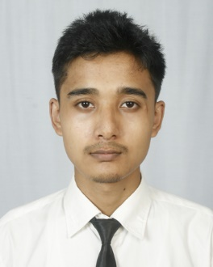
Anish
Dahal
WORK EXPPERIENCE
Web Developer Intern
Dhaulagiri School, MilanChowk, Pokhara-25 Sep 2024 – Present

- Assisted in building responsive websites for school events.
- Developed and maintained the school’s official website
- Collaborated with the design team to ensure smooth UI/UX integration.

PROFILE
I am a computer engineering student with passion for continuous learning. I am skilled in problem-solving and have strong background in computer science. I am a strong communicator and enjoy working collaboratively with others.

