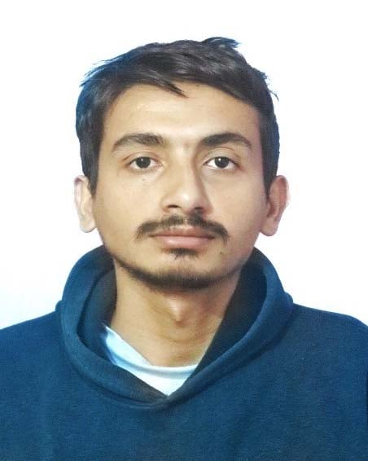
Name: Anish Dahal

Email: glacticoanish@gmail.com
Linkedin: linkedin.com/in/galacticoanish
Phone: +977 9845533201
DOB: June 21, 2002

Experience:
- Web Developer Intern (Sep 2024 – Present)
Assisted in building responsive websites for school events. Developed and maintained the school’s official website using HTML, CSS, and JavaScript. Collaborated with the design team to ensure smooth UI/UX integration.
Education:
- Bachelor in Computer Engineering
- +2 in Science
Skills:
- Hard Skills: HTML & CSS, JavaScript, Python, Git, NodeJS
- Soft Skills: Problem-Solving, Teamwork, Communication, Time Management
Languages:
- English (Proficient)
- Nepali (Proficient)
Interests:
- Web Development
- App Development
- UI/UX Design
- Coding Challenges
- Video Games

