v
INTERESTS
- Chess and Puzzles
- Reading Tech Blogs
- Open Source Contributions
HOBBIES
- Video Games
- Music
LANGUAGES
- English: Proficient
- Nepali: Proficient
SKILLS
- Python
- SQL
- Pandas
- Numpy
- Scikit-Learn
- Matplotlib

CONTACT
++977 9819119125
 pas077bct019@wrc.edu.np
 Hemja Pokhara-25, Kaski

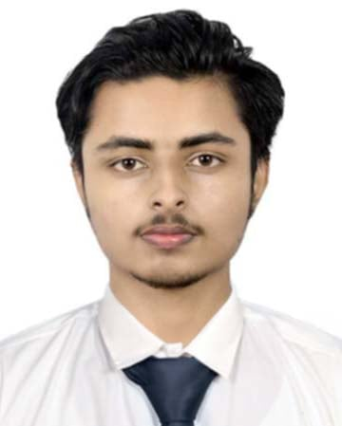
DIPAK
POUDEL
WORK EXPPERIENCE
Freelance Data Projects
Remote, Hemja, Pokhara-25 JUN 2024 – Present

- Conducted exploratory data analysis on Kaggle datasets.
- Built a recommendation system for a mock e-commerce platform using collaborative filtering.

Internship at Dishhome
ChipleDhunga, Pokhara-8 SEP 2023 – JAN 2024

- Assisted in cleaning and preprocessing large datasets using Python (Pandas, NumPy)
- Built predictive models using Scikit-learn to forecast customer churn.
- Created dashboards in Tableau for client reporting.
EDUCATION
Bachelor in Computer Engineering
June 2021 – April 2025
Pashchimanchal Campus, Tribhuvan University, IOE
+2 in Science
April 2018 – July 2020
SOS Hermann Gmeiner Secondary School, Gandaki

PROFILE
I am a computer engineering student with passion for continuous learning. I am skilled in problem-solving and have strong background in computer science. I am a strong communicator and enjoy working collaboratively with others.

