Name: Dipak Poudel
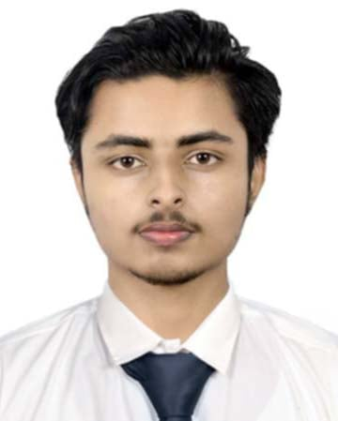
Email: pas077bct019@wrc.edu.np
Linkedin: linkedin.com/in/dipakpoudel.10
Phone: +9779819191534
DOB: June 26, 2001

Experience:
- Freelance Data Projects (JUN 2024 - Present)
Conducted exploratory data analysis on Kaggle datasets. Built a recommendation system for a mock e-commerce platform using collaborative filtering.

- Internship at Dishhome (SEP 2023 – JAN 2024)
Assisted in cleaning and preprocessing large datasets using Python (Pandas, NumPy). Built predictive models using Scikit-learn to forecast customer churn. Created dashboards in Tableau for client reporting.

Education:
- Bachelor in Computer Engineering
- +2 in Science
Skills:
- Hard Skills: Python, SQL, Pandas, Numpy, Scikit-learn, Matplotlib, Seaborn, Tensorflow, Tablea, Github
- Soft Skills: Problem-Solving, Leadership, Collaboration, Communication
Languages:
- English (Proficient)
- Nepali (Proficient)
Interests:
- Machine Learning & AI
- Data Storytelling
- Open-source Contributions
- Chess and Logical Puzzles
- Reading Tech Blogs

