v
INTERESTS
- Digital Art
- App Development
- Graphics Design
HOBBIES
- Drawing
- Video Games
- Music
LANGUAGES
- English: Proficient
- Nepali: Proficient
SKILLS
- Kotlin
- Java
- Android Studio
- XML
- Firebase
- Git
CONTACT
+977 9846602254
 saroj101@gmail.com
 Parsayang, Pokhara-5, Kaski

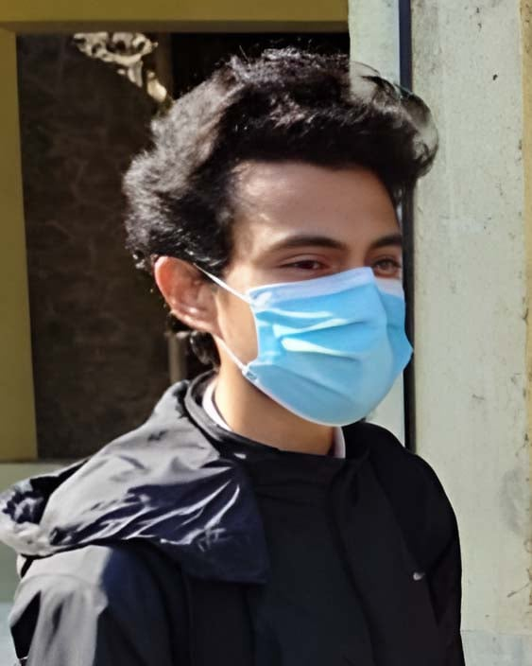
Saroj
Adhikari
WORK EXPPERIENCE
Android Developer Intern
Parsyang , Pokhara-5 Jan 2025 – Apr 2025

- Built basic Android applications using Java and Kotlin in Android Studio.
- Integrated Firebase for real-time database and authentication.
- Participated in code reviews and collaborated in agile development teams.
Studio Assistant
Parsyang, Pokhara-5 2023 – Present

- Developed a to-do list app and a budget tracker using XML UI and SQLite for local data storage
- Published a basic weather app using OpenWeatherMap API
- Uploaded source code on GitHub with proper documentation
EDUCATION
Bachelor in Computer Engineering
June 2021 – April 2025
Pashchimanchal Campus, Tribhuvan University, IOE
+2 in Science
April 2018 – July 2020
Motherland Secondary School, Gandaki

PROFILE
I am a computer student with passion for continuous learning. I am skilled in problem-solving and have strong background in computer science. I am a strong communicator and enjoy working collaboratively with others.

