v
INTERESTS
- Web Development
- App Development
- Graphics Design
HOBBIES
- Drawing
- Video Games
- Music
LANGUAGES
- English: Proficient
- Nepali: Proficient
SKILLS
- Python
- Javascript
- HTML & CSS
- Photoshop
- Ms. Word
- English Typing (65 wpm)
CONTACT
+977 9846602320
 sentake101@gmail.com
 Kahunkhola, Pokhara-13, Kaski

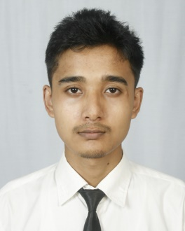
Saujanya Shrestha
WORK EXPPERIENCE
Graphics Designer
Pinnacle Academy, Phoolbari, Pokhara-11 Sep 2024 – Present

- Designed posters for the school’s facebook page
- Designed banners for the school’s parent’s day
- Worked closely with the client to meet their needs

Studio Assistant
Photo Pratibimba, Kahunkhola, Pokhara-13 2018 – Present

- Worked in a photo studio to capture, edit and develop professional photographs.
EDUCATION
Bachelor in Computer Engineering
June 2021 – April 2025
Pashchimanchal Campus, Tribhuvan University, IOE
+2 in Science
April 2018 – July 2020
SOS Hermann Gmeiner Secondary School, Gandaki

PROFILE
I am a computer student with passion for continuous learning. I am skilled in problem-solving and have strong background in computer science. I am a strong communicator and enjoy working collaboratively with others.

