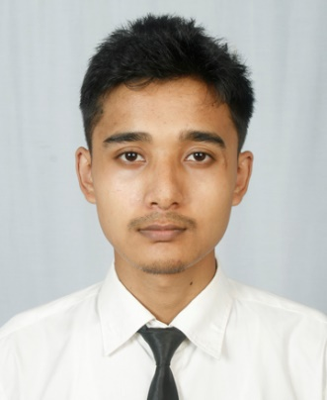
Saujanya Shrestha

Phone: 9846602320
DOB: April 26, 2003
Email: sentake101@gmail.com
Linkedin: linkedin.com/in/saujanyashrestha

Experience:
- Graphics Designer (Sep 2024 - Present)
Designed posters for the school’s facebook page. Designed banners for the school’s parent’s day. Worked closely with the client to meet their needs.
- Studio Assistant (2018 - Present)
Worked in a photo studio to capture, edit and develop professional photographs.
Education:
- Bachelor in Computer Engineering
- +2 in Science
Skills:
- Hard Skills: Python, Javascript, HTML & CSS, Photoshop, Ms. Word, English Typing (65 wpm)
- Soft Skills: Problem-Solving, Leadership, Collaboration, Communication
Languages:
- English (Proficient)
- Nepali (Proficient)
Interests:
- Web Development
- App Development
- Graphics Design
- Drawing
- Video Games
- Music

