- If only 1 student is viewing video then only 1 view per user should be given
otherwise testing team logic is fine then per one payment only once video should be played
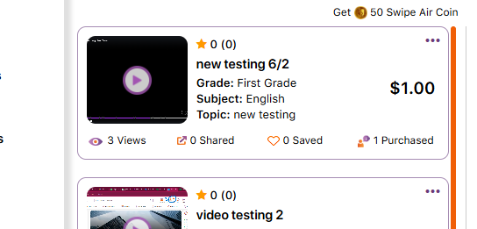
- In case of free video it should show free instead of 0 purchased
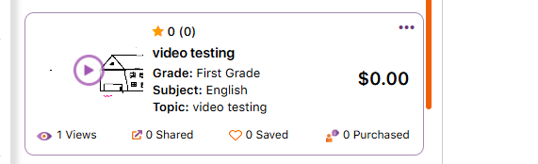
- Should be made dynamic or hiden
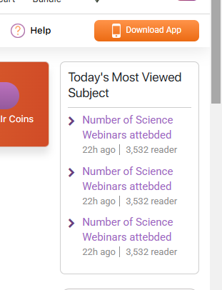
- Share should be hidden
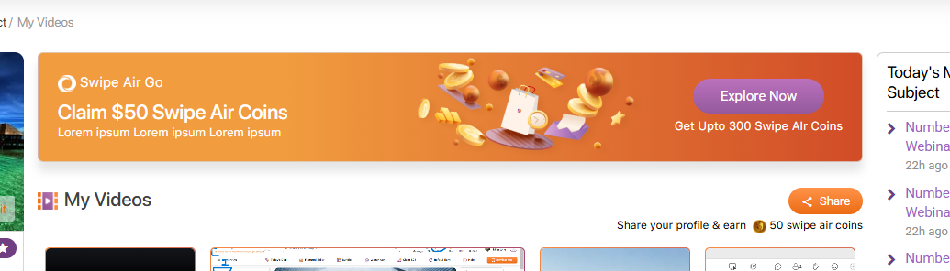

- In tutor indication should be given to given as to of word limit otherwise it is getting partial text video listing page of student
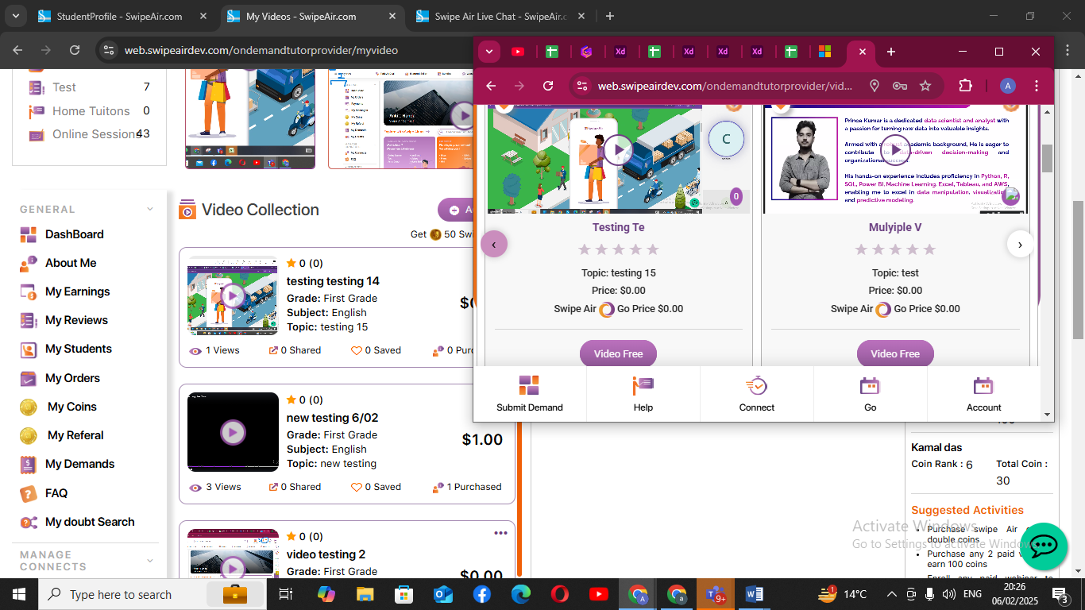
- As soon as I bring my cursor to share and earn it is showing pop up, and uable to go to next filter
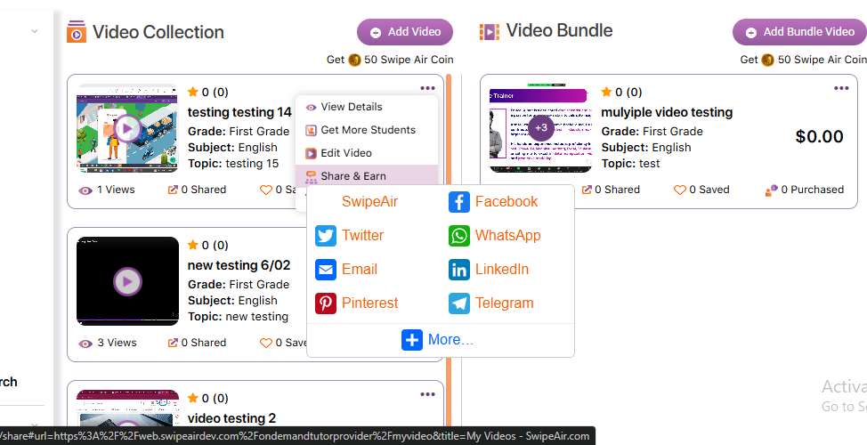
- Getting pop up on share and earn
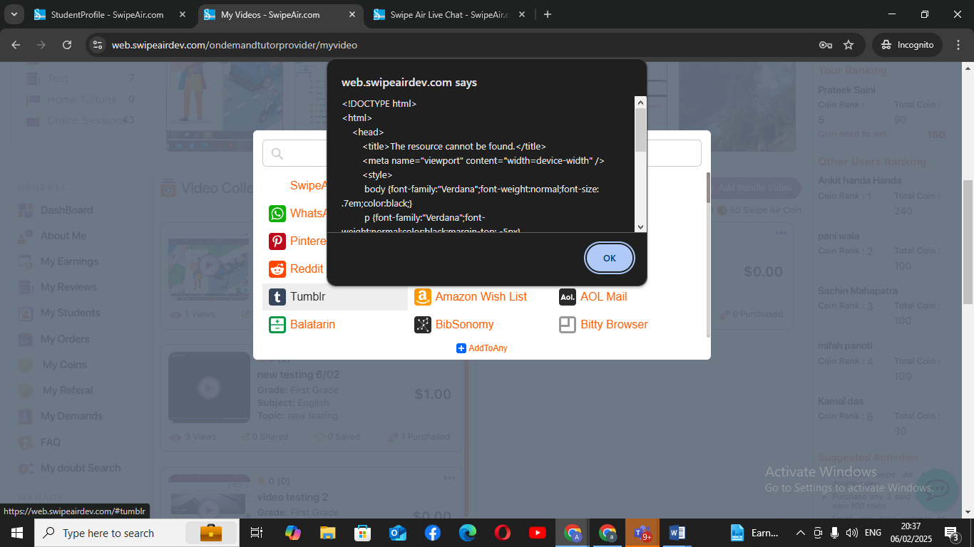
- G=deleted video from tutor side stil visiblet ostudent refreshed twice
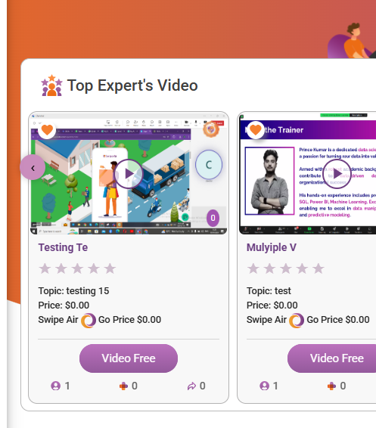
- On video addition 50 coins should be given, given only 20.
even if we’re changing from admin there should be sink b/w the two
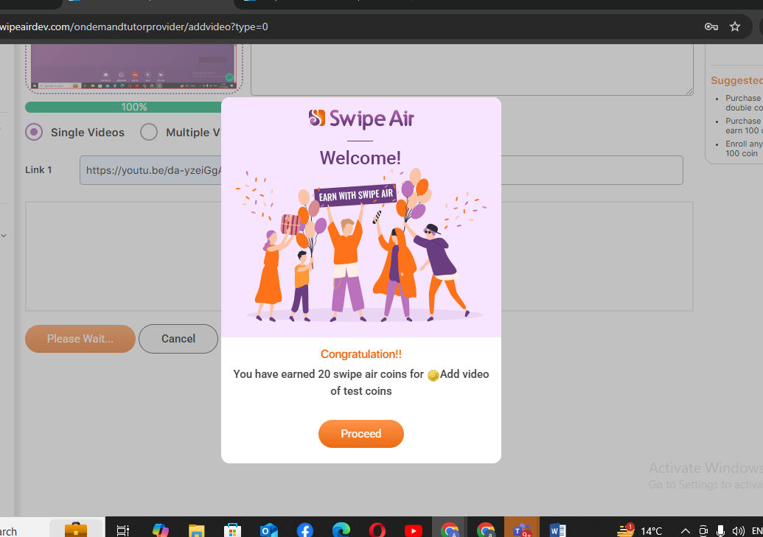

- After clicking cross it is getting disappeared from the first one too and
