Document On
“All SKU Pending Detail List”

- Admin will login
  - Username
  - Password
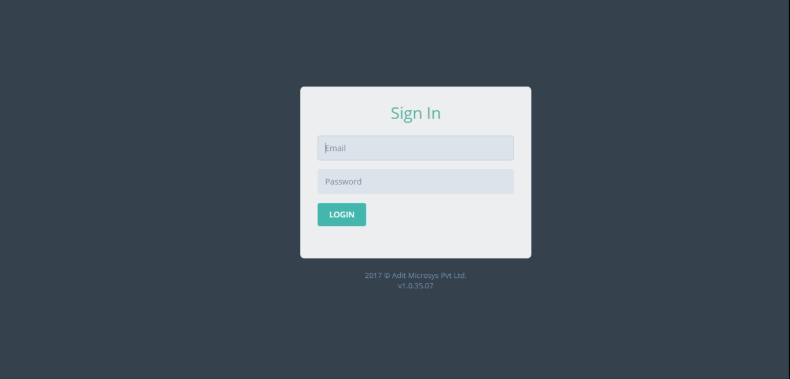
- Dashboard
  - From dashboard, click on All SKU Pending Detail List
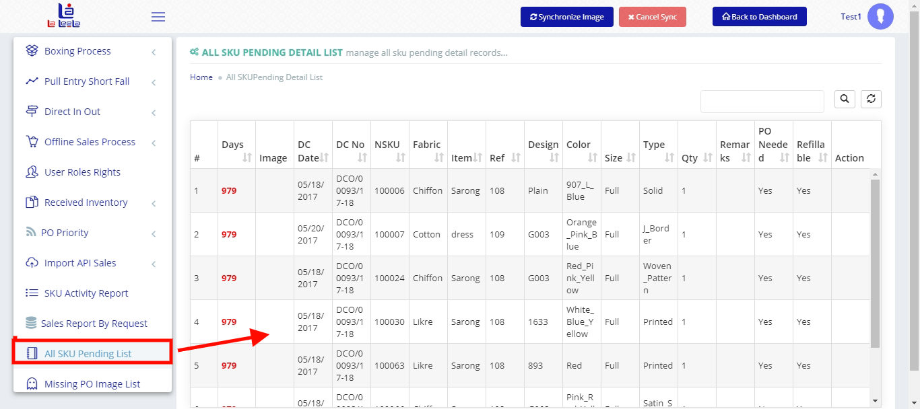

- Whose SKUs Creation is pending will show



