1. If only 1 student is viewing video then only 1 view per user should be given   
   otherwise testing team logic is fine then per one payment only once video should be played  
   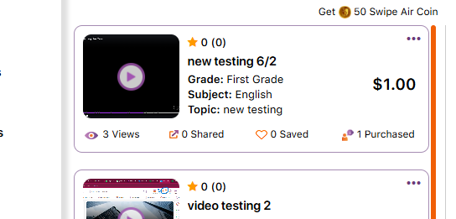
2. In case of free video it should show free instead of 0 purchased

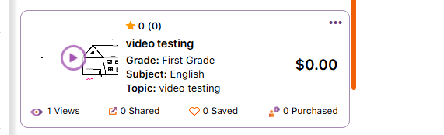

1. Should be made dynamic or hiden  
   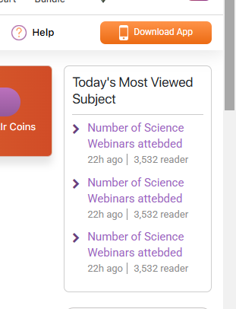
2. Share should be hidden   
   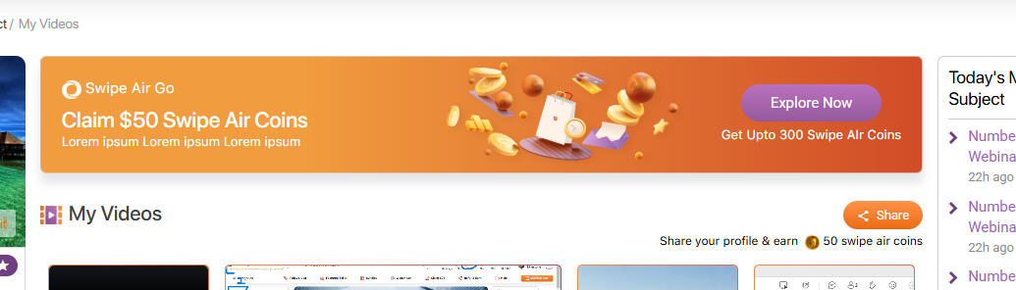
3. In tutor indication should be given to given as to of word limit otherwise it is getting partial text video listing page of student   
   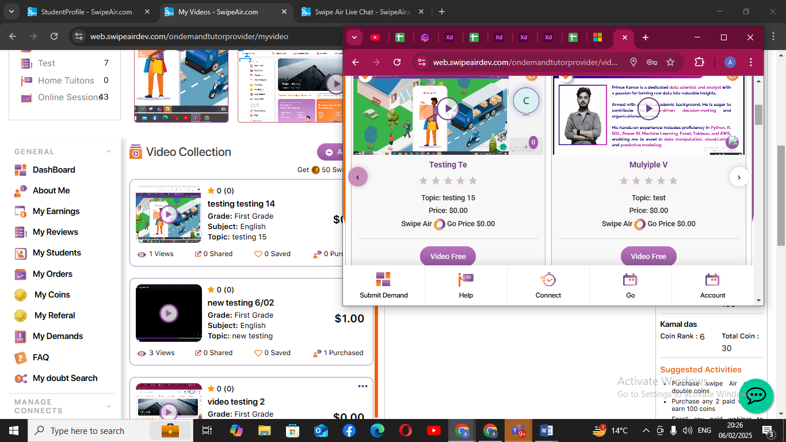
4. As soon as I bring my cursor to share and earn it is showing pop up, and uable to go to next filter  
   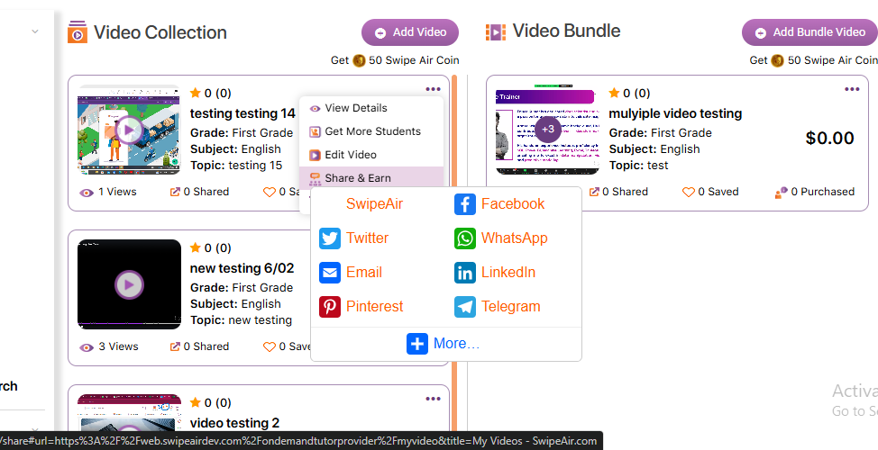
5. Getting pop up on share and earn   
   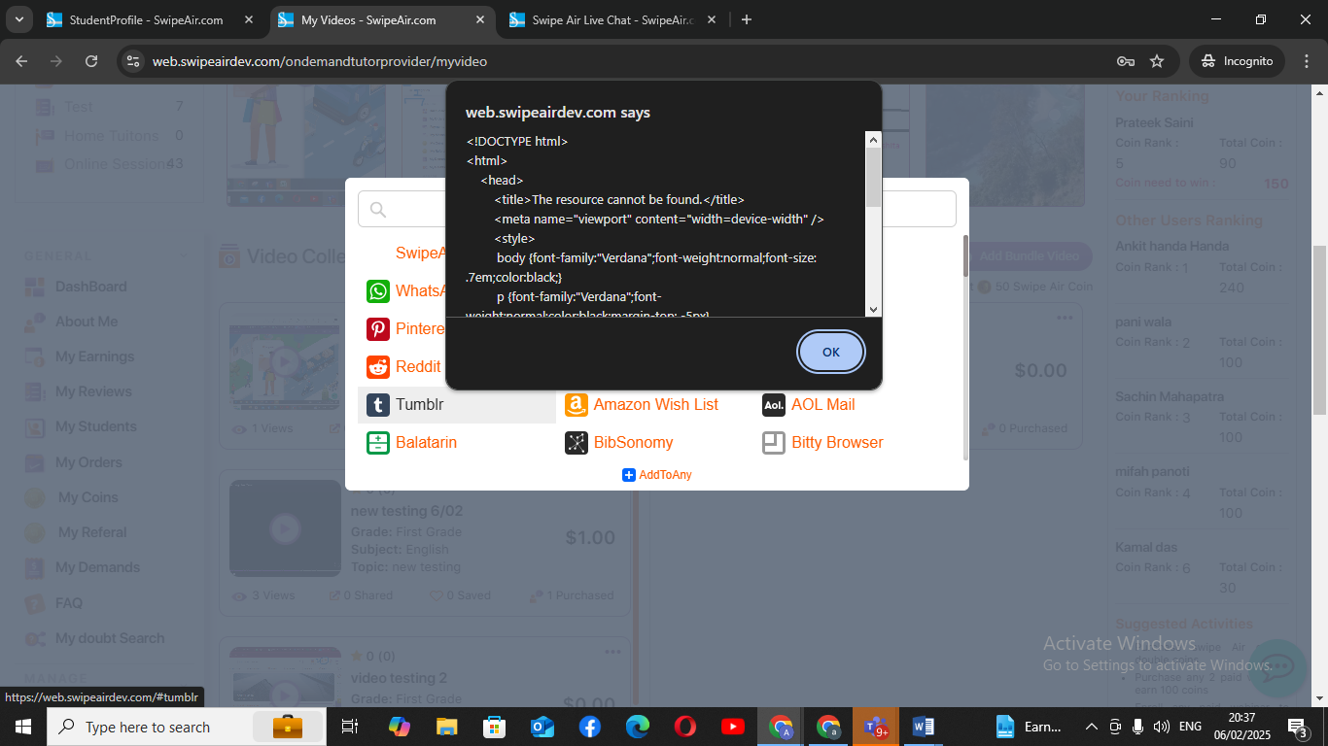
6. G=deleted video from tutor side stil visiblet ostudent refreshed twice   
   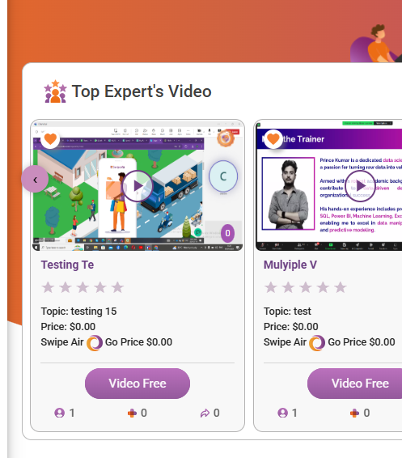
7. On video addition 50 coins should be given, given only 20.  
   even if we’re changing from admin there should be sink b/w the two  
   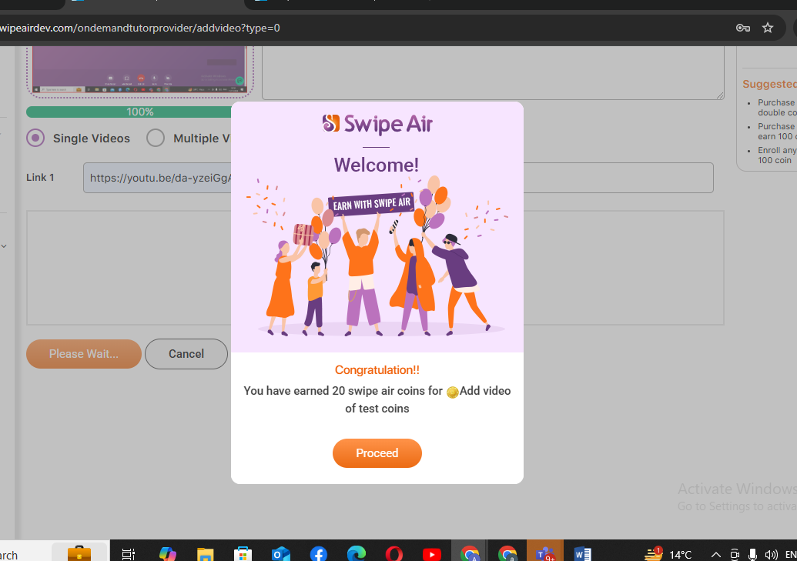
8. After clicking cross it is getting disappeared from the first one too and  
   