Hotness classification on professors

Zidong Wang
School of Information
University of Michigan
wzidong@umich.edu
Yuzhou Gong
School of Information
University of Michigan
yzhgong@umich.edu
Seungbum Park
School of Information
University of Michigan
purblue@umich.edu

ABSTRACT
In this paper, we describe the formatting guidelines for ACM SIG Proceedings.
Keywords
Keywords are your own designated keywords.

INTRODUCTION
The evaluation of professors and their classes has been important to both faculty and students since for faculty, it is one of major consideration for promotion, and for students, they can decide which classes to take. Typically, the evaluation has been based forms that are filled out anonymously by students in a classroom using formal, well-defined and controlled processes [1]. However, as well as the typical resources, new source of faculty rating data has recently become available on the Web, which has known as online faculty rating sites. In these sites, students can informally share information about professors and their lectures based on their personal experiences. Since students can be much freer and open, different from the traditional evaluation process, many students have used it to evaluate faculty and decide lectures fitting well to their desire, while the information is hard to be officially used in institution due to their inherent bias. Due to its new possibility, there have been various researches to verify their effectiveness [1].
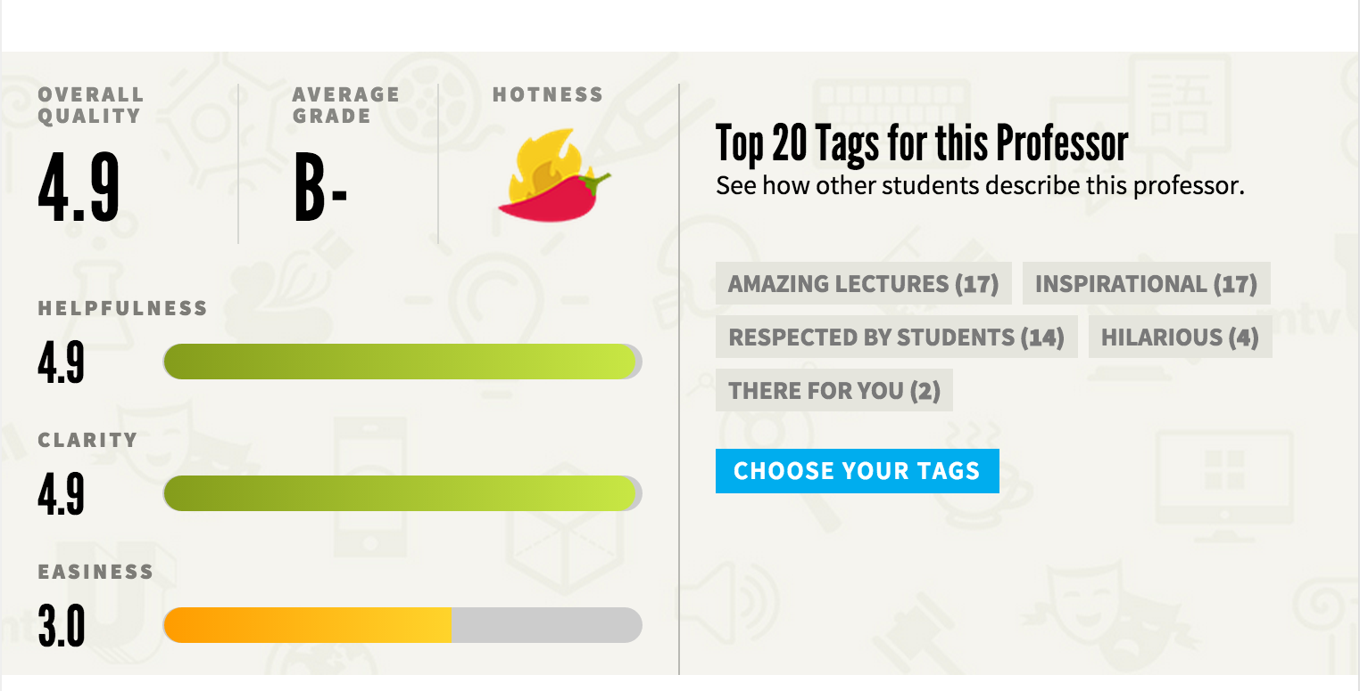
RateMyProfessor.com is one of the famous online faculty rating sites. The site has several categories in which a professor is ranked: overall quality, helpfulness, clarity, easiness and hotness. Figure 1 shows an example of ratings and comments in the site. While most of measures directly indicates teaching effectiveness of a given professor, the hotness factor identified by red-chili denotes interesting characteristic, how attractive a professor is. In fact, the hotness is meant to be not only physical beauty, but also other various subjective characters of professors, such as passion about their subject, which are possible to have great impact on students’ decision when class registration. While attractiveness is something that tends to be different depending of the viewer, there is often a general society-created standard. Therefore, we want to analyze which features are important for the hotness, and based on the analysis, we try to predict the hotness.
Essentially, the problem is a classification problem labeled by the hotness, which is either hot or not hot. In order to analyze the hotness, we first divide entire data into three types: numeric, categorical and text data. Numeric data provides quantitative information of teaching effectiveness, such as overall quality of a professor, helpfulness, clarity, and easiness. Categorical data refers to tags that students choose, and there are 20 pre-defined tag set. Lastly, text data means all text reviews of a professor. The reason why we try to divide the data into the three types is that different characteristics depending on the types lead to different approaches. Therefore, in order to evaluate our approaches, we first apply various classification algorithms into a single large matrix that contains all three data types, and then

PROBLEM STATEMENT
All material on each page should fit within a rectangle of 18 × 23.5 cm (7" × 9.25"), centered on the page, beginning 1.9 cm (0.75") from the top of the page and ending with 2.54 cm (1") from the bottom. The right and left margins should be 1.9 cm (.75")

The text should be in two 8.45 cm (3.33") columns with a .83 cm (.33") gutter.

DATASET
We directly gather data from RateMyProfessors.com using our own crawler since the official API of RateMyProfessors.com is not available any more. We target professors in public universities in Michigan, Illinois, and California. For each professor, we crawl not only overall scores, such as hotness, quality, average grade, helpfulness, clarity, easiness, and top 20 tags, but also all individual comments, which contains various numeric measures like the overall scores, selected tags and text reviews. As a result, we get 33,565 professor data in total, which are labeled by hotness (either hot or not hot), and all comments for each professor. Average number of comments per professor is 12.1 with 20.3 standard deviation, and maximum number of the comments is 737. In addition, since 70% of our test data are labeled as “hot”, a baseline of classification would be 70%, which equals to the accuracy if we forcibly predict all the data as “hot”. We used 70% of entire data as training set, and the remaining as test set with maintaining the proportion of the labels. Finally, we divide data into three types in order to use different approach depending on the type: numeric, categorical (or tag) and text data.

Numerical data
For numeric data, we use the 8 aggregated scores including overall quality, helpfulness, clarity, easiness, average interest, average textbook-used-or-not, average taken-for-credit-or-not and number of ratings. Note that we do not use average Grade since 70% of data are missing, while other variables do not contain missing values. Specific description and distribution of the numeric variables are summarized in Table 2.

Categorical Data
Tag features are categorical data. A student could choose tags from a pool of 20 and attach them to a professor. A professor’s tags would be the union of all the tags he gets from students. Therefore, the dimension of tag matrix is 20, each column corresponding to a tag. And the numeric value of that column is intuitively how many that tags the professor gets.

Text Data
For text reviews, we aggregate all text reviews into a single text for each professor, and then apply several natural language processing steps. After stop word and special character removal, and lemmatization with NLTK package, we vectorize the text data with both unigram and bigram for feature selection by using Scikit-Learn package [2]. Since the dimensionality is about 1.3 million, we apply Chi-Square feature selection in order to reduce the dimension.

CLASSIFICATION APPROACH

Place Tables/Figures

Single Classifier
Although we have 3 feature groups, numerical, tags, and text, a classical approach would be considering them equally and combining the 3 feature groups into a big matrix. The pipeline flow of this approach is shown in figure below.
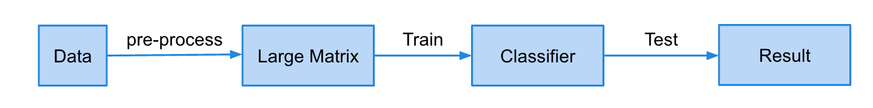

We employ different underlying classifiers in Scikit-Learn package, which are Multinomial Naive Bayes, Gaussian Naive Bayes, Logistic Regression, and Random Forest to implement this method. Naive Bayes is a popular classifier based on “word bags” concept and it usually performs well on text features. Logistic Regression method is known to perform well and run fast when applied to binary classification. Random Forest is an ensemble learner, which could effectively avoid over-fitting problem, though it takes longer to train especially when features dimension is high. We finally decide to use those 4 classifiers to implement this approach and make comparison.

Dynamic Classifier Selection

EVALUATION

Single Classifier

The heading of subsections should be in Times New Roman 12-point bold with only the initial letters capitalized. (Note: For subsections and subsubsections, a word like the or a is not capitalized unless it is the first word of the header.)

Subsubsections
The heading for subsubsections should be in Times New Roman 11-point italic with initial letters capitalized and 6-points of white space above the subsubsection head.

Subsubsections
The heading for subsubsections should be in Times New Roman 11-point italic with initial letters capitalized.

Subsubsections
The heading for subsubsections should be in Times New Roman 11-point italic with initial letters capitalized.

CONCLUSION
Our thanks to ACM SIGCHI for allowing us to modify templates they had developed.

REFERENCES
- Bowman, M., Debray, S. K., and Peterson, L. L. 1993. Reasoning about naming systems. ACM Trans. Program. Lang. Syst. 15, 5 (Nov. 1993), 795-825. DOI= http://doi.acm.org/10.1145/161468.16147.
- Ding, W. and Marchionini, G. 1997. A Study on Video Browsing Strategies. Technical Report. University of Maryland at College Park.
- Fröhlich, B. and Plate, J. 2000. The cubic mouse: a new device for three-dimensional input. In Proceedings of the SIGCHI Conference on Human Factors in Computing Systems (The Hague, The Netherlands, April 01 - 06, 2000). CHI '00. ACM, New York, NY, 526-531. DOI= http://doi.acm.org/10.1145/332040.332491.
- Tavel, P. 2007. Modeling and Simulation Design. AK Peters Ltd., Natick, MA.
- Sannella, M. J. 1994. Constraint Satisfaction and Debugging for Interactive User Interfaces. Doctoral Thesis. UMI Order Number: UMI Order No. GAX95-09398., University of Washington.
- Forman, G. 2003. An extensive empirical study of feature selection metrics for text classification. J. Mach. Learn. Res. 3 (Mar. 2003), 1289-1305.
- Brown, L. D., Hua, H., and Gao, C. 2003. A widget framework for augmented interaction in SCAPE. In Proceedings of the 16th Annual ACM Symposium on User Interface Software and Technology (Vancouver, Canada, November 02 - 05, 2003). UIST '03. ACM, New York, NY, 1-10. DOI= http://doi.acm.org/10.1145/964696.964697.
- Yu, Y. T. and Lau, M. F. 2006. A comparison of MC/DC, MUMCUT and several other coverage criteria for logical decisions. J. Syst. Softw. 79, 5 (May. 2006), 577-590. DOI= http://dx.doi.org/10.1016/j.jss.2005.05.030.
- Spector, A. Z. 1989. Achieving application requirements. In Distributed Systems, S. Mullender, Ed. ACM Press Frontier Series. ACM, New York, NY, 19-33. DOI= http://doi.acm.org/10.1145/90417.90738.

Columns on Last Page Should Be Made As Close As Possible to Equal Length

