Mechanical Overview

Year: 2022 Semester: Fall Team: 12 Project: Project Rachel

Creation Date: ­Sept 22, 2022 Last Modified: September 24, 2022

Author: Jack Myers Email: myers395@purdue.edu

Assignment Evaluation:

|  |  |  |  |  |
| --- | --- | --- | --- | --- |
| **Item** | **Score (0-5)** | **Weight** | **Points** | **Notes** |
| **Assignment-Specific Items** | | | | |
| **Commercial Packaging Analysis 1** |  | x2 |  |  |
| **Commercial Packaging Analysis 2** |  | x2 |  |  |
| **CAD Model Illustrations** |  | x4 |  |  |
| **Project Packaging Specifications** |  | x2 |  |  |
| **PCB Footprint Layout** |  | x2 |  |  |
| **Writing-Specific Items** | | | | |
| **Spelling and Grammar** |  | x2 |  |  |
| **Formatting and Citations** |  | x1 |  |  |
| **Figures and Graphs** |  | x2 |  |  |
| **Technical Writing Style** |  | x3 |  |  |
| **Total Score** |  | | |  |

5: Excellent 4: Good 3: Acceptable 2: Poor 1: Very Poor 0: Not attempted

Comments:

*Comments from the grader will be inserted here.*

1. Commercial Product Packaging
   1. STIGA SensorScore

The STIGA SensorScore [3, Fig. 1] accomplishes the primary task of our project using contact microphones, just as we plan to do. Therefore, our central, table mounted unit containing our custom PCB is largely the same as this product.

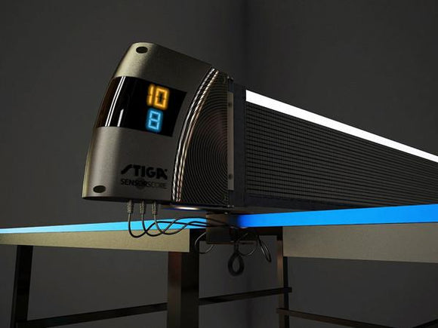

Figure 1. STIGA SensorScore Mounted to a Table

The STIGA SS is unique in that its packaging protects the electronics inside, as well as serving as a mount for the net. Protruding from the bottom of the package are the three sensor inputs that make score tracking possible. Each interface with the main unit through a TS connection. The override controls are connected directly to the unit through a single cable and cannot be separated. The primary unit, it’s mounting bracket and all connected components can be seen in Figure 2.

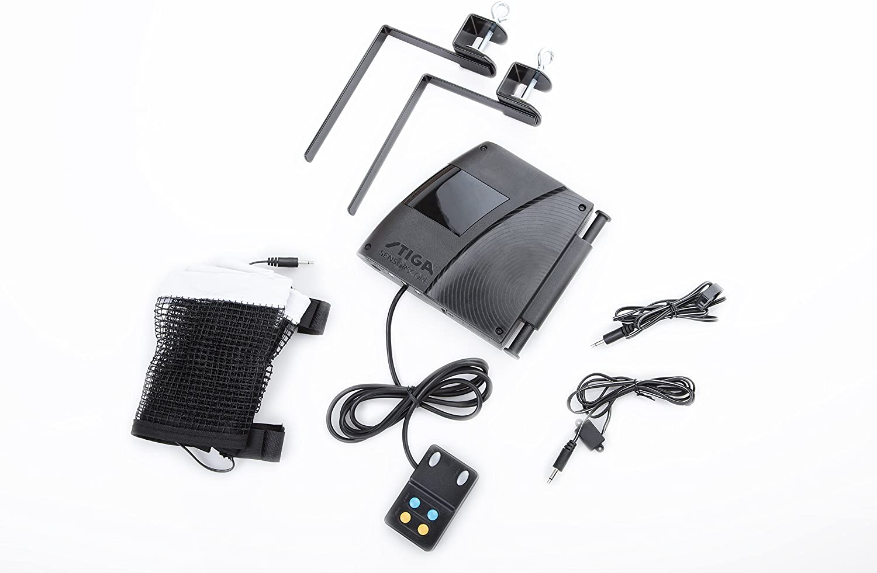

Figure 2. STIGA SensorScore Components

This design has a few key attractive characteristics; first is mounting: the contact microphones and override controls are secured to the table using small nonobtrusive screws which ensures that these devices will not come undone from small vibrations. Additionally, the bracket that holding the main unit to the table, enables a central placement, that does not obstruct gameplay. The second advantage to this design is modularity. Apart from the override unit, all peripherals can be plugged and unplugged using standard connections, making the installation, and adjustment process easier.

Overall, this design is refined, and well thought out. And while the product’s functionality may be lack luster, its packaging and presentation is not.

* 1. ThinkCentre Tiny and Desk Mount Bracket

The second included project does not relate to table tennis at all. However, it’s general purpose is the same as ours. The ThinkCentre Tiny [2] is a workstation in a small form factor, a consumer PC that can accomplish general tasks and connect a variety of peripherals though USB protocol. The addon mounting bracket [4] allows for the device to be secured to the bottom of a table [4, Fig 3]. While the accomplished task of this product is more diverse than our product, it’s form factor and package directly relate to our product. The ThinkCentre and corresponding mounting bracket create a computing device that is mounted underneath a table and connected to external peripherals through an easily accessible IO panel. The design of this computer and it’s mounting will directly inspire our design, as we decide how to appropriately position the microphone and peripheral ports for ease of wire routing and to limit the obstruction of table tennis gameplay.

Figure 3. Lenovo ThinkCentre and Table Mounting Bracket

2.0 Project Packaging Description

Figure 4 shows an isometric view of our PCB enclosure. The PCB enclosure is a simple box, with a few cutouts for interfacing with important devices. The two holes at the bottom of the enclosure serve as a mounting point for our packaging. These two holes will allow us to secure the box either directly to the table, to an L bracket, or to a clamp to allow for easy repositioning and portability. The walls of the container are 5mm thick and can be enlarged if it is found not be sturdy enough. In the four corners of the box there is a long hole that is mirrored on the top of the box. This channel will be used to hold the final product together using a long bolt and a nut at the bottom. The IO is all on one side to make it easier to interact with. Included on the IO panel is a small slot for a Micro-USB port, that will interface with the laptop over serial and provide power to the unit. To the right of this port are the 8 ports for the microphones. Each one slows a TRS on the PCB to be accessible. This standardized connector will allow us to disconnect and reconnect easily when the product needs to be adjusted or moved. Overall, our design is simple but will accomplish the task of holding our device securely to the table.

3.0 Sources Cited

[1] “How much does a 3D printing filament cost?,” Fusion3. [Online]. Available: <https://www.fusion3design.com/how-much-does-3d-printing-filament-cost/#:~:text=PLA%20%26%20ABS%20(Generic%20Formulations),per%20kilogram%20from%20quality%20suppliers>. [Accessed: 24-Sep-2022].

[2] “Lenovo thinkcentre M70Q: Business desktop PC,” Lenovo ThinkCentre M70q | Business Desktop PC | Lenovo US. [Online]. Available: <https://www.lenovo.com/us/en/p/desktops/thinkcentre/m-series-tiny/thinkcentre-m70q/wmd00000405>. [Accessed: 24-Sep-2022].

[3] “Stiga Sensorscore with net and post set,” Ping Pong Champs. [Online]. Available: <https://pingpongchamps.com/products/stiga-sensorscore-with-net-and-post-set>. [Accessed: 23-Sep-2022].

[4] “ThinkCentre tiny under Desk Mount Bracket,” ThinkCentre Tiny Under Desk Mount Bracket | Lenovo US. [Online]. Available: <https://www.lenovo.com/us/en/p/accessories-and-software/tiny-accessories/tiny-brackets/0b47097?cid=us%3Asem%7Cse%7Cgoogle%7CGS_1PO%7C%7C%7C0B47097%7C18333294919%7C%7C%7Cshopping%7Cpmax&amp;gclid=Cj0KCQjw1bqZBhDXARIsANTjCPJXDFbPoUdOV7cVj6WtuVZfgdjaL37r3T3sMvog9d2Wmo2DMrcHzlkaAuJdEALw_wcB>. [Accessed: 24-Sep-2022].

[5] We've covered the 3D printing industry since 2017, “How many meters of filament on a spool? [filament calculator],” 3DSourced, 27-May-2022. [Online]. Available: <https://www.3dsourced.com/rigid-ink/how-many-meters-of-filament-on-a-spool-calculator/#:~:text=PLA%20Density%20is%201.24g,weight%20of%20the%20empty%20spool>. [Accessed: 24-Sep-2022].

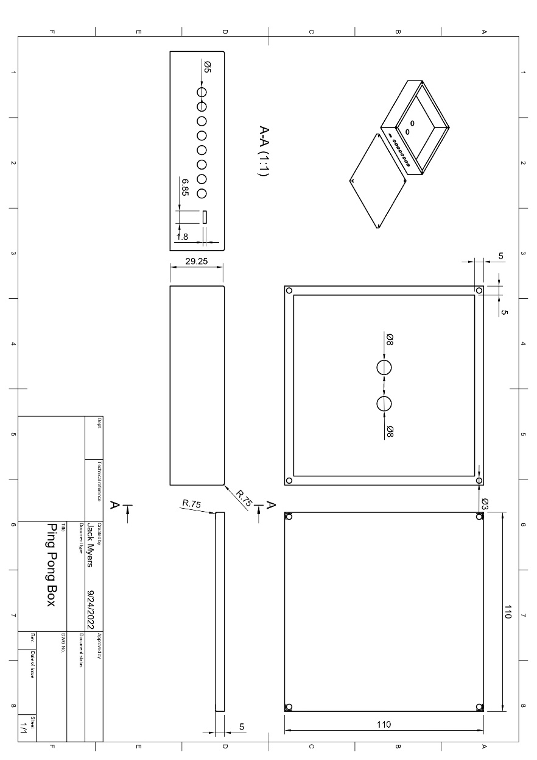*

Figure 4. 3D CAD Model of the Two Parts of Enclosure

Figure 5. Drawing of Enclosure (Units: mm)

Appendix 2: Project Packaging Specifications

The total volume required to 3D this casing with 100% infill is roughly 171.925 cm cubed. With the cost of PLA at 25 dollars per Kg [1] and the density of PLA being 1.24 g/cm cubed, our final cost for a full enclosure is $5.30. Alternatively, our case could be assembled using laser cut acrylic which would require a revision to our design, favoring a finger joint for the corners, and would cut down on production cost and time. The full list of materials and their relative costs are listed in Figure 6. The final estimated weight of our product will be no greater than 500 g.

|  |  |  |  |
| --- | --- | --- | --- |
| Material | Tools Required | Amount | Total Cost |
| PLA Plastic Filament | 3D Printer | 171.925 Cubic Centimeters | 5.30 |
| L-Bracket | N/A | 1 | 2.00 |
| M3-0.5 x 40 mm Screws | Philips Head Screwdriver | 4 | 5.00 |
| M3-.5 Hex Nut | Socket Wrench | 4 | 5.00 |
| Total: | | | 17.30 |

Figure 6. PCB Enclosure Materials

Appendix 3: PCB Footprint Layout

Below is a rough design for our PCB. This design was drafted when we were planning on using two micros and facilitated communication between the two using UART across an ethernet port, as seen in the top right [Fig. 6]. However, our new design, existing of only one MCU, will replace this UART connection point with a micro-USB connection to the laptop, and add the additional ports for the contact microphones that would have been located on the other board. The MCU is placed central in our PCB design, to eliminate long stretching traces. The programming header is placed in the upper left, and a few GPIO pins are made available to the right. Whenever applicable, we have chosen to use 0805 sized surface mount parts as this is what is available through the ECE shop. Finally on our board we have a single programmable button that will serve as most likely a reset button. The redesigned PCB will be larger than our preliminary design, as it will have to incorporate the interfaces for the microphones (most likely simple connectors) all on one side of the PCB. We estimate the final PCB to exist within a 100x100mm area, and include a few extra GPIO access pins, and programmable buttons, to aid with debugging.

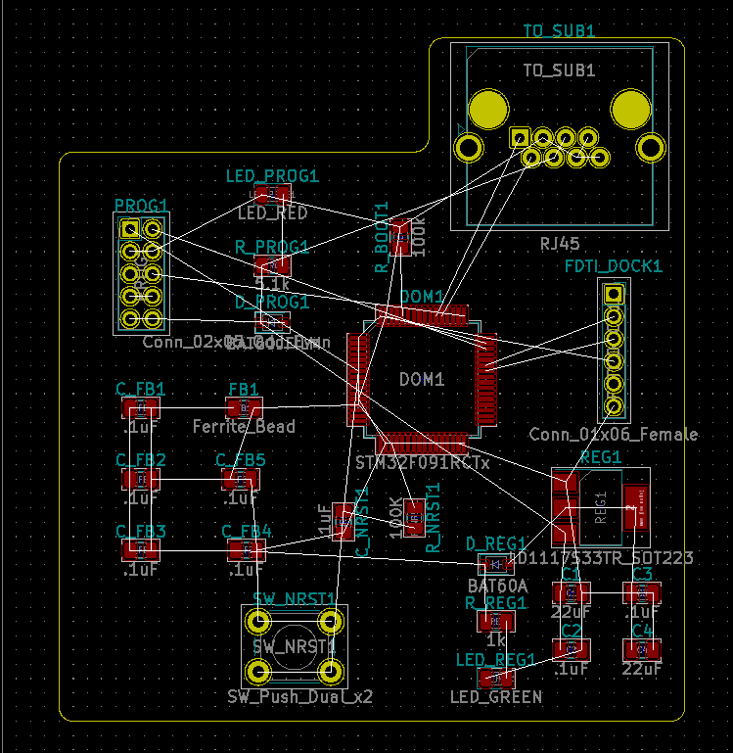

Figure 6. Initial PCB Design