**Bus Buddy 2016 Documentation**

Jacob Ditslear, Sawyer Kieffer, Adam Killeen, Abigail Lutes

**1. Project Summary**

The BusBuddy app design project was initialized during the May semester of 2015 by GDAT from the 2015 Global Engineering Design Ireland Maymester Study Abroad course, partnering with Enable Ireland, a non-profit organization benefiting children and adults with disabilities. The BusBuddy app is a project specified for Christina, the client of Enable Ireland. Christina lives in Dublin, Ireland, and has requested a device that aids her ability to navigate the Dublin bus system independently. Initial steps for design were taken, and are detailed in their 2015 design document. Their progress included much of the preliminary information gathering, brainstorming, and initial design. Their progress was halted at the turn of the semester. It was placed on the backburner, and since has been picked up by our new device design team consisting of Adam Killeen, Jake Ditslear, Abigail Lutes, and Sawyer Kieffer as a part of the 2016 Global Engineering Design Ireland Maymester Study Abroad course.

The 2016 team has not had the chance to meet the direct user, Christina, so all of the 2015 team’s documentation of our community partner, user profile, and statements of need will be placed directly in thisdocument. Let it be known that this was their work, not ours. Their conceptual designs were taken into account and understood. However when this project was handed over we were directly told that an app would be the device of choice for Christina. Therefore, our work has been to improve and build upon the 2015 team’s detailed designs. We have named their detailed design version 1, and have named our detailed design version 2 for now. Upon the release of an actual deliverable prototype, we expect that it will be renamed version 1.0 and any iterations and modifications made to that prototype will be updated versions built upon version 1.0.

Because of our very limited ability in app design in Swift coding language, our expectations for our progress is to create the outline for a fully functional app that addresses all of Christina’s needs. At the conclusion of our developments, we plan to present our design to Christina and troubleshoot any communication issues that arise between Christina and the app. Because a prototype has not been achieved, no real feedback can be obtained on how well or poorly our design will help Christina once our ideas have been put into coding language and produced into a functioning app. Feedback on how Christina can communicate with the app will be the best result of this May semester design course. At our project’s conclusion, we plan on passing our completed design to Purdue’s app design students enrolled in EPICS, who will make our outline into a functional prototype. This prototype, version 1.0, we expect can be improved upon into the future in order to develop a more universal design that can ideally help any user in any city.

*[Sections 2 - 7.2 written by 2015 team]*

**2. Community Partner Profile: Enable Ireland**

Enable Ireland is a non-for-profit organization that serves individuals with physical disabilities free of charge. They assist both children and adults, as well as families. Enable Ireland's staff help individuals as well as their families create age and developmentally appropriate plans for each life stage from early infancy through adulthood. Their services promote independence and provide crucial tools to their beneficiaries. Their mission statement is as follows, "Enable Ireland’s mission is to work in partnership with those who use our services to achieve maximum independence, choice and inclusion in their communities." Enable Ireland initially began as Cerebral Palsy Ireland, in 1948, and has since expanded to include services for a variety of disabilities. Currently, they provide aid in 14 counties across Ireland at 40 locations. The demand for their high quality services are increasing greatly, and it is their goal to meet those need by expanding even further.

Enable Ireland Website:  <http://www.enableireland.ie/>

**3. User Profile: Christina**

The primary benefactor of this project is Christina, a blind woman located in Dublin. Her problems navigating the city prompted this project, therefore the parameters for the design follow her needs. Christina has been blind since birth, and uses a white cane to navigate. Unfortunately, a modern city is full of hazards and when travelling alone, Christina faces many challenges. One primary challenge is the Dublin Bus system, which is ill-equipped to help passengers who are visually impaired. Christina uses this bus system to travel to and from her classes at the National Council for the Blind in Ireland, as well as usual navigation around the city shopping or for other errands. Unfortunately, the Dublin Bus System contains old buses, which often do not read out stops or alert passengers. Since Christina cannot use visual clues to know where she is, it is difficult for her to get off at the right stop or catch the right bus. Taking the wrong bus or getting off in a strange area makes it nearly impossible to navigate independently, and she must call someone to assist her. This can often take long periods of time, and is extremely inconvenient for everyone involved.

Although she is unable to see, Christina uses technology in her day to day life. Through speech to text technology, she uses her iPhone with the same functionality as any other user. The existing technology for the iPhone allows her to navigate the device using audio feedback. The device lists all text and options on the screen, and she uses these audio signals to navigate the technology. This audio is extremely rapid, and to an untrained ear, it would seem incomprehensible, however Christina is able to process this speech and respond. In order to signal to the phone that she wants to select an action, Christina must only tap the screen. This allows her to use the device intuitively and without problems. However, current GPS technology does not work with this system. The maps are difficult to use without sight, and it is hard for her to measure distances and directions.

While this project is primarily designed for Christina, Turas plans to make the design of this project as inclusive and universal as possible. The technology could be used to help other blind individuals in Dublin as well as individuals in other big cities who wish to use the bus systems safely and efficiently. Subsequently, the tool will be designed so that easy adaptation for other cities and individual routes.

**4. Statement of Need**

**4.1 Needs Statement**

There is a need for intuitive and non-intrusive technology that will allow an individual with visual impairments to navigate public transportation safely, independently and without struggle in order to allow them to maneuver the city in their daily lives.

**4.2 Design Specifications**

|  |  |  |  |
| --- | --- | --- | --- |
| Need # | User Need | Spec # | Specification |
| 1 | *Must have auditory response* |  |  |
|  |  | 1.1 | Must be connected to headphones/earphones for the user to get intuitive voice feedback about the surroundings. |
|  |  | 1.2 | Should respond in more user friendly way, than mathematical or literal way. E.g The GPS uses numbers to map a position, but the App should relay that information in a way that any common user can understand. |
| 2 | *Should be discreet* |  |  |
|  |  | 2.1 | Small yet powerful to be accurate even when used in public or data-wise crowded locations. |
| 3 | *Should allow the user to travel independently* |  |  |
|  |  | 3.1 | Must be self-sufficient in gathering and portraying data in an intuitive way. |
| 4 | *Should be location intelligent* |  |  |
|  |  | 4.1 | Should be location aware so that it can provide relevant data to the user as well as other closely connected users (like family members) for them to come for assistance to any part of the city in worst case scenarios. |
|  |  | 4.2 | Should be aware of any updated changes to regular routes that the user uses and guide the user accordingly. |
| 5 | *Must be weather proof* |  |  |
|  |  | 5.1 | Should be usable (ideally) in all diverse weather conditions, with a special consideration for the weather of Ireland. |

**4.3 Stake Holders**

|  |  |
| --- | --- |
| Project: | ***Turas*** |
| # | Stakeholder |
| 1 | *Christina - expert AT blind woman, and the solution is being made for her* |
| 2 | *Family Members, Caretakers, and colleagues of user* |
| 3 | *Enable Ireland* |
| 4 | Purdue University |
| 5 | Smart Technology companies |
| 6 | GPS creation companies |
| 7 | Other companies that create the parts necessary for the cane modification |
| 8 | People who use white canes in general |
| 9 | Public Transportation Systems |

**4.4 Social Implications**

This project, once completed, will have many positive social implications. Not only will this affect Christina greatly as it will provide her a safe and independent way to use the bus systems in Dublin, on a larger scale, this technology could be used to better help the blind/visually impaired community of Dublin by providing them the same resources. In the long term, this technology could be applied to an even larger, global community by designing other system-specific tools for other cities. However, for the purpose of our project we hope to provide a tool that will allow Christina a way to easily use the Dublin bus system and navigate around the city.

This project is crucial because it will provide technology that will significantly affect people's lives by providing safer and more efficient ways for them to travel independently, despite their visual impairment. It will make daily life easier for users, and help them navigate around the city.

**5. Similar Existing Technologies**

Research into existing technology led to the conclusion that not many technologies with similar uses exist. There are a few instances of other groups who are currently undergoing similar projects in various parts of the world, however none of these have succeeded yet. Additionally, while those projects are similar, they do not focus on bus accessibility. In much the same way, while apps do exist that have similarities to the one we plan on producing, they are insufficient for the user needs. The most similar apps are Ubibus and Blindsquare. Ubibus, a Spanish app, connects with the bus system and although the initial concept is not meant as an assistive technology tool, it is accessible for individuals who are visually impaired, however, it only works in Spain and requires that the user speak Spanish. Blindsquare, while meant as an assistive technology device, does not work with the bus system. Instead, it functions like foursquare. The app informs users about their surroundings, helping them find shops and restaurants. This mapping technology is extremely useful, and could be an important element of our design, however, the app itself does not solve the need for a bus assistance app.

**6. Conceptual Designs**

**6.1 BrainStorming**

While in the brainstorming phase, the team came up with many ideas, some more useful than others. Ideas we entertained included a device inspired by the Harry Potter spell "Point me" from the Fourth book, which would use a wand like device to detect surroundings. Other more practical ideas included a cane with an independent computer built in. This would eliminate the need for a specific phone, however, ultimately we decided that a cane that could interact with the user could be a future add on. One idea that developed in response to a problem with existing technology was a new set of headphones. The problem is that users who are visually impaired require their ears to sense around them, making it impossible for them to use normal headphones. However, current models of outer ear headphones could be adapted to interact with the technology and help the user while also allowing them to remain aware of the world around them.

While brainstorming, we also came up with a few necessary functions for the device. We determined that it would require vocal recognition and audio feedback in order to function. However, the group also decided that symbol capabilities would allow the user to interact with the app in areas that might be loud or where they can't talk. After a bit of discussion about the pros and cons, the group decided to ultimately choose to follow both paths and make the app fit both preferences. Additionally, the group decided that the program must learn paths and common routes, in order to better serve the user. Currently, the team is exploring manually programming routes into the app, however a smarter, learning program would be preferable.

Another interesting feature that we determined might be necessary is biometric step tracking. This would trace the user's steps and calculate the distance they have traveled and how much further they would have to go. However, this biometric technology is still in its infancy, and many measuring devices are not accurate. For example, using multiple types of devices (such as a phone's built in tracking and a wearable tracker) may produce different results, and cannot calculate to the level of precision needed by someone who is visually impaired. The group plans to explore biometric options in the future, however at the moment they decided to not focus on this feature. Consultation with Purdue's International Center for Biometrics Research may be pursued at a later date.

Safety was also a primary concern during brainstorming. One issue with using a phone is battery life. In order to try to resolve this, the app must not drain the battery. Solutions to this problem are still being discussed. Additionally, an emergency notification function must be integrated with the app, in case the technology does have an issue or something else happens to the user.

**6.2 Potential App Process Flowchart**

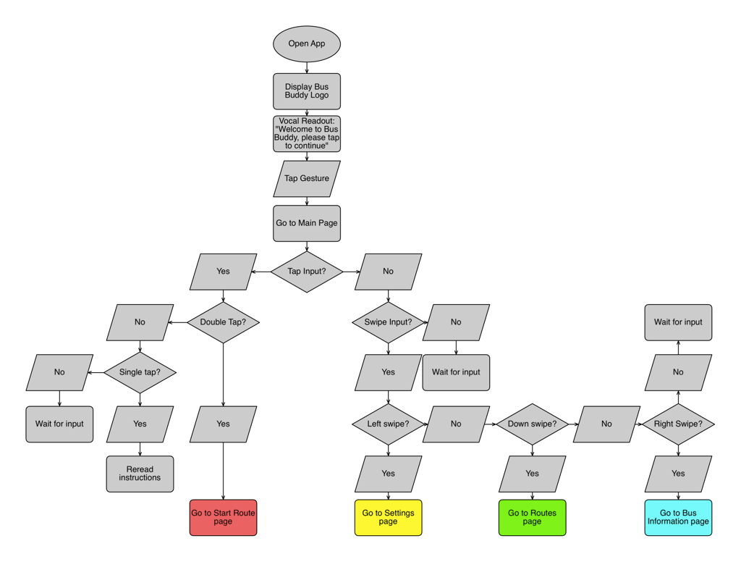

**6.3 Electronic App Designs**

App Pages Initial Draft:

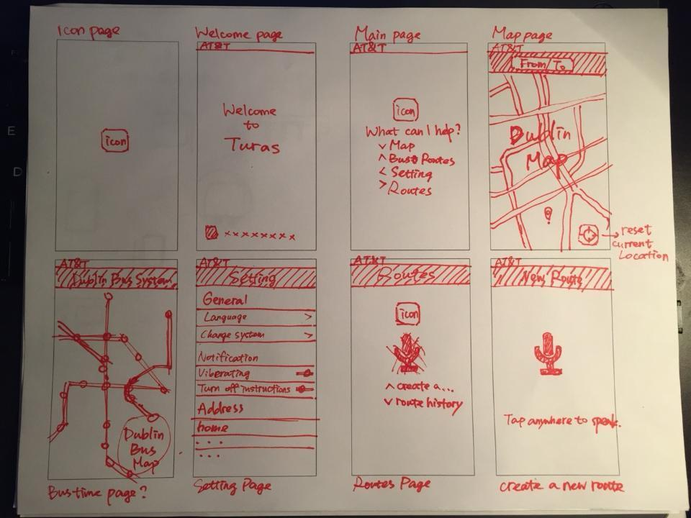

App Icon Ideas:



App Pages Initial Concept Art:

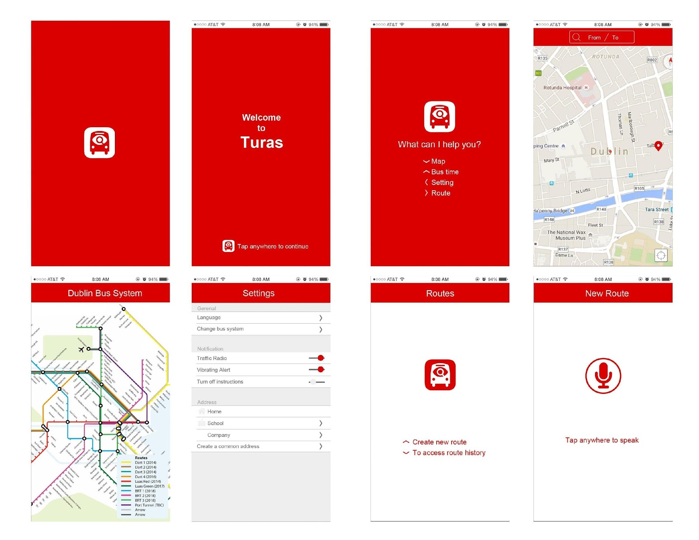

**7. Detailed Design**

**7.1 App Prototyping**

While prototyping this app, our team came across many challenges. Our team chose to program the app in Swift. Unfortunately, since this is a relatively new coding language that is specific to iOS development, we did not have any experience with this language. Additionally, there were fewer available resources for us to use. However, we chose Swift for a few reasons. When programming an iPhone, two languages are options: Object-Oriented C and Swift. While doing research, most sources said that transferring a code from Swift to Object-Oriented C would be easier than changing code from Object-Oriented C to Swift. This, combined with the fact that Swift is the language that will likely be most prominent in iOS development in upcoming years, led us to decide that programming in Swift would give the app longer functionality and relevancy.

As of the end of the 2015 semester, we have the first few main pages made, and some of the connections created. We are currently working on refining these pages, and incorporating open source code in order to allow the user to use multiple types of swipes on the page. Creating an app for someone who is visually impaired posed a particular challenge, because we could not use many of the functionalities built in to Swift. This includes buttons and selection menus. Subsequently, we worked around this issue by outlining a collection of swipes and gestures that will allow the user to travel from one page to the next. Additionally, we plan on incorporating voice control to provide even more accessibility to the user. We decided both were necessary because voice control, while easier to use, is not accessible in loud environments such as buses and city bus stops.

Later improvements we plan to make to the app, ideally by the end of the 2016, is the incorporation of voice control and connection with the Dublin bus system and maps. In order to begin working on functions to create a route, we must do this and have this accessible in the app’s working memory. These will allow us to go further than our current primitive backbone.

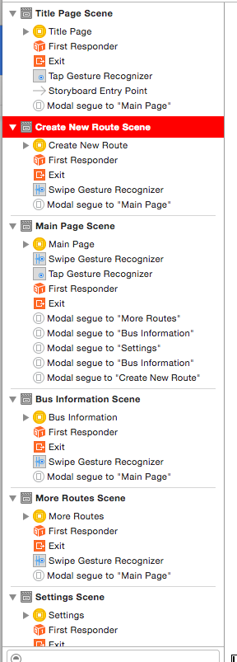

**Version 1:**

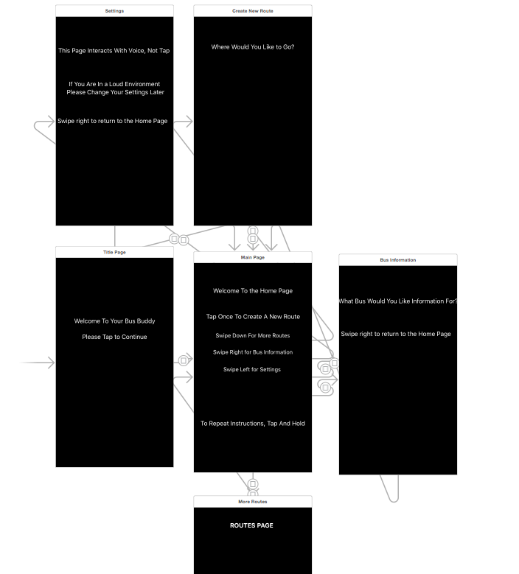

Image X. Initial app design.

*[Sections 7.2 and on written by 2016 team]*

**7.2 Critical Review of 2015 Design**

The previous design team created a layout for an application that would be programmed using Swift, the layout can be seen in image X. Constraints on the app include being limited only using voice commands and gestures in Swift and avoiding the use of visual features. With limited numbers of gestures, each page has a limited number of commands that can be input by the user. Additionally, the app needs to use minimal battery consumption.  In order to comply with the constraints, the app was designed with a dark background and minimal visual features to decrease battery consumption by the application.

When opening the application, the user will be prompted with a welcome screen that will say, “Welcome to bus buddy, please tap to continue.” Following a tap input by the user, the application will move into a homepage that will say “Welcome to the home page, tap once to create a new route, swipe down for more routes, swipe right for bus information, swipe left for settings. To repeat instructions, press and hold.”

From the home page, when the user taps once the app will move to the “Create new route” page. The page will prompt the user, “Where would you like to go?” using voice commands the user will input their destination.

From the home page, when a right swipe is input the app will move into the bus information page. On the bus information page, the app will read “What bus would you like information for? Swipe right to return to the home page.” Using voice commands, the user will input which bus he or she would like information for and the app would provide such information over voice.

From the home page, when a left swipe is input the app will move into the settings page. On this page, the user will change settings using voice commands. From the home page, when a down swipe is input the app will move into the “More routes page”. On this page, the user will view several routes to the destination.

Reviewing the design the user interface does not seem complete or intuitive, meaning the needs of the user will not be met through the features incorporated and the combination of gestures and voice commands does not feel natural.  The application relies very heavily on voice commands, our team found this to be an issue due to the user living in a busy city where noise could be an issue. To improve upon these issues in the next version, the team plans on creating a user interface with the user in mind with features and a layout that will allow the user to easily navigate and get to his or her destination. The team plans on relying less on voice commands by creating an application that can operate almost wholly on gesture and voice commands only when necessary.

**8 App Redesign 2016**

**8.1 App Brainstorming**

We worked as a group to decide what all we could feasibly include in the first version of our app. There were many discussions on things we wanted the app to capture and we put all of our ideas down originally. This made the scope of the app very large and the navigation within the app very complex. Therefore, we decided to cut out things that made it too complex or unfeasible.  If we were to include all of our ideas it would take way too long to get a tangible end product to our direct user.

As a group we decided to get rid of a favorite routes page because we have a favorite destinations page already. The saved destination will just give you the fastest route. This made having a favorite routes option repetitive and therefore unnecessary, plus we decided it would be too complex to code and for Christina to navigate through.

We decided to give one option for the fastest route. We had originally thought to give 3 options like Apple Maps provides, and we do still think this is a viable option for a future version of the app. However, for the sake of this initial app we have decided to provide only the fastest route as the option because this is the route she will most likely take anyways. It will save her time from having to listen to the other options, and it will make the programming less complex.

As a team, we decided to give the user the option to select his/her intended direction from the saved favorite destinations by using voice controls. Originally we had tried to keep most of the app used by only swiping the screen in order to limit voice inputs in case the user was in a loud or busy area. To save the user time, we decided to give the option to speak the destination they are searching for but also keep the option to hear all the favorite favorite destinations and tap the one they are looking for.

One problem that Christina communicated is that she can easily get lost and will require assistance if she boards the wrong bus or gets turned around. To address this, we plan to incorporate a feature in which the user can pinch the screen at any time in the app, and the user’s current location is read, as well as bus route and next stop if on a bus.

App directions were drafted that will give any user a sound basic understanding of how to use the app, with or without vision. We decided that these app directions should be easy accessible from the main page of the app and should be presented as an audio tutorial. Additionally, we decided that a good feature would be to allow the user to toggle between full instructions and simplified instructions on each page of the app, something that can be controlled in settings. We want our app to be full explicative and unambiguous throughout its use, so it has been designed to read a full set of directions on each page of the app. However, we recognized that this would be repetitive and a hinderance for a frequent user of BusBuddy. By toggling to turn off the directions on each page, directions like “Swipe down to go back” or “Double tap to repeat” can be eliminated, just to preserve the sanity of the user. If the directions need to be read, then double tapping the screen can always activate them to be read so that the user doesn’t get lost in the app in case he/she forgets what to do. Our team expects that these features will ensure that the user will know exactly how to use the app without any instruction, enhancing the user’s independence.

The biggest piece of progress made during the 2 week study abroad program was creating a functional flowchart that accurately demonstrates how the app’s user can navigate through the app. The flowchart indicated many flaws in our initial design and made it easy for iterative redesign. Additionally, the flowcharting makes our app presentable to Enable Ireland and Christina. The flowcharts should provide a sound starting point for the app coding.

**8.2 App Flowchart**

**8.2.1 Navigation flowchart**

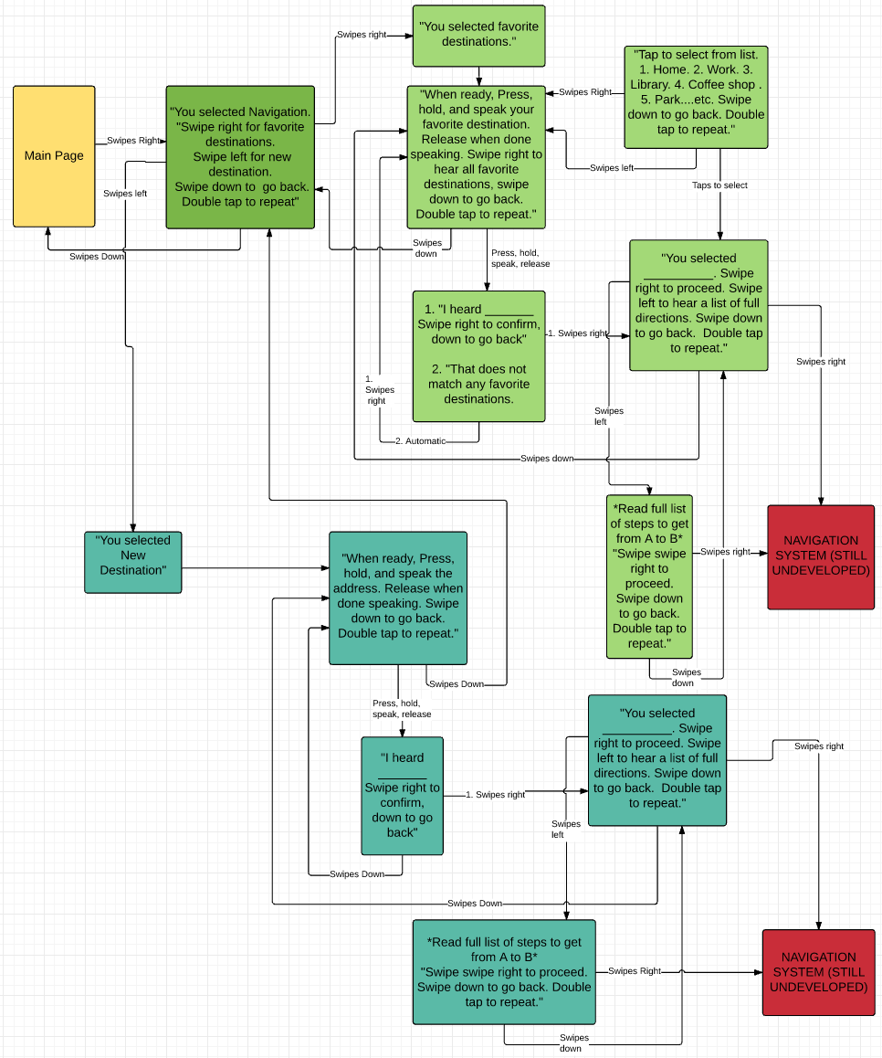

**8.2.2 Settings Flowchart**

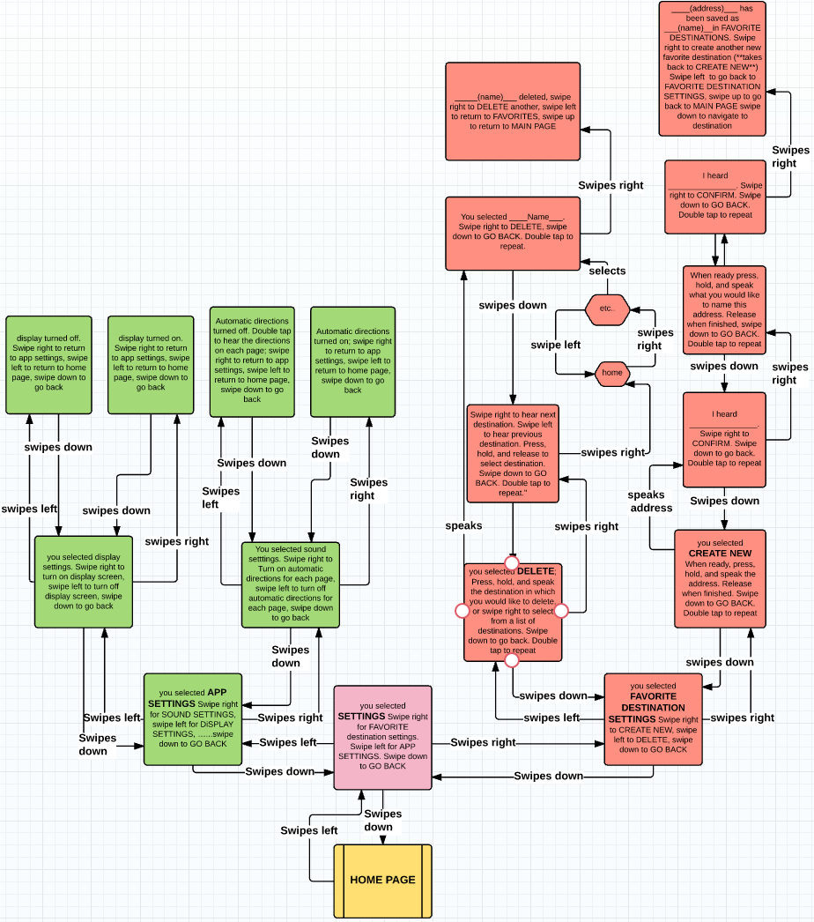

**8.2.3 App Instructions Flowchart**

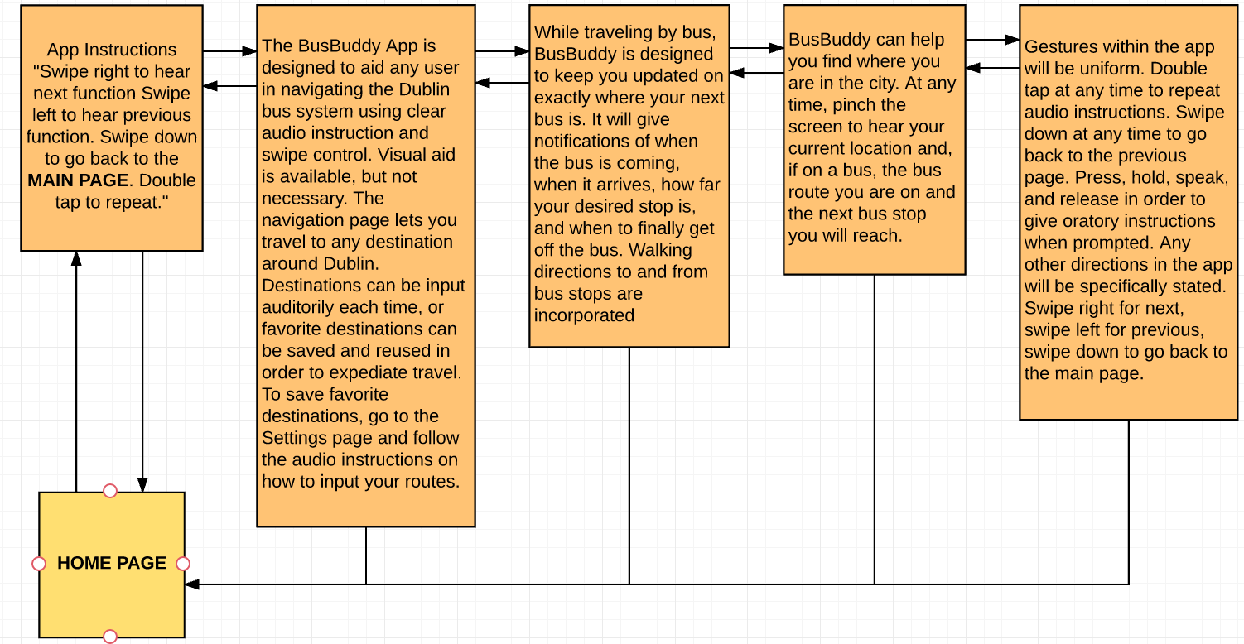

**8.3 Future App Plans**

There are several things that we want to incorporate into the Bus Buddy App that we feel are too complex for our first version. Our primary goal is to get an initial product out to our user that is functional for her needs. However, there are many things that would make the app easier to navigate or extra features that would be helpful to have in the long run. These include:

* Option to “pinch” any screen and bring up a search option.
  + A search feature that will search within the app things like “work” so that the user can very quickly find a saved destination and start the navigation
* Language setting option to possibly open the app up to be used in multiple languages
* Ability to turn on/off visual or auditory aids. This will make the app more universal so both people with and without visual impairments can use the app.
  + Idea along with this: Only read instructions when double tap is used. Otherwise, only read what page is on (idea for more advanced users who want to skip past unnecessary auditory instructions)
* Give three route options instead of one. This would give backup options in case of things like traffic.
* Connect with Dublin Bus Drivers. Possibly alert a driver when someone using the app is boarding their bus.
* Expand the app’s use beyond the Dublin Bus system so it can be utilized anywhere in the world.

**8.4 Enable Ireland Feedback**

Meeting with Christina on the final day of the GDDI trip in Ireland was very successful in providing feedback on the direction that this app must take. During the meeting, we tested the layout of our app by reading each page’s directions to Christina and allowing her to control the app as she would independent of any directions from us. The results were successful in that the directions were clear and easy for her to follow. This method also gave rise to more helpful feedback. Too much direction is not beneficial, as it takes time and can be bothersome if it must be read off every time. Consolidating long instructions to be more quickly read and understood would increase user friendliness, as well as having the option to turn off some audio features altogether.

The most fruitful piece of information we gained was the absolute necessity to incorporate Apple VoiceOver into the design of our app. We learned that iOS is the frontrunner in accessible phone capabilities for the blind, and VoiceOver is the primary mode with which the blind will utilize their phones. Therefore, instead of designing the app for a user to be able to use with unadjusted touching capabilities, like the swiping that we were using, we must take into consideration how the app design will function with VoiceOver as the mode of navigation through the app. The suggestion that Christina made was to convert all swiping directions into clearly labeled buttons, as VoiceOver will read out what each button says. To continue the product design of this app, it will be essential for the next design team to learn and understand VoiceOver, as we did not and this caused issues for us. For example, from the beginning of our design we assumed that “double-tap” would allow the user to repeat instructions. However with VoiceOver, double-tapping is the selection of a button, and repetition of instruction can be as easy as hitting a button again to have it read out.

Most of the volume of feedback we received was further instruction on how the app would help get Christina from one place to another once her route is set. Currently, Christina uses an app called Walk Dublin which seems to be a fantastic way to convey location to the user by using landmarks like nearby roads. Having thorough walking instructions, such as *how much* she has to turn and *how far* she has to walk in very understandable terms was important to her, For example, the app may read out “turn 90 degrees to your left in 30 meters,” then, after the user had walked 30 meters, it may read out “turn 90 degrees left now.” If the user did not turn the full 90 degrees, the app may read out “continue turning 20 degrees”, for example, to ensure the user does not get off track. Additionally, very thorough instructions on which bus to get on and what stop to get off at are essential. Our idea was to have the app give notifications 2 stops in advance, 1 stop in advance, and obviously at her stop. When boarding a bus, give estimated time of arrival, and notifications 1 minute before arrival and at arrival. Christina says it is very common to contact the bus system and notify them that a blind passenger will be boarding, and that info is then relayed to the bus driver. If this process could be simplified in any way, it would make travel much easier for both the bus driver and the traveller. Christina hoped for direct communication with the bus.

Currently, Christina uses features that allow her to search by stop number or bus number, or to locate stops near her. These should be incorporated into the app design.

A keyboard should supplement any voice-controlled functions in case the app misreads the voice control. This was another one of Christina’s suggestions.

**8.5 Future Timeline**

Over the summer following the maymester, the feedback received from Enable Ireland will reviewed. Over the course of the fall semester a prototype should be developed using the designs of the maymester and feedback received from Christina in mind. Collaboration with both Dublin Bus and i3Digital will ensure understanding of the information available to the app in terms of the bus system and give the team guidance as they develop an app. At the end of the fall semester, progress and design changes should be presented to Christina to obtain feedback. The feedback will then be reviewed and incorporated into the design. A functioning application should be presented to Christina and Enable Ireland in May 2017.

**8.6 Helpful Contact Information**

Christina provided the best methods to get in contact with her over the next two semesters, something that should be emphasized moving forward as this project nears its first working prototype. Additionally, contact info for Dublin Bus and i3Digital (creator of Dublin Bus app) is included. Dublin Bus was contacted but we could not make time to meet. i3Digitial did not respond to our initial attempt to open communication. Moving forward, think of developing a line of contact with Walk Dublin as well.

**Christina’s contact info:**

Email: mccarc15@tcd.ie

Skype: christinamccarthy21

**Dublin Bus:**

Customer Service Line: (01) 8734222

Email: [dbonline@dublinbus.ie](mailto:dbonline@dublinbus.ie)

<http://www.dublinbus.ie/Contact-Us1/>

**i3Digital:**

Telephone: +353 (0)1 839 6580

Email: dublin@i3digital.com

<http://www.i3digital.com/Contact>