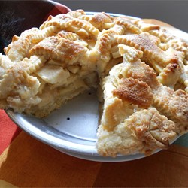

You decide to donate four pies to the fall bazaar.

1)How much of each filling ingredient do you need to buy?

Butter ______

Flour_______

White Sugar ______

Brown Sugar ______

Apples _______

2) You have a small oven and can only bake two pies at a time. How long, in total, is your oven turned on?

_________________________________________________

3)After you get all of your apples ready, you realize you are short one cup of sugar. Who are you most likely to borrow a cup of sugar from?___________

Apple Pie by Grandma Ople

Ingredients

* 1 recipe pastry for a 9 inch double crust pie
* 1/2 cup unsalted butter
* 3 tablespoons all-purpose flour
* 1/4 cup water
* 1/2 cup white sugar
* 1/2 cup packed brown sugar
* 8 Granny Smith apples - peeled, cored and sliced

Directions

1. Preheat oven to 425 degrees F. Melt the butter in a saucepan. Stir in flour to form a paste. Add water, white sugar and brown sugar, and bring to a boil. Reduce temperature and let simmer.
2. Place the bottom crust in your pan. Fill with apples, mounded slightly. Cover with a lattice work crust. Gently pour the sugar and butter liquid over the crust. Pour slowly so that it does not run off.
3. Bake 15 minutes in the preheated oven. Reduce the temperature to 350 degrees F (175 degrees C). Continue baking for 35 to 45 minutes, until apples are soft.