**FUNCTION GENERATION TOOL GUIDELINE R1.3**

|  |  |  |  |
| --- | --- | --- | --- |
| **Releases** | **Date** | **Author** | **Description** |
| **Function_tool_R1.1** | **23/10/2020** | **Ha Tien Tai (RBVH-EDA23)** | * **First release** |
| **Function_tool_R1.2** | **03/11/2020** | **Ha Tien Tai (RBVH-EDA23)** | * **Synchronize precondition signal list with db_keyoword** * **Added high-low level for function disabled** * **Add none security option in extended session** * **Enable private can signal for TJA function** |
| **Funtion_tool_R1.3** | **02/12/2020** | **Ha Tien Tai(RBVH-EDA23)** | * **Change the testcase title inside xml file to correct form** * **Automatically detect and import DBC file from coresi folder** * **Add search keyword for all the signal textbox** * **Optimizing configured procedure(remove done button for individual tab)** * **Fixing bug from users feedback** |

* **Note: This guideline only mentions about update feature. To get the overall step of how to use the tool, please refer to the first gen guideline**
* **Change the testcase title inside xml file to correct form**

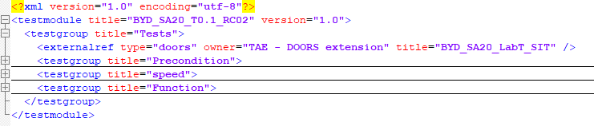

* **Automatically detect and import DBC file from coresi folder**

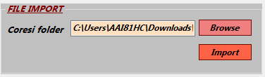

* The import file has been reduced to only one directory. This time you only need to put in the coresi folder.
* The rest will be handled by the tool, you don’t even need to fill in the node for private-public can in dbkeyword before you import DBC like previous version
* **Add search keyword for all the signal textbox**

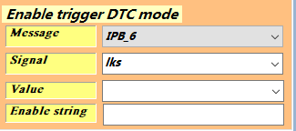

* Example for DTC tab, you want to select the signal LKS_Enable. All you need to do is fill up a part of the signal keyword and hit enter, the tool will find the signal that best fit for your case

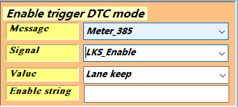

* However, if the display signal isn’t the correct one, you have to specify more about the keyword because there’s may be some identical signals for your keyword
* This feature also applies for all function tab
* **Optimizing configured procedure(remove done button for individual tab)**

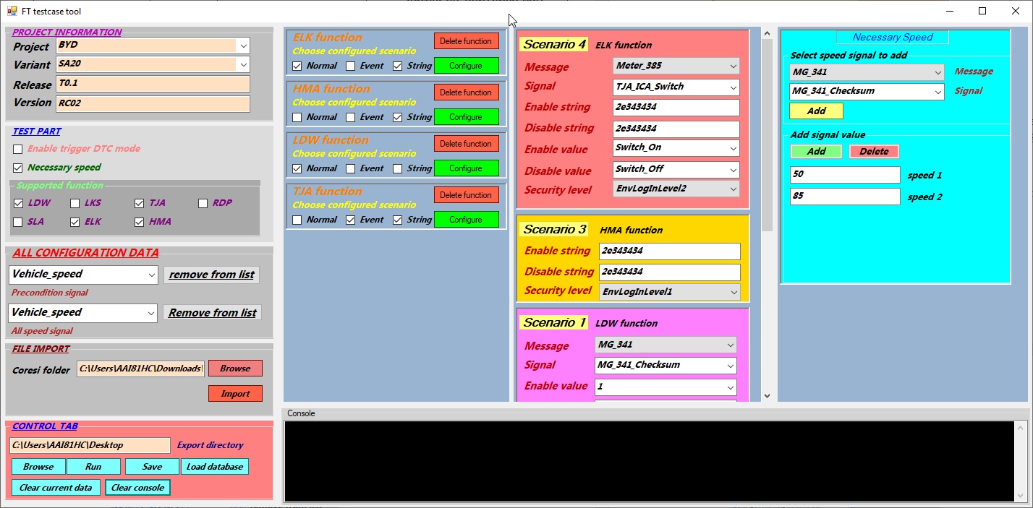

* This time you don’t have to press done and close the tab whenever you need to save your data, all the saving process has been moved to the Save button in the control tab
* Only the visible tab can be saved when press save button
* **Fixing bug from users feedback**
* Keep enable-disable string when switching signal in function tab
* Inform more specify error in console
* Fix Release textbox empty when remove signal
* Fix error indication in function tab
* Fix duplicated signal data when configure function tab
* Update xml file export (return to Default session after enable-disable string)