**TEAMDUTY Web-application**

Project Proposal

**By**

Mr. Manuchet Manoi 542115049

Mr. Saknarong Noipaksa 542115061

Department of Software Engineering

College of Arts, Media and Technology

Chiang Mai University

**Project Advisor**

______________________________________

**Aj. Jayakrit Hirisajja**

**Document History**

|  |  |  |  |  |  |  |  |
| --- | --- | --- | --- | --- | --- | --- | --- |
| **Document Name** | **Version** | **Status** | **Date** | **Viewable** | **Reviewer** | | **Responsible** |
| **Documents** | | | | | | | |
| TEAMDUTY-Proposal-V.0.1.docx | **- Add Chapter 2**  - Technology Review  - Development Tool Review  **- Add Chapter 4**  - Motivation  - Aims and Objective  - Deliverables and Limits  **-Add Chapter 5**  - | Draft | 4 March 2014 | MM,  SN,JH | | MM,  SN | MM,  SN |
| TEAMDUTY-Proposal-V.0.2.docx | **- Add Chapter 1**  - Introduction & Background  **- Add Chapter 2**  - Business Review  - Business Tools and Software Review  - Technology Review  - Development Tool Review  **- Add Chapter 3**  - ISO29110  **- Add Chapter 4**  - Motivation  - Aim and Objective  - Deliverables and Limits  - Schedule & Milestone  **- Add Chapter 5**  - References | Draft | 6 March 2014 | MM,  SN,JH | MM,  SN | | MM,  SN |
| TEAMDUTY-Proposal-V.0.3.docx | **- Adjust Chapter 1**  -Approve grammar writing Introduction & Background  **- Adjust Chapter 2**  - Change some sentence within Business Review  **- Adjust Chapter 4**  - Remove Objective  - Add more Deliverables and Limits | Draft | 19  March 2014 | MM,  SN,JH | MM,  SN | | MM,  SN |
| TEAMDUTY-Proposal-V.0.4.docx | **- Adjust Chapter 2**  - Add reference number in Technology Review And Development Tool Review  **- Adjust Chapter 3**  - Add reference in ISO29110  **- Adjust Chapter 4**  - Add Objective  - Change feature and show feature in type table  - Change 1 Proposal Milestone  **- Adjust Chapter 5**  -Renumber of reference | Draft | 20  March 2014 | MM,  SN,JH | MM,  SN | | MM,  SN |
| TEAMDUTY-Proposal-V.0.5.docx | **- Adjust Chapter 1**  -Approve grammar writing Introduction & Background  **- Adjust Chapter 2**  - Change some sentence within Business Review | Draft | 23  March 2014 | MM,  SN,JH | MM,  SN | | MM,  SN |
| TEAMDUTY-Proposal-V.0.6.docx | **- Adjust Chapter 3**  -Add Software Development Model  **- Adjust Chapter 4**  - Approve feature table and move feature table form 4.5 Schedule & Milestones to 4.4 Deliverables and Limits | Draft | 25  March 2014 | MM,  SN,JH | MM,  SN | | MM,  SN |

**\*MM = Manuchet Manoi**

**\*SN = Saknarong Noipaksa**

**\*JH = Jayakrit Hirisajja**

**Table of Contents**

**Chapter One | Introduction and Background** 5

**Chapter Two | Literature Review** 6

2.1 Business Review 6

2.2 Business Tools and Software Review 7

2.3 Technology Review 10

2.4Development Tool Review 15

**Chapter Three | Quality Standard** 19

3.1 ISO 29110 19

**Chapter Four | Project Plan** 22

4.1 Motivation 22

4.2 Aims and Objectives 22

4.3 System Architecture 23

4.4 Deliverables and Limits 25

4.5 Schedule & Milestones 28

**Chapter Five | References** 34

.

# **Chapter One | Introduction and Background**

Currently software has a great impact on human life in more modern times. Software industry plays an important role in the social and economic development of modern society, both domestically and internationally. The process of producing software requires a multi-step process and many theories and ideas have been proposed to improve the production process, which also contributes to enhancing the quality of software.

At each stage of software production, there must be a professional personnel who are knowledgeable and experienced in each field. In order to achieve the software quality as expected, finding people with sufficient capability and experience is crucial to the success of any project. In reality, however, it is not an easy task and lots of resources are wasted as a result of mismatch between skill sets required and skill sets available. To help people that have capabilities and skills in software production find a project or task that matches with own capabilities. , it is essential that the details of work should be explained thoroughly so that the demands of workforce requirements are clearly communicated between the employer and potential employees.

To help entrepreneurs solve the problem related to human resource, software freelancers have the responsibility of finishing each project as planned because they are likely to work on more than one projects at a given time. The problem is “how to know whether software-freelancers have skills that match with software-tasks or software-projects or not?” Currently, the question is left to the entrepreneurs who should consider software freelancer skills based on their profile or communication with them.

# **Chapter Two | Literature Review**

### 2.1 Business Review

**Overview**

A freelancer[1] is someone who performs tasks, usually for multiple employers over the course of a year. A freelancer is somewhat like a free agent in professional sports - he or she essentially sell their services to the highest bidder - except that they usually work for more than one employer.

Freelancers may work part-time or full-time. Because they are not considered employers, freelancers are allowed to work for other employers and are usually permitted to perform tasks in their own way, so long as the work gets done to the client's specifications.  
  
 A software freelancer is a person who has specify skill about producing and developing the software for example producing application on mobile/on internet/on personal computer, producing software regarding to business and etc.

Nowadays software freelancer is a big role. Because software come with a role to facilitate in everyday life. So, development software is one way to improve economy.  
Anyway, software freelance are required to develop those software by their skill.

In Software industry has increment number employment the freelancer. Because of many reasons. Employer can select the freelancer to work a project. And selected freelancer that has capability match with software work .that reason that make a project driven faster and make it have more independence to work for freelancer. Work will be acceptable to both employer and freelancer.

It is better if there is some software can help both employer and freelancer manage the problem about employment.

**Target**

**-**Find alternative of software task or software freelancer via web application.

**Benefit**

-user can get software task that match with their capability.

-user can get software freelancer that match with software project.

2.2 Business Tools and Software Review **2.2.1 www. Freelancer.com** [2]

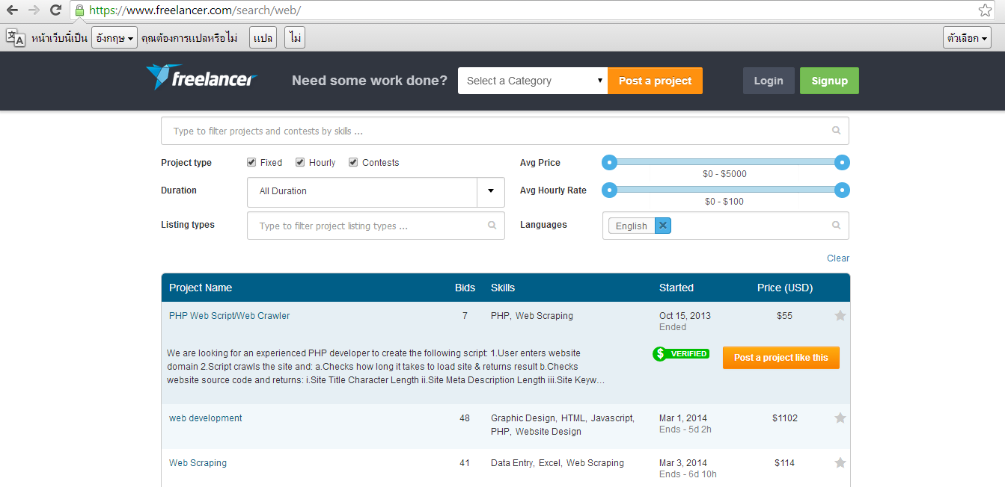

**Figure 2.2.1 www. Freelancer.com**

Freelancer.com is the world's largest freelancing, outsourcing, and crowdsourcing marketplace for small business. With over 10 million users, you can hire a freelancer to do your contract work at a fraction of the cost. Whether you need PHP developers, web designers, or content writers, you can outsource jobs within minutes. Browse through hundreds of skills including copywriting, data entry, and graphic design or more technical areas like coding HTML, programming MySQL, and designing CSS. Are you an entrepreneur just starting a company? Find a quality graphic designer to create a logo to your specifications. Once you get new customers rolling in, you can even hire customer support or a virtual personal assistant to simplify your life without the risky overhead and cost of hiring full-time staff. From beginning to end, Freelancer.com makes it easy to hire freelancers and find freelance jobs online.

**Pros**  
 - freelance.com deals with all the documents meaning you save time  
 - The certificate provides a guarantee for the employer that you are complying with the current laws  
 - largest online marketplace for freelance workers.

**Cons**

* Posting a job need some money depends on manner of task.
* To find project, only searching are allowed.

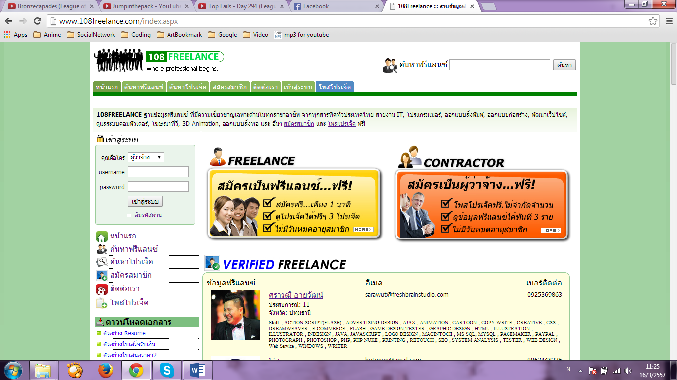**2.2.2.** [**www.108freelance.com**](http://www.108freelance.com)[3]

**Figure 2.2.2 http://www.108freelance.com/**

Online Service system that collects data throughout Thailand Freelance together. That easy to find of useful information and Providing for the Employers In a details of the project. To be easy for Freelancer who interest project to contact you directly [15].

**Pros**  
 - update news about freelancer everyday

- have example document of resume and contract form

**Cons**

- 108freelance.com support only Thai language

- Very complicate register before using.

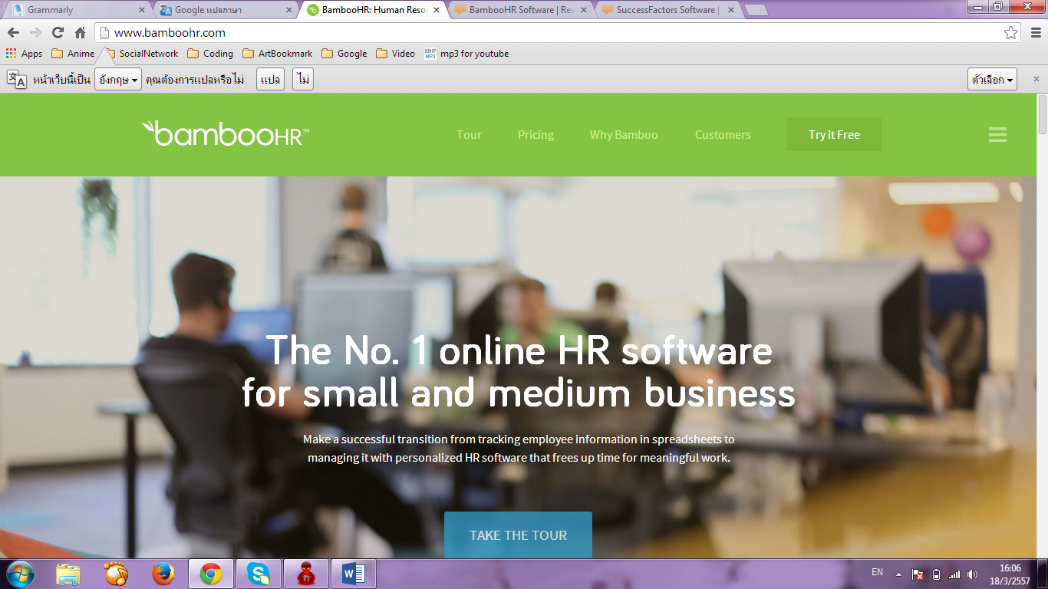**2.2.3 http://www.bamboohr.com** [4]

**Figure 2.2.3 http://www.bamboohr.com**

BambooHR is an online HR software service for small and medium-sized businesses. As the price/performance leader, BambooHR makes it easy and affordable for small and growing companies to transition from spreadsheets to a Human Resource Information System (HRIS) that adapts to their changing needs.

**Pros**  
 -BambooHR have compare system between software personnel

-high Human resource system management for support enterprise

**Cons**

-didn’t have function to support freelancer

-low independence define resume for freelancer

2.3 Technology Review **2.3.1 HTML5[5]**

**Figure 2.3.1 HTML5 logo**

**Development Tool Description** HTML is a language for describing web pages. HTML5 is the latest standard for HTML. It is a markup language to create a webpage and present contents that can be displayed in a web browser.  
  
 **Alternative tool.**  
 - HTML4. **The selection of this tools.** - To read HTML documents and display them as web pages.

- Support every browser

- Modern Hyperpertext and support CSS3

#### **2.3.2** **Cascading Style Sheets 3 (CSS3) [6]**



**Figure 2.3.2 CSS3 logo**

**Development Tool Description**

 A [style sheet language](http://en.wikipedia.org/wiki/Style_sheet_language) used for describing the [look and formatting](http://en.wikipedia.org/wiki/Presentation_semantics) of a document written in a [markup language](http://en.wikipedia.org/wiki/Markup_language). While most often used to style [web pages](http://en.wikipedia.org/wiki/Web_page) and [interfaces](http://en.wikipedia.org/wiki/Interface_(computing)) written in [HTML](http://en.wikipedia.org/wiki/HTML) and [XHTML](http://en.wikipedia.org/wiki/XHTML), the language can be applied to any kind of [XML](http://en.wikipedia.org/wiki/XML) document, including [plain XML](http://en.wikipedia.org/wiki/Plain_Old_XML), [SVG](http://en.wikipedia.org/wiki/Scalable_Vector_Graphics) and [XUL](http://en.wikipedia.org/wiki/XUL). CSS is a cornerstone specification of [the web](http://en.wikipedia.org/wiki/The_web) and almost all web pages use CSS style sheets to describe their presentation.

**The selection of this tools.  
 -**To handle displaying html on web site.

#### **C:\Users\Maxim\Desktop\pic for pp\js.jpg2.3.3 JavaScript[7]**

**Figure 2.3.3 JS logo**

**Development Tool Description**  JavaScript is a scripting language is a lightweight programming language.

JavaScript is programming code that can be inserted into HTML pages.

JavaScript code can be executed by all modern web browsers.

**Alternative tool.**  
 -JSX

**The selection of this tools.  
 -** Allow many page effects.And support effect interact with web browser

**-** Javascript developers to write snippets of Javascript which can execute on desired web pages to extend its functionality.

**2.3.4 Microsoft Internet Information Service (IIS7)** [16]

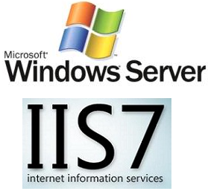

**Figure 2.3.4 IIS7 logo**

**Development Tool Description**   is an extensible [web server](http://en.wikipedia.org/wiki/Web_server) created by [Microsoft](http://en.wikipedia.org/wiki/Microsoft) for use with [Windows NT](http://en.wikipedia.org/wiki/Windows_NT) family. IIS supports [HTTP](http://en.wikipedia.org/wiki/HTTP), [HTTPS](http://en.wikipedia.org/wiki/HTTPS), [FTP](http://en.wikipedia.org/wiki/File_Transfer_Protocol), [FTPS](http://en.wikipedia.org/wiki/FTPS), [SMTP](http://en.wikipedia.org/wiki/Simple_Mail_Transfer_Protocol) and [NNTP](http://en.wikipedia.org/wiki/Network_News_Transfer_Protocol). It has been an integral part of the Windows NT family since [Windows NT 4.0](http://en.wikipedia.org/wiki/Windows_NT_4.0), though it may be absent from some editions (e.g. Windows XP Home edition).

**Alternative tool.**  
 **-**Apache web server

**The selection of this tools.**

**-** It also introduced a hierarchical configuration system allowing for simpler site deploys, a new [Windows Forms](http://en.wikipedia.org/wiki/Windows_Forms)-based management application

**-** Support .NET Framework

**2.3.5 Microsoft SQL Server 2012**[17]

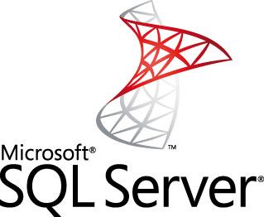

**Figure 2.3.4 Micresoft SQL Server logo**

**Development Tool Description**   is a [relational database management system](http://en.wikipedia.org/wiki/Relational_database_management_system) developed by [Microsoft](http://en.wikipedia.org/wiki/Microsoft). As a database, it is a software product whose primary function is to store and retrieve data as requested by other software applications, be it those on the same computer or those running on another computer across a network (including the Internet).

**Alternative tool.**  
 **-** Microsoft SQL Server 2008

**-** Microsoft SQL Server 2008 R2

- Microsoft Windows Azure

**The selection of this tools.**

- Support Visual studio 2013

**-** Support .NET Framework

**-** can generated form in to .sql.

**-** have guideline to use on publish web application

**-** Can use for free

### 2.4Development Tool Review

**2.4.1 ASP.Net MVC4**[8]

**Figure 2.4.1 ASP.Net MVC4 logo**

**Development Tool Description**  
 ASP.NET MVC 4 is a framework for building scalable, standards-based we applications using well-established design patterns and the power.

**Alternative tool.**  
 -ASP,NET MVC other version (1.2.3.5)**.**

**The selection of this tools.  
 -**Building enterprise web applications.  
 -Using the Model View Control (MVC) features.

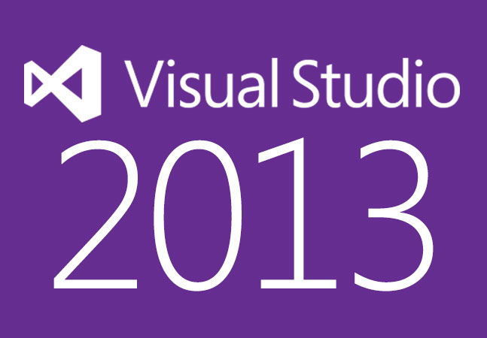**2.4.2 Visual studio 2013**[10]

**Figure 2.4.3 Visual studio 2013 logo**

**Development Tool Description**  
 Visual Studio 2013, a family of products, tools, and technologies that you can use to build powerful, high-performance apps. You can use the resources in this topic to learn how to create Windows Store apps, in addition to desktop, web, phone, and game-console apps, in this release of Visual Studio .

**Alternative tool.**  
 **-**Visual Studio .NET.

**-**Visual Studio2012.

**The selection of this tools.  
 -**Provide c# and asp.net inside.

**-**latest version with enhanced featuresthan Visual Studio2012.

**2.4.3 Google Chrome** [11]



**Figure 2.4.5 Google Chrome logo**

**Development Tool Description**Google Chrome is a free-ware web browser which developed by Google, Inc. Google Chrome combines a minimal design with sophisticated technology to make the web faster, safer, and easier.

**Alternative Tool**

-Mozilla Firefox.

-IE (Internet Explorer)

**The selection of this tool**

-To run application.

-Supported HTML5.

-Supported CSS3.

-Fast to load web pages.

**2.4.4 GitHub** [12].

**Figure 2.4.6 Github logo**

**Development Tool Description**  
 GitHub is a [web-based hosting service](http://en.wikipedia.org/wiki/Shared_web_hosting_service) for software development projects that use the [Git](http://en.wikipedia.org/wiki/Git_(software)" \o "Git (software)) [revision control](http://en.wikipedia.org/wiki/Revision_control) system. GitHub offers both paid plans for private repositories, and free accounts for [open source](http://en.wikipedia.org/wiki/Open_source) projects.

**Alternative Tool**

**-** SVN tortoise.

**-** Mercurial SCM

**The selection of this tool**

- Participate with another member.

- be able to identity version control.

- shared file.

# **Chapter Three | Quality Standard**

### 3.1 ISO 29110

In order to establish the most standard software. We establish our software based on ISO29110 .What is ISO29110? Standard ISO / IEC 29110 is international software engineering standards, the International Organization for Standardization. It is a standard that focuses on a small software development. Used to raise the quality of the software products and services are recognized internationally that integrated in the development of continuous improvement.

Currently, ISO / IEC 29110 is a new standard for enterprise and has been widely used internationally. ISO/IEC 29110, under the general title *Software engineering — Lifecycle profiles for Very Small Entities (VSEs).* For the purpose of ISO/IEC 29110, a VSE is an entity (enterprise, organization, department or project) having up to 25 people. VSEs also develop and/or maintain software that is used in larger systems. Therefore, recognition of VSEs as suppliers of high quality software is often required [13].

**3.1.1 Project management process**

First, definition of project is temporary in that it has a defined beginning and end in time, and therefore defined scope and resources. The development of software for an improved business process, the construction of a building or bridge, the relief effort after a natural disaster. Therefore Project management is the application of knowledge, skills and techniques to execute projects effectively and efficiently. It’s a strategic competency for organizations, enabling them to tie project results to business goals

The purpose of Project management process for the systematic performance of the analysis, design, construction, integration and test actives for new or modified software products according to the specified requirements.

Selected process

***3.1.1.1 Project planning process***

***3.1.1.2 Project plan execution process***

***3.1.1.3 Project assessment and control process***

***3.1.1.4 Project closer process***

**3.1.2 Software implementation process**

 A systematically structured approach to effectively integrate a [software](http://en.wikipedia.org/wiki/Software) based service or component into the workflow of an organizational structure or an individual end-user. The purpose of the software implementation process is the systematic performance of the analysis, design, construction, integration and test actives for new or modified software products according to the specified requirements.

Selected process

***3.1.2.1 Software implementation process***

***3.1.2.2 Software requirement analysis process***

***3.1.2.3 Software architectural design process***

***3.1.2.4 Software construction process***

***3.1.2.5 Software integration process and test process***

***3.1.2.6 Software delivery process***

#### 

#### **3.1.3 Software Development Model**

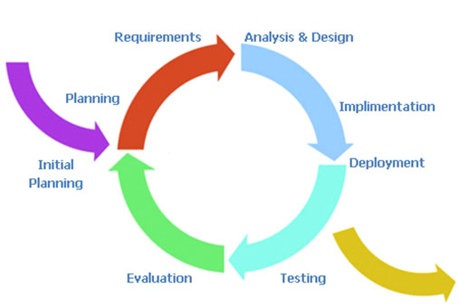

*Figure 3.1.3 the iterative development model.*

**Iterative development model** Iterative development model is a methodology of software development that divides a project into many phrase like the waterfall model. The main idea of iterative development is to create small projects that have a well-defined scope and duration and constantly do builds and updates as soon as possible.

**Advantage of iterative development model.** It supports changing requirements and during life cycle software is produced early which facilitates customer evaluation and feedback. In iterative model less time is spent on documenting and more time is given for designing. We can work following the figure*3.1.3* above until the overall systems will be completed

# **Chapter Four | Project Plan**

### 4.1 Motivation

Nowadays, Job related software side is extremely competitive. Software Freelancer want to find job that match with own capacity don’t have directly web application มีเป็นแสน for software side. But they have to find on a web based applications to find job. Which might make the job does not match with capacity. This web application will target on finding software job side only for find jobs that match with the software produce process in each side. And help Software Freelancer to find out job that match with their capability or software task process in software project. And promote their own software Freelancer skills. In addition this software enterprisers will be find out software Freelancer that match with their software project task process or software job.

### 4.2 Aims and Objectives

#### **4.2.1 Aims**

This project aims to improve software side. So, only activities about software is concerned. The activities in software are System Analyst, Software design, Software development, Software testing, Software management, Software Consult and etc. For example. Aims to developed software job or software task process. For software Freelancer will be able to find out software project task or software job that match or related with their capability. And help them to promote their specialist skill by comment form Completion software work. Or vote from software entrepreneur.In addition aim to develop in term of software entrepreneur for find out software Freelancer to match with project. Therefor if you interest work about software this web application is one choice for you.

#### **4.2.2 Objective**

- To help the software-enterpriser find software-freelancer via web-application  
 - To help the software-freelancer find project and work via web application

- To help the software-freelancer and software- enterpriser communicate via web-application

### 4.3 System Architecture

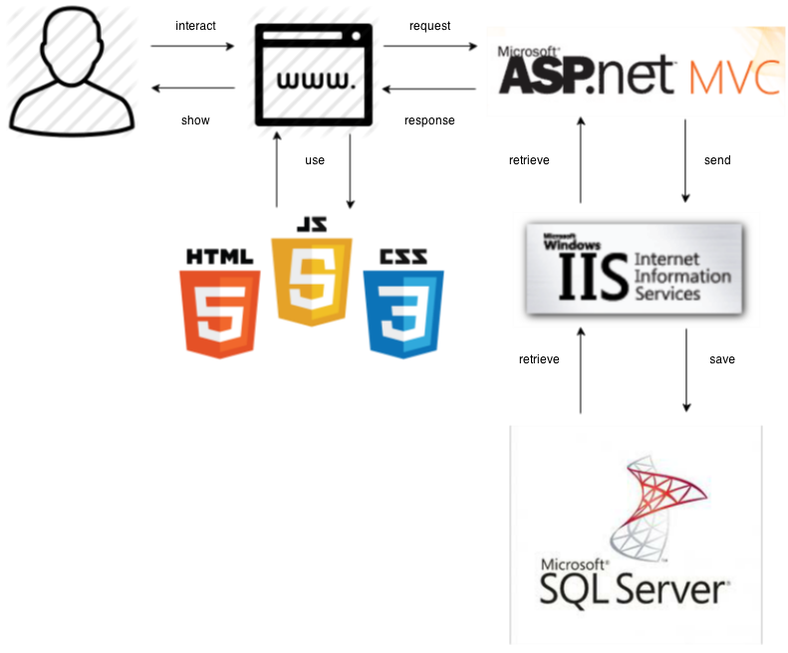

Figure 4.3.1: Overall Web-application application

Figure 4.3.1 shows the overall of TEAM DUTY system. The system consist of Client use internet to connect with the Browser to request to asp.net MVC service and send to the Database(SQL Server) via the webserver (IIS7)

*All users use same architecture*

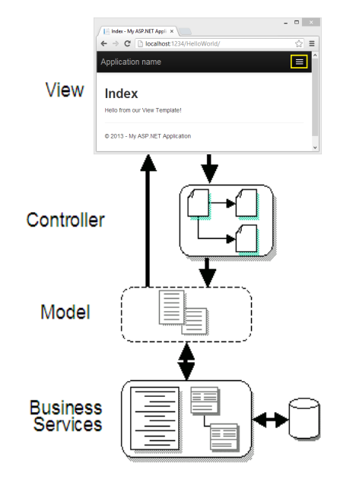

Figure 4.3.2: MVC Web-application Architecture

The Model-View-Controller (MVC) architectural pattern separates an application into three main components: the model, the view, and the controller The ASP.NET MVC framework provides an alternative to the ASP.NET Web Forms pattern for creating MVC-based Web applications. MVC is a standard design pattern that many developers are familiar with. Some types of Web applications will benefit from the MVC framework. Others will continue to use the traditional ASP.NET application pattern that is based on Web Forms and post backs. Other types of Web applications will combine the two approaches; neither approach excludes the other [14].

MVC framework includes the following components:

**Models**. Model objects are the parts of the application that implement the logic for the application s data domain. Often, model objects retrieve and store model state in a database. For example, a Product object might retrieve information from a database, operate on it, and then write updated information back to a Products table in SQL Server.

**Views**. Views are the components that display the application s user interface (UI). Typically, this UI is created from the model data. An example would be an edit view of a Products table that displays text boxes, drop-down lists, and check boxes based on the current state of a Products object.

**Controllers**. Controllers are the components that handle user interaction, work with the model, and ultimately select a view to render that displays UI. In an MVC application, the view only displays information; the controller handles and responds to user input and interaction. For example, the controller handles query-string values, and passes these values to the model, which in turn queries the database by using the values.

### 4.4 Deliverables and Limits

|  |  |  |  |  |  |
| --- | --- | --- | --- | --- | --- |
| **No** | **Feature**  **Name** | **Description** | **User support** | | |
| **service request customer** | **freelance supply** | **Administrator** |
| 1 | **Account management system** | Part of system to Allowed Software-enterprisers and Software-Freelancer to register with e-mail to be member in system. And include Login, Logout and Online status and this system have to be identified type of user within system (i.e. this user is Freelancer, this user is Administrator) | v | v | v |
| 2 | **Profile management**  **system** | Part of system to allows users involve Software-enterprisers, and Software-Freelancer to manage the information. The information of Software-enterprisers consist of detail about him/her selves or company detail. The information of Software-Freelancer consist of detail about him/her selves and include team members if any. Of course, each profile of different users also different form as well | v | v |  |
| 3 | **Software-service request customer management system** | Part of Software-enterprisers to manage everything about their project. Such project title, type of project or view and request software- Freelancer that interested in project within system. This part will have function that only Software-enterprisers can do within it. | v |  |  |
| 4 | **Search system** | Part of system to allow users involve Software-enterprisers, and Software-Freelancer to search information within system by type some keyword which regard to software. In each user can search difference type of word. (i.e. Software-enterprisers search freelancer from skill, name but Software-Freelancer can search project by skill, wage etc.) | v | v |  |
| 5 | **Software- freelance supply management system** | Part of Software-Freelancer to manage about their own history, Employment and resume such **Task status**\*\*, including request to do project with Software-enterprisers, This part will have function that Software-Freelancer can do within it. |  | v |  |
| 6 | **Community system** | Part of system to allows users involve Software-enterprisers and Software-Freelancer to send message to author users within system for communicate or exchange experience of each users. And Notified of the problems that occur in the web application. | v | v |  |
| 7 | **Verification system\*\*\*** | Part of system to allow Software-Freelancer to verify his/her selves for receive the privilege. And made for reduce some problem that will occur within system (i.e. scum member) and each information will be verified by administrator. |  | v | v |
| 8 | **Admistrator**  **Management**  **system** | Part of Administrator to manage system within web application. For response some message you users. And improve web application to be appropriated one. |  |  | v |

#### **4.4.1 Deliverables**

***4.4.1.1 Feature & System Overview***

***Figure 4.4.1.1 Feature &System Overview Table***

**There are three types of User**s:  
 -First is **service request customer =** people with in system who want employment.

-Second is  **freelance supply** = people with in system who want to find project or job to work.

-Third is  **administrator** = people with in system who admin the system.

* **v** = associated with in system

**  **Task status** = status to show that Freelancer ready to get a job or not  
*** **Verification system** is the freelancer have to attach the Thai National ID card’s image (with the fixing side and size (not identify yet)) then admin will verify that the image is Thai people or not, for the foreigner could use passport’s image. About the enterprise don’t need to verify because you can check that the enterprise is fake or not you just can find them from address they input. Verification take time not over 3 days

***4.4.1.2 Software Document***

* Project Proposal
* Project Plan
* Software Requirement Specification
* Software Design Document
* Testing Document
* Test Plan  
  - Unit Test Document  
  - System Test Document
* Test Report  
  - Unit Test Document  
  - System Test Document
* Traceability Record
* Progress Status Report
* Self-Assessment Report

#### **4.4.2 Limits**

* Internet connection is required for using web application.
* Web browser is required for using web application.
* User must be member before using web application.
* User will be using username in form email address to using in web application

### 4.5 Schedule & Milestones

The schedule and milestones of the learning through activities system**.** During period of time, there are work terminologies. And the description is shown below that:

**Feature#1: Account management system**

**Feature#2: Profile management system**

**Feature#3: Software-service request customer management system**

**Feature#4: Search system**

**Feature#5: Software- freelance supply management system**

**Feature#6: Community management system**

**Feature#7: Verification system**

**Feature#8: Administrator management system**

#### **4.5.1 Schedules**

|  |  |  |  |
| --- | --- | --- | --- |
| **Milestone** | **Task** | **Milestone Criteria** | **Planned date** |
| 1 | Proposal | Topic defined | February |
| 2 | Proposal | - Proposal reviewed  - Proposal submitted  - Proposal presentation | March |
| 3 | Progress Report I | - Software requirement specification  - Feature#1 - 2  - Feature designed  - Test planned  - Feature implemented  - Feature tested  - Progress report submitted  - Progress report presentation | Mid May |
| 4 | Progress Report II | - Feature# 3-5  - Feature designed  - Test planned  - Feature implemented  - Feature tested  - Progress report submitted  - Progress report presentation | Mid July |
| 5 | ShowPro | Overall of the system should be higher than 65%. | Beginning of September |

|  |  |  |  |
| --- | --- | --- | --- |
| 6 | Progress Report III | - Feature#6-8  - Integrate and review all documents.  - Integrate and review all documents.  - Tests all features.  - Reviews documents are completed.  - Progress report submitted  - Progress report presentation | End of September |

#### **4.5.2 Milestones**

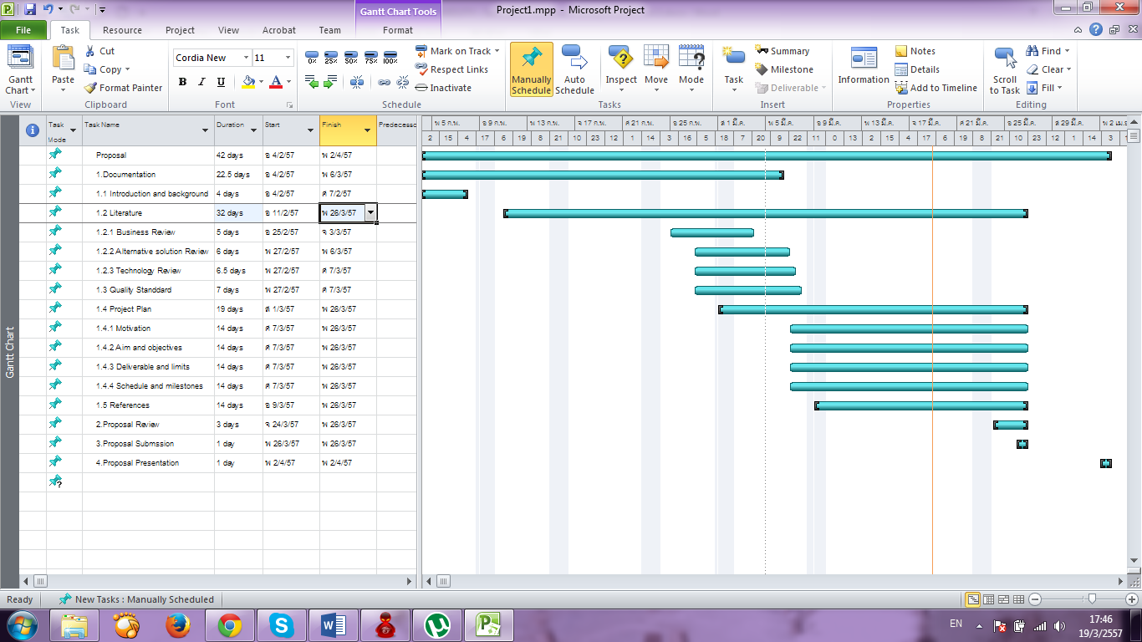***4.5.2.1 Proposal Milestones***

***4.5.2.2 Progress 1 Milestones***

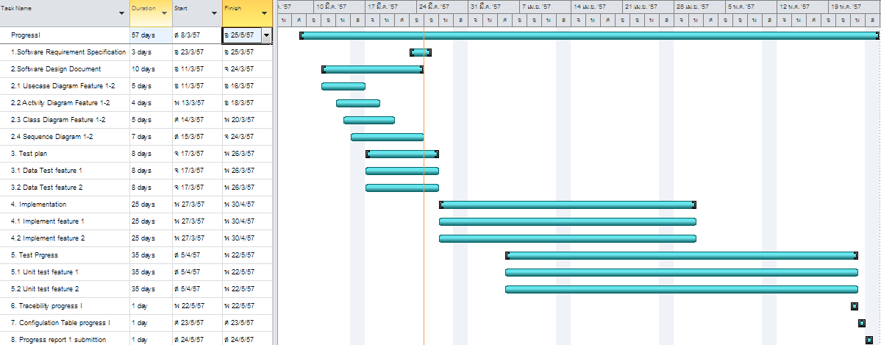

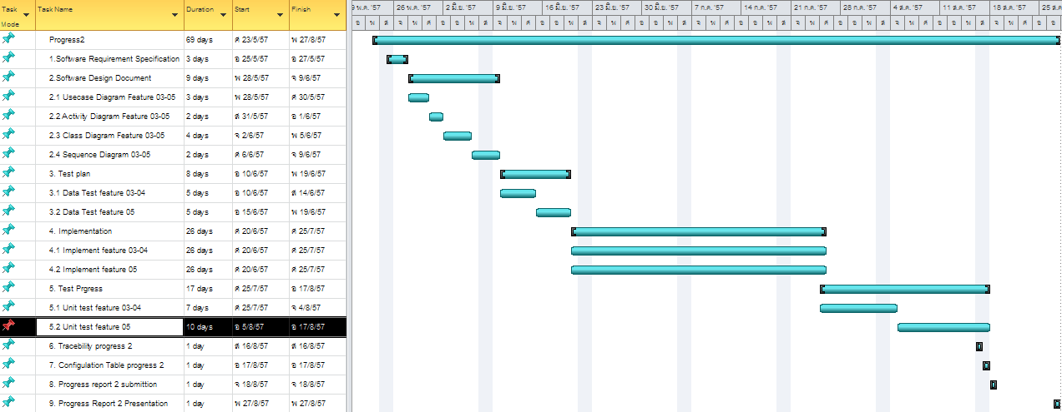***4.5.2.3 Progress 2 Milestones***

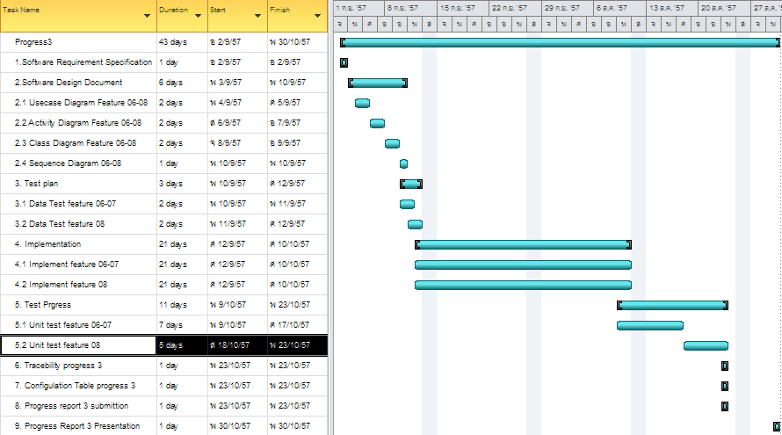***4.5.2.4 Progress 3 Milestones***

# **Chapter Five | References**

[1] homebusiness.about.com/od/homebusinessglossar1/g/freelancer.htm

[2] [www.freelancer.com/](https://www.freelancer.com/)

[3] [www.108freelance.com](http://www.108freelance.com)

[4] www.bamboohr.com

[5] www.w3schools.com/html/html_intro.asp

[5] http://evincetech.wordpress.com/2013/02/02/pros-cons-of-html5/

[5] http://en.wikipedia.org/wiki/HTML5#cite_note-HTML5-20110405-2

[6] <http://www.w3schools.com/css/css_intro.asp>

[6] http://en.wikipedia.org/wiki/Cascading_Style_Sheets

[7] http://en.wikipedia.org/wiki/JavaScript

[8] http://www.asp.net/mvc/mvc4

[9] http://msdn.microsoft.com/en-us/library/aa983532(v=vs.71).aspx

[9] http://msdn.microsoft.com/en-us/library/kx37x362.aspx

[10] http://www.visualstudio.com/

[11] <https://www.google.com/intl/en/chrome/browser/>

[12] <http://en.wikipedia.org/wiki/GitHub>

[13] www.etsmtl.ca/Professeurs/claporte/.../These_UBO_Volume-I.pdf‎

[14] msdn.microsoft.com/en-us/.../dd381412(v=vs.108).aspx‎

[15] <http://www.108freelance.com/about.aspx>

[16] <http://en.wikipedia.org/wiki/Internet_Information_Services>

[17] en.wikipedia.org/wiki/**Microsoft**_**SQL**_**Server**‎