**Project Proposal**

**THE LEARNING THROUGH ACTIVITIE SYSTEM**

Project Proposal

**By**

Miss. Jirada Somanasak 542115009

Miss. Putsacha Owatsakul 5421150037

Department of Software Engineering

College of Arts, Media and Technology

Chiang Mai University

**Project Advisor**

**Aj. Chartchai Doungsa-ard**

**Document History**

|  |  |  |  |  |  |  |
| --- | --- | --- | --- | --- | --- | --- |
| **Document Name** | **Version** | **Status** | **Date** | **Viewable** | **Editable** | **Responsible** |
| **Documents** | | | | | | |
| **LTAS-Proposal_V.0.1.docx** | - Add Chapter1  - Introduction & Background  - Add Chapter2  - Business Review  - Technology Review  - Add Chapter5 | Draft | 17-02-2014 | Jirada, Putsacha, Aj.Chartchai | Jirada, Putsacha | Jirada, Putsacha |
| **LTAS-Proposal_V.0.2.docx** | - Add Chapter3  - Quality Standards  - Add Chapter4  - Motivation  - Aims and Objectives  - System Architecture  - Deliverables and Limits  - Plan Milestone | Draft | 25-02-2014 | Jirada, Putsacha, Aj.Chartchai | Jirada, Putsacha | Jirada, Putsacha |
| **LTAS-Proposal_V.0.3.docx** | - Add Abstract  - Add Reference  - Edit Chapter2  - Business Review  - Technology Review  - Edit Chapter4  - Deliverables  - Schedule and Milestone | Draft | 2-03-2014 | Jirada, Putsacha, Aj.Chartchai | Jirada, Putsacha | Jirada, Putsacha |
| **LTAS-Proposal_V.1.0.docx** |  | Review | 4-03-2014 | Jirada, Putsacha, Aj.Chartchai | Jirada, Putsacha | Jirada, Putsacha |

**Table of Contents**

# Chapter One | Introductionand Background

The learning through activities included in the curriculum of Chiang Mai University because the learning through activities is an important for students. The learning through activities and opportunity for students to know each other better, so the Students are able to live with other people as well. The experience that students receive from the activities is necessary and very important in the future. Because society does not only need talent alone, but the society need people with good knowledge of academic subjects, and able to work with other people. These aspects are what indicate students graduated with quality and ready for the future.

Nowadays, most of the problems about learning through activities in Chiang Mai University came from the traditional procedure. When Chiang Mai University used the traditional method to assess the students activities, The instructors must sign the signature in the activities passport book to allow the students pass the activities. There are many problems from using the activities passport book, such as students lost their passport book and students ask friends to forged signatures to sign name for pass activities. When the instructors use paper for evaluate the grade of activities, It is difficult for the instructors to spend time with the evaluated score to each student.

To solve these problems, the learning through activities system is proposed. The learning through activities system provides the activities information to the students plan to achieve the courses. In addition, the learning through activities system provides the students information to the instructors to evaluate the student's grade. The instructors do not need to use a piece of paper to check the students who have participated the activities. The learning through activities helps the instructors solve the problems of data lost by losing the student's grade paper.

Therefore, the learning through activities system aids the people who faces problem when they use the activities passport books. The learning through activities system helps people manage the activities easier. The user can manage the activities whenever he wants.

# Chapter Two | Literature Review

## 2.1 Business Review

The learning through activities is a part of the curriculum of Chiang Mai University. There are various assessment techniques for learning through the activity course in each faculty of Chiang Mai University. Some faculty use the collecting the activities hours and some faculty are just counting the course. Therefore, to evaluate the score of the activities in each committee would be way different. In addition, there are also the different activity types such as the mandatory activities, the optional activities. Therefore, the students cannot have the clear standard used to assess the activities results, and the students cannot plan to achieve the course.

Most of the faculties in Chiang Mai University are using the activities passport books for evaluating the score of the activities. When the students attend the activities will receive a passport book for assessing the participate activities. In the activities passport book, the students can write the description of feeling when the activities participate. Then, the students submit the passport book to the instructors. After that, the instructors will sign the signature to confirm the participation activities of each student. Then, the instructors provide the grade for students. There are many problems when use the activities passport book. Most problems are the students forget the activities passport book when come to join the activities. Therefore, the learning through activities system provides clear standards used to evaluate the activities results for each faculty has the same understanding.

***Work Flow***

## **2.2 Alternative Solution Review**

2.2.1 **Student Information System Chiang Mai University** [1]

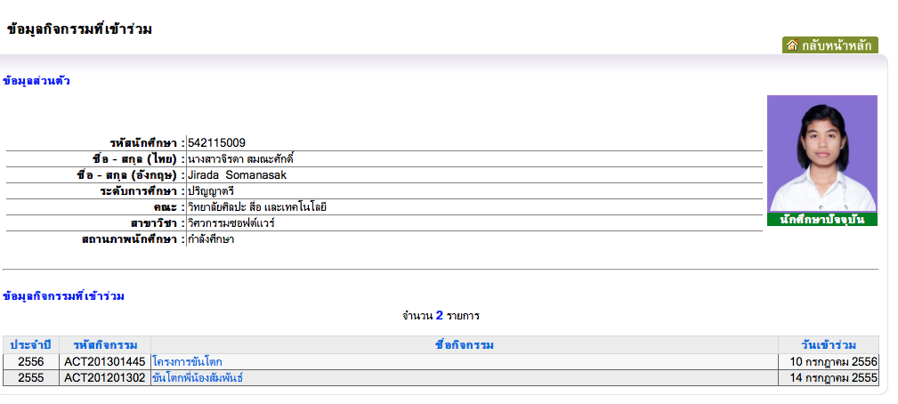The student information system of Chiang Mai University show the information of activities that students participated. The information of students activities consist of academic year, activity id, name of activities, and date of participated the activities.

**Figure 1: Student activities information of Chiang Mai University.**

Figure 1 shows student activities information of Chiang Mai University. This system provides information for students. On This system students can views the information of activities that participated. The instructors can view the overall the activities of each advisee.

The disadvantage of this system is the user interface does not look friendly. This system is difficult to use because it is hard to find activities information in this system. On the user interface provide quite not clear the advice word on index page of web. So, it very hard for user to find the page that want to go. In the student information system of the Chiang Mai University show the overall activities that student participated but the system not provide the details of the each activity. The information of each activity is important for students to plan how to achieve the course in the next semester.

**2.2.2 Management Information System Prince of Songkla University,   
 Pattani campus (MIS Center PSU Pattani)** [2]

This application provides information for their user such as a student and instructor. The student can select the semester and type of activities. On MIS Center System students can view activities information separate by type of activities. This application contains services for users' management such as the students can change password and update the users' information.

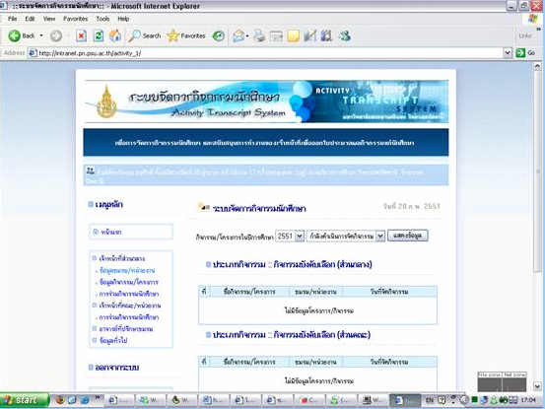

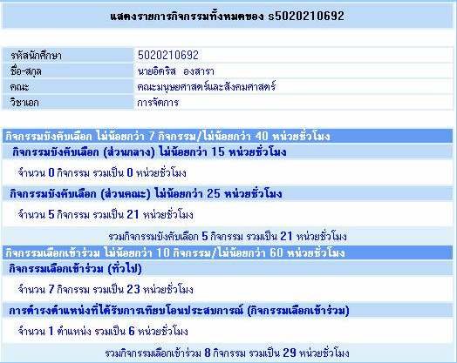

**Figure 2: Student activities information of PSU Pattani.**

Figure 2 shows student activities information of Prince of Songkla University, Pattani campus. Students can views semester activities. The students can select a year, and semester that they want to views and after that an application provides.

The disadvantages of this application is the student cannot see information of each activity. So, it cannot help student plan about how to achieve the course.

**2.2.3 Activity Transcript of Sirindhorn International Institute of   
 Technology (SIIT) Thammasat University** [3]

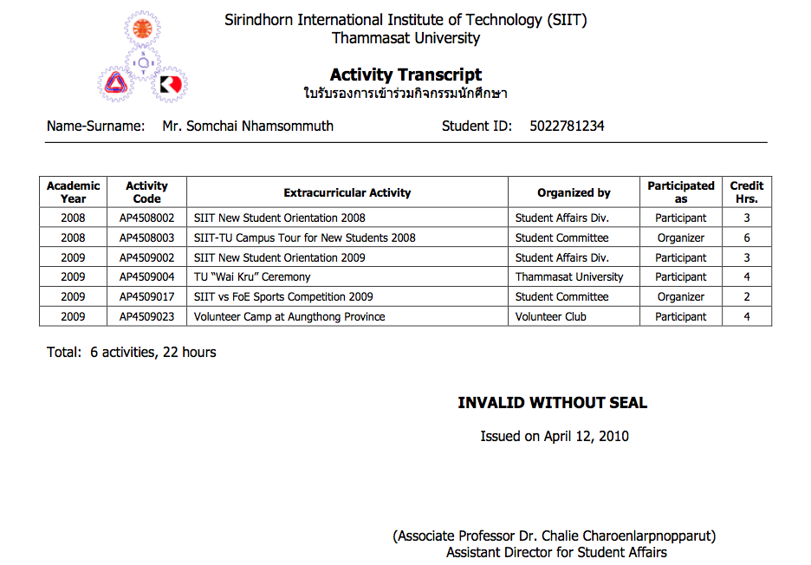This application provide the activity transcript of Sirindhorn International Institute of Technology(SIIT), Thammasat University provide by show the information of each activity that student participated and show the total time.

**Figure 3: Activity Transcript of SIIT Thammasat University.**

Figure 3 shows activities transcript of each student in Sirindhorn International Institute of Technology, Thammasat University. On this transcript show academic year, activity code, extracurricular activity, name of organizer and credit hours. The student can view the total activities and total time that student participated.

The disadvantage of this application is the activity transcript not provide the grade for each course that students joined the activity. So, the students cannot plan for future to achieve the course in the next semester.

**Summarize**  
 From the system that show above, each university has different Learning through Activities System. For Chiang Mai University, students and instructors can see only the name of activities. They cannot plan about how to achieve the course. For Prince of Songkla University, Pattani campus. Student can select the semester and type of activities, and then student can see activities information separate by type of activities.

The MIS Center PSU Pattani system has announce about the time of each activity that user must achieve, but it cannot show the details of each activity. So, the students cannot know what activities that they joined. For Activity Transcript of Sirindhorn International Institute of Technology, Thammasat University show the list of activities that student participated and show the total time, but it does not contain the grade for each activity course that student have. The student cannot plan for achieve the course in the next semester. To solve the problem, The Learning through Activities System will improve the ability that others web cannot do. The Learning through Activities System provide the information of each activity and evaluate the grade for student. The Learning through Activities system can help students and instructors have clear standards to have the same understanding. Also, the students can plan how to achieve the course.

## 2.3 Technology Review

**2.3.1 Spring MVC Framework**

Spring MVC Framework is an open Source application framework based on Java for building Java web applications. Spring MVC Framework developed by Spring Source Company. Spring provides the support for Hibernate, JSP, struts, JQuery, and many other frameworks. Spring helps the developer to create high performing, easily testable and reusable code. [4][5]

Spring MVC is based on Model-View-Controller (MVC) design pattern which divided into 3 layers. First layer is Presentation Layer (View), which render response to users. Second layer is Business Layer (controller), which receiving the request from the users and handles request. The third layer is Data Layer (Model), which handles data processes or encapsulating the application data. [6]

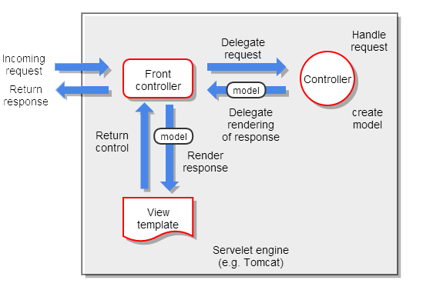

**Figure 4: Show Spring MVC execution sequence**

Figure 4 show Spring MVC execution sequence. First, the client sent a request to the front controller and it handles the request. Second, the front associated controller. Third, the controller executes the business logic and then the controller returns model and view object to the front controller. Fourth, the front controller passes the model object to the view. Fifth, the view is rendered and then front controller sends the output to servlet container. Finally, the servlet containers send the result back to the client.

**The selection of this technology** We uses Spring MVC because it helps the developers to produce high-performance web application. Spring MVC is based on Java platform, which is also used in the project. The other reason of choosing this technology because Spring MVC is free open source software. Developers can go to the community to find how to solve the problem.

**2.3.2 JSF (Java Server Faces)**

JSF (Java Server Faces) is the user interface component based on Java web application framework and JSF as an API for building web user interface component. It simplifies development by providing a component-centric approach to developing Java web user interface. JSF technology also includes UI components, handing events and validator, defining page navigation, and back-end-data integration. [8][9]

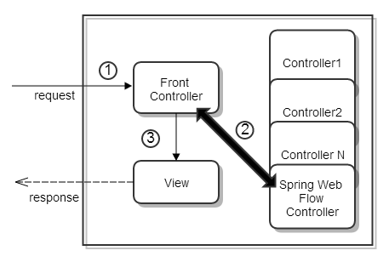 **Figure 5: Java Servlet Faces Implementation of MVC.**

Figure5 show Java Servlet Faces Implementation of MVC. First, the client sent a request to the front controller and it handles the request. The front controller is a Faces Servlet. Second, Faces Servlet dispatches the request to controller base on mapping some controller are flows. Third, the controllers return control to the Faces Servlet with the model and view to render. Faces Servlet resolves the view (JSF) and ask it to render the model

**The selection of this technology**

We uses JSF because it uses MVC design pattern, which also uses in this project. The JSF is easy to use and build web pages more responsibility and interactive. An application uses Spring MVC Framework which JSF can integrate with Spring MVC framework.

**2.3.3 JQuery** [7]

JQuery is a JavaScript framework which contains JavaScript library. It is easy to make JavaScript on website. The JQuery library contains HTML/DOM manipulation, CSS manipulation, HTML event methods, effects and animations, AJAX and Utilities. JQuery is a single file library and very smaller size file for developing JQuery.

JQuery is one of the most favorite JavaScript frameworks. Many of the famous companies use JQuery such as Google, Microsoft, IBM and Netflix. JQuery can integrate with many other framework such as PHP, ASP. NET and almost all the web programming languages. JQuery builds web pages good interaction between browser and client.

**The selection of this technology**

We uses JQuery because there are many tutorials resources. In addition, JQuery save project memory because the core file’s packed size is small. JQuery helps to build web pages more responsibility and interactive.

**2.3.4 CSS (Cascading Style Sheets)**

CSS is style sheets languages that work for control about design of document on the website. It also improves the look and feel for web page and can modify about font, image, table and etc. Main advantage of CSS, it also make or improve the impression for users when they visit the website.

**The selection of this technology** We uses CSS because

**2.3.5 HTML5**

**The selection of this technology**

**2.3.6 MySQL**

MySQL is one of the most popular language for adding, accessing and managing database and provides free open source Relational Database Management System (RDBMS) that uses Structured Query Language (SQL). It provides a quick processing, reliability data, usability, adaptability and high performance. Furthermore, it available on almost all the platforms (UNIX, Windows and Mac) and it is an essential part of almost every open source PHP application.

**The selection of this technology**

We uses MySQL server because it is an open source and popular database server. It has many tool for more adaptable such as Appserv, PHP MyAdmin, Easy PHP, and My SQL Workbench. MySQL provides many function and service with more efficient of reliability and performance

# Chapter Three | Quality Standard

## 3.1 ISO29110 for Very Small Entity (VSE)

ISO29110 is a guide applies to a Very Small Entity (VSE), enterprise, organisation, department or project up to 25 people, dedicated to software development. The Guide provides Project Management and Software Implementation processes which integrate practices based on the selection of ISO/IEC 12207- *Systems and Software Engineering —Software Life Cycle Processes* and ISO/IEC 15289*Software Engineering – Software Life Cycle Process – guidelines for the content of software life cycle process information products (documentation)* standards elements.

**3.1.1 Project Management Process**

The purpose of the Project Management process is to establish and carry out in a systematic way the tasks of the software implementation project, which allows complying with the project’s objectives in the expected quality, time and cost.

**Selected process**

1. Project Planning Process
2. Project Plan Execution Process
3. Project Assessment and Control Process
4. Project Closer Process

**3.1.2 Software Implementation Process**

The purpose of the Software Implementation process is the systematic performance of the analysis, design, construction, integration and tests activities for new or modified software products according to the specified requirements.

**Selected process**

1. Software Implementation Initiation Process
2. Software Requirements Analysis Process
3. Software Architectural Design Process
4. Software Construction Process
5. Software Integration and Test Process
6. Software Delivery Process

# Chapter Four | Project Plan

## 4.1 Motivation

Nowadays, Chiang Mai University need to make the student has more than talent. They need to make student with good knowledge of academic subjects, professional in the field, and able to work with other people. So,Chiang Mai University provide the activities for student to join.Chiang Mai University has various assessment techniques for the Learning through the activity course in each faculty. Some use the collecting the activity hours, some are just counting the course. There are also the different activity types such as the mandatory activities, the optional acidity. In addition, there are different result as well. So, Chiang Mai University have not clear standard to evaluate the score of the activities. Therefor we decide to make The Learning through Activities system for provide the clear standards used to evaluate the activities results for each faculty has the same understanding.

## 4.2 Aims and Objectives

**4.2.1 Aims**

This project aims to develop the learning through activities system for every faculty in CMU. There are various assessment techniques for the Learning through the activity course in each faculty. Some use the collecting the activity hours, some are just counting the course. There are also the different activity types such as the mandatory activities, the optional acidity. In addition, there are different result as well. As a consequence, the project have to gather the information of the students who attends the activities and evaluate the grade they have, and also create the report for each students, or the faculties so they can plan how to achieve the course.

**4.2.2 Objective**

**-** To help student about their activities plan easily.  
 - To help student plan how to achieve the activity course.  
 - The through activities system provide the information of each activity to help  
 student make decision about participation.  
 - To help adviser track their advisees.

## 4.3 System Architecture

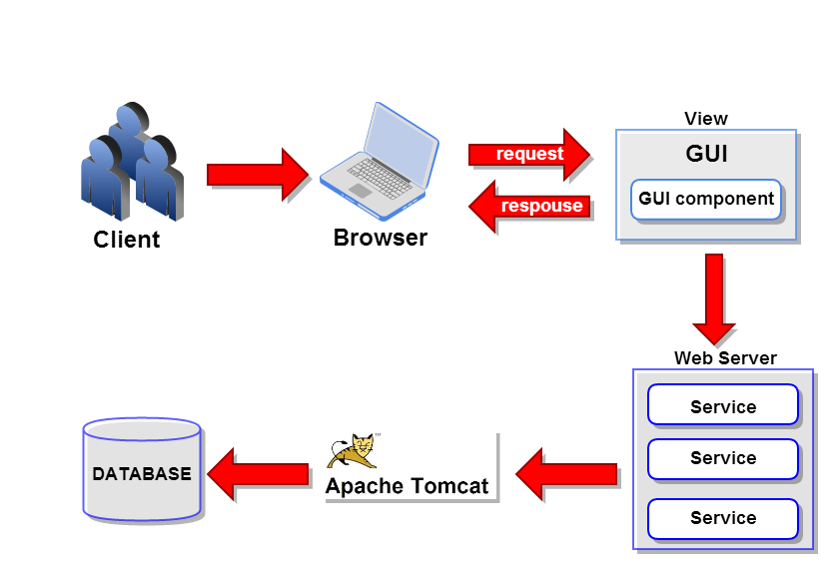  
 **Figure 6: The Leaning Thought Activities System**

Figure6 shows the overall of the learning through activities system. The system consist of Client connect with the Bowser to request the page GUI and send to the Web Service via the Apache Tomcat and save the data into the database

.

## 4.4 Deliverables and Limits

**4.4.1 Deliverables**

**4.4.1.1 Architecture Overview**

User   
Management

Activity  
Management

Participate Histories  
Management

Grade  
Management

Activity Transcript  
Management

**Figure 7: Architecture Overview of Learning through activities system**

Figure 7 shows overall of architecture learning through activities system. This system consist of User management, Activity management, Grade management, and PDF file management.

***User management*** The learning through activities system allows users involve administrator, student, and instructor to manage the information. The information of the student consist of student id, name, faculty, and the history of participated the activities. The students can update the information by add and edit the name, surname, address, and telephone number.

***Activity management*** The activity management part. The instructor can provide the information of each activity such as the name of activity, date, time, place and the description of the activity.

***Participate Histories Management*** The participate histories management show date and the information of each activity that student participated. The student can see the list of activities separate by type of activity. In participate histories management, the students can able to describe the experience of participating in activities on the website. Moreover, the instructors can gather the information of the students who attends the activities.

***Grade management***  The grade management, the system can evaluate the grade of each activity .Both students and instructors can see the grade for each activity course. The learning through activities system provides grade information such as activity name, grade and credit.

***Activity Transcript Management*** The learning through activities system provide a PDF file management for create the activity transcript. In the activity transcript show the name of student, and information of activity such as ID, name, and credit of each activity.

**4.4.1.2 Software Document**

* Project Proposal
* Project Plan
* Software Requirement Specification
* Software Design Document
* Testing Document
* Test Plan  
  - Unit Test Document  
  - System Test Document
* Test Report  
  - Unit Test Document  
  - System Test Document
* Traceability Record
* Progress Status Report
* Self-Assessment Report

**4.4.2 Limits**

* Internet connection is required for using the learning through activities system.
* Web browser is required for using application.
* The student should have CMU account (542115009.cmu.ac.th)

## 4.5 Schedule & Milestones

The schedule and milestones of the learning through activities system**.** During period of time, there are work terminologies. And the description is shown below that:

**Feature#1:** User Management

**Feature#2:** Activity Management

**Feature#3:** Participate Histories Management

**Feature#4:** Grade management

**Feature#5:** Activity Transcript Management

|  |  |  |  |
| --- | --- | --- | --- |
| **Milestone** | **Task** | **Milestone Criteria** | **Planned date** |
| 1 | Proposal | Topic defined | February |
| 2 | Proposal | - Proposal reviewed  - Proposal submitted  - Proposal presentation | March |
| 3 | Progress Report I | - Software requirement specification  - Feature#1,2  - Feature designed  - Test planned  - Feature implemented  - Feature tested  - Progress report submitted  - Progress report presentation | Mid May |
| 4 | Progress Report II | - Feature# 3  - Feature designed  - Test planned  - Feature implemented  - Feature tested  - Progress report submitted  - Progress report presentation | Mid July |
| 5 | ShowPro | Overall of the system should be higher than 75%. | Beginning of September |
| 6 | Progress Report III | - Feature#4  - Integrate and review all documents.  - Integrate and review all documents.  - Tests all features.  - Reviews documents are completed.  - Progress report submitted  - Progress report presentation | End of September |

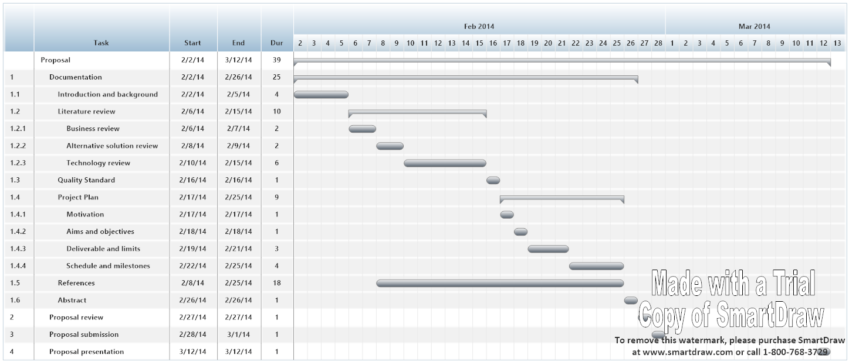

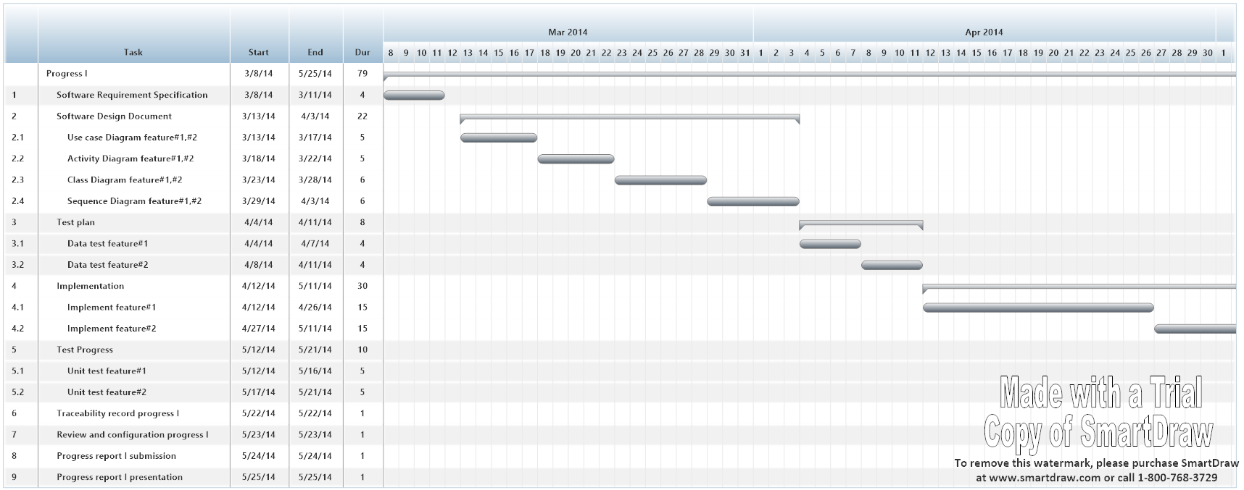

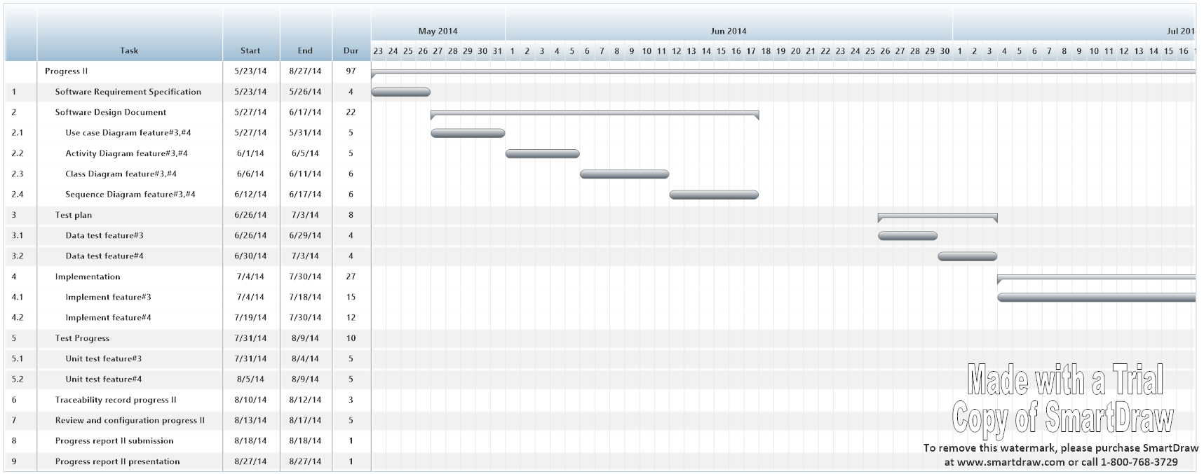

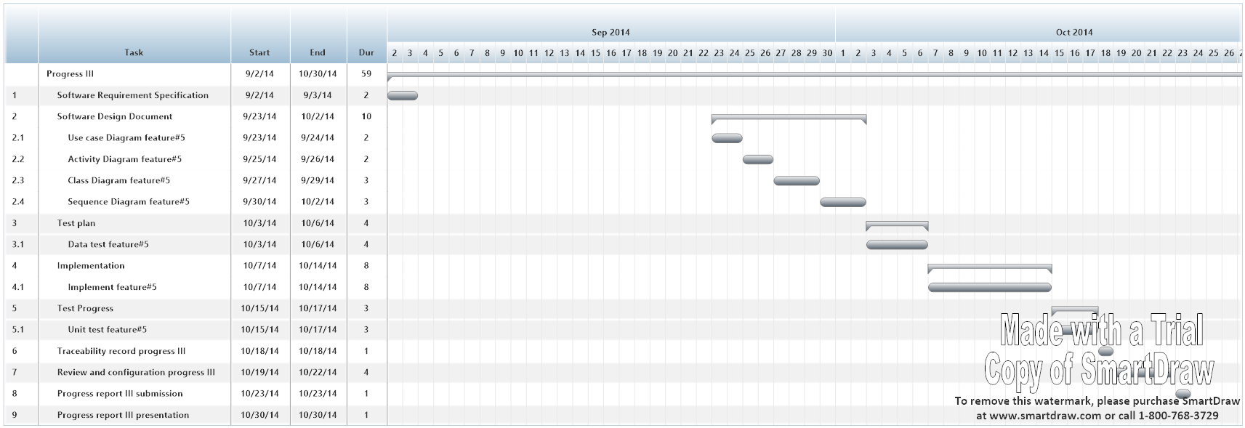

# Chapter Five | References

[1] Student Information System Chiang Mai University (CMU SIS) [Online]   
- http://mis.cmu.ac.th/cmumis/mainstudentlogin.html

[2] Management Information System Prince of Songkla University, Pattani campus  
 (MIS Center PSU Pattani) [Online]   
- http://studaffairs.pn.psu.ac.th/transcript_pj/news_transcript1.html

[3] Activity Transcript of Sirindhorn International Institute of Technology (SIIT)  
 Thammasat University [Online]   
- <http://sa.siit.tu.ac.th/ats/file/sample_acTranscript.pdf>

[4] Spring Framework, Chapter 13, Web MVC framework [Online]   
- http://static.springsourse.org/spring/docs/2.0.x/reference/mvc.html

[5] Viral Patel, Spring 3 MVC – Introduction to Spring 3 MVC Framework [Online]   
- http://viralpatel.net/blogs/tutorial-spring-3-mvc-introduction-spring-mvc-framework

[6] Developer book. Model-View-Controller (MVC) Architecture [Online]   
- <http://www.developerbook.com/articles/MVC-Architecture.php>

[7] W3schools, JQuery Introduction [Online]   
- http://www.w3schools.com/jquery/jquery_intro.asp

[8] joomla Loginradius, JQuery Introduction [Online]  
- http://www.joomla.loginradius.com/index.php/what-is-loginradius

[9] Vogella, JSF(JavaServer Faces) Tutorial [Online]  
- <http://www.vogella.com/articles/JavaServerFaces/article.html>

[10] Roseindia, What is JSF? [Online]  
- http://www.roseindia.net/jsf/whatisjsf.shtml

[11] Microsoft,Microsoft SQL Server [Online]   
- http://www.microsoft.com/en-us/download/details.aspx?id=29062

[12] Microsoft, Microsoft SQL Server [Online]   
- http://www.microsoft.com/en-us/download/details.aspx?id=29062

[13] SiteGround, Inc.“What is MySQL*”* [Online]   
- http://www.siteground.com/tutorials/php-mysql/mysql.htm

[14] [Jennifer Bourn](http://www.bourncreative.com/author/jenbourn/), What are CSS? [Online]

- <http://www.bourncreative.com/what-are-cascading-style-sheets-css-in-website-design/>