**Web-based Multiplayer Online Battle Survival Game   
& Gaming Network**

Project Proposal

By

**Mr. Witsarus Suninhong 542115058**

**Mr. Athit Chananchana 542115074**

Department of Software Engineering

College of Arts, Media and Technology

Chiang Mai University

Project Advisor

________________________

**Mr.Kittitouch Suteeca**

|  |  |  |  |  |  |  |
| --- | --- | --- | --- | --- | --- | --- |
| **Document Name** | **Version** | **Status** | **Date** | **Viewable** | **Reviewer** | **Responsible** |
| **Documents** | | | | | | |
| SCRUM-Proposal-V.0.1.docx | - Add Chapter 1  -  - Add Chapter 2  - Technology Review  - Development Tool Review  - Add Chapter 3  -  - Add Chapter 4  - Motivation  - Aims and Objective  - Deliverables and Limits  -Add Chapter 5  - | Draft | 28 Jan 2014 | WS, AC, KS | WS, AC | WS, AC |
| SCRUM-Proposal-V.0.2.docx | - Add Chapter 1  - Introduction & Background  - Add Chapter 2  - Business Review  - Business Tools and Software Review  - Technology Review  - Development Tool Review  - Add Chapter 3  - ISO29110  - Add Chapter 4  - Motivation  - Aim and Objective  - Deliverables and Limits  - Future Work  - Schedule & Milestone  - Add Chapter 5  - References | Draft | 6 Feb 2014 | WS, AC, KS | WS, AC | WS, AC |
| SCRUM-Proposal-V.0.3.docx | - Fix Schedule and Milestone  - Fix Reference  - Fix Abstract | Draft | 7 Feb 2014 | WS, AC, KS | WS, AC | WS, AC |
| SCRUM-Proposal-V.0.4.docx | - Rewrite Chapter 3  - Recreate Milestone | Draft | 24 Feb 2014 | WS, AC, KS | WS, AC | WS, AC |

**Document History**

**\*WS = Witsarus Suninhong**

**\*AC = Athit Chananchana**

**\*KS = Kittitouch Suteeca**

**Abstract**

Game industry in the last decade has grown up because a lot of game developers want to challenge to make a game pass their own imagination. In game development process is not easy because game developer need to find and understand everything about technologies. Moreover, in the part of three dimension game need to have very strong skill more than two dimension such as modeling, physical action and surface of an object. Even lighting effect, texture and collocation need to practice and understand it. According to “Web-based Multiplayer Online Battle Survival Game & Gaming Network”, we selected new technologies that have efficiency such as Node.js to make a JavaScript server. We believe that a game which build by new technologies will provide a nearby performance same as other game.

**Table of contents**

Chapter One | Introduction and Background 5

Chapter Two | Literature Review 6

2.1 Business Review 6

2.2 Business Tools and Software Review 6

2.3 Technology Review 7

2.4 Development Tool Review 13

Chapter Three | Quality Standard 19

3.1 ISO29110 for Very Small Entity (VSE) 19

3.1.1 Project Management process 19

3.1.2 Software Implementation process 19

Chapter Four | Project Plan 20

4.1 Motivation 20

4.2 Aims and Objectives 20

4.3 Deliverables and Limits 21

4.3.1 Annotation 21

4.3.2 Deliverables 21

4.3.3 Limits 22

4.4 Future Work 22

4.5 Schedule & Milestones 23

Chapter Five | References 30

# **Chapter One | Introduction and Background**

Nowadays, online game businesses have grown so fast and gain a lot of money from game player. DotA and MineCraft are popular game in personal computer that every game player bought a product and installed. In additional, Steam is a social system which help to support about game player trading. It makes game player easy and fast to pay the money. Each features of Steam supported game trading system. Although it used more CPU power for run Steam in Windows environment.

In term of web application, HTML5 is a new technology that can support multimedia contents. There are many technologies that supported real time web application such as Node.js, WebRTC, Websocket, etc. It sufficient quality for makes web application that can display three dimensional model or can make more activities in web application. Eventually, web application may be application which can response desirable of game player. Furthermore, web application is an application that easy to access, fast and more efficiency. Also, it is a technology that support on smartphone and tablet.

Player realization is a big part of background, in the sense that player will gain from a game is the thing that cannot do in the real world. Some game, most player need to kill the other player character for finish game objectives. For entertain game player, game style is an importance thing that can determine complacency of game player.

From game entertainment trends and technologies, new system can be develop into web application. For this project, “Web-based Multiplayer Online Battle Survival Game & Gaming Network” (SCRUM) will provide game player connect with other game player through a web application. SCRUM is the name that we called. It will difference from other game style because SCRUM is combine game style between survivals and multiplayer online battle arena (MOBA). Furthermore, game player do not installation and add more three dimension plugin. SCRUM will connect game player together.

# **Chapter Two | Literature Review**

## Business Review

**Overview**

Web-based Multiplayer Online Battle Survival Game & Gaming Network is a web application that derived by HTML5, Node.js, and other technologies that supported the real time web application. It will provide the social gaming network and provide the entertaining game.

**Target**

* Game player can play the game through a web browser.

**Benefit**

* Game player gets convenient because no installation and add more plugin.

## Business Tools and Software Review

**2.2.1 MineCraft**

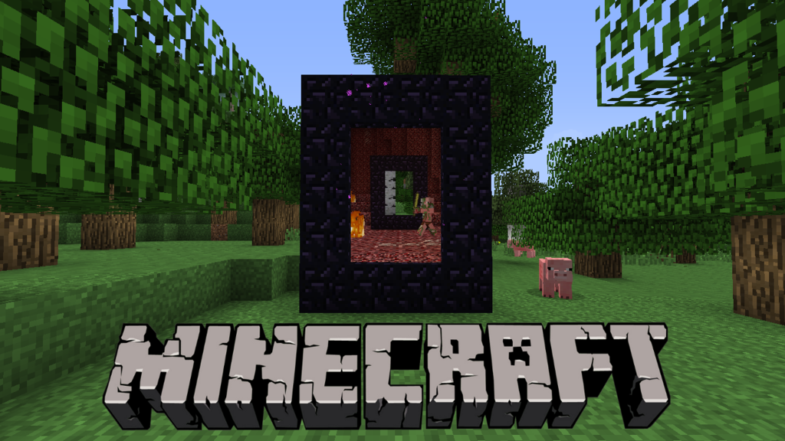

**Figure 2.1 MineCraft Review**

MineCraft is a one of survival game that popular in the world. The game involves player creating and breaking a three dimensional environment. Inside the game, player must be survived from monsters and dangerous places. The player takes an avatar that can destroy or create blocks, forming structures and play the artwork with various multiplayer servers in map.

**Pros**

* Great balance between adventuring and building.
* One of 2011’s best original game soundtracks.
* Survival mode can satisfying game player.

**Cons**

* No tutorial inside the game.
* Some element feel unfinished.
* Impatient game player need not apply.
* Can’t sent sound or audio.
* Need to installation.
* Risk of being pretend other game player.

## Technology Review

## Node.js



**Figure 2.2 Node.js Logo**

## Technology Detail

Node.js is a platform that to build scalable network in server-side real time applications. Node.js used the JavaScript as its scripting language. Also, contains server library for makes it lightweight and more efficient in server-side real time application.

## Alternative Technology

* Apache
* Lighttpd

## The selection of this technology

* Appropriate for the application that have a lot of concurrent connection.
* Real time communications.
* Used lesser CPU power.
* Transfer data faster.
* Free (Open-Source).

## Three.js

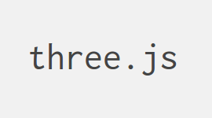

**Figure 2.3 Three.js Logo**

## Technology Detail

Three.js is a JavaScript 3D library that used to create and display animated 3D computer graphics on web browsers. Three.js scripts born from the conjunction between HTML5 canvas element and WebGL.

## The selection of this technology

* Free (Open-Source).
* Do not need to build our own WebGL components.
* Client can view a well product without relying web-browser plugin.
* Lightweight library.

## Cascading Style Sheets 3 (CSS3)



**Figure 2.4 CSS3 Logo**

## Technology Detail

CSS3 is stands for Cascading Style Sheets 3. It defined how to display HTML elements that presentation of web pages, including colors, layout, and fonts.

## The selection of this technology

- Easier to implement page layout.

- Standardized.

## HTML5



**Figure 2.5 HTML5 Logo**

## Technology Detail

HTML5 is the fifth revision of the HTML. It is a markup language to create a webpage and present contents that can be displayed in a web browser.

## Alternative Technology

* HTML older version.
* SVG.
* XUL (Mozilla Firefox).

## The selection of this technology

- Accessible sites easier than older version.

- Clean code.

- Support Three.js.

- Support multimedia content.

- Standardized.

## MongoDB



**Figure 2.6 MongoDB Logo**

## Technology Detail

MongoDB is a Non-SQL Database which is an open-source schema database system. The most of functionality can be accessed directly through JavaScript notation and focused on JSON style documents with dynamic schema.

## Alternative Technology

* MySQL Server.
* Redis Server.

## The selection of this technology

- Rich document queries.

- Flexible aggregation and data processing.

- Store file of any size.

- Free (Open-Source).

- Node.js dependency.

## WebRTC – Web Realtime Communication JavaScript API



**Figure 2.7 WebRTC Logo**

## Technology Detail

WebRTC is an open project that enables web browsers with real-time communications capabilities via JavaScript API and HTML5.

## Alternative Technology

* Flash player.
* Skype plugin.

## The selection of this technology

- Free (Open-Source).

- Without downloads.

- Fast and easy to create real-time communication.

- Support HTML5.

- High performance voice and video (TCP).

- Safe (Secured data transfer).

- Node.js dependency.

## WebGL



**Figure 2.8 WebGL Logo**

## Technology Detail

WebGL is a royalty-free web standard for a low-level 3D graphics API based on OpenGL ES, exposed through the HTML. The WebGL will brings free-plugin 3D to the web that implemented on the major web browsers.

## Alternative Technology

* DirectX.

## The selection of this technology

* Open-Source engine.
* Standardized.
* Supported multi-platform.
* Supported popular browsers.

## Socket.IO



**Figure 2.9 Socket.IO Logo**

## Technology Detail

Socket.IO is a JavaScript library for real time web application. In this library it has two parts. First one is client-side library which run on browser and second one is server-side which is library for Node.js. Socket.IO can working with difference transport mechanism.

## Alternative Technology

* XML HTTP Request Polling (XHR-Polling).
* Chrome socket.
* Flash socket.

## The selection of this technology

* Suitable for WebRTC.
* Real-time communications.
* Node.js dependency.
* Transfer data faster.

## Websocket



**Figure 2.10 Websocket Logo**

## Technology Detail

Websocket is protocol that providing communications channel over TCP connection on web browsers. For web server, Websocket makes possible to interact between server and web browsers, supported real-time content. So, it can be used for creating the real-time game.

## Alternative Technology

* XML HTTP Request Polling (XHR-Polling).
* Chrome socket.
* Flash socket.

## The selection of this technology

* Suitable for WebRTC.
* Real-time communications.
* Node.js dependency.
* Transfer data faster.
* Standardized.

## Development Tool Review

## Notepad++

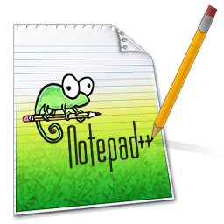

**Figure 2.11 Notepad++ Logo**

## Development Tool Description

Notepad++ is a free source code editor that supported several language. Running in the Microsoft windows environment.

## Alternative Tool

* Dreamweaver any version.

## The selection of this tool

* Easy to read and coding.
* Less CPU power.
* Multiple plugins.
* Lightweight.
* Free.

## Macromedia Flash 8



**Figure 2.12 Macromedia Flash 8 Logo**

## Development Tool Description

Macromedia flash 8 is software that help to create or edit multimedia, animation and graphics. Now, this tool is a popular on the websites because its make very interesting presentation.

## Alternative Tool

* Photoshop any version.
* SAI paint tool.

## The selection of this tool

* Help to draw images easier.
* Previously used.
* Supported animation.

## Photoshop CS6



**Figure 2.13 Photoshop CS6 Logo**

## Development Tool Description

Photoshop is software that help to develops more beautiful images. Help to make images, edit images and create a beautiful work with fast performance.

## Alternative Tool

* GIMP (cross-platform).
* Paint.NET (Windows only).

## The selection of this tool

* Edit images easier.
* More image effects.
* Previously used.
* Supported animation.
* Can save in several image file.

## Audacity



**Figure 2.14 Audacity Logo**

## Development Tool Description

Audacity is the most popular open source digital audio editor. The program provides functions for capturing and editing only. The sounds can record from microphone if the user want.

## Alternative Tool

* Wavepad Sound Editor.

## The selection of this tool

* Can capture and edit sounds.
* Previously used.
* Free (Open-Source).
* Multi-track.

## Autodesk 3Ds Max 2013



**Figure 2.15 Autodesk 3Ds Max 2013 Logo**

## Development Tool Description

Autodesk 3Ds Max is a famous 3D graphics modeling tool, can help to create the objects or any model which this tool can create or edit the vertices of the object, rendering the surface of the object and animating the object. Help to finish faster and more efficiency. It is a main tool that help us to create the models of game.

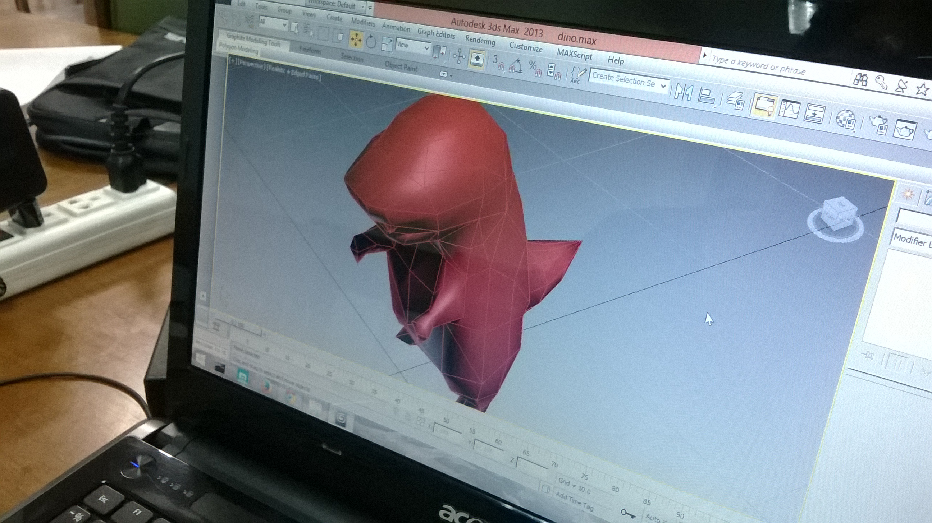

**Figure 2.16 Autodesk 3Ds Max 2013 Review**

## Alternative Tool

* Autodesk Maya.
* Blender.

## The selection of this tool

* Create 3D models easier.
* Supported animation.
* Supported game model type.
* Previously used.

## Firefox + Firebug



**Figure 2.17 Firefox + Firebug Logo**

## Development Tool Description

Firefox is a web browser for playing our game and Firebug are a helper Firefox while developer develop the web application. Help to edit, debug and display the line of code that errors occur.

## Alternative Tool

* Maxthon Cloud Browser.

## The selection of this tool

* Appropriate for testing.
* Standardized.
* Supported advanced HTML5.
* Supported CSS3.
* Free for developer.

## Google Chrome



**Figure 2.18 Google Chrome Logo**

## Development Tool Description

Google Chrome is a free-ware web browser which developed by Google, Inc. The Google Chrome developer tools are a set web debugging tools for web application.

## Alternative Tool

* Maxthon Cloud Browser.

## The selection of this tool

* Appropriate for testing.
* Standardized.
* Supported advanced HTML5.
* Supported CSS3.
* Free for developer.

# **Chapter Three | Quality Standard**

# **Chapter Four | Project Plan**

## Motivation

Nowadays, the online games are popular entertainment. It makes online game businesses have grown so fast also gain a lot of money. In the world, Multiplayer Online Battle Arena (MOBA) is the most popular game genre. In additional, Steam is a system which help game player to pay money and connecting game player to be game social together.

MineCraft is a one of survival game, it makes player always excite and must collaborate with other player for alive. It makes funny and relax because player cannot do it in the real world.

Therefore, this project want to a combination between survival game style and hunting game style into the real-time web application which no installation and no include 3D graphics plugin by using new technologies that suitable, fast and more efficient.

## Aims and Objectives

**4.2.1 Aims**

The project aims to develop gaming network on a web browser that connecting between game players by using the new technologies such as Node.js that passing data so fast, WebRTC that supported HTML5. In term of game style, this project target on multiplayer online survival game on web application with no installation. About social communications, this project aims to develop real-time web application and can co-operating players with audio and video.

**4.2.2 Objectives**- Independent game playing.  
- Game application on web browser.  
- Real-time communications on web browser.  
- New gaming experiences.  
- Laying the foundation of gaming network on web browser.  
- Connecting game players.  
- Applying the new technologies into gaming business.  
- Enhancing web-based game to become a professional business.

## Deliverables and Limits

### Annotations

SCRUM = Web-based Multiplayer Online Battle Survival Game  
SMOG = Gaming Network

### Deliverables

1) 1st progress

- Player Control System.  
 - Map System.  
 - Environment System.

2) 2nd progress

- Item System.  
 - SCRUM Statistic System.  
 - Battle System.   
 - Collision System.  
 - Health System.  
 - Planting System.

3) 3rd progress

- SCRUM & SMOG Networking System.  
 - SMOG Statistic System.  
 - SCRUM & SMOG Accounting System.  
 - SMOG Video and Voice Conferencing System.  
 - Monster System.  
 - Game Configurations System.  
 - HUD System (GUI).  
 - Job System.  
 - Class System.   
 - Trading System.

4) The document and other material

- Proposal.

- Project plan.

- Quality plan.

- Software requirement specification.

- Traceability record.

- Software design document.

- Testing document.

* Test plan.
* Unit test report.
* System Test report.

- 1 DVD stores client source code, relate file, all documents and poster files in PDF format.

- 1 project poster.

### Limits

* User requires network devices and internet to access the system.
* The game system requires a web browser that support advanced HTML5 (Google Chrome and Firefox).
* User has to register the Gaming Network (SMOG) System before playing the game.
* User requires mouse, keyboard and monitor to play the game.
* The game system requires graphic card that support WebGL (OpenGL ES 2.0).

## Future Work

* The gaming network will provide a customer API to take their games or their websites into the system.
* The game could be played on any smartphone or tablet that meet the game requirements (advanced HTML5, WebGL, efficient hardware, etc.). The game will build into an app on the smartphone or tablet online store.
* The gaming network system is scalable for cloud computing growth. The database of the system is supporting the big-data storing. Also, the system could expand the business across the world by improving the server and technologies.
* The game will provide more gaming features such as additional monster, more classes, more jobs, event system or fashionable item shopping system.

## Schedule & Milestones

* Feature#1: Consist of player control system.
* Feature#2: Consist of map system.
* Feature#3: Consist of environment system.
* Feature#4: Consist of item system.
* Feature#5: Consist of SCRUM Statistic System.
* Feature#6: Consist of battle system.
* Feature#7: Consist of collision system.
* Feature#8: Consist of health system.
* Feature#9: Consist of planting system.
* Feature#10: Consist of SCRUM & SMOG networking system.
* Feature#11: Consist of SMOG statistic system.
* Feature#12: Consist of SCRUM & SMOG accounting system.
* Feature#13: Consist of SMOG video and voice conferencing system.
* Feature#14: Consist of monster system.
* Feature#15: Consist of game configurations system.
* Feature#16: Consist of HUD system (GUI).
* Feature#17: Consist of job system.
* Feature#18: Consist of class system.
* Feature#19: Consist of trading system.

**Schedule Plan:**

Proposal phase: Create proposal document.

Progress I: Create Development plan, Quality plan, SRS, SDD and some part of Test document. Start creates feature# 1, 2, and 3 of system.

Progress II: Create feature# 4, 5, 6, 7, 8 and 9 of the system, overall of the system should be higher than 65%. Continue on Test document.

Progress ShowPro: Create feature# 10, 11, 12, 13, 14, 15, 16, 17, 18 and 19 of the system and integrate all features. Overall of the system should be complete or nearly. Continue on Test document.

Final progress: Integrate and review all document. Make sure all system and document are complete.

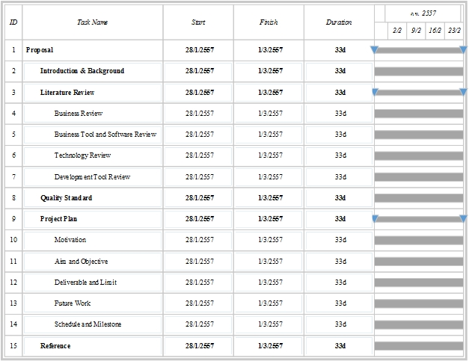

**Figure 4.1 Proposal Milestone**

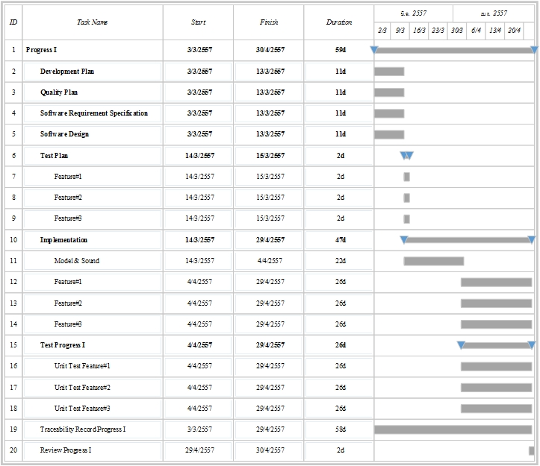

**Figure 4.2 Progress I Milestone**

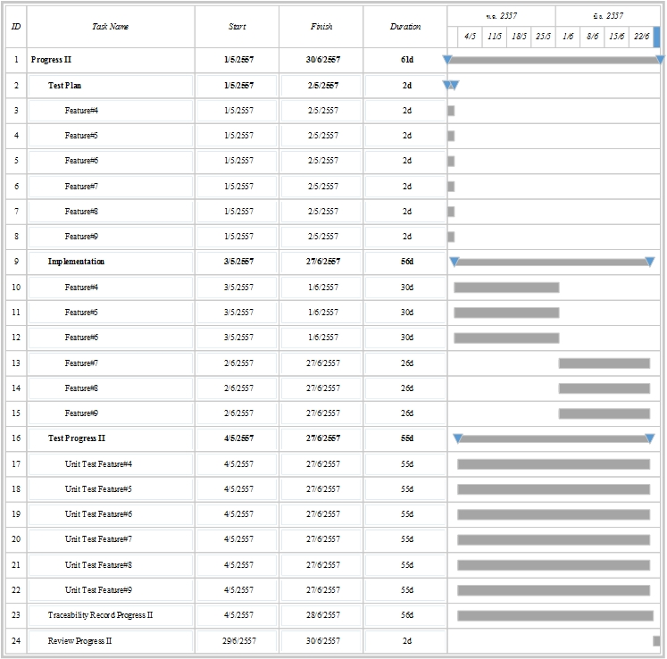

**Figure 4.3**

**Progress II Milestone**

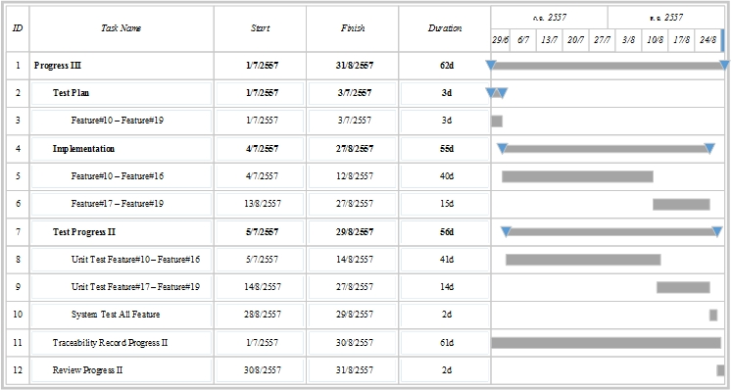

**Figure 4.4 Progress III Milestone**

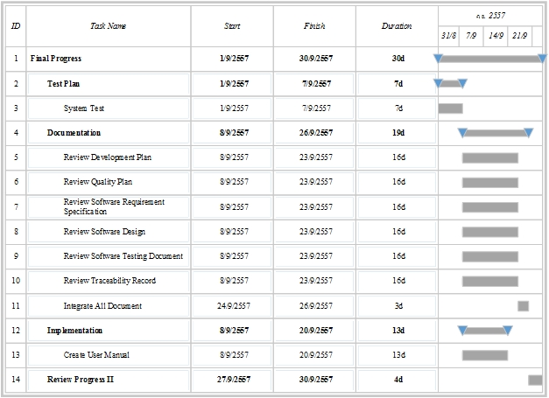

**Figure 4.5 Final Progress Milestone**

# **Chapter Five | References**

[1] HTML5; <http://www.html5rocks.com/>, <http://www.w3.org/html/wg/drafts/html/master/>

[2] HTML5 Game; http://www.html5gamedevelopment.com/

[3] Node.js; <http://nodejs.org/>, https://github.com/joyent/node

[4] Three.js; <http://threejs.org/>, https://github.com/mrdoob/three.js/

[5] CSS3; https://developer.mozilla.org/en-US/docs/Web/CSS/CSS3

[6] WebGL; http://www.khronos.org/webgl/

[7] MongoDB; http://www.mongodb.org/

[8] NoSQL; http://en.wikipedia.org/wiki/NoSQL

[9] WebRTC; <http://www.webrtc.org/>, <http://simplewebrtc.com/>, http://dev.w3.org/2011/webrtc/editor/webrtc.html

[10] WebSocket; <https://developer.mozilla.org/en-US/docs/WebSockets>

[11] Socket.io; <http://socket.io/>, https://github.com/learnboost/socket.io

[13] Adobe Photoshop CS6; http://www.adobe.com/mena_en/products/photoshop.html

[14] Audacity; http://audacity.sourceforge.net/

[15] Notepad++; http://notepad-plus-plus.org/

[16] Autodesk 3Ds Max; https://area.autodesk.com/blogs/maxstation/n118_autodesk_3ds_max_2013_new_features

[17] Firebug; http://getfirebug.com/

[18] Firefox; http://www.mozilla.org/en-US/firefox/beta/

[19] Chrome; https://www.google.com/intl/en/chrome/browser/beta.html

[19] DotA; http://www.playdota.com/

[19] MineCraft; https://minecraft.net/