Which inputs carry a CS2 round win-probability model
An explanation of an 83-input model, and a test of its input groups on the team's metric, GDT.
Working draft, 6 November 2026. Companion slides: https://claude.ai/artifact/<artifact-id>.

Abstract
A win-probability model estimates, second by second, how likely the counter-terrorist (CT) side is to win a Counter-Strike 2 round. We explain an 83-input gradient-boosted model of this probability and test which groups of inputs it needs. TreeSHAP attributes each prediction to its inputs, and permutation importance gives a black-box check. The loadout difference between the two teams carries most of the signal, averaging 13.3 percentage points of probability per second. The 24 position inputs total 3.5 points.
We retrained the model without each group and scored every retrain with the team's evaluation metric, GDT: the gain over a fixed lookup table, on 295 matches. The full model scores 0.0254. The loadout inputs alone score 0.0098. Removing the 24 position inputs gives 0.0205 (−0.0049 against the full model); site and spread alone costs −0.0020, and contact alone nothing measurable.The checklist's 77-input fallback gives 0.0251 (−0.0003), and log loss +0.00028 against the full model. Dropping the alive counts, the armour sums or the blindness inputs changes GDT by 0.0002 or less. Dropping the VIEW or bomb-geometry group changes it by about 0.0005 each.
Calibration holds: predicted and observed CT-win rates agree within 0.01 in every decile over 1.5 million validation seconds, and in the 1-versus-5 state the expected and observed CT round wins agree. Several inputs remain flagged for rebuild, and the design matrix has not been regenerated from raw data, so the reproduction is incomplete.

1. Introduction
A round win-probability model gives, at every second of a Counter-Strike 2 round, the chance that the CT side wins. The team uses such a model to read live rounds and to judge which game-state inputs are worth their cost. Two questions follow. Which inputs drive the prediction, and by how much? And does each input group earn its place when the model is judged on the metric the team actually uses?
The model is trained to minimise log loss on every second of the training matches. The team scores models with GDT, the gain over a fixed lookup table of CT-win rates by coarse situation (who is alive, the bomb, the time left, and each side's gear). GDT is computed on sampled datapoints, one per round per situation, so the two metrics weight the seconds of a round differently. Section 2.4 explains the difference, and why it matters for the input decisions.
This report answers five questions: (1) which inputs carry the signal, and how much; (2) what the position inputs add beyond the non-positional inputs; (3) whether the 83-input model is preferable to the 77-input checklist fallback; (4) whether single predictions and example matches on GDT look sensible; and (5) whether the model is calibrated. Appendices hold the detailed tables.

2. Data, model and metric

2.1 Data and splits
The training pool is 14,804 matches dated 2 August to 13 October 2026. The validation sample holds 1,168 matches and 1,515,228 seconds. Explanations use a sample of 100,000 validation seconds. GDT is scored on a population of 295 matches dated 1 September to 8 October, restricted to rounds that start five against five: 5,239 rounds and 354,519 seconds. The Oct 26 to 31 holdout and the frozen test were not read for this work. The team's handoff and the cache disagree on the match count for 9 and 10 October; Appendix G lists the open reconciliation.

2.2 Inputs
The 83 inputs fall into 59 non-positional inputs (loadout, round state and map) and 24 position inputs (where the players are and what they can see). Table 1 lists the groups.
Group | Inputs | What it holds | Positional?
Loadout difference (CT minus T) | 6 | Team HP, equipment, rifles, SMGs, AWPs and armoured players, as CT minus T | No
Loadout, each side | 40 | Per-side equipment, weapons, health and armour, grenades and kit | No
Round state | 6 | Alive counts, the alive difference, bomb planted, round clock, seconds since the plant | No
Map | 7 | Indicator for each of the seven maps | No
Bomb geometry | 4 | Distance to the nearest bomb spot, bomb-area counts, and defuse slack | Yes
Site and spread geometry | 9 | Distances to the two sites, spread of each side, centroid distance | Yes
Contact | 3 | Nearest enemy distance and in-contact flags | Yes
VIEW | 4 | Sees-enemy and exposed flags for each side (flagged in the team's notes) | Yes
BLIND | 4 | Blind counts and sums for each side (flagged in the team's notes) | Yes
Table 1. The 83 inputs by group. Non-positional = 59 inputs; positional = 24 inputs. The counts add to 83.

2.3 Model
- XGBoost with the binary logistic objective, log-loss evaluation, depth 4, learning rate 0.03, minimum child weight 20, subsample 0.8 and 256 histogram bins. Early stopping after 100 rounds on a 10% split, with a 3,000-round cap. Monotone constraints on the alive counts.
- The shipped booster is a CPU refit with best iteration 2,695. Its validation log loss is 0.450210. The sprint's GPU fit gave 0.450228. The file holds 2,796 boosted rounds: the best iteration plus 100 early-stopping rounds. Predictions and explanations must use the first 2,696 rounds (iteration_range=(0, 2696)). A plain predict uses all rounds and differs by up to 0.02.
- The ablations in this report refit the full model in one environment (GPU, three seeds). Their full-model log loss is 0.450270 on average, so the ablations are compared with each other, not with the shipped file.

2.4 The metric, and why training on log loss is not the same
GDT is the table's log loss minus the model's log loss, averaged over sampled datapoints. The scorer draws one second per round per situation, at random, and the table's loss is fixed. So a GDT difference between two models is exactly a difference in their log losses on those draws. Training on every second instead weights a long-lived situation by its length: thirty seconds of the same situation count thirty times. GDT counts it once. The objectives therefore differ in weighting, not in direction. We did not train on GDT. Section 5.1 lists the retraining with sample weights as the next experiment.

2.5 Candidate models compared
Five models answer the questions in the introduction. All use the same matrix, split and fit path, so differences come from the inputs alone.
- Full model, 83 inputs: the model that is explained.
- Non-positional model, 59 inputs: the full model without the 24 position inputs.
- Checklist fallback, 77 inputs: the full model without the armour sums and the VIEW inputs. The team's checklist asked for these to be removed, and this is the disclosed fallback.
- Minus round state, 77 inputs: the full model without the six round-state inputs. The count is the same as the fallback but the inputs differ.
- Loadout only, 46 inputs, and round state only, 6 inputs: single-group models for reference.
A 57-input submission model (v6) drops the heavy weapons and the position inputs. It was fitted separately and is reported in Appendix D only, for log loss and explanation, because it was not refitted under this report's settings.

3. Methods

3.1 Explanations
TreeSHAP gives each input's contribution to the log-odds, and the contributions add up to the prediction exactly. The effect of an input in percentage points per second is 100 times the sigmoid of the row's log-odds minus the sigmoid of the same log-odds without that contribution. Its mean absolute value summarises importance on the probability scale. Bundles add the contributions of their members, so bundle effects are exact. Permutation importance shuffles one input (or a bundle) over all 1.5 million validation seconds and records the rise in log loss. It is a black-box check, and it is distorted for inputs that are missing or sentinel-coded or that are exact functions of others.

3.2 Retraining and scoring
Each candidate is refitted with the same settings and three seeds. The GDT scorer is the team's own (score_gdt.py). It is run on the same datapoints for every model, so the differences are paired. The paired difference for a seed is the candidate's GDT minus the full model's GDT on that seed's datapoints. The table reports the mean of three seeds and the range of the paired difference over seeds.

3.3 Calibration
Calibration uses the shipped booster on all validation seconds, in deciles of predicted probability. Seconds within a round are not independent, so the round-level check sums each round's mean predicted probability in the 1-versus-5 state and compares it with the number of rounds the CT side won.

3.4 Example matches
Example matches are chosen by fixed rules, not by eye. Among matches with at least 60 sampled datapoints, we take the match that the full model beats the table on most, the one it does worst on, and the two with the largest and smallest difference between the full and non-positional models. One round from the largest-difference match is drawn second by second.

4. Results

4.1 Which inputs carry the signal
The loadout difference carries most of the signal, with a mean absolute effect of 13.29 percentage points per second. Round state follows at 3.11 points, and the bomb-distance and defuse-slack bundle at 2.56. The 24 position inputs total 3.50 points: bomb geometry, site geometry and contact, with visibility at 0.63 and blindness at 0.03. Table 2 gives the bundles and Figure 1 shows them.
Bundle | Inputs | Mean |effect| (pp per second) | Mean signed (pp per second) | Permutation: rise in log loss
LOADOUT_DIFF | 6 | 13.29 | 0.57 | 0.18432
ROUND_STATE | 6 | 3.11 | 0.04 | 0.04319
BOMB_GEO | 4 | 2.56 | 0.68 | 0.11118
GEO_SITES_SPREAD | 9 | 1.83 | -0.29 | 0.00946
LOADOUT_T_HEALTH_ARMOR | 6 | 1.46 | -0.16 | 0.00765
MAP | 7 | 1.10 | 0.04 | 0.00158
LOADOUT_CT_EQUIP | 1 | 1.07 | 0.48 | 0.00300
LOADOUT_CT_WEAPONS | 8 | 1.01 | 0.08 | 0.00223
LOADOUT_CT_HEALTH_ARMOR | 6 | 0.93 | 0.14 | 0.00891
LOADOUT_T_WEAPONS | 8 | 0.71 | -0.06 | 0.00152
VIEW | 4 | 0.63 | 0.03 | 0.00099
LOADOUT_T_EQUIP | 1 | 0.51 | -0.32 | 0.00286
LOADOUT_CT_GRENADES | 5 | 0.37 | 0.01 | 0.00035
LOADOUT_T_GRENADES | 5 | 0.31 | -0.06 | 0.00038
GEO_CONTACT | 3 | 0.14 | -0.05 | 0.00010
BLIND | 4 | 0.03 | -0.00 | 0.00002
Table 2. Bundle effects for the 83-input model. Combined position and loadout totals are in Appendix A.
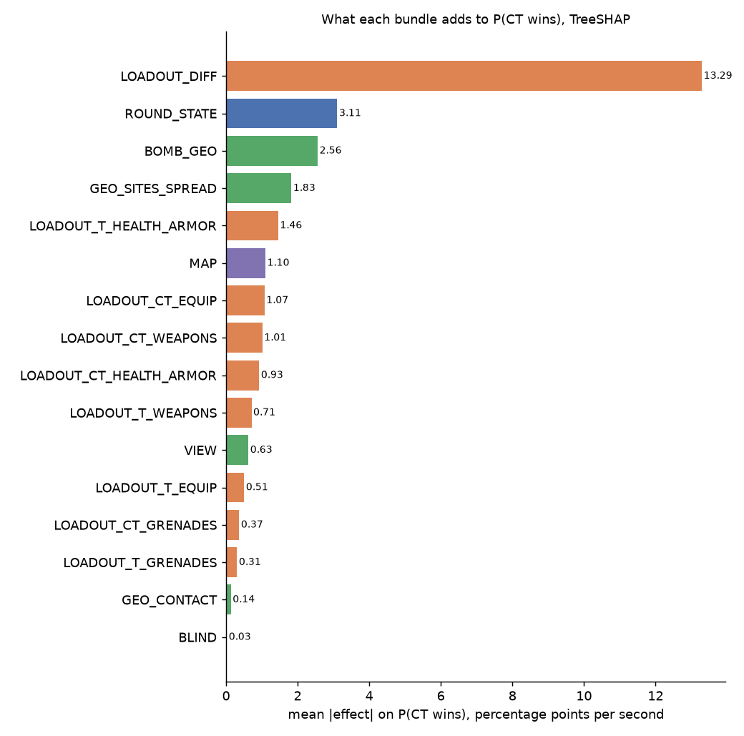
Figure 1. Mean absolute effect on P(CT wins) by bundle, in percentage points per second (validation sample).

4.2 Economy and health, in per-unit terms
A 100-HP difference in team health (CT minus T) moves the probability by about 3.7 points, and the slope is steady across the middle of its range. Each armoured player of difference is worth about 1.9 points, each rifle about 0.75 points, and each $1,000 of equipment difference about 0.37 points. Defuse slack, when the bomb is planted, adds about 0.14 points per second of slack. Appendix A.1 gives every loadout input.

4.3 What the team's metric says
On GDT the full model scores 0.0254 on 295 matches (scorer interval 0.0217 to 0.0290). Table 3 gives every drop-group and single-group retrain, paired with the full model. Negative changes mean worse than the full model, and a negative GDT means worse than the lookup table.
Feature set | Inputs | GDT (mean of 3 seeds) | GDT change vs full | Seed range of change | Log-loss change vs full
Full model (83) | 83 | 0.0254 | reference |  | reference
Non-positional (59) | 59 | 0.0205 | -0.0049 | -0.0049 to -0.0048 | +0.003433
Checklist fallback (77) | 77 | 0.0251 | -0.0003 | -0.0004 to -0.0001 | +0.000281
Minus alive counts | 80 | 0.0256 | +0.0002 | 0.0000 to +0.0003 | +0.000266
Minus armour sums | 81 | 0.0255 | +0.0001 | 0.0000 to +0.0004 | -0.000010
Minus blind | 79 | 0.0254 | 0.0000 | -0.0001 to +0.0002 | -0.000015
Minus round state | 77 | 0.0253 | -0.0001 | -0.0002 to +0.0001 | +0.000826
Minus VIEW | 79 | 0.0249 | -0.0005 | -0.0005 to -0.0004 | +0.000282
Minus bomb geometry (incl. defuse slack) | 79 | 0.0249 | -0.0005 | -0.0007 to -0.0003 | +0.000344
Loadout only (46) | 46 | 0.0098 | -0.0156 | -0.0158 to -0.0154 | +0.012896
Round state only (6) | 6 | -0.0164 | -0.0418 | -0.0418 to -0.0416 | +0.046797
Minus site and spread (74) | 74 | 0.0233 | -0.0020 | -0.0022 to -0.0019 | +0.001530
Minus contact (80) | 80 | 0.0254 | 0.0000 | -0.0002 to +0.0001 | +0.000010
Table 3. Retrain ablations scored on GDT. The scorer's interval for the full model is 0.0217 to 0.0290, so compare the changes, not the levels.
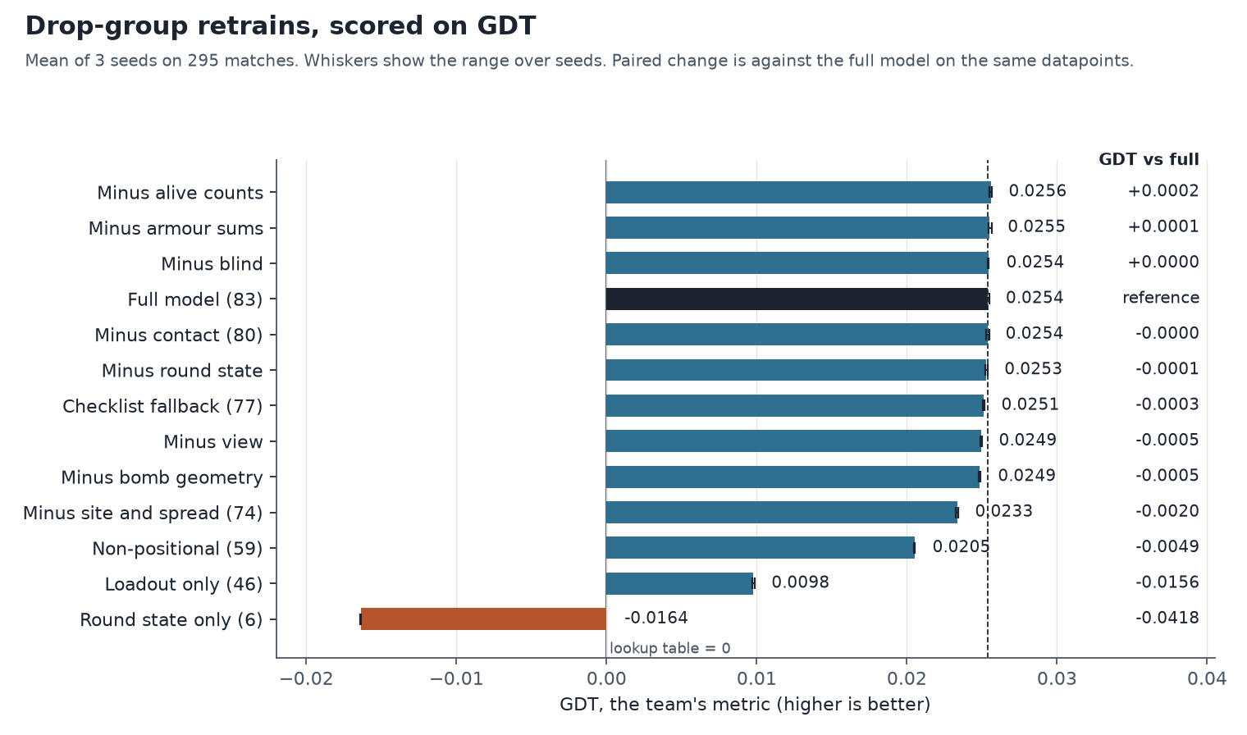
Figure 2. GDT for each feature set, mean of three seeds. Whiskers show the range over seeds. Bars below zero score worse than the lookup table.
- Alive counts add nothing on GDT. Dropping them changes GDT by +0.0002, while log loss rises by +0.00027. This is the one set where the two metrics disagree in direction.
- Armour sums and blindness are not measurable on GDT. Dropping the armour sums changes GDT by +0.0001, and dropping the BLIND inputs by 0.0000. Neither is distinguishable from zero across seeds.
- View and bomb geometry are small but consistent. Each changes GDT by about −0.0005. The bomb-geometry set includes defuse slack, so defuse slack is not tested alone.
- Loadout is most of the model. The 46 loadout inputs alone score 0.0098. Round state alone scores −0.0164, below the lookup table.

4.4 Positional and non-positional inputs
Table 4 sets the full model beside the non-positional model. The non-positional model has the 59 inputs that are not position inputs and is fitted in the same way. On log loss it is worse by +0.00343, and on GDT it scores 0.0205, a change of −0.0049 (seed range −0.0049 to −0.0048). The position inputs matter for the metric as a whole.Single-group drops are smaller than the block: site and spread costs −0.0020, bomb geometry and VIEW about 0.0005 each, and contact nothing measurable. These do not add up to the block, because the groups overlap. The 57-input submission model also has no position inputs, and its validation log loss is 0.453557 (Appendix D).
Model | Inputs | Validation log loss (mean of 3 seeds) | Log loss vs full | GDT (mean) | GDT vs full (seed range)
Full model (83): all inputs | 83 | 0.450270 | reference | 0.0254 | reference
Checklist fallback (77): no armour sums, no VIEW | 77 | 0.450551 | +0.00028 | 0.0251 | -0.0003 (-0.0004 to -0.0001)
Minus round state (77): no round state | 77 | 0.451096 | +0.00083 | 0.0253 | -0.0001 (-0.0002 to +0.0001)
Non-positional (59): no position inputs | 59 | 0.453703 | +0.00343 | 0.0205 | -0.0049 (-0.0049 to -0.0048)
Loadout only (46) | 46 | 0.463166 | +0.01290 | 0.0098 | -0.0156 (-0.0158 to -0.0154)
v6 submission model (57): no position, heavy dropped | 57 | 0.453557 | +0.00329 | not scored
Table 4. Positional and non-positional models, and the checklist fallback, on log loss and GDT. The 57-input submission model is not scored on GDT here.

4.5 The 83-input model against the 77-input variants
The team's checklist asked for the armour sums and the VIEW inputs to be removed. The 83-input model keeps them, and the disclosed fallback removes them, giving 77 inputs. The fallback changes log loss by +0.00028 and GDT by −0.0003 (seed range −0.0004 to −0.0001). A second 77-input set removes round state instead. It changes log loss by +0.00083 and GDT by −0.0001 (seed range −0.0002 to +0.0001).
Against the checklist fallback, the 83-input model is better on both measures, and the sign holds in every seed. Its GDT is higher by 0.0003 (the fallback is negative in all three seeds) and its log loss is lower by 0.00028 (positive in all three seeds). Most of the GDT loss from the fallback comes from removing the VIEW inputs, partly offset by removing the armour sums, which are close to zero on their own. The margin is small. If VIEW is rebuilt and kept, the 83-input model is the better choice on the evidence; if VIEW is removed for reliability, the fallback costs about 0.0003 GDT. Against minus round state, GDT cannot separate the two models (the difference changes sign across seeds), while log loss favours the 83-input model in every seed. The round-state group therefore adds no measurable GDT over the other inputs, but it does improve log loss, and that is the reason to keep it.

4.6 Example matches on GDT
Where does the full model beat the lookup table? Figure 3 averages the gain by alive count. The full model beats the table in 78% of the 295 matches. Figure 4 shows the spread across matches, and the paired difference between the full and non-positional models. Table 5 names four example matches chosen by the rules in Section 3.4.
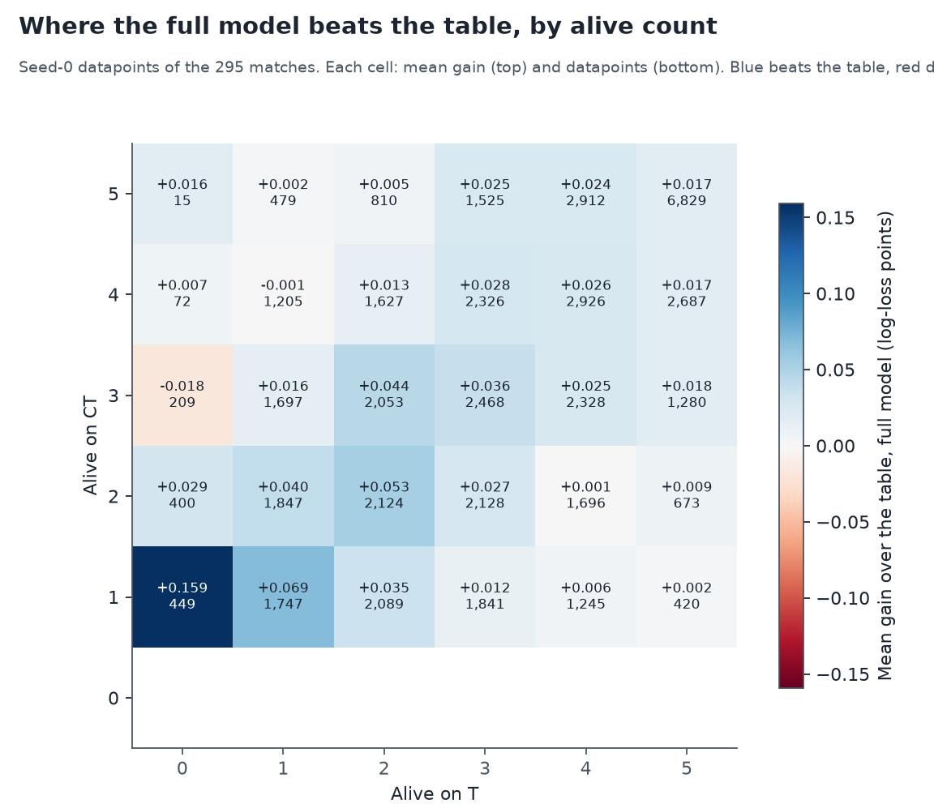
Figure 3. Mean gain over the lookup table by alive count, full model, seed-0 datapoints. Blue beats the table, red does worse; the count under each value is the number of datapoints.
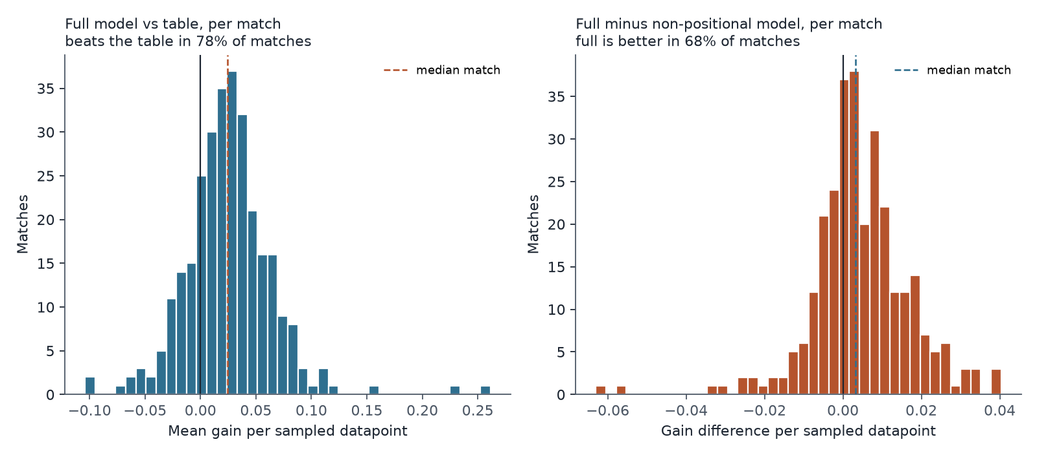
Figure 4. Per-match gain over the table for the full model (left), and the full model minus the non-positional model (right).
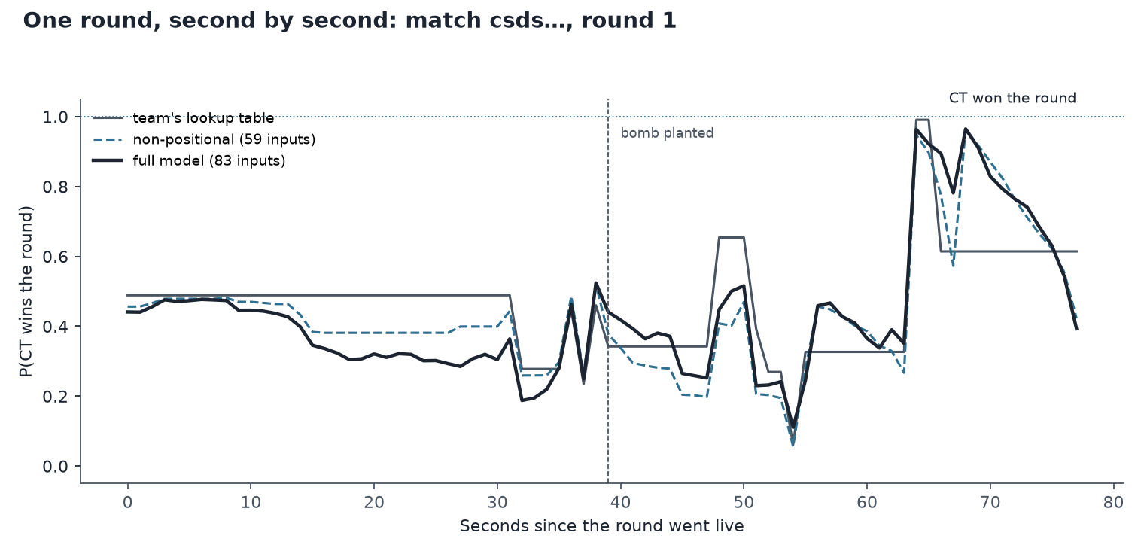
Figure 5. One round from the match where the position inputs help most, second by second. The table, the non-positional model and the full model are shown with the round's outcome.
Example | Match | Date | Sampled datapoints | Full model gain | Non-positional gain | Full minus non-positional
beats the table most | csds… | 2026-09-23 | 189 | +0.1155 | +0.1019 | +0.0136
does worst against the table | csds… | 2026-10-05 | 133 | -0.0631 | -0.0486 | -0.0145
gains most from the position inputs | csds… | 2026-09-22 | 159 | +0.1091 | +0.0689 | +0.0402
loses most from the position inputs | csds… | 2026-09-12 | 189 | +0.0265 | +0.0560 | -0.0295
Table 5. Example matches on GDT (seed-0 draw). A gain is the table's log loss minus the model's, per sampled datapoint, averaged over the match.

4.7 One prediction
The largest-loss second in the validation sample is round 2 of a match on 9 October. The model gave CT a 0.11% chance, and CT won the round. Figure 6 walks the prediction down from the average value, input by input. Team HP difference (CT has 100 HP, T has 370) and CT alive minus T alive account for most of the push against CT. Appendix E gives the four example seconds and two contrasts.
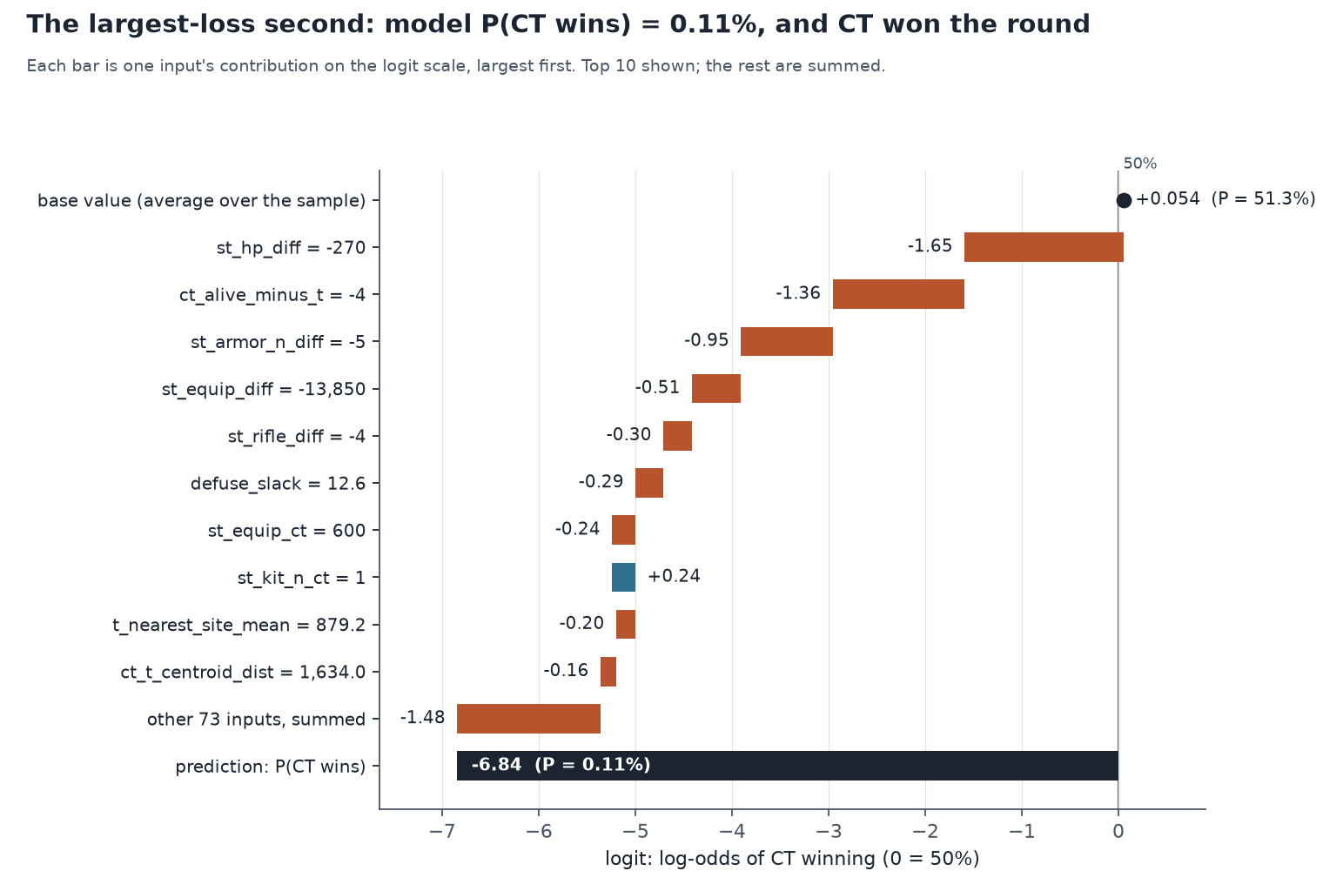
Figure 6. Contributions to the log-odds of CT winning for the largest-loss second. The base value is the average over the sample; the bars sum to the prediction.

4.8 Explaining whole matches
The waterfall in Section 4.7 explains one prediction. Matches are what people watch, so we also explain every row of three validation matches: the largest-loss match, the match where the position inputs help most on GDT, and the match where the full model does worst against the table. For each row, TreeSHAP splits the log-odds into the ten bundles of Table 1, and the bundles sum exactly to the prediction. Figure 7 shows the largest-loss match, and Appendix E.4 the other two.
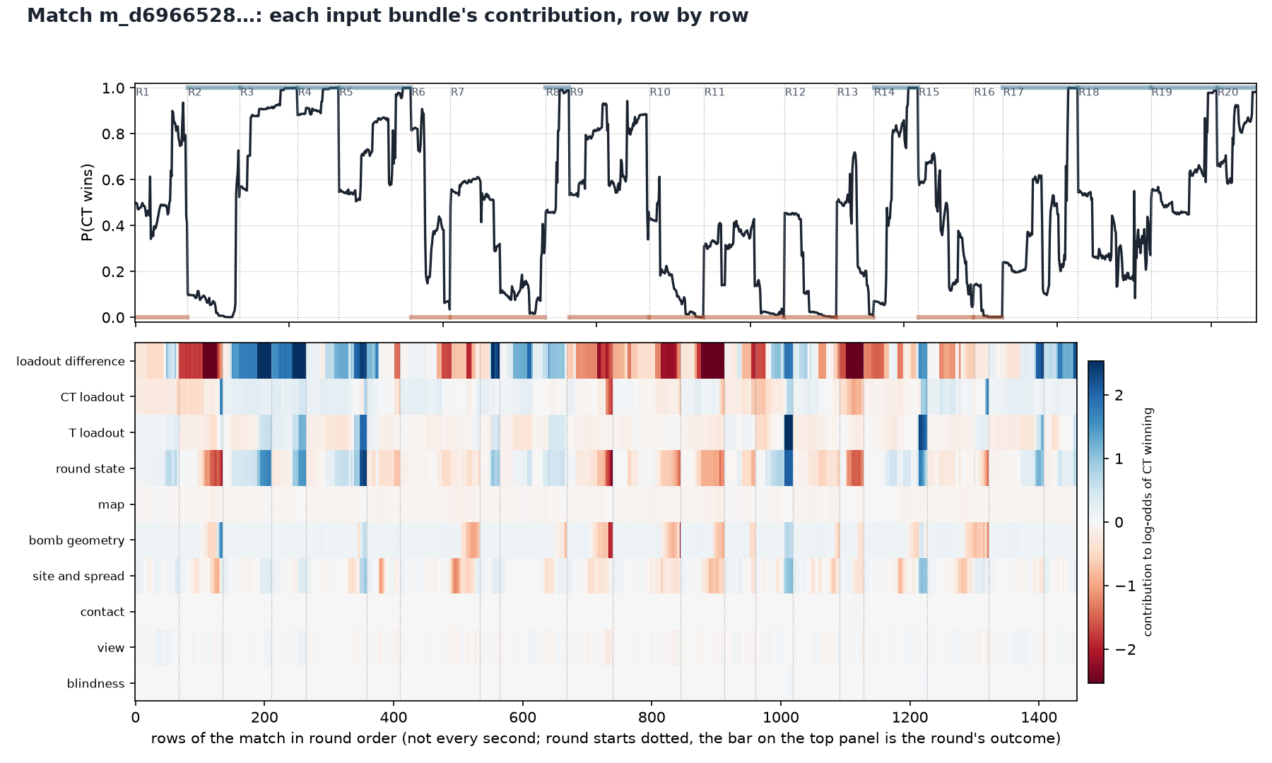
Figure 7. P(CT wins) over the largest-loss match (top), and each bundle's contribution to the log-odds for every row (bottom). Rows are the seconds the matrix holds, in round order. The bar on the top panel is the round's outcome: blue for a CT win, red for a T win.
Round | Seconds | P(CT wins) | Change | Biggest mover (log-odds) | Second mover (log-odds) | Outcome
2 | 62 to 63 | 0.06 to 0.54 | +47.7 pp | CT loadout (+1.64) | bomb geometry (+0.46) | CT won
18 | 73 to 74 | 0.55 to 0.08 | -46.6 pp | loadout difference (-1.41) | round state (-0.72) | CT won
10 | 13 to 14 | 0.61 to 0.18 | -43.1 pp | loadout difference (-1.41) | round state (-0.51) | T won
9 | 100 to 101 | 0.88 to 0.47 | -41.8 pp | loadout difference (-0.90) | round state (-0.45) | T won
17 | 81 to 82 | 0.25 to 0.66 | +40.8 pp | loadout difference (+1.00) | round state (+0.34) | CT won
Table 6. The five largest moves in P(CT wins) between consecutive rows of the largest-loss match, with the two bundles that moved most.
Bundle | Largest-loss match | Position inputs help most | Worst against the table
loadout difference | 44.2% | 39.9% | 38.3%
CT loadout | 8.9% | 9.9% | 12.2%
T loadout | 9.2% | 6.4% | 9.5%
round state | 16.9% | 12.6% | 14.2%
map | 2.5% | 2.7% | 2.8%
bomb geometry | 8.2% | 17.4% | 11.6%
site and spread | 7.5% | 8.8% | 8.4%
contact | 0.4% | 0.5% | 0.5%
view | 1.9% | 1.8% | 2.4%
blindness | 0.1% | 0.1% | 0.1%
Table 7. Share of the absolute log-odds contribution by bundle, for each match, summed over its rows.
The loadout bundles account for 62%, 56% and 60% of the absolute contribution in the three matches. The largest single move in the largest-loss match is from 6% to 54% between seconds 62 and 63 of round 2. The explanation puts most of it on the CT loadout, with bomb geometry second. A move that size in one second should be checked against the raw seconds before it is read as a game event.

4.9 Calibration
Across 1,515,228 validation seconds, the predicted probability matches the observed CT-win rate to within 0.01 in every decile (Figure 7; Appendix C.1). In the 1-versus-5 state, the model expected 1.48 CT round wins over 1,033 rounds, and CT won one. The one win is the round of the largest per-second miss, so the data do not show a calibration problem in that state.
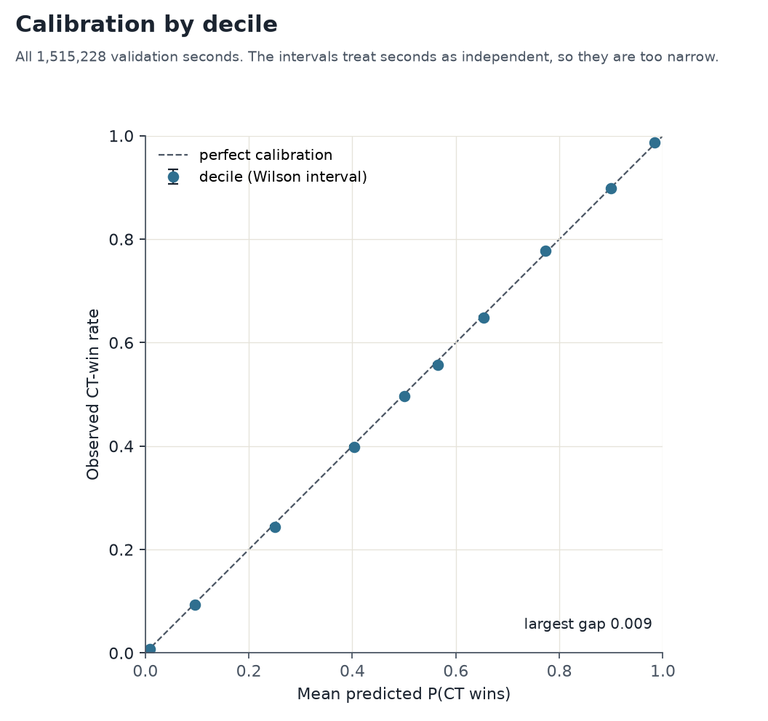
Figure 7. Calibration by decile, shipped booster, all validation seconds. The intervals treat seconds as independent, so they are too narrow.

5. Discussion

5.1 What the results suggest for the model
- The armour sums can be removed at no measurable GDT cost, as the team's notes ask. This is the cheapest change.
- The BLIND inputs have no measurable effect on GDT. Rebuild them from the player blind events before deciding whether to keep them.
- Site and spread is the largest single position group (−0.0020 GDT alone). Rebuild it first, and then retest it. Contact has no measurable effect on either metric, so it is a candidate to drop, as the BLIND inputs are.
- The VIEW inputs are flagged as unreliable, and they carry a small GDT gain. Rebuild them first, and then retest the group.
- Defuse slack is flagged as crude. It is in the bomb-geometry group, and that group's drop test cannot separate it from its neighbours. A rebuild should be tested alone.
- Retraining with weights that equalise each round's situations would align the training loss with GDT. This is the next experiment, and it is not yet run.

5.2 What the explanations do not show
Explanations describe how the model uses its inputs. They do not show that an input causes the outcome. TreeSHAP splits credit between correlated inputs, so the alive counts get little direct credit while the loadout inputs carry the signal. The drop tests are the stronger evidence for whether a group is needed, and they say little about any one input inside a group.

6. Limitations
- GDT differences are small. The paired change for a set varies by about 0.0002 to 0.0003 across seeds, so changes of that size or less should not be read as real.
- The position effect is not additive across groups. The single-group drops (site and spread −0.0020, VIEW and bomb geometry −0.0005 each, contact about zero) sum to about 0.003, against 0.0049 for all 24 together. The overlap between groups is not measured.
- GDT here uses the 295-match validation window. It is not the frozen test days, and it is not comparable to scores the scorer's README gives on other populations.
- The shipped booster is a CPU refit, and its per-row predictions differ from the sprint's GPU run by up to 0.25 (mean 0.004), though their log losses agree closely.
- The design matrix has not been regenerated from raw data, and frozen_test_keys.json was not found. The matrix is the Nov 3 build.
- The October 9 and 10 match counts disagree between the handoff and the cache, and the choice affects the training pool.

7. Conclusion
The loadout difference drives most of the model's signal, and round state and position inputs add to it. On GDT, the full model scores 0.0254. The position inputs add about 0.005 GDT as a group, mostly through site and spread; the checklist's fallback costs a little on both measures, and the round-state group adds nothing measurable on GDT but improves log loss (Section 4.5). The model is calibrated over the validation window. The remaining work is in the reproduction and the input rebuilds listed in Appendix G.

Appendices
The detailed tables that support the body. Each one is labelled with the section it supports.

Appendix A. Loadout and bundle detail

A.1 Economy and health inputs
Slope is the change in effect (percentage points) per one unit of the input. Change P10 to P90 is the mean effect of the top 10% of values minus the bottom 10%. For difference inputs, a positive slope means the CT side has more of the thing.
Input | Unit | Mean |effect| (pp/s) | Slope (pp/unit) | Change P10 to P90 (pp) | Perm. Δ log loss
st_hp_diff | team HP sum (0 to 500), CT minus T | 4.87 | +0.03746 | 11.51 | 0.0390
st_equip_diff | team equipment value (dollars), CT minus T | 3.83 | +0.0003724 | 9.60 | 0.0100
st_armor_n_diff | players carrying armor (0 to 5), CT minus T | 3.52 | +1.852 | 9.33 | 0.0121
st_rifle_diff | rifle count (0 to 5), CT minus T | 1.31 | +0.7521 | 4.27 | 0.0030
st_awp_diff | AWP count (0 to 5), CT minus T | 0.10 | +0.032 | -0.02 | 0.0002
st_smg_diff | SMG count (0 to 5), CT minus T | 0.19 | +0.2903 | 0.88 | 0.0002
st_hp_ct | team HP sum (0 to 500), CT | 0.28 | +0.001957 | 0.87 | 0.0021
st_hp_t | team HP sum (0 to 500), T | 0.87 | -0.004746 | -2.91 | 0.0039
st_equip_ct | team equipment value (dollars), CT | 1.07 | +0.0001263 | 3.50 | 0.0031
st_equip_t | team equipment value (dollars), T | 0.51 | -2.005e-05 | -0.40 | 0.0029
st_armor_n_ct | players carrying armor (0 to 5), CT | 0.01 | -0.002153 | -0.02 | 0.0000
st_armor_n_t | players carrying armor (0 to 5), T | 0.08 | -0.01591 | -0.01 | 0.0001
Table A1. Economy and health inputs. Units are from the cache definitions: HP and armour are team sums; equipment is in dollars.
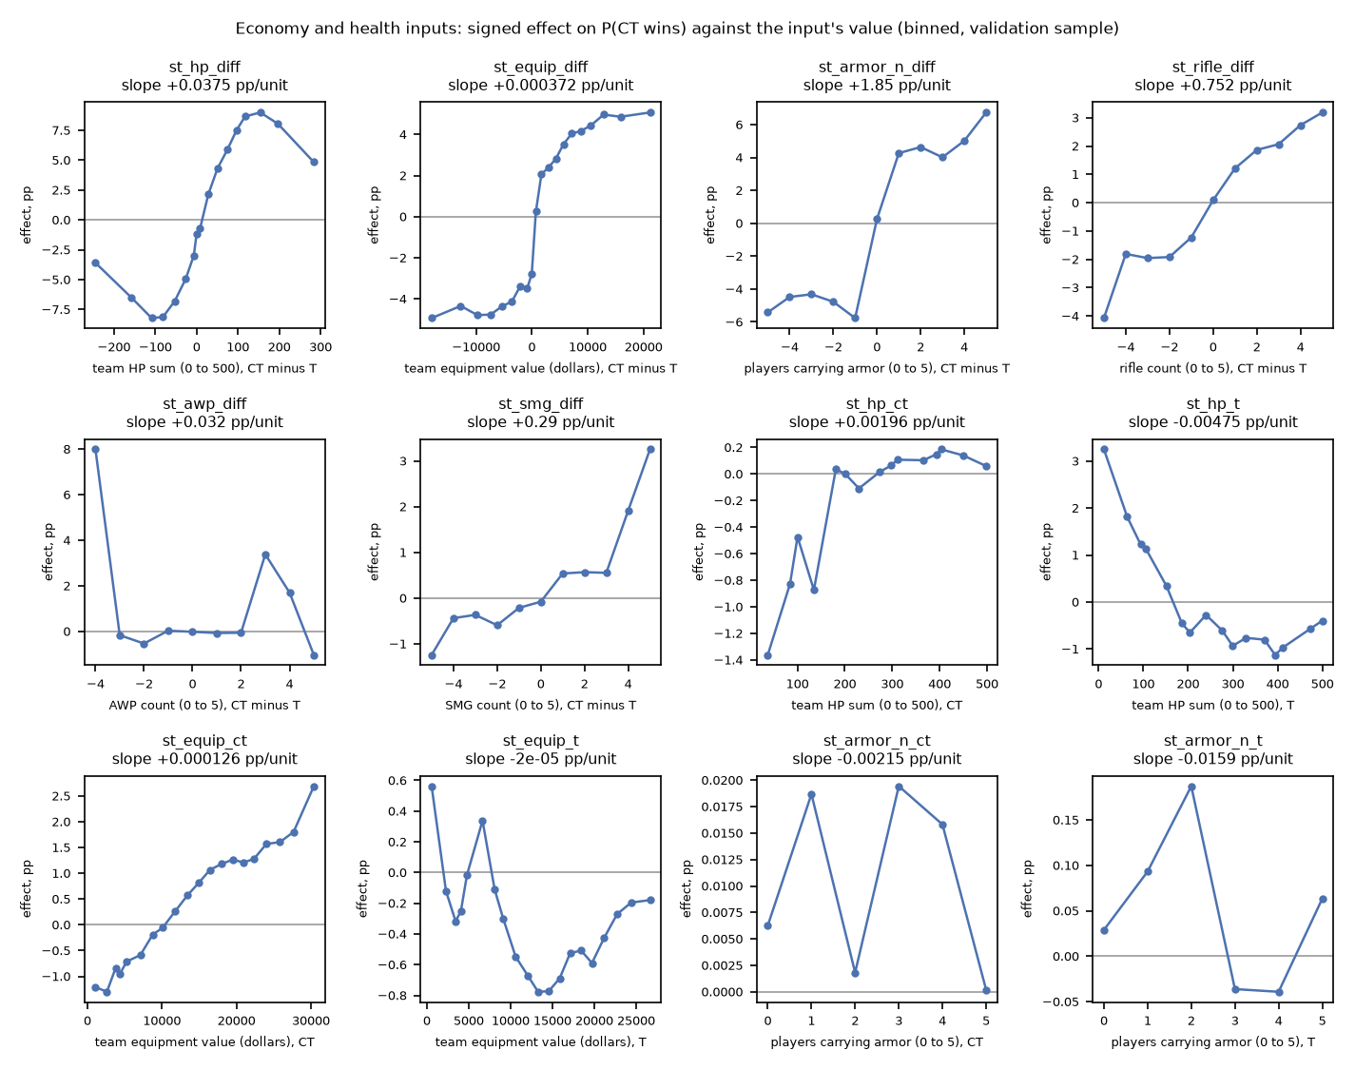
Figure A1. Signed effect on P(CT wins) against each input's value, binned (validation sample). Flagged inputs are marked in the team's notes.

A.2 Bundle totals
Bundle | Inputs | Mean |effect| (pp/s) | Mean signed (pp/s) | Perm. Δ log loss
ALL_LOADOUT | 46 | 15.81 | 0.76
LOADOUT_DIFF | 6 | 13.29 | 0.57 | 0.18432
ALL_POSITION (GEO+VIEW+BLIND) | 24 | 3.50 | 0.26
ROUND_STATE | 6 | 3.11 | 0.04 | 0.04319
BOMB_GEO | 4 | 2.56 | 0.68 | 0.11118
GEO_SITES_SPREAD | 9 | 1.83 | -0.29 | 0.00946
LOADOUT_T_HEALTH_ARMOR | 6 | 1.46 | -0.16 | 0.00765
MAP | 7 | 1.10 | 0.04 | 0.00158
LOADOUT_CT_EQUIP | 1 | 1.07 | 0.48 | 0.00300
LOADOUT_CT_WEAPONS | 8 | 1.01 | 0.08 | 0.00223
LOADOUT_CT_HEALTH_ARMOR | 6 | 0.93 | 0.14 | 0.00891
LOADOUT_T_WEAPONS | 8 | 0.71 | -0.06 | 0.00152
VIEW | 4 | 0.63 | 0.03 | 0.00099
LOADOUT_T_EQUIP | 1 | 0.51 | -0.32 | 0.00286
LOADOUT_CT_GRENADES | 5 | 0.37 | 0.01 | 0.00035
LOADOUT_T_GRENADES | 5 | 0.31 | -0.06 | 0.00038
GEO_CONTACT | 3 | 0.14 | -0.05 | 0.00010
BLIND | 4 | 0.03 | -0.00 | 0.00002
Table A2. All bundles, including the combined position and loadout totals, which have no permutation value.

Appendix B. Ablation detail

B.1 Per-seed results
Feature set | Seed | Inputs | Validation log loss | Log-loss change vs full (same seed) | Best iteration
Full model (83) | 0 | 83 | 0.450279 | 0.000000 | 2321
Full model (83) | 1 | 83 | 0.450319 | 0.000000 | 1943
Full model (83) | 2 | 83 | 0.450211 | 0.000000 | 2889
Non-positional (59) | 0 | 59 | 0.453707 | +0.003428 | 1556
Non-positional (59) | 1 | 59 | 0.453717 | +0.003398 | 1295
Non-positional (59) | 2 | 59 | 0.453685 | +0.003473 | 1536
Checklist fallback (77) | 0 | 77 | 0.450588 | +0.000309 | 2090
Checklist fallback (77) | 1 | 77 | 0.450518 | +0.000199 | 2414
Checklist fallback (77) | 2 | 77 | 0.450546 | +0.000334 | 2546
Minus alive counts | 0 | 80 | 0.450524 | +0.000244 | 2984
Minus alive counts | 1 | 80 | 0.450508 | +0.000189 | 2986
Minus alive counts | 2 | 80 | 0.450575 | +0.000364 | 2986
Minus armour sums | 0 | 81 | 0.450293 | +0.000014 | 2088
Minus armour sums | 1 | 81 | 0.450222 | -0.000096 | 2784
Minus armour sums | 2 | 81 | 0.450262 | +0.000051 | 1907
Minus blind | 0 | 79 | 0.450264 | -0.000015 | 2209
Minus blind | 1 | 79 | 0.450279 | -0.000040 | 2779
Minus blind | 2 | 79 | 0.450221 | +0.000010 | 2204
Minus round state | 0 | 77 | 0.451082 | +0.000803 | 2217
Minus round state | 1 | 77 | 0.451062 | +0.000744 | 2940
Minus round state | 2 | 77 | 0.451143 | +0.000931 | 1922
Minus VIEW | 0 | 79 | 0.450535 | +0.000255 | 2391
Minus VIEW | 1 | 79 | 0.450592 | +0.000273 | 2169
Minus VIEW | 2 | 79 | 0.450528 | +0.000317 | 2421
Minus bomb geometry (incl. defuse slack) | 0 | 79 | 0.450664 | +0.000385 | 2089
Minus bomb geometry (incl. defuse slack) | 1 | 79 | 0.450586 | +0.000267 | 2230
Minus bomb geometry (incl. defuse slack) | 2 | 79 | 0.450591 | +0.000380 | 2343
Loadout only (46) | 0 | 46 | 0.463233 | +0.012954 | 2115
Loadout only (46) | 1 | 46 | 0.463142 | +0.012823 | 2131
Loadout only (46) | 2 | 46 | 0.463122 | +0.012911 | 1806
Round state only (6) | 0 | 6 | 0.497065 | +0.046786 | 708
Round state only (6) | 1 | 6 | 0.497067 | +0.046748 | 892
Round state only (6) | 2 | 6 | 0.497068 | +0.046856 | 803
Minus site and spread (74) | 0 | 74 | 0.451771 | +0.001491 | 2333
Minus site and spread (74) | 1 | 74 | 0.451849 | +0.001530 | 2083
Minus site and spread (74) | 2 | 74 | 0.451779 | +0.001568 | 1834
Minus contact (80) | 0 | 80 | 0.450337 | +0.000058 | 2087
Minus contact (80) | 1 | 80 | 0.450316 | -0.000002 | 2041
Minus contact (80) | 2 | 80 | 0.450185 | -0.000027 | 2305
Table B1. Each retrain on each seed. The log-loss change is paired with the full model on the same seed.

B.2 Earlier sprint run (log loss only)
Feature set | Δ log loss vs base | Note
base (59 inputs) | 0 | reference
base + GEO | -0.00313 | GEO alone
base + VIEW | -0.00067 | VIEW alone
base + BLIND | -0.00002 | BLIND alone
base + GEO + VIEW | -0.00348
base + GEO + BLIND | -0.00312
base + VIEW + BLIND | -0.00066
full (83 inputs) | -0.00344 | all position groups
Table B2. Earlier sprint run of the position groups (eta 0.05, base of 59 inputs, three seeds). Superseded for decisions by Table 3; kept for the record. Negative means better than base.

Appendix C. Calibration detail

C.1 Deciles
Decile | Seconds | Mean predicted P(CT wins) | Observed CT win rate | Observed 95% interval | Observed minus predicted
1 | 151,523 | 0.0089 | 0.0082 | 0.0077 to 0.0087 | -0.0007
2 | 151,523 | 0.0964 | 0.0926 | 0.0912 to 0.0941 | -0.0038
3 | 151,523 | 0.2498 | 0.2443 | 0.2422 to 0.2465 | -0.0055
4 | 151,523 | 0.4029 | 0.3984 | 0.3960 to 0.4009 | -0.0045
5 | 151,523 | 0.5006 | 0.4961 | 0.4936 to 0.4986 | -0.0045
6 | 151,523 | 0.5657 | 0.5567 | 0.5542 to 0.5592 | -0.0091
7 | 151,523 | 0.6535 | 0.6481 | 0.6457 to 0.6505 | -0.0053
8 | 151,523 | 0.7728 | 0.7771 | 0.7750 to 0.7792 | +0.0043
9 | 151,522 | 0.8990 | 0.8988 | 0.8973 to 0.9003 | -0.0002
10 | 151,522 | 0.9834 | 0.9864 | 0.9858 to 0.9869 | +0.0029
Table C1. Calibration deciles for the shipped booster. The largest gap is 0.009, in decile 6. Wilson intervals treat seconds as independent, so they are too narrow.

C.2 Round level, 1-versus-5 states
Per round: expected is the sum over rounds of each round's mean predicted probability; observed is the number of rounds CT won.
1-versus-5 state | Rounds | Matches | Expected CT round wins | Observed CT round wins
Any 1v5 state (either bomb status) | 1,033 | 652 | 1.48 | 1
Bomb planted | 580 | 436 | 0.59 | 1
No bomb planted | 724 | 520 | 1.30 | 0
Table C2. Round-level 1-versus-5 check. The one CT win in the planted state is the same round as the largest per-second miss. A round can count in both bomb states, so the rows do not add to the first row.

Appendix D. The 57-input submission model
Model winprob_v6_drop_heavy: 57 inputs, no position inputs, heavy weapons dropped. Best iteration 1029. Validation log loss 0.453557 on all 1,515,228 validation seconds. It was explained on the same 100,000 seconds as the 83-input model, so the bundle columns compare the two on identical rows.
- Without the position inputs, round state takes more of the signal: 4.7 points against 3.1, and its permutation cost is 0.125 log loss against 0.043.
- The bomb-timing inputs take over what defuse slack and bomb distance did in the 83-input model. Their permutation values are inflated by the −1 sentinel used when no bomb is planted.
- The economy inputs barely change: LOADOUT_DIFF is 13.3 points in the 83-input model and 14.1 in the 57-input model.
Bundle | 83-input |effect| (pp/s) | 57-input |effect| (pp/s) | 83-input perm. Δ | 57-input perm. Δ
ALL_LOADOUT | 15.81 | 16.84
LOADOUT_DIFF | 13.29 | 14.07 | 0.1843 | 0.2092
ALL_POSITION (GEO+VIEW+BLIND) | 3.50
ROUND_STATE | 3.11 | 4.72 | 0.0432 | 0.1249
BOMB_GEO | 2.56 |  | 0.1112
GEO_SITES_SPREAD | 1.83 |  | 0.0095
LOADOUT_T_HEALTH_ARMOR | 1.46 | 1.28 | 0.0077 | 0.0063
MAP | 1.10 | 0.72 | 0.0016 | 0.0005
LOADOUT_CT_EQUIP | 1.07 | 1.02 | 0.0030 | 0.0030
LOADOUT_CT_WEAPONS | 1.01 | 0.90 | 0.0022 | 0.0017
LOADOUT_CT_HEALTH_ARMOR | 0.93 | 1.18 | 0.0089 | 0.0124
LOADOUT_T_WEAPONS | 0.71 | 0.81 | 0.0015 | 0.0019
VIEW | 0.63 |  | 0.0010
LOADOUT_T_EQUIP | 0.51 | 0.55 | 0.0029 | 0.0043
LOADOUT_CT_GRENADES | 0.37 | 0.40 | 0.0003 | 0.0003
LOADOUT_T_GRENADES | 0.31 | 0.37 | 0.0004 | 0.0005
GEO_CONTACT | 0.14 |  | 0.0001
BLIND | 0.03 |  | 0.0000
Table D1. Bundle effects, 83-input and 57-input models, on the same validation seconds.
Input | Bundle | Mean |effect| (pp/s) | Mean signed (pp/s) | Perm. Δ log loss
st_hp_diff | LOADOUT_DIFF | 5.04 | 0.17 | 0.0428
st_equip_diff | LOADOUT_DIFF | 3.99 | 0.01 | 0.0106
st_armor_n_diff | LOADOUT_DIFF | 3.72 | 0.03 | 0.0113
ct_alive_minus_t | ROUND_STATE | 2.84 | -0.01 | 0.0222
seconds_since_plant | ROUND_STATE | 1.79 | 0.26 | 0.0591
st_rifle_diff | LOADOUT_DIFF | 1.38 | -0.06 | 0.0034
bomb_planted | ROUND_STATE | 1.23 | 0.21 | 0.0041
st_equip_ct | LOADOUT_CT_EQUIP | 1.02 | 0.39 | 0.0030
st_hp_t | LOADOUT_T_HEALTH_ARMOR | 0.88 | -0.03 | 0.0033
st_kit_n_ct | LOADOUT_CT_HEALTH_ARMOR | 0.70 | 0.02 | 0.0019
st_equip_t | LOADOUT_T_EQUIP | 0.55 | -0.20 | 0.0044
st_armor_sum_ct | LOADOUT_CT_HEALTH_ARMOR | 0.54 | 0.31 | 0.0041
st_ak_t | LOADOUT_T_WEAPONS | 0.50 | -0.11 | 0.0007
st_armor_sum_t | LOADOUT_T_HEALTH_ARMOR | 0.49 | -0.35 | 0.0022
st_rifle_ct | LOADOUT_CT_WEAPONS | 0.44 | 0.05 | 0.0003
alive_t | ROUND_STATE | 0.43 | -0.04 | 0.0055
seconds_since_round_live | ROUND_STATE | 0.40 | 0.01 | 0.0023
map_is_mirage | MAP | 0.38 | 0.00 | 0.0000
st_no_primary_ct | LOADOUT_CT_WEAPONS | 0.29 | -0.03 | 0.0003
st_smg_diff | LOADOUT_DIFF | 0.27 | -0.01 | 0.0003
Table D2. The 20 largest inputs in the 57-input model.

Appendix E. Local explanations

E.1 Four example seconds
Four seconds from the 100,000-second sample, chosen by fixed rules (recorded in local/local_explain_meta.json). The waterfall for each is in local/.
Example | Round | Second | CT won (1 = yes) | P(CT wins) | Logit z | Log loss
largest_loss | 2 | 52 | 1 | 0.1065% | -6.84 | 6.845
confident_ct_win | 23 | 100 | 1 | 99.9992% | 11.74 | 0.000
confident_t_win | 2 | 71 | 0 | 2.09e-5% | -15.38 | 0.000
close_call | 18 | 49 | 0 | 50.0001% | 0.00 | 0.693
Table E1. The example seconds with their log-loss and probability fields.

E.2 Contrasts between the two confident calls
The two confident calls are P = 99.999% for CT and P = 0.00002% for T. The logit gap is 27.1, and the per-input differences sum to it exactly.
Rank | Input | Bundle | Value (CT call) | Value (T call) | Difference in logit
1 | defuse_slack | BOMB_GEO | 24.1 | -20.4 | +4.59
2 | st_hp_diff | LOADOUT_DIFF | 393.0 | -326.0 | +2.95
3 | ct_alive_minus_t | ROUND_STATE | 4.0 | -4.0 | +2.72
4 | c_min_bomb_dist | BOMB_GEO | 6.5 | 2,431.1 | +2.05
5 | st_armor_n_diff | LOADOUT_DIFF | 4.0 | -5.0 | +1.94
6 | seconds_since_plant | ROUND_STATE | 10.2 | 40.7 | +1.85
Table E2. The six largest per-input contributions to the logit gap between the two calls.

E.3 Interactions between inputs
Pairwise SHAP interaction values on 2,000 validation seconds, for the eight largest pairs. The interactions are small beside the main effects: the largest pair, seconds since the plant with defuse slack, averages 0.039 log-odds. The standard total pair effect is twice the value in the table.
Rank | Input A | Input B | Mean |interaction| (log-odds) | Mean |SHAP| A | Mean |SHAP| B
1 | seconds_since_plant | defuse_slack | 0.039 | 0.06 | 0.24
2 | st_hp_diff | st_armor_n_diff | 0.034 | 0.48 | 0.33
3 | ct_alive_minus_t | st_armor_n_diff | 0.033 | 0.30 | 0.33
4 | c_min_bomb_dist | defuse_slack | 0.030 | 0.13 | 0.24
5 | st_defusing_ct | defuse_slack | 0.030 | 0.04 | 0.24
6 | st_equip_diff | st_armor_n_diff | 0.030 | 0.29 | 0.33
7 | t_nearest_site_mean | ct_t_centroid_dist | 0.028 | 0.15 | 0.08
8 | st_hp_diff | st_equip_diff | 0.025 | 0.48 | 0.29
Table E3. Largest pairwise SHAP interactions in the validation sample (local/interactions_top_pairs.csv). The file reports xgboost's off-diagonal entry.

E.4 The other two matches
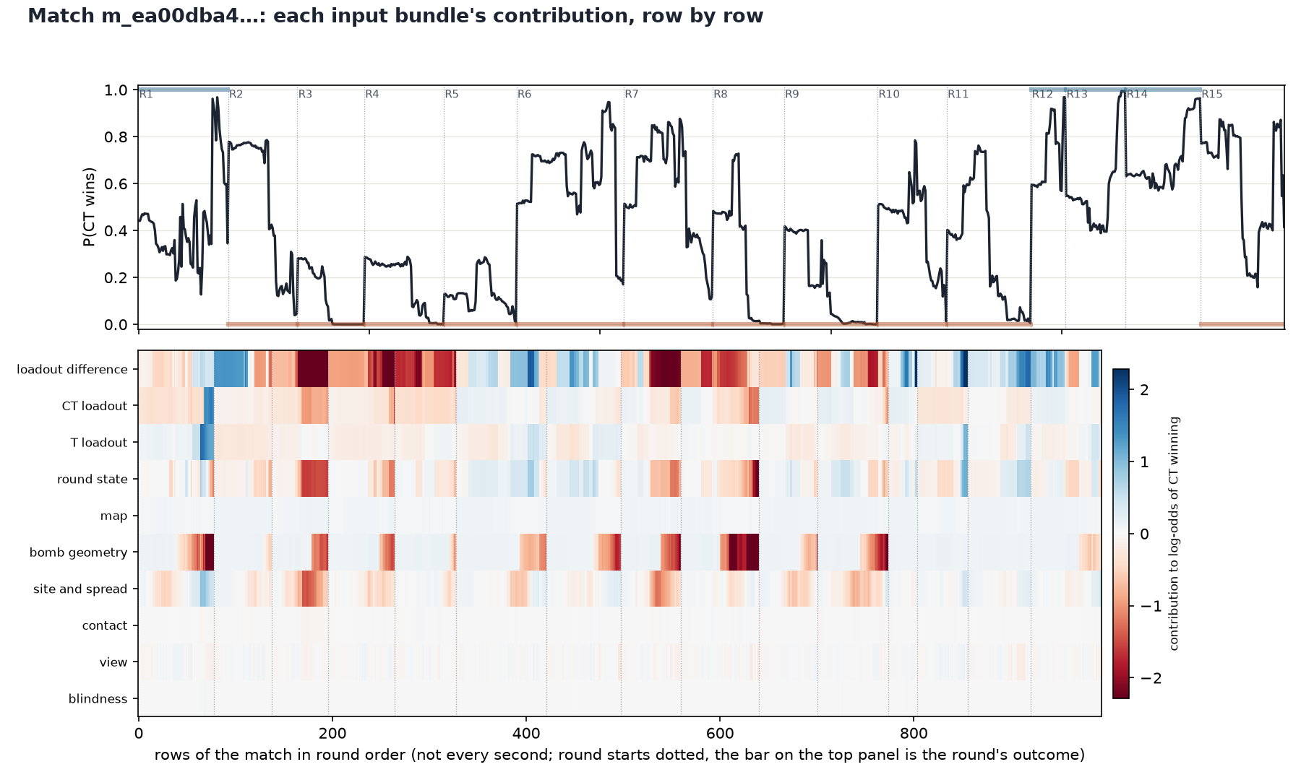
Figure E4. The match where the position inputs help most on GDT: each bundle's contribution, row by row.
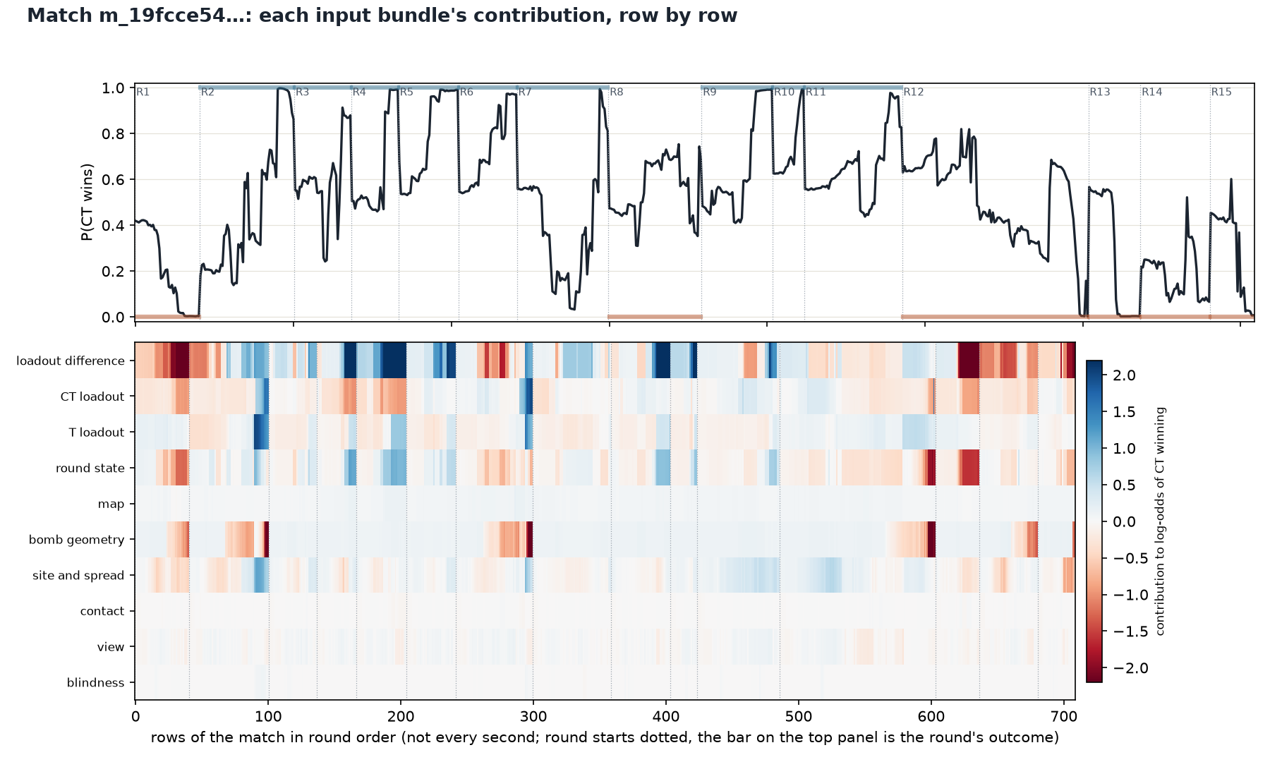
Figure E5. The match where the full model does worst against the table.

Appendix F. Example matches and the GDT datapoints
The full population has 295 matches and 50,107 sampled datapoints for seed 0. The median match gains +0.0243 GDT per sampled datapoint.
Example | Match | Date | Sampled datapoints | Full model gain | Non-positional gain | Full minus non-positional
beats the table most | csds… | 2026-09-23 | 189 | +0.1155 | +0.1019 | +0.0136
does worst against the table | csds… | 2026-10-05 | 133 | -0.0631 | -0.0486 | -0.0145
gains most from the position inputs | csds… | 2026-09-22 | 159 | +0.1091 | +0.0689 | +0.0402
loses most from the position inputs | csds… | 2026-09-12 | 189 | +0.0265 | +0.0560 | -0.0295
Table F1. The example matches in Table 5, with every field.
The plain mean of each model's gain over the sampled datapoints equals the scorer's own GDT to four decimal places. The check is run in gdt_examples.py against summary.json for seed 0.

Appendix G. Open items and reconciliation
- Reproduce the design matrix from the raw tomes. sprint_prepare.py has not been rerun, frozen_test_keys.json is not on this machine, and the builder of cache_pos_2026_trainctr.parquet is not identified.
- Reconcile October 9 and 10. The handoff gives 2,598 matches for these days, and the training cache has 4,865.
- Rebuild the flagged inputs from the team's notes: VIEW (sees-enemy and exposed), BLIND (from player blind events) and defuse slack (time to reach and defuse). Then rerun the explanation.
- The Oct 26 to 31 holdout has one recorded read from an earlier candidate and no new scoring. Any new read needs a pre-registration pin and an explicit go-ahead.
- The deep model has a handoff only (handover/deep-model/README.md). No training has run.

Appendix H. Reproduction
The data is not in git. Where each input lives is in handover/explainability/README.md. The commands, in order:
- Explanation: xgb83_explain.py (train, explain, report), feature_curves.py, feature_curve_figs.py, xgb83_local.py, xgb57_explain.py, xgb83_calibration.py.
- Ablations (WSL, GPU): xgb83_drop_ablation.py, which now also fits no_position and checklist_77.
- GDT: xgb83_gdt.py, then xgb83_ablation_report.py, then gdt_examples.py.
- Figures and report: readme_figs.py, then prep_docx_data.py, then build_docx.js.

