**Audit Report Of Wbtcprice.io**

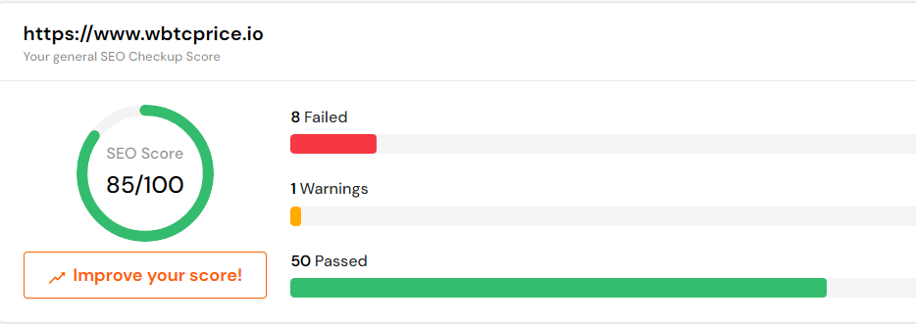

**Site Loading Speed Test**- Your website loading time is around 19.03 seconds and is over the average loading speed which is 5 seconds.

**HTML Page Size Test** - The size of your webpage's HTML is 53.22 Kb, and is greater than the average size of 33 Kb. This can lead to slower loading times, lost visitors, and decreased revenue. Good steps to reduce HTML size include: using HTML compression, CSS layouts, external style sheets, and moving javascript to external files.

**Image Alt Test -** Your webpage is using "img" tags with empty or missing "alt" attribute.

**Responsive Image Test -** Not all images in this page are properly sized! You are serving images that are larger than needed for the size of the user's viewport.