CURRICULUM VITAE

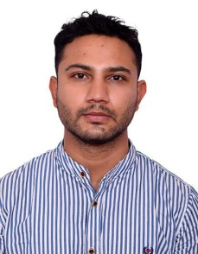

Dr. Kshiteez Puri (Orthopedic Surgeon)

NBMS (National Board of Medical Specialist

Equivalent to MS from Tribhuvan University
📍 Address: Bairiya (R.N.P- 10 ) , Chitwan
📞 Contact No.: +977 9866366061
📧 Email: kshiteez_puri@outlook.com
🩺 Nepal Medical Council Registration No.: 23651

PROFESSIONAL SUMMARY
I am a Orthopedic Surgeon with structured training in diagnosis and management of musculoskeletal disorders, trauma, and orthopedic surgical care. Trained at a tertiary care center with hands-on experience in OPD, IPD, emergency services, and operative assistance.

EDUCATIONAL QUALIFICATIONS
- NBMS – Orthopedics
National Board of Medical Specialist (Equivalent to Tribhuvan University – TU)
Grande International Hospital, Nepal
Year of Completion: 2025
- MBBS
Institution: Taishan Medical University
Study duration Year: 2012 ( Nov) – 2018 (Nov )

CLINICAL TRAINING & EXPERIENCE
Orthopedics Trainee / Resident
Grande International Hospital, Nepal
Duration: 3 years
- Evaluation and management of orthopedic OPD and IPD patients
- Exposure to trauma, fracture management, and emergency orthopedic care
- Assisted in elective and emergency orthopedic surgeries
- Pre-operative assessment and post-operative patient management
- Participation in ward rounds, academic sessions, and case discussions

CORE COMPETENCIES & SKILLS
- Orthopedic clinical examination and diagnosis
- Fracture management and immobilization techniques
- Trauma and emergency orthopedic care
- Pre- and post-operative patient management
- Assisting in orthopedic surgical procedures

RESEARCH / PUBLICATIONS
Case Report - ( Myocystecercosis in Hand ) published in Grande medical journa

PERSONAL DETAILS
- Date of Birth: Jan 26 1994
- Gender: Male
- Nationality: Nepalese
- Languages Known: Nepali , English , Hindi and Chinese ( Mainland Mandarin )

REFERENCES
Dr Binod Bijukacche
Dr Hemant Gupta

