Jonathan Lewis | Ian Davies | Jacob Schwartz

Design Patterns Final

Team Eagle Plaid

Game Description

Our game is based on Adventure Time, developed in MonoGame, XNA and C#. The game supports 1 to 2 players and each person may choose from a selection of characters at the beginning menu and play through the dungeon.

We went with a classic Zelda / Gauntlet style feel for the game. The characters and enemies move and attack each other in real time. The ultimate goal of the game is for the players to reach the exit in the map alive. If all players die before reaching the exit, the game is lost.

The game was developed in MonoGame and the XNA Framework through .NET C#.

Game Play

# Controls

## Player 1

Movement: WASD Keys

Attack: Space

Pick-up Item: E

## Player 2

Movement: Arrow Keys

Attack: Right-Ctrl

Pick-up Item: Right Shift

## Other

Toggle Debug Display: ~ key

This displays information on the players, and the map (such as the end goal)

Pause: ESC

Exit: F4

# Player Selection

When the game starts, players may choose the characters to use at the menu. Up to 2 players may be in the map at once.

# Goal

The goal of this game is to reach the finish alive.

# Game1

# Menu

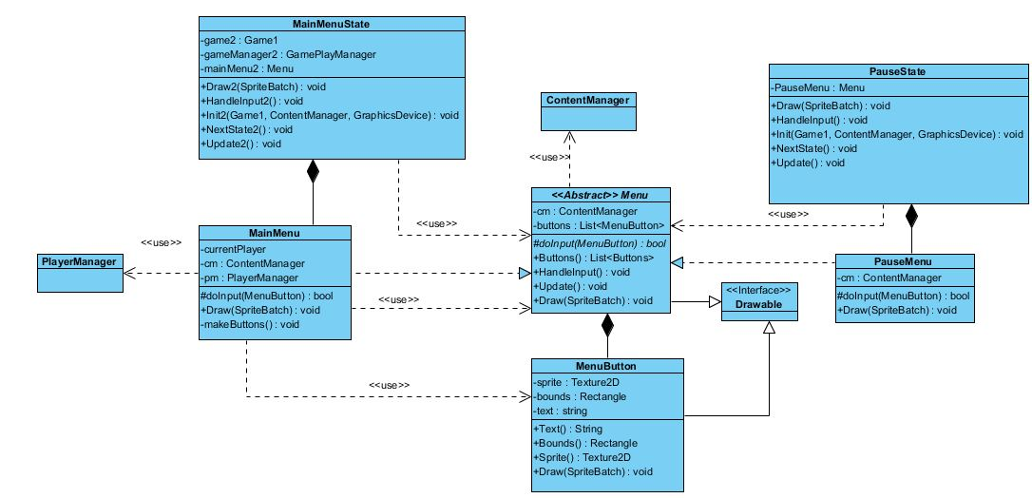

# Map Generation

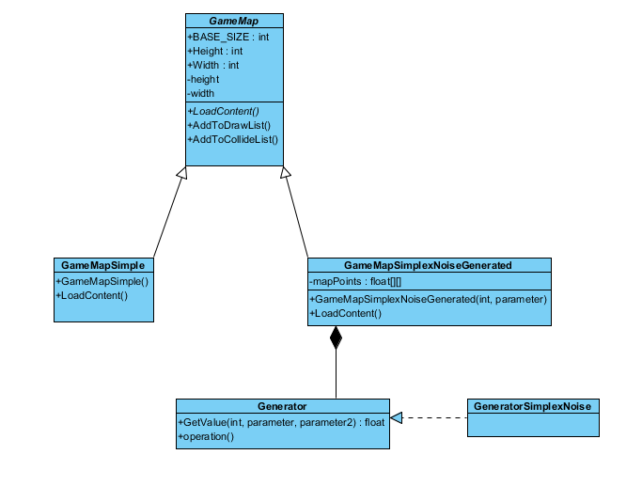

# Game State

