**Assignment 4**

**Instruction:** Put your answers, source codes, and/or figures in your report file and save it as a PDF file. Then, submit your PDF file via the online submission system in the class website by 11.59 PM of September 24, 2020.

1. Consider a discrete-time system described by the difference equation



* 1. Find the transfer function *H*(*z*).

**Ans**

We take the Z-transform to the difference equation. We obtain that

* 1. Write down the form of the natural mode terms of this system.

**Ans**

The natural modes are generated by the poles of $H(z)$.

$$H\left(z\right)=\frac{2z^{-1}-1.6z^{-2}}{1-z^{-1}+0.24z^{-2}} \\ H\left(z\right)=\frac{2z-1.6}{z^{2}-z+0.24} \\ H\left(z\right)=\frac{2(z-0.8)}{(z-0.6)(z-0.4)}$$

So, the natural modes of the system are .

* 1. Find the zero-state response to the step input 

**Ans**

Firstly, we find the Z-transform of $x\left(k\right)$

$$X\left(z\right)=\frac{10z}{z-1}$$

The zero-state response can be evaluated by

$$Y\left(z\right)=H\left(z\right)X\left(z\right) \\ Y\left(z\right)=\frac{2\left(z-0.8\right)}{\left(z-0.6\right)\left(z-0.4\right)}×\frac{10z}{z-1} \\ Y\left(z\right)=\frac{20z\left(z-0.8\right)}{(z-0.6)(z-0.4)(z-1)}$$

To find $y(k)$, we have to take the inverse of Z-transform. In this case, we should the partial fraction technique.

* 1. Find the zero-state response to the causal exponential input  Does a forced mode term appear in *y*(*k*)? If not, why not?

**Ans**

$$X\left(z\right)=\frac{z}{z-0.8}$$

$$Y\left(z\right)=H\left(z\right)X\left(z\right) \\ Y\left(z\right)=\frac{2\left(z-0.8\right)}{\left(z-0.6\right)\left(z-0.4\right)}×\frac{z}{z-0.8} \\ Y\left(z\right)=\frac{2z}{\left(z-0.6\right)\left(z-0.4\right)} \\ Y\left(z\right)=2\left(\frac{3}{z-0.6}-\frac{2}{z-0.4}\right)$$

The zero-state response is

$$y\left(k\right)=2\left[3{\left(0.6\right)}^{k}-2{\left(0.4\right)}^{k}\right]μ\left(k\right).$$

The forced mode does not appear in $y(k)$ because it is suppressed by the zero of the transfer functions.

* 1. Find the zero-state response to the causal exponential input  Is this an example of harmonic forcing? Why or why not?

**Ans**

$$X\left(z\right)=\frac{z}{z-0.4}$$

$$Y\left(z\right)=\frac{2\left(z-0.8\right)}{\left(z-0.6\right)\left(z-0.4\right)}×\frac{z}{z-0.4} \\ Y\left(z\right)=\frac{2z\left(z-0.8\right)}{\left(z-0.6\right){\left(z-0.4\right)}^{2}}$$

$$Y\left(z\right)=2\frac{z^{2}-0.8z}{\left(z-0.6\right){\left(z-0.4\right)}^{2}} \\ y\left(k\right)=\left[Res\left(0.6,k\right)+Res\left(0.4,k\right)\right]μ\left(k-1\right)$$

$$y\left(k\right)=\left[\frac{2\left(0.6\right)\left(0.6-0.8\right){\left(0.6\right)}^{k-1}}{\left(0.6-0.4\right)}+2\frac{d}{dz}{\left(\frac{\left(z^{2}-0.8z\right)z^{k-1}}{z-0.6}\right)}_{z=0.4}\right]μ\left(k-1\right) \\ y\left(k\right)={\left[-\frac{6}{5}{\left(0.6\right)}^{k-1}+2{\left.\frac{\left(z-0.6\right)\left(\left(k+1\right)z^{k}-0.8kz^{k-1}\right)-(z^{k+1}-0.8z^{k})}{{\left(z-0.6\right)}^{2}}\right|}_{z=0.4}\right]}_{ }μ\left(k-1\right) \\ y\left(k\right)=\left[-\frac{6}{5}{\left(0.6\right)}^{k-1}+2\frac{\left(-0.2\right)(\left(k+1\right){\left(0.4\right)}^{k}-0.8k{\left(0.4\right)}^{k-1})-{\left(0.4\right)}^{k+1}+0.8{\left(0.4\right)}^{k})}{{\left(0.2\right)}^{2}}\right]μ\left(k-1\right) \\ y\left(k\right)=\left[-2{\left(0.6\right)}^{k}+10\left(k+1\right){\left(0.4\right)}^{k}\right]μ(k-1)$$

It appears that $y\left(k\right)$ is stable because the ${0.4}^{k}$ is going to 0 faster than $k+1$. The $y(k)$ is stable. I think that this is not the example of the harmonic forcing.

$$\lim_{k→∞}{\frac{k+1}{{0.4}^{-k}}=\lim_{k→∞}{\frac{k+1}{e^{-klog⁡(0.4)}}=\lim_{k→∞}{\frac{1}{-\log\left(0.4\right)e^{-k\log{0.4}}}}=0}}$$

1. Consider a discrete-time system described by the following transfer function.



* 1. Suppose the zero-state response to an input  is  Find 

**Ans**

* 1. Find 

**Ans**

$$X\left(z\right)=\frac{1}{3}\left[\frac{3}{z-1}-\frac{\frac{4}{5}}{z-0.4}\right] \\ x\left(k\right)=\frac{1}{3}\left[3-\frac{4}{5}{\left(0.4\right)}^{k}\right]μ\left(k\right) \\ x\left(k\right)=\left[1-\frac{4}{15}{\left(0.4\right)}^{k}\right]μ\left(k\right).$$

1. Consider the following discrete-time signal 
   1. Find 

**Ans**

Firstly, we construct the transformation matrix $W$

$$W_{ij}=W_{4}^{ij}$$

where, and .

So,

* 1. Compute the magnitude spectrum 

**Ans**

Magnitude spectrum is

So,

* 1. Compute the phase spectrum 

**Ans**

The phase spectrum is that

* 1. Compute the power density spectrum 

**Ans**

So,

* 1. Verify the Parseval’s identity in this case.

**Ans**

We need to show that

$$\sum_{k=0}^{N-1}{{\left|x\left(k\right)\right|}^{2}=\frac{1}{N}\sum_{i=0}^{N-1}{{\left|X\left(i\right)\right|}^{2}}} \\ 1^{2}+2^{2}+1^{2}+0^{2}=\frac{1}{4}\left(4^{2}+{\left|-2i\right|}^{2}+0^{2}+{\left|2i\right|}^{2}\right) \\ 6=\frac{1}{4}\left(16+4+0+4\right) \\ 6=6$$

The Parseval’s identity is verified.

1. Let  be a periodic pulse train of period *T*0 = 1. Suppose the pulse amplitude is *a* = 10 and the pulse duration is  as shown in Figure 1. This signal can be represented by the Fourier series



Write a program that uses the DFT to compute the value of the coefficients *d*0 and  for  Plot *di* and *θi* using the function stem.



Figure 1. Periodic pulse train.

**Ans**

The code to compute $d_{0}$ and $θ_{i}$ is shown as the following figures.

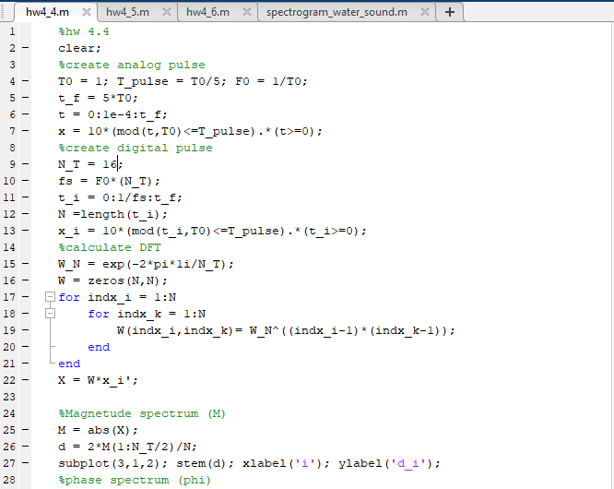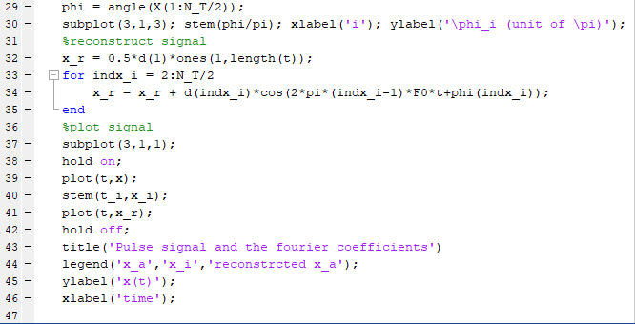

The results are shown in the below figure.

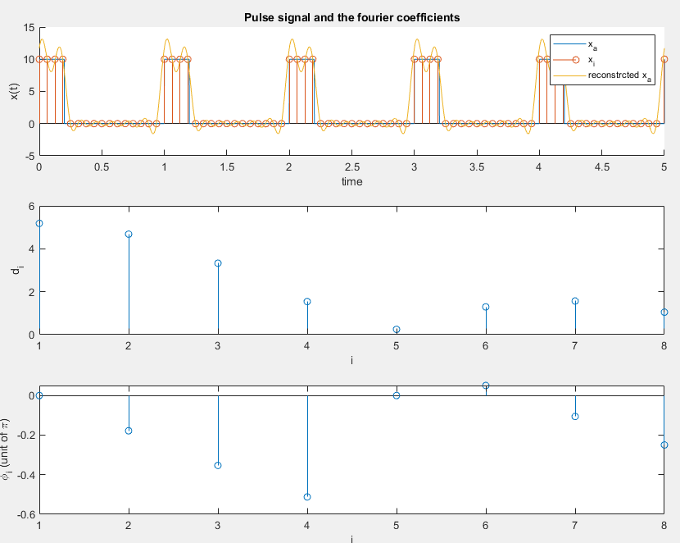

1. Consider the following noisy periodic signal with a sampling frequency of *fs* = 1600 Hz and *N* = 1024.



Here *v*(*k*) is zero-mean Gaussian white noise with a standard deviation of  Write a program that performs the following tasks.

* 1. Compute and plot the power density spectrum  for .

**Ans**

The code to compute the power density spectrum is shown as the following figures.

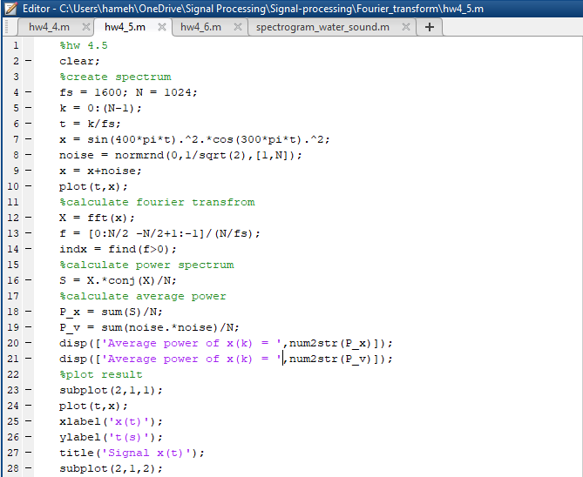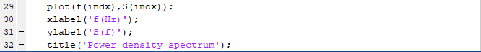

The signal and the power spectrum are shown in the below figure. It appears that there are four outstanding peaks at 100 Hz, 300 Hz, 400 Hz, and 700 Hz.

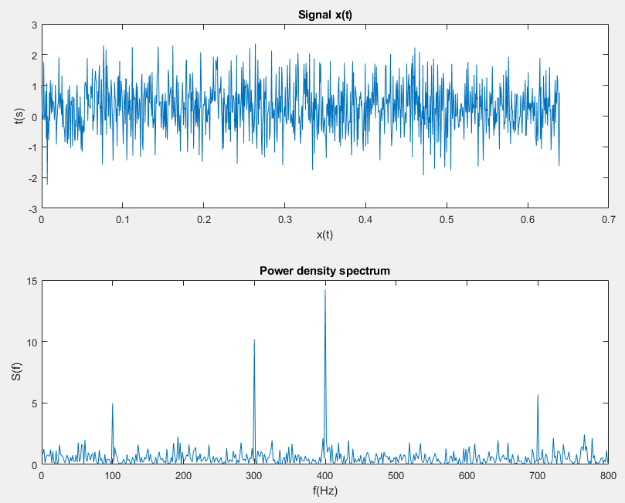

* 1. Compute and print the average power of *x*(*k*) and the average power of *v*(*k*).

**Ans**

We print the average power of $x(k)$ and $v(k)$ in the following figure.

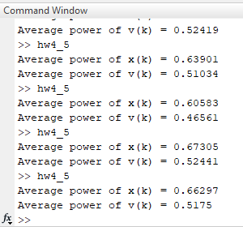

It appears that the average power of the noise is closed to the given signal. However, we can distinguish between the noise and the signal clearly by observing the power density spectrum.

1. Compute a spectrogram of the Happy Birthday signal (hbd.mp3) using a Hanning window of length *L* = 4000. Hint: Modify the example code spectrogram_water_sound.m and adjust the color scale appropriately so that we can clearly see the pattern in the computed spectrogram.

**Ans**

The code to compute the spectrogram is shown in the following figure.

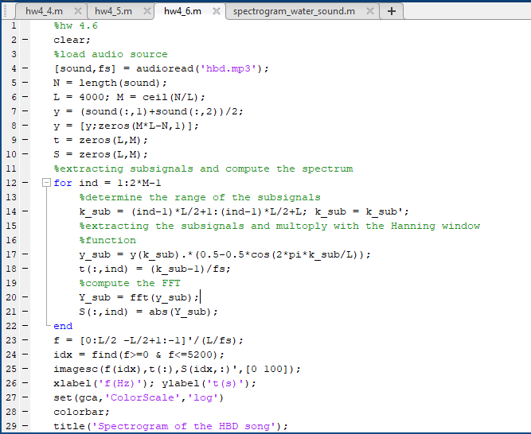

We use the logscale for the colorbar to see the signals clearly. The spectrogram is shown in the below figure.

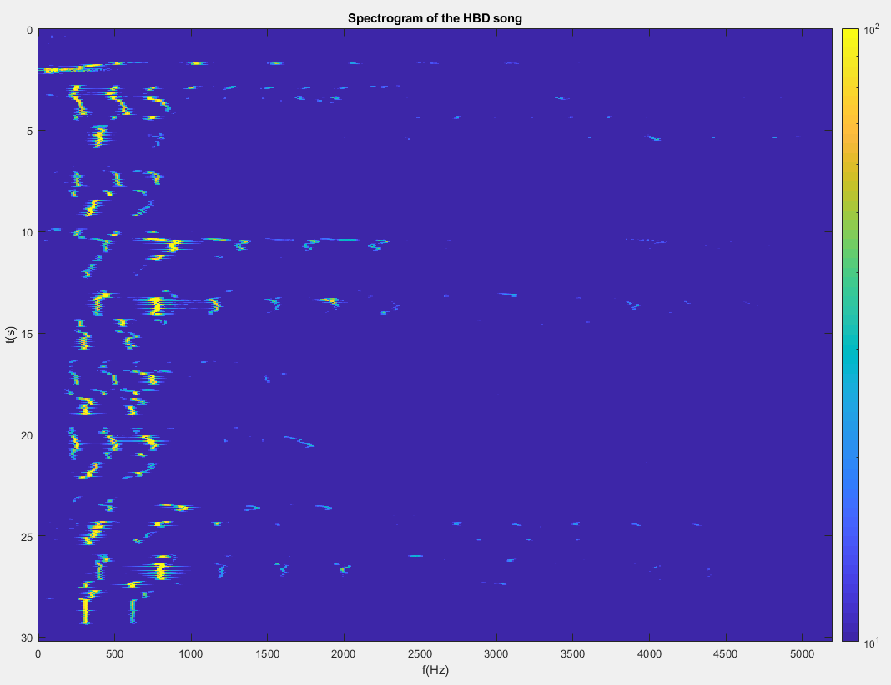

The kid sang ‘Happy birthday to you’ 8 times. From the spectrogram, we can see unclear patterns at $f<1200$ Hz.

