

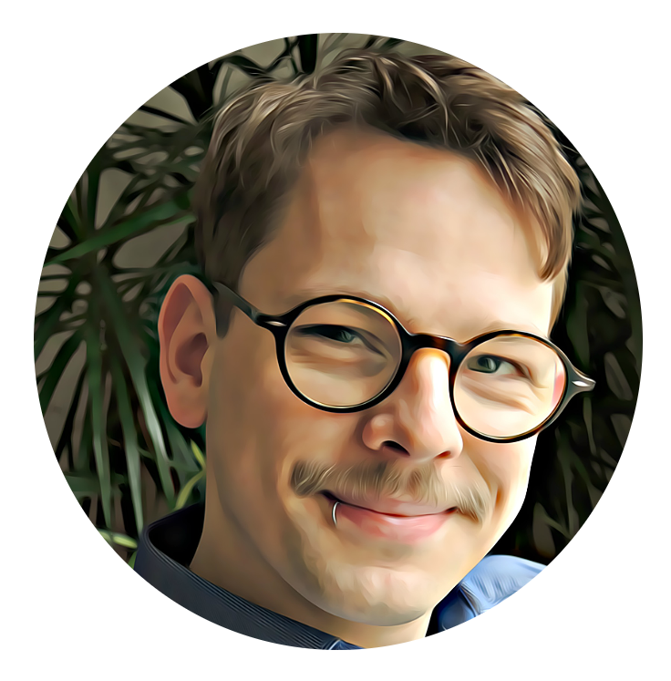Alexander Staedtler

Enthusiastic Fullstack Dev from Germany with a pivot towards backend. My background in archaeology has taught me a great deal about managing projects and quality standards. As a process-oriented professional, I care deeply about well-functioning teams, clearly formulated goals and priorities, as well as agile structures and strategies.

# TECHNICAL SKILLS

## Links

[www.linkedin.com/in/alexander-stae](http://www.linkedin.com/in/alexander-stae) dtler

https://github.com/a-urbanite

[https://www.staedtler-mapdesign.de](http://www.staedtler-mapdesign.de/)

**Languages** German - native English - fluent

Italian - intermediate

## General

JavaScript Typescript PHP (basic) R (basic)

## Backend

NodeJS

ExpressJS REST

MongoDB/PostgreSQL/GraphQL

## Frontend

React Redux

Webpack HTML

CSS

## Tools and technologies

Visual Studio Code Docker

Git/GitHub/GitHub Actions

Cloud Platforms (MongoDB Atlas, ElephantSQL, Heroku, AWS) TDD/BDD with Mocha/Jest

Agile work methods CI/CD

## Geodata

QGIS/ArcGIS

Meshlab

Metashape Leaflet/Openlayers/ArcGIS Server

# EDUCATION & TRAINING

## Full Stack JavaScript - School of Applied Technology </salt>

Intensive three month training program for full stack web development with a focus on TDD, mob programming, and applied learning.

## Prehistoric Archaeology B.A. + M.A. - Freie Universitat Berlin

*October 2009 - November 2018 Erasmus in Rome in 2013*

## Applied Computer Science B.Sc. - HTW Berlin

*April 2015 - November 2015 - unfinished*

## Cultural Heritage Management Assistent

*October 2008 - September 2009*

# WORK EXPERIENCE

## Webmaster - Deutsches Archaologisches Institut

*April 2020 - December 2021* - Berlin, Germany

Technical Management of PR Infrastructure including Wordpress and Liferay CMS, Atlassian stack

## Heritage Consultant - Artefact Pty Ltd.

*February 2019 - June 2019* - Sydney, NSW Australia Supervising construction works from an archaeological perspective

## Research Assistant - Deutsches Archaologisches Institut, Freie Universitat Berlin

*March 2012 - September 2018*

A sequence of employments with archaeological institutes and projects. Activities spanned from office work in Berlin to Field Work in Saudi Arabia, mostly revolving around Geodata and Research Data Management.