15.6”

Ultra

Slim

Notebook
4.08
No rating value average rating value is 0.0 of 5. Read 0 Reviews Same page link.

(0)
Model: GWNR71517
The 15.6” Ultra Slim Notebook from Gateway is the ultimate portable notebook that brings crystal-clear picture for all of your tasks. It is the ideal way to get the best audio for on-the-go entertainment. The computer is powered by AMD Ryzen™ 7 3700U Processor and has 8 GB memory RAM. With a sleek and metallic design, this computer also features a 512 GB Solid State Drive.
- Windows 11 Home
- AMD Ryzen™ 7 3700U Processor with Radeon™ RX Vega 10 Graphics, 2.3GHz base, Up to 4.0GHz
- 15.6” IPS FHD Display, (1920 x 1080)
- Tuned by THX™ Audio
- 512 GB Solid State Drive
- 8 GB Memory (RAM)
- Up to 10 hours of battery life
- Fingerprint Scanner
Color
Color:Gray
- Gray
- Blue

Buy Now

Share
Need help?
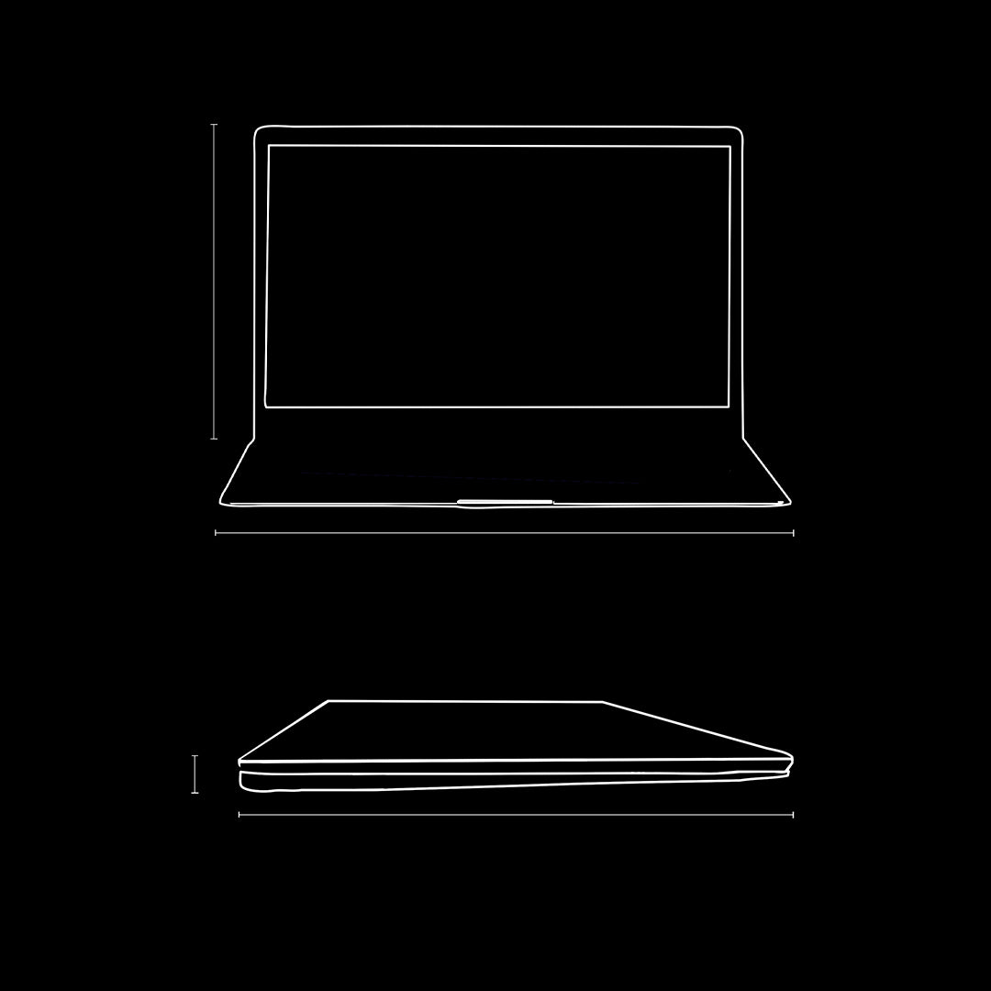
Product Dimensions
Length: 14.1”
Height: 9.4”
Width: 0.78"
Gateway Laptop
Laptop Charger
Warranty Book
Quick Start Guide
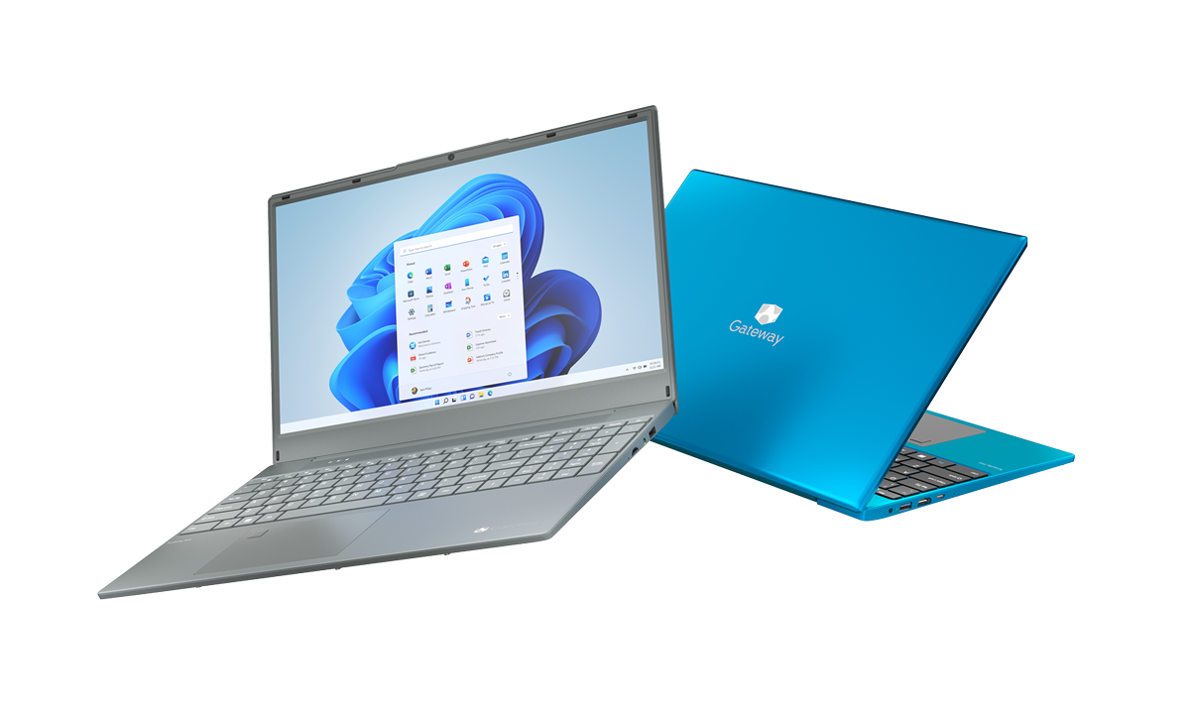
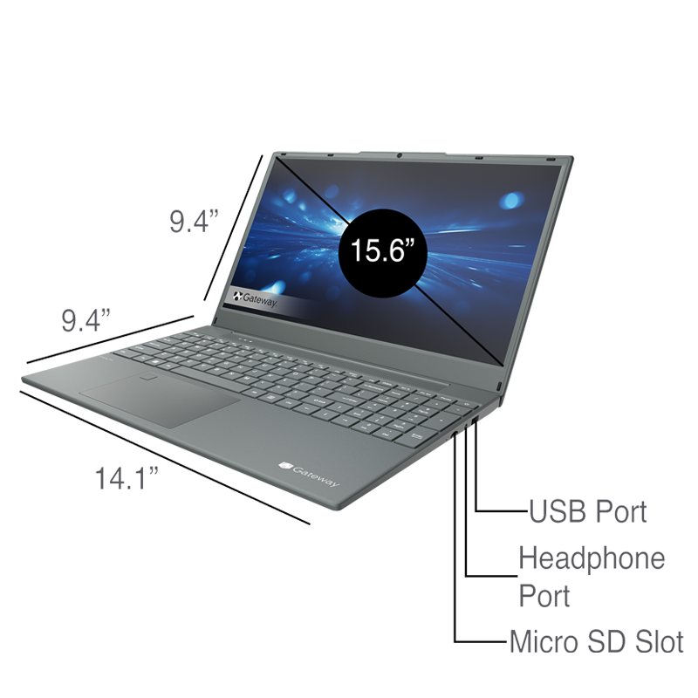
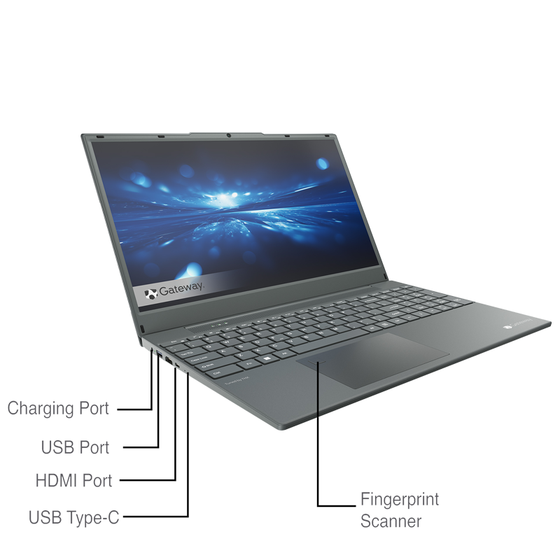

Product

Specs

Operating System
Windows 11 Home
Processor
AMD Ryzen™ 7 3700U Processor
with Radeon™ RX Vega 10 Graphics, 2.3GHz base, Up to 4.0GHz
Display
15.6” IPS FHD Display, (1920 x 1080)
Hard Drive
512 GB Solid State Drive
Micro SD
Micro SD Slot (Up to 512 GB) x 1

Front Camera
2.0 MP Front-Facing
Battery Life
Up to 10 hours of battery life
RAM Memory
8 GB Onboard RAM
Ports
USB Type-C x 1 USB 3.0 x 2

