**Subjective Questions**

1. **How has the global average life expectancy changed from 1952 to 2007? Plot a line graph to visualize this trend. Discuss the various reasons that could have contributed to the change.**

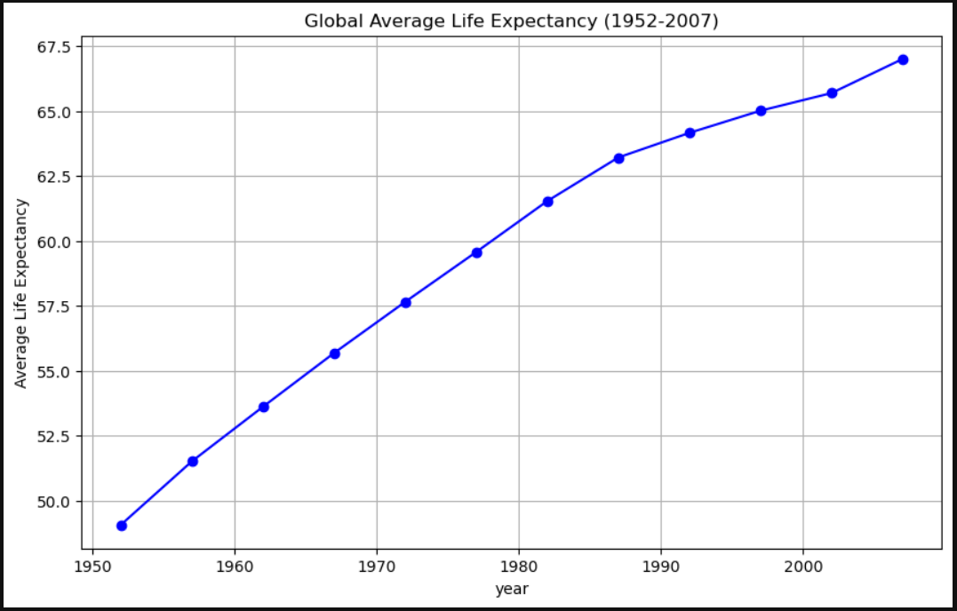

The global average life expectancy increased from 1952 to 2007 due to several key reasons:

1. **Improved Healthcare:** Advances in medicine, vaccines, and better access to healthcare services reduced the number of deaths from infectious diseases, especially among children.
2. **Better Nutrition:** As economies grew, more people had access to better food and clean water, improving overall health and longer lives.
3. **Sanitation and Hygiene:** Widespread improvements in sanitation and personal hygiene, such as clean drinking water and proper waste disposal, reduced the spread of diseases.
4. **Public Health Initiatives:** Governments and organizations launched successful public health campaigns to educate people about health practices, vaccination programs, and disease prevention.
5. **Technological Advances:** Innovations in medical technology, such as antibiotics and advanced surgical techniques, allowed for treating previously fatal conditions.
6. **Economic Growth:** As countries become wealthier, they could invest more in healthcare infrastructure and services, improving overall life expectancy.
7. **Education:** Increased education levels, especially among women, led to better health practices and smaller family sizes, which in turn improved health outcomes for both mothers and children.

These combined factors contributed to people living longer, healthier lives over this period.

1. **For 2007, analyse the relationship between life expectancy and GDP per capita. Is there a noticeable trend or correlation? Represent this using a scatter plot.**

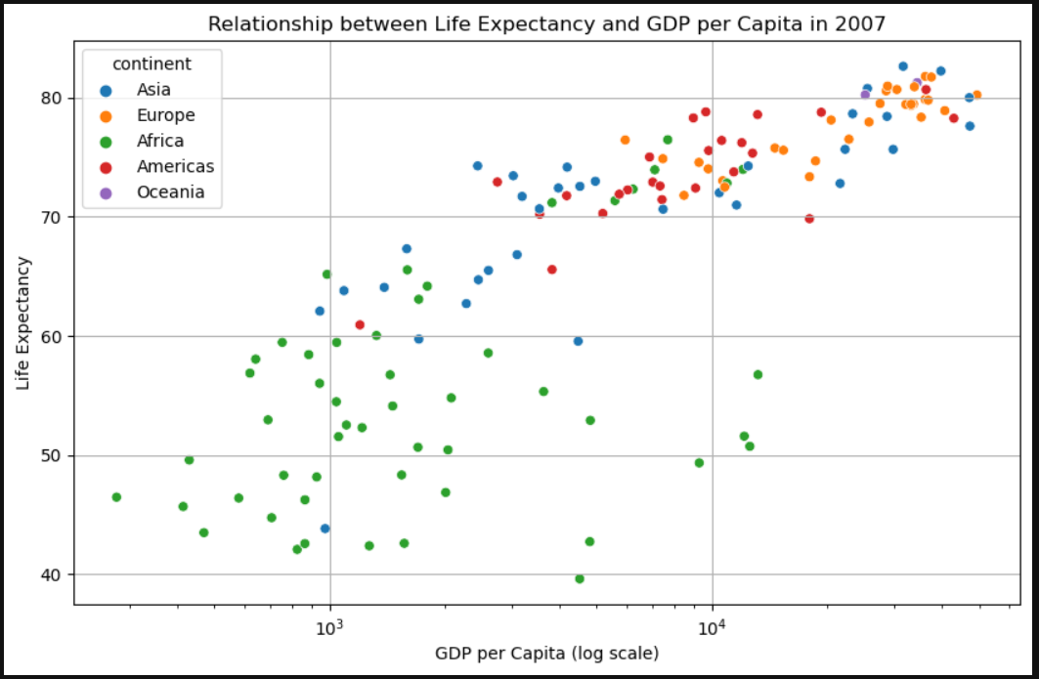

Yes, there is a noticeable trend and correlation between life expectancy and GDP per capita in 2007. Here’s a summary of the key points:

1. **Positive Correlation:**

There is a general positive correlation between GDP per capita and life expectancy, meaning that as GDP per capita increases, life expectancy also tends to increase. This suggests that wealthier countries, on average, tend to have longer life expectancies, likely due to better access to healthcare, nutrition, education, and overall living conditions.

1. **Logarithmic Scale:**

The scatter plot uses a logarithmic scale for GDP per capita, which helps visualize the data more clearly, especially since GDP per capita can vary widely. The log scale tends to linearize the relationship, making the correlation more apparent.

1. **Regional Patterns:**

By coloring the scatter plot by continent, you might notice distinct clusters for different regions. For example:

Africa: Generally lower GDP per capita and lower life expectancy.

Europe and Oceania: Typically, higher GDP per capita and higher life expectancy.

Asia and the Americas: A wide range of GDP per capita, with life expectancy varying accordingly.

1. **Outliers:**

You may observe some outliers, such as countries with relatively high GDP per capita but lower life expectancy compared to others with similar economic status. Conversely, some countries might have lower GDP per capita but relatively high life expectancy, which could indicate effective healthcare systems or other societal factors contributing to better health outcomes despite lower economic wealth.

**Conclusion:**

The relationship between GDP per capita and life expectancy is strong and positive, reflecting how economic prosperity often correlates with better health outcomes. However, some variations and outliers suggest other factors also play significant roles in determining a country's life expectancy.

1. **Compare the average GDP per capita for each continent in the year 2007. Use a bar chart for this comparison. Why is the average GDP per capita for Oceania higher than the Americas even though the Americas have more countries?**

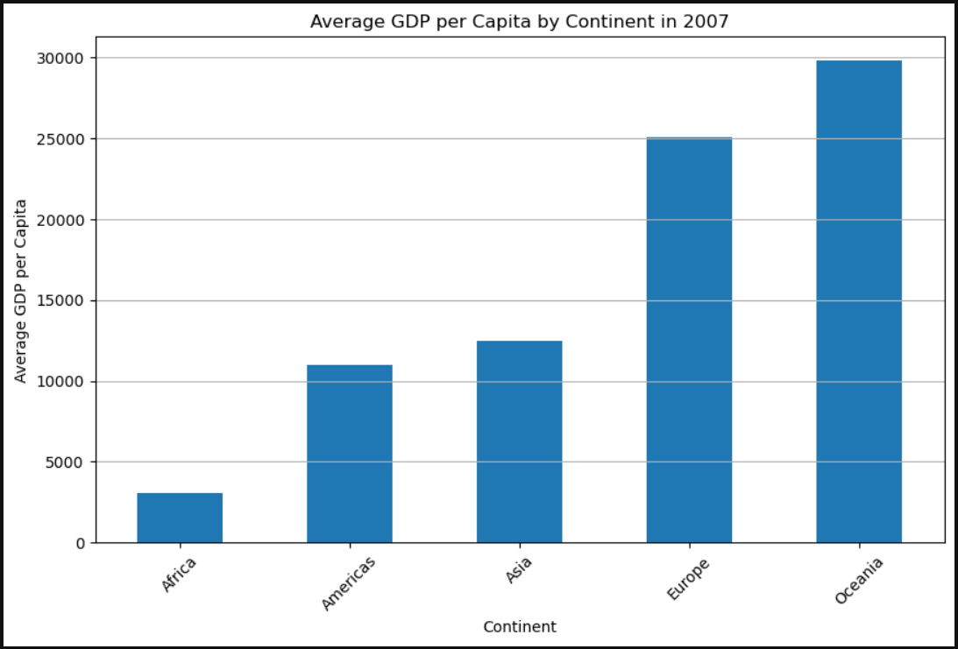

The average GDP per capita for Oceania is higher than that of the Americas, despite the Americas having more countries, due to the following reasons:

1. **Small Number of Countries in Oceania:**

Oceania has very few countries, with Australia and New Zealand being the most economically dominant. Both of these countries have high GDP per capita, which significantly skews the average for the entire continent.

1. **Wealth Concentration:**

Australia and New Zealand are both highly developed countries with strong economies, high standards of living, and relatively small populations. Their high GDP per capita values heavily influence the average for Oceania, especially since there are few other countries to lower the average.

1. **Diverse Economic Status in the Americas:**

The Americas, on the other hand, include a much more diverse set of countries with a wide range of economic statuses. This continent includes some highly developed countries like the United States and Canada, which have high GDP per capita, but it also includes many countries in Latin America and the Caribbean with much lower GDP per capita. The presence of these lower-income countries brings down the overall average GDP per capita for the continent.

1. **Impact of Country Size and Population:**

In Oceania, the wealth is concentrated in a few large and developed countries, which dominate the economic landscape. In contrast, the Americas have both large, wealthy countries and smaller or less developed countries, resulting in a more balanced or lower overall average when comparing GDP per capita.

**Conclusion:**

The higher average GDP per capita in Oceania compared to the Americas is primarily due to the economic dominance of Australia and New Zealand, which are both wealthy nations with relatively small populations. In contrast, the Americas have a wider range of countries with varying economic levels, leading to a lower overall average GDP per capita.

1. **Compare the life expectancy and GDP per capita of Afghanistan (a country known for its historical conflicts) and Switzerland (representing a peaceful and economically prosperous country) using the dataset provided.**

* **Firstly, for the year 2007, use a bar chart to directly compare the life expectancy and GDP per capita between these two countries.**
* **Then, create two separate line graphs to show the trends of these two metrics over all available years in the dataset for both countries.**

**What differences do you observe in terms of life expectancy and economic development? How might the stability or instability of a country influence these key metrics over time? Analyse the data through these visualizations and discuss your inferences.** 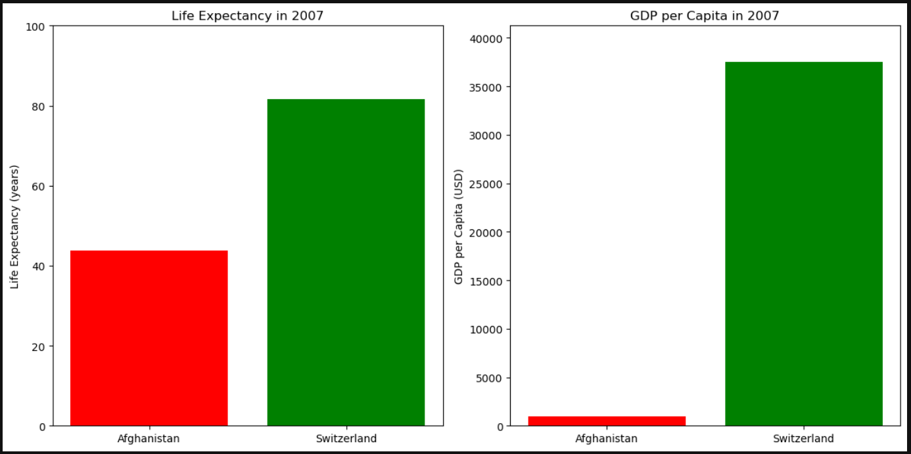

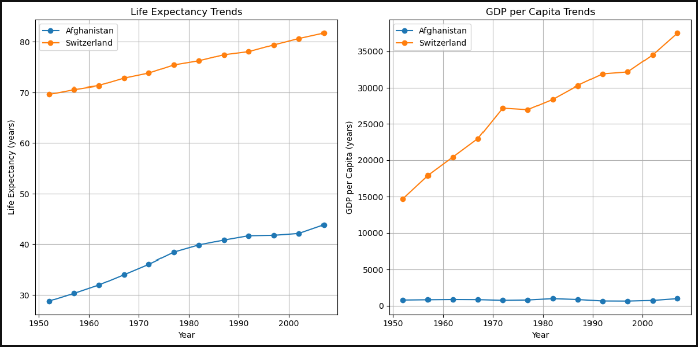

**Observations from the Visualizations:**

1. **Life Expectancy (2007 Comparison)**:
   * **Switzerland**: In 2007, Switzerland had a significantly higher life expectancy (around 82 years) compared to Afghanistan (approximately 43 years). This stark contrast highlights the impact of socioeconomic factors on health outcomes.
   * **Afghanistan**: Afghanistan’s life expectancy is much lower, reflecting the long-term effects of conflict, poor healthcare infrastructure, and other socio-economic challenges.
2. **GDP per Capita (2007 Comparison)**:
   * **Switzerland**: The GDP per capita for Switzerland in 2007 was extremely high (over USD 40,000), showcasing its strong, stable economy.
   * **Afghanistan**: In contrast, Afghanistan's GDP per capita is much lower (around $600 USD), indicating significant economic challenges and underdevelopment.
3. **Trends Over Time (Life Expectancy)**:
   * **Switzerland**: The life expectancy trend for Switzerland shows a steady increase over the years, reflecting consistent improvements in healthcare, living conditions, and overall societal stability.
   * **Afghanistan**: Afghanistan's life expectancy trend shows more fluctuation and slower growth, likely due to ongoing conflict, political instability, and insufficient healthcare infrastructure.
4. **Trends Over Time (GDP per Capita)**:
   * **Switzerland**: Switzerland's GDP per capita trend is consistently high and shows gradual growth over time, indicative of a mature, stable, and prosperous economy.
   * **Afghanistan**: Afghanistan’s GDP per capita remains low with less consistent growth, reflecting the impact of instability, conflict, and limited economic development.

**Inferences and Analysis:**

1. **Impact of Stability on Life Expectancy**:
   * **Switzerland**: The high and steadily increasing life expectancy in Switzerland can be attributed to its stable political environment, robust healthcare system, and high standards of living. Stability allows for continuous investment in healthcare, education, and infrastructure, which directly improves life expectancy.
   * **Afghanistan**: In contrast, Afghanistan's low life expectancy is a direct consequence of decades of conflict and instability, which have disrupted healthcare services, worsened living conditions, and led to higher mortality rates, especially among vulnerable populations.
2. **Impact of Stability on Economic Development**:
   * **Switzerland**: The high GDP per capita in Switzerland reflects its strong economic foundations, characterized by stability, innovation, and a well-developed financial sector. Economic stability fosters business growth, attracts investments, and enables sustained economic development.
   * **Afghanistan**: Afghanistan’s low GDP per capita is indicative of a fragile economy affected by continuous conflict, poor infrastructure, and limited access to global markets. Instability hampers economic growth by discouraging investments, disrupting trade, and causing resource depletion.
3. **Interrelationship Between Life Expectancy and GDP per Capita**:
   * The visualizations show a positive correlation between GDP per capita and life expectancy. Countries with higher economic development (like Switzerland) tend to have better healthcare systems, leading to longer life expectancy. Conversely, countries with lower economic development and instability (like Afghanistan) struggle with both low life expectancy and GDP per capita.
4. **Role of Historical Conflicts**:
   * The data reflects how historical conflicts in Afghanistan have had long-lasting impacts on both life expectancy and economic development. These conflicts have caused destruction of infrastructure, displacement of people, and a continuous state of insecurity, all of which contribute to poor health outcomes and economic stagnation.

**Conclusion:**

The stability or instability of a country plays a critical role in determining its life expectancy and economic development. Stable countries like Switzerland enjoy high life expectancy and GDP per capita due to their ability to invest consistently in healthcare, infrastructure, and economic activities. In contrast, countries like Afghanistan, which have experienced prolonged instability, face significant challenges in these areas, resulting in lower life expectancy and economic underdevelopment. These visualizations underscore the importance of political stability and peace as foundational elements for improving both health and economic outcomes.