RPA_170 iNTERNAL DATA REVIEW PART 1

  - Design Document (DD)

Opportunity ID | RPA_170
Business Unit | GBS
Process Group | Global Payment Transparency
Process Name | 3rd Party Data Collections

Document Version | V1.16
Document Status | Approved version
Status Date | August 2019

Contents

1. Introduction 8
1.1. Document purpose 8
1.2. Definitions 8
1.3. Reference artefacts 9
2. Process Overview 9
2.1. High-level Process Description (as-is) 9
2.2. High-level Process Flow Diagram 10
2.3. Process Flow Description(s) – In-scope “Happy Path” 11
2.4. Process Flow Description(s) – In-scope “Alternate Path(s)” 12
2.5. Process Flow Description(s) – Out of scope “Alternate Path(s)” 12
2.6. Inputs and outputs 12
2.7. Dependencies 13
2.8. Service level agreements 14
3. Detailed Process Design 15
3.1 Work Instructions 15
3.2 Exception Handling 92
3.3. Re-usable Components 94
4. Target applications and roles 95
5. Solution Design 97
5.1. Data Flow – Solution Overview 97
97
6. Data Management and Reporting 98
6.2 Reporting Requirements 98
6.3. Storage 98
6.4. Privacy 98
6.5. Security 99
6.6. Preservation 99
7. Solution Configuration 99
7.1. System Access and Credentials 99
7.2. Configuration Schedule 99
7.3. Component Configuration 99
7.4. Configuration Testing 99
8. Process and Functional Risk Assessment 100
8.1. Risk Assessment 100
9. Business Continuity 101
9.1. Physical workforce unavailability 101
9.2. Virtual workforce unavailability 101
9.3. Target application unavailability 101
9.4. Excessive workload 101
10. Maintenance Activity 101
i. Business Glossary 102
ii. Attachments 102

Document Control
The version history of this template is as follows.
Version | Date | Author | Change Summary
V1.0 | 16 July 2018 | Andy Waller | - New template created
V1.1 | 11 Jan 2019 | Diane Walker | - Addition of Business Quality Manager as key stakeholder for GxP  - Amended Page 1 field names to match PQD  - Added guidelines to risk section  - Added dependencies section

Version history
This document’s change history is as follows.
Version | Date | Author | Approver | Change Summary
V0.1 | 11th December 2018 | Raluca Lupsan | Megan Dalaya/Christine Fernandes | - 1st Draft started
V0.2 | 5th March 2019 | Raluca Lupsan | Megan Dalaya/Christine Fernandes | - 2nd Draft
V0.3 | 18th March 2019 | Raluca Lupsan | Megan Dalaya/Christine Fernandes | - 3rd Draft
V0.4 | 27th March 2019 | Raluca Lupsan | Megan Dalaya/Christine Fernandes | - 4th Draft
V0.5 | 07th May 2019 | Raluca Lupsan | Megan Dalaya/Christine Fernandes | - 5th Draft
V0.6 | 27th May 2019 | Raluca Lupsan | Megan Dalaya/Christine Fernandes | - 6th Draft
V0.7 | 11th June 2019 | Raluca Lupsan | Megan Dalaya/Christine Fernandes | - 7th Draft
V0.8 | 12th June 2019 | Raluca Lupsan | Megan Dalaya/Christine Fernandes | - 8th Draft
V0.9 | 14th -18th June 2019 | Raluca Lupsan | Megan Dalaya/Christine Fernandes/Rachel Moore | - 9th Draft
V1.0 | 26th June 2019 | Raluca Lupsan | Rachel Moore | - Updated post GPO review of process steps
V1.1 | 27’th June 2019 | Sai Lakshmi | Naveen | - Updated sections 5 and 6
V1.2 | 27th June | Raluca Lupsan | Megan Dalaya/Christine Fernandes | - Updated post sign off of sections 3.1.68 to 3.1.82 to align the Sweden process steps with NAM as per the latest updates (dropdown lists and mapping tables moved on the Shared Network Path) & section 3.1.58 applicability for Iteration 2 only blue colored
V1.3 | 1st July | Raluca Lupsan | Megan Dalaya/Christine Fernandes | - Updated post sign off of sections 3.1.34 to add applicability of the step for Iteration 1 only and section 3.1.14 corrected the column to ‘Recipient Type’
V1.4 | 2ND July | Raluca Lupsan | Megan Dalaya/Christine Fernandes | - Corrected post sign off of section 3.1.31: column ‘NAM - TH Match?’
V1.5 | 8th July | Raluca Lupsan | Megan Dalaya/Christine Fernandes | - Corrected post sign off of sections 3.1.28, 3.1.29, 3.1.29b, 3.1.62, 3.1.63, 3.1.91, 3.1.92 to update the columns position and header names in the DD as per the Dictionaries
V1.6 | 9th July | Raluca Lupsan | Megan Dalaya/Christine Fernandes | - Corrected post sign off of sections 3.1.9, 3.1.10, 3.1.31, 3.1.60, 3.1.61, 3.1.65, 3.1.94
V1.7 | 11th July | Raluca Lupsan | Megan Dalaya/Christine Fernandes | - Detailed walk through all the steps post sign off: small corrections on the wording. Note: nothing has been change on the process steps
V1.8 | 16th July | Raluca Lupsan | Megan Dalaya/Christine Fernandes | - Updated post sign off: section 3.1.3 to include the additional column in the TH dictionary used for vlookup
V1.9 | 17th July | Raluca Lupsan | Megan Dalaya/Christine Fernandes | - Updated post sign off: section 3.1.56 and 3.1.52.3
V1.10 | 25th July | Raluca Lupsan | Megan Dalaya/Christine Fernandes | - Updated post sign off to add the business exceptions and correct the dropdowns location sheet. Corrected section 3.1.65.26 to include Teaching Hospital as a filtering criteria
V1.11 | 30th July | Raluca Lupsan | Megan Dalaya/Christine Fernandes | - Included ‘Purchasing Document Number’ as a column to be converted to number in steps 3.1.2.3, 3.1.52.3 and 3.1.85.3
V1.12 | 5th of August | Raluca Lupsan | Megan Dalaya/Christine Fernandes | - Corrected ‘PURCHASE ORDER NUMBER’ to be converted to text in section 3.1.50 and 3.1.83
V1.13 | 8th of August | Raluca Lupsan | Megan Dalaya/Christine Fernandes | - Added the recipients email addresses for the email expectations post DD sign off
V1.14 | 12’th of August | Sai Lakshmi | Megan Dalaya/Christine Fernandes | - Added some changes regarding Section 7 to 8
V1.13 | 21st of August | Raluca Lupsan | Megan Dalaya/Christine Fernandes | - Added section 10
V1.16 | 26th of August | Raluca Lupsan | Megan Dalaya/Christine Fernandes | - Updated post sign off: output file names

Key Stakeholders
Stakeholder | Document Role | Name
Global Process Owner/Business Process Expert | Approver | Rachel Moore
Process Analyst | Owner | Raluca Lupsan
Bot Configurator | Consulted | Purnachandrarao Mannem
Scrum Master | Consulted | Venkat Prasad
Delivery Architect | Consulted | Naveen Bollampally
System Owner(s) | Consulted | Ashok Verma, Ireneusz Jasielski
Quality Manager | Approver (if GxP) | N/A
Compliance Manager | Approver (if SOx) | N/A
Business Quality Assurance/Manager | Consulted

1. Introduction

1.1. Document purpose
The purpose of the Design Document (DD) is to capture the business-related details of the process being automated and to describe the technical solution developed to meet the requirements of the process, including any technical pre-requisites required to deploy, operate and maintain the process. It describes how the automated process is intended to work, including risk and data management controls. It also considers how the virtual workforce will operate alongside a human workforce.

The component describing the automation package or technical solution (“the solution”) will develop incrementally as the solution is built and finalised prior to deployment. The solution represents the business objects and processes, as well as any other peripheral technical components (e.g. queues, credentials, templates, databases etc.) used to deliver the automated process.

1.2. Definitions
Abbreviation | Definition
RPA | Robotic Process Automation
MVP | Minimum Viable Product
CSR | Consolidated SAP Report
NAM | North America Hub
ROW | Rest of World
USOP | US Open Payments
EFPIA | European Federation of Pharmaceutical Industries and Associations
ICON | UK data

1.3. Reference artefacts
The following artefacts should be read in conjunction with this document.
Title | Version | Location
Process Qualification Document (PQD) | V0.7 | https://az.app.box.com/file/364982017157

2. Process Overview
This section describes the high level design of the automated process.

2.1. High-level Process Description (as-is)
Six different reports are currently pulled out from SOAR. A pre-work is manually performed on each file depending on the recipient (USOP, EFPIA and ROW) and SAP hub. These are added directly to the downloaded SAP Spreadsheet. For EFPIA: “Unique ID”, G/L Decision, Review, Reason, MDM ID, Recipient Class, Reportability, Comments/Details, Budget Holder, Function, Department if Function N/A, Cost Category and Signed Amount (for Sweden only). For USOP: G/L Decision, PO Status, Review, Reason, EIN/AZID, Recipient Class, Reportability, Comments/Details, Budget Holder, Function, Department if Function N/A, Expense Type and additional columns for USOP NAM file: IS Contribution, IS Grant, IS Viewpoint, Vendor Review and Vendor Description. The data used to populate some of these columns is pulled from mapping tables or “dictionaries” including a GL Accounts Dictionary, PO Dictionary and Vendor Dictionary using VLOOKUP. A Values List is used as the reference list for the various dropdowns required to be populated by the analysts. For Sweden Hub and ICON data, an additional lookup against SOAR- ADHOC data is performed to eliminate spend that has been automatically loaded as reportable through the Hub feed. Function will be derived based upon a new dictionary specific to management unit. The reports are populated with supplemental data and relevant transactions are marked for review. Then the report is passed on to an analyst who will determine whether each transaction is truly reportable and populate the files with the remaining information. New columns are added and populated depending on recipient country and source hub.
In the To-Be process, a Global Template will be created and the CSR report will be copied onto the template. The columns will be populated with the relevant information for each specific hub data and recipient.

2.2. High-level Process Flow Diagram
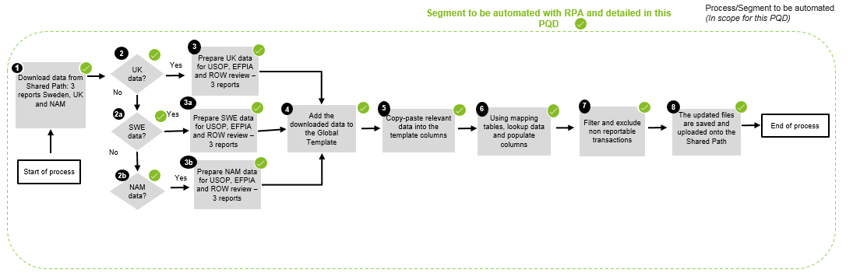

2.3. Process Flow Description(s) – In-scope “Happy Path”
Step 2.3.1 – On the 4th working day of the month, RPA checks the Shared Path folder and downloads the files
Step 2.3.2 – Based on the file name, RPA will start the preparation of the reporting
Step 2.3.3 – When file contains NAM data: RPA will use the Global Template saved in Internal Memory
Step 2.3.4 – RPA will copy-paste the NAM CSR data into the template at the end of the pre-populate columns header
Step 2.3.5 – RPA will VLOOKUP data in the Global Template using the PO/Vendor Dictionaries and Teaching Hospital list saved in the Shared Path folder

Step 2.3.6 – RPA will apply filters and populate Template columns to sort the reportable transactions
Step 2.3.7 – RPA will copy the information from the CSR report columns under the Global Template columns
Step 2.3.8 – RPA will create dropdown lists for the blank cells under the Global Template columns
Step 2.3.8 – RPA saves and uploads file into Shared Path folder
Step 2.3.9 – When file contains the Sweden data: RPA will use the Global Template saved in Internal Memory
Step 2.3.10 – RPA will copy-paste the Sweden CSR data into the template at the end of the pre-populated columns
Step 2.3.11 – RPA will VLOOKUP data in the Global Template using the PO/Vendor/GL Dictionaries and ASPEN SWE Adhoc Dictionary saved in the Shared Path folder
Step 2.3.12 – RPA apply filters and populate Template columns in order to sort the reportable transactions
Step 2.3.13 - RPA will copy the information from the CSR report columns under the Global Template columns
Step 2.3.14 - RPA will create dropdown lists for the blank cells under the Global Template columns
Step 2.3.15 - RPA saves and uploads file into Shared Path folder
Step 2.3.16 – When file contains the ICON data: RPA will use the Global Template saved in Internal Memory
Step 2.3.17 – RPA will copy-paste the ICON CSR data into the template at the end of the pre-populated columns
Step 2.3.18 – RPA will VLOOKUP data in the Global Template using the PO/Vendor/GL Dictionaries and ASPEN ICON Adhoc Dictionary saved in the Shared Path folder
saved in the Shared Path folder
Step 2.3.19 – RPA apply filters and populate Template columns in order to sort the reportable transactions
Step 2.3.20 - RPA will copy the information from the CSR report columns under the Global Template columns
Step 2.3.21 - RPA will create dropdown lists for the blank cells under the Global Template columns
Step 2.3.22 - RPA saves and uploads file into Shared Path folder

2.4. Process Flow Description(s) – In-scope “Alternate Path(s)”
- RPA cannot open email/download files -> RPA sends notification email to the controller
- RPA does not get returns in lookups -> RPA continues process for subsequent records

2.5. Process Flow Description(s) – Out of scope “Alternate Path(s)”

N/A

2.6. Inputs and outputs
Inputs
- 9 Excel Spreadsheets containing HCP/HCO finance information : NAM, ICON and SWEDEN data for 3 Iterations:
- NAM_MonthYear_Americas_Iteration_1
- NAM_ MonthYear_Europe_Iteration_2
- NAM_ MonthYear_ROW_Iteration_3

- SE_ MonthYear_Americas_Iteration_1
- SE_ MonthYear_Europe_Iteration_2
- SE_ MonthYear_ROW_Iteration_3

- ICON_MonthYear_Americas_Iteration_1
- ICON_ MonthYear_Europe_Iteration_2
- ICON_ MonthYear_ROW_Iteration_3

- Global Template saved in Robot’s local PC (My docs)
- Mapping tables: Recipient Country Mapping, Recipient State Mapping, Data Source Mapping, Function Mapping
- Dictionaries:
- ‘PO Dictionary_MASTER’ – for all HUBs (NAM, SWE, UK) and Iterations
  - Pull back ADE columns for NAM only though
- ‘Vendor Dictionary_MASTER’ – for all HUBs (NAM, SWE, UK) but only look in respective iteration column for results
- ‘GL Dicitonary_MASTER’ - for all HUBs (NAM, SWE, UK) but only look in respective iteration column for results
- ‘ASPEN Dictionaries’
- Adhoc Report-Cube_SWE_SOAR_MonthYear -> For Sweden HUB Iteration 2 (Europe Recipients) ONLY
- Adhoc Report-Cube_ICON_SOAR_MonthYear -> For ICON HUB Iteration 2 (Europe Recipients) ONLY
- ‘Teaching_Hospital_List_MASTER’ – APPLICABLE for NAM HUB Iteration 1 only (i.e. US recipients)
- Management Unit Dictionary_MASTER – for all HUBs (NAM, SWE, UK) and Iterations
Outputs
- 9 Excel Spreadsheets populated with supplemental data and relevant transactions marked for the analyst review uploaded to the Shared Path folder:
- NAM_AMERICAS_Month_Year_CSR_Assignments
- NAM_EUROPE_Month_Year_CSR_Assignments
- NAM_ROW_Month_Year_CSR_Assignments
- ICON_AMERICAS_Month_Year_CSR_Assignments
- ICON_EUROPE_Month_Year_CSR_Assignments
- ICON_ROW_Month_Year_CSR_Assignments
- SE_AMERICAS_Month_Year_CSR_Assignments
- SE_EUROPE_Month_Year_CSR_Assignments
- SE_ROW_Month_Year_CSR_Assignments

- Notification emails containing the business exceptions
- Notification email sent to business when process is completed

2.7. Dependencies
- Mapping files and Vendor Dictionaries need to be prepared and maintained before robot starts the process
- Global Template created and saved in internal memory (My Docs) for use in the reporting preparation process
- VLOOKUP in the mapping tables and dictionaries -> If the columns position will be changed in the mapping tables and dictionaries, the VLOOKUP function will return incorrect values or the lookup values will not be found at all.

2.8. Service level agreements
- Must be completed in accordance with compliance requirements
- Process will be performed on the 4th working day of the month for the previous month

3. Detailed Process Design
This section describes the detailed Process Design.

3.1 Work Instructions
*Color code:
Green – steps applicable only for Iteration 1
Blue – steps applicable only for Iteration 2
Purple – steps applicable only for Iteration 3
Black– steps applicable for all iterations
Red - updates
 | Process Description | Business rule / exceptions | Screenshot of Step
3.1.1 Start the Process | Start Process – Input  The Bot will be scheduled to run on the 4th business day of the month  - Go to the shared path location using link \\seskcifssvm01\EUGG_RPA\HUB\DownloadStage  - Check files availability  - Start process if files are available for the previous month  NOTE: Robot will always process the files from the previous month. E.g: on the 4th of September 2019 bot will start the process for the data for the previous month August 2019.  NOTE: 9 CSR reports should be available in the Download Stage folder containing NAM, UK and Sweden data as described in the Input section DD 2.6 | IF: Files are not available on the shared path for the previous month  THEN: Email notification will be sent to Global-Payment-Transparency@astrazeneca.com, Megan.Dalaya@astrazeneca.com, radoslaw.orski@astrazeneca.com, and Christine.Fernandes1@astrazeneca.com informing that files are missing  IF: Not all 9 input files are available on the shared path for the previous month  THEN: Robot will start the process for the available files and send an email notification to Global-Payment-Transparency@astrazeneca.com, Megan.Dalaya@astrazeneca.com, radoslaw.orski@astrazeneca.com, and Christine.Fernandes1@astrazeneca.com with the name of the missing files | 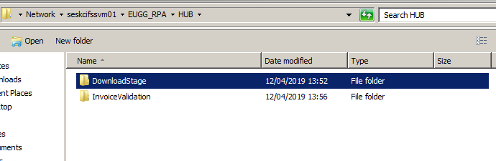  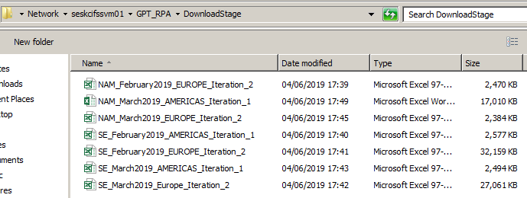
3.1.2 Preparation of NAM CSR report Use Global Template.  *Step applicable for all Iterations (1,2,3) | Preparation of NAM CSR reports for Iteration 1,2, and 3: Use Global Template  - Download and open the NAM reports: NAM_MonthYear_Americas_Iteration_1  NAM_MonthYear_Europe_Iteration_2  NAM_MonthYear_ROW_Iteration_3  NOTE: The month and year will be in the following format MMMM/YYYY  - Check if the CSR columns that will be used in the process are available. Column names that bot will check: ‘Vendor Tax ID 2’, ‘Payment Method Supplement’, ‘Vendor Text’, ‘Name 1’, ‘Signed Amount’, ‘GL Account’, ‘Purchasing Document Number’, ‘Vendor ID’, ‘Name 2’, ‘Vendor Search Term2’, ‘Vendor Address Line Item 1’, ‘Vendor City’, ‘Vendor Postal Code’, ‘Clearing Date’, ‘Signed Amount’, ‘Currency Key’, ‘Reference Document Number’, ‘WBS Element’, ‘Document Number’, ‘Vendor Region’, ‘Vendor Country Code’, ‘Invoice Line Item’, ‘Company Code’, ‘Fiscal Year’, ‘System ID’, ‘Management Unit’, ‘SAP PO Type’,’Cost Center’, ‘Business Area’ *added by Rachel after review  *Updated ‘Vendor Name 2’ to ‘Name 2’ in 14th of June  - Convert the column ‘GL Account’, ‘Document Number’, ’Cost Center’, Management Unit’, Vendor ID’, ‘Purchasing Document Number’ to number format by highlighting each whole column and executing “text to columns” function. Added by Rachel after review in 25th of June  IF any of these columns are not available  THEN robots will send notification email to Global Transparency Team with ‘Columns [names] are not available in the CSR data report [name]’ and move to the next report  - Use the Global Template saved in Robot internal Memory (My Docs) to copy-paste the CSR NAM data into the template at the end of the pre-populated column names starting column BS  - Leave one blank row between the header and the content for the CSR data | IF any of these columns are not available  THEN robot will send notification email to Global-Payment-Transparency@astrazeneca.com, Megan.Dalaya@astrazeneca.com, radoslaw.orski@astrazeneca.com, and Christine.Fernandes1@astrazeneca.com with ‘Columns [names] are not available in the CSR data report [name]’ and move to the next report | 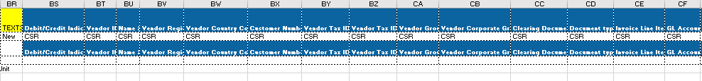
3.1.3 Preparation of NAM CSR report. Populate Global Template columns.  *Only applicable for Iteration 1 | Populate column ‘NAM – TH Match?’ in the Global Template  - Go to shared path folder using link \\seskcifssvm01\GPT_RPA\Dictionaries to download and open the ‘ ‘2019_Teaching_Hospital_List_MASTER’ file  - Search in the dictionary using CSR column ‘Vendor Tax ID 2’ and the EIN number in the dictionary ‘2019_Teaching_Hospital_List_MASTER’ and bring in the content within column Hub_Vlookup (Q) in the ‘NAM – TH Match?’  NOTE: The column ‘NAM – TH Match?’ will be populated with ‘Yes’ and ‘N/A’. Leave #N/A for any non-matches  Step updated in 16.07.2019 to include the vlookup returns from column Q Hub_Vlookup included in the dictionary |  | 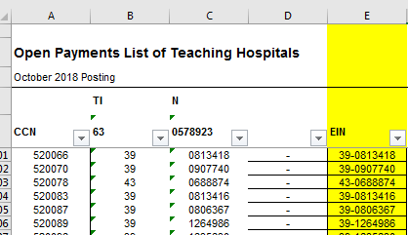  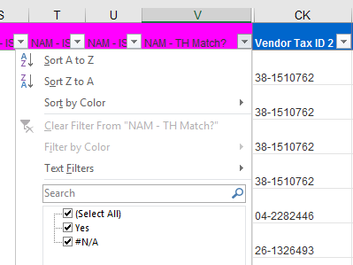
3.1.4 Preparation of NAM CSR report. Populate Global Template columns.  *Only applicable for Iteration 1 | Populate column ‘NAM – IS_VWP’ in Global Template  - Go to column ‘Payment Method Supplement’ from CSR report and filter on ‘PR’ and/or ‘EM’  - Then go to column ‘Vendor Text’ from CSR report and filter on values that ‘Begin with’ ~*00000  NOTE: Tilde symbol (~) added in front of * in this step because some excel programs consider * as a wildcard.  - Then go to column ‘NAM – IS_VWP’ from Global Template and fill in ‘Yes’ in the filtered cells  - Remove all filters  - Go to column ‘Vendor Text’ from CSR report and filter on values that ‘Begin with’ ~*00000  NOTE: Tilde symbol (~) added in front of * in this step because some excel programs consider * as a wildcard.  - Then go to column ‘Payment Method Supplement’ from CSR report and apply filters on ‘#’ cells only  - Then go to column ‘Name 1’ from CSR report and filter only the ‘AHM NOVUS COMMUNICATIONS’ or ‘IQVIA INC’ data  - Go to column ‘NAM - IS_VWP’ from Global Template and fill in ‘Yes’ in the filtered cells  - Remove all filters  - Go to column ‘Vendor Text’ from CSR report and filter on values that ‘Begin with’ ~*00000  NOTE: Tilde symbol (~) added in front of * in this step because some excel programs consider * as a wildcard.  - Then go to column ‘Payment Method Supplement’ from CSR report and apply filters on ‘#’ cells only  - Then go to column ‘Signed Amount’ from CSR report and apply filter on the values that are ‘less than or equal to’ 0  - Go to column ‘NAM - IS_VWP’ from Global Template and fill in ‘Yes’ for the filtered values  - Remove all filters  - Go to column ‘Payment Method Supplement’ from CSR report and filter on ‘VP’ and ‘VR’  - Go to column ‘NAM - IS_VWP’ from Global Template and fill in ‘Yes’ for the filtered data  - Remove all filters  NOTE: Not all the data mentioned above may be available in the report. The robot should filter the available ones. | IF the values to be filtered are not available  THEN ignore the step and move to the next one that would not be dependent on that particular step. | 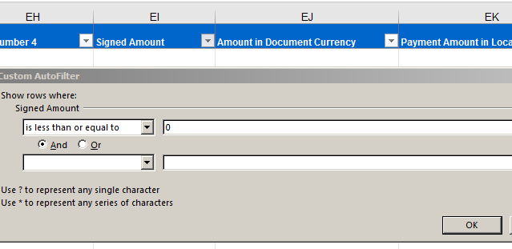  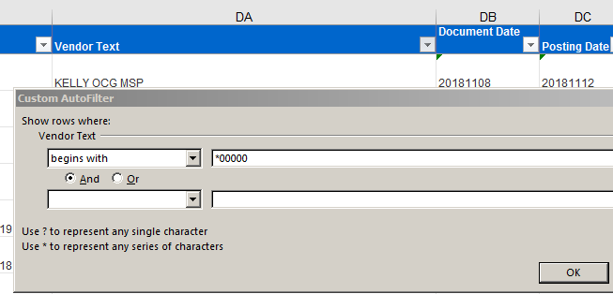  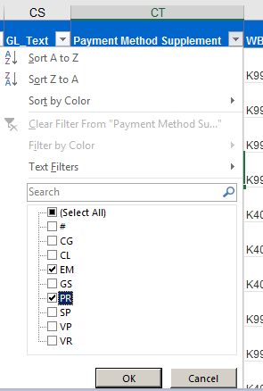
3.1.5 Preparation of NAM CSR report. Populate Global Template columns  *Only applicable for Iteration 1 | Populate column ‘NAM - IS_Grant’ from Global Template:  - Go to column ‘GL Account’ from CSR report and filter on the GL number ‘73180100’  - Then go to ‘Vendor Text’ column from CSR report and filter on everything that starts with ‘*CME’ and ‘*Non CME’  - Go to column ‘NAM - IS_Grant’ from Global Template and fill in ‘Yes’ for the filtered data  - Remove all filters | IF GL ‘73180100’ is not available in column GL Account  THEN the robot should ignore the step 3.1.5 and move to the next one | 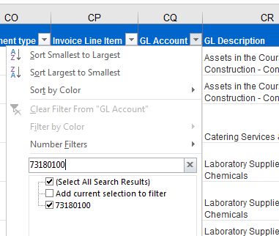  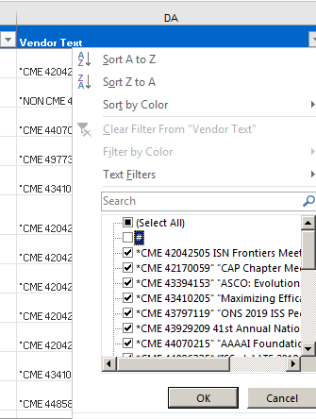
3.1.6 Preparation of NAM CSR report. Populate Global Template columns.  *Only applicable for Iteration 1 | Populate column ‘NAM - IS_Contribution’ from Global Template:  - Go to column GL Account from CSR report and filter on GL numbers contains 73110100, 73110110, 73160100, 73110210  - Go to column ‘NAM - IS_Contribution’ from Global Template and fill in ‘Yes’ for the filtered data  - Remove all filters  NOTE: Not all GL account numbers may be available in the report. The robot should filter the available ones. Change the format ‘GL Account’ column from CSR report to Number first! | IF the values to be filtered are not available  THEN ignore the step 3.1.6 and move to the next one | 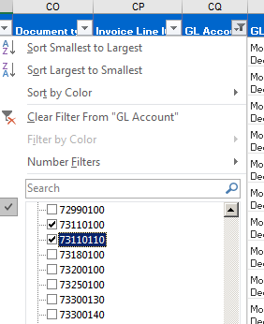
3.1.7 Preparation of NAM CSR report. Populate Global Template columns  *Step applicable for all Iterations (1,2,3) | Populate the column ‘PO Excluded due to Type?’ from Global Template:  - Go to column ‘SAP PO Type’ from CSR report and filter on ‘NB’, ‘RB’, or ‘MRO’  - Populate column ‘PO Excluded due to Type?’ from Global Template with ‘Yes’ for the filtered data  - Remove all filters  NOTE: It may be possible that not all the data ‘NB’, ‘RB’, or ‘MRO’ will be available in the report. In this case, the robot will apply the filter on the available values only. | IF the values to be filtered are not available  THEN ignore the step 3.1.7 and move to the next one
3.1.8 Preparation of NAM CSR report. Populate Global Template columns  *Step applicable for all Iterations (1,2,3) | Populate column ‘PO Reportability’ from Global Template:  - Go to shared path folder using link \\seskcifssvm01\GPT_RPA\Dictionaries to download and open the ‘PO Dictionary_MASTER’  - Go back to the Global Template data column ‘PO Reportability’ and vlookup the ‘Purchasing Document Number’ column from CSR report content in the file ‘PO Dictionary_MASTER’ in column B ( ‘Reportability’)  NOTE: Do not remove the #N/A returns; Note may need to format ‘Purchasing Document Number’ column from CSR report to Number first! |  | 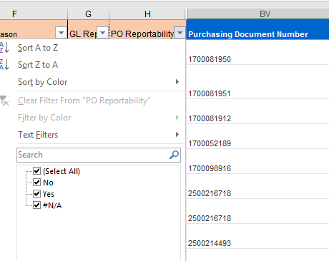  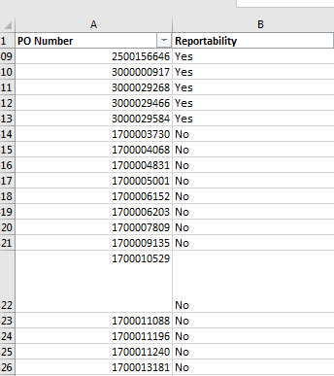
3.1.9 Preparation of NAM CSR report. Populate Global Template columns  *Step applicable for all Iterations (1,2,3) | Populate column ‘PO Reason’ from Global Template:  - Then vlookup the ‘Purchasing Document Number’ from CSR report column content in the file ‘PO Dictionary_MASTER’ in column C ( ‘Reason’) in order to populate the Global Template column ‘PO Reason’  Removed the filtering step in 09.07.2019  NOTE: Do not remove the #N/A returns |  | 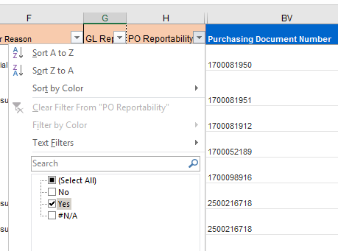  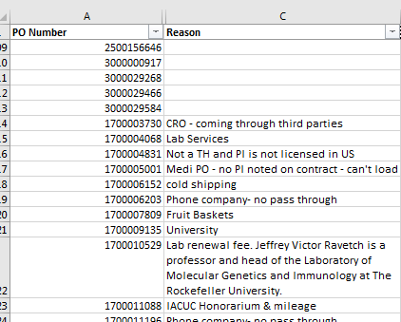
3.1.10 Preparation of NAM CSR report. Populate Global Template columns  *Step applicable for all Iterations (1,2,3) | Populate column ‘Spend Category’ from Global Template:  - Go to column ‘PO Reportability’ from Global Template and filter on ‘Yes’ values  - Vlookup the ‘Purchasing Document Number’ column from CSR report in the file ‘PO Dictionary_MASTER’ in column D ( ‘Spend Category’) |  | 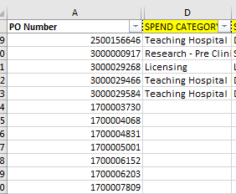
3.1.11 Preparation of NAM CSR report. Populate Global Template columns  *Step applicable for all Iterations (1,2,3) | Populate column ‘Spend Subcategory’ from Global Template:  Note: Do not remove the filter from column ‘PO Reportability’  - Vlookup the ‘Purchasing Document Number’ column from CSR report in the file ‘PO Dictionary_MASTER’ in column E ( ‘Spend Subcategory’) |  | 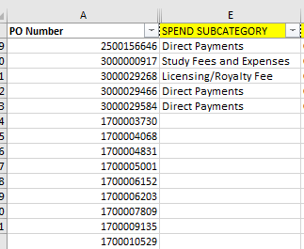
3.1.12 Preparation of NAM CSR report. Populate Global Template columns  *Step applicable for all Iterations (1,2,3) | Populate column ‘Nature of Payment’ from Global Template:  Note: Do not remove the filter from column ‘PO Reportability’  - Vlookup the ‘Purchasing Document Number’ column from CSR report in the file ‘PO Dictionary_MASTER’ in column F ( ‘Nature of Payment’) |  | 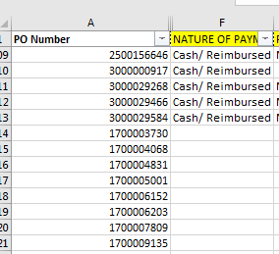
3.1.13 Preparation of NAM CSR report. Populate Global Template columns  *Step applicable for all Iterations (1,2,3) | Populate column ‘Product’ from Global Template:  Note: Do not remove the filter from column ‘PO Reportability’  - Vlookup the ‘Purchasing Document Number’ column from CSR report in the file ‘PO Dictionary_MASTER’ in column G ( ‘Product’) |  | 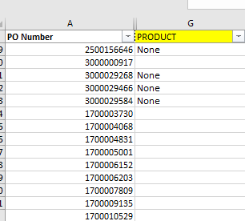
3.1.14 Preparation of NAM CSR report. Populate Global Template columns  *Step applicable for all Iterations (1,2,3) | Populate column ‘Recipient Type’ from Global Template (corrected in 01.07.2019)  Note: Do not remove the filter from column ‘PO Reportability’  - Vlookup the ‘Purchasing Document Number’ column from CSR report in the file ‘PO Dictionary_MASTER’ in column H ( ‘Recipient’) |  | 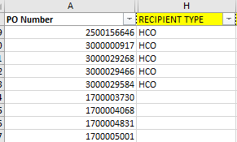
3.1.15 Preparation of NAM CSR report. Populate Global Template columns  *Step applicable for all Iterations (1,2,3) | Populate column ‘Recipient identification Type’ from Global Template:  Note: Do not remove the filter from column ‘PO Reportability’  - Vlookup the ‘Purchasing Document Number’ column from CSR report in the file ‘PO Dictionary_MASTER’ in column I ( ‘Recipient Identification Type’) |  | 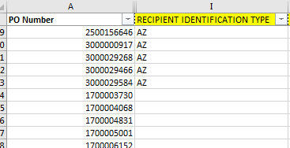
3.1.16 Preparation of NAM CSR report. Populate Global Template columns  *Step applicable for all Iterations (1,2,3) | Populate column ‘RECIPIENT IDENTIFIER’ from Global Template:  Note: Do not remove the filter from column ‘PO Reportability’  - Vlookup the ‘Purchasing Document Number’ column from CSR report in the file ‘PO Dictionary_MASTER’ in column J ( ‘RECIPIENT IDENTIFIER’) |  | 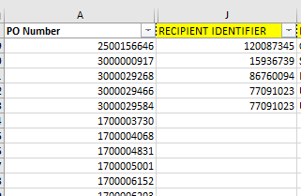
3.1.17 Preparation of NAM CSR report. Populate Global Template columns  *Step applicable for all Iterations (1,2,3) | Populate column ‘Recipient Name’ from Global Template:  Note: Do not remove the filter from column ‘PO Reportability’  - Vlookup the ‘Purchasing Document Number’ column from CSR report in the file ‘PO Dictionary_MASTER’ in column K ( ‘Recipient Name’ |  | 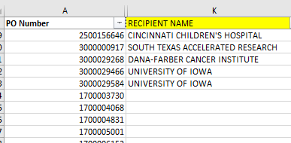
3.1.18 Preparation of NAM CSR report. Populate Global Template columns  *Step applicable for all Iterations (1,2,3) | Populate column ‘PI Identification Type’ from Global Template:  Note: Do not remove the filter from column ‘PO Reportability’  - Vlookup the ‘Purchasing Document Number’ column from CSR report in the file ‘PO Dictionary_MASTER’ in column L ( ‘PI Identification Type’) |  | 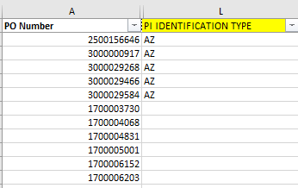
3.1.19 Preparation of NAM CSR report. Populate Global Template columns  *Step applicable for all Iterations (1,2,3) | Populate column ‘PI Identifier’ from Global Template:  Note: Do not remove the filter from column ‘PO Reportability’  - Vlookup the ‘Purchasing Document Number’ column from CSR report in the file ‘PO Dictionary_MASTER’ in column M ( ‘PI Identifier’) |  | 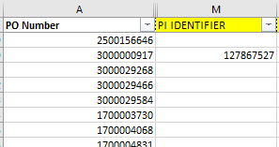
3.1.20 Preparation of NAM CSR report. Populate Global Template columns  *Step applicable for all Iterations (1,2,3) | Populate column ‘PI Name’ from Global Template:  Note: Do not remove the filter from column ‘PO Reportability’  - Vlookup the ‘Purchasing Document Number’ column from CSR report in the file ‘PO Dictionary_MASTER’ in column N ( ‘PI Name’) |  | 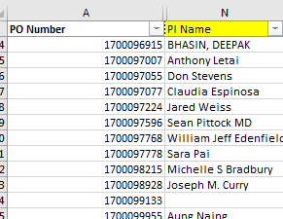
3.1.21 Preparation of NAM CSR report. Populate Global Template columns  *Step applicable for all Iterations (1,2,3) | Populate column ‘Description of meeting/event’ from Global Template:  Note: Do not remove the filter from column ‘PO Reportability’  - Vlookup the ‘Purchasing Document Number’ column from CSR report in the file ‘PO Dictionary_MASTER’ in column O (’Description of meeting/event’) |  | 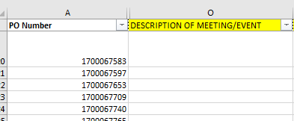
3.1.22 Preparation of NAM CSR report. Populate Global Template columns  *Step applicable for all Iterations (1,2,3) | Populate column ‘Event City’ from Global Template:  Note: Do not remove the filter from column ‘PO Reportability’  - Vlookup the ‘Purchasing Document Number’ column from CSR report in the file ‘PO Dictionary_MASTER’ in column Q (‘Event City’) |  | 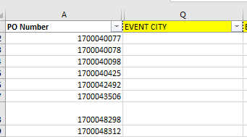
3.1.23 Preparation of NAM CSR report. Populate Global Template columns  *Step applicable for all Iterations (1,2,3) | Populate column ‘Event State’ from Global Template:  Note: Do not remove the filter from column ‘PO Reportability’  - Vlookup the ‘Purchasing Document Number’ column from CSR report in the file ‘PO Dictionary_MASTER’ in column R (‘Event State‘) |  | 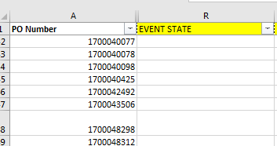
3.1.24 Preparation of NAM CSR report. Populate Global Template columns  *Step applicable for all Iterations (1,2,3) | Populate column ‘Event Country’ from Global Template:  Note: Do not remove the filter from column ‘PO Reportability’  - Vlookup the ‘Purchasing Document Number’ column from CSR report in the file ‘PO Dictionary_MASTER’ in column S (‘Event Country’‘) |  | 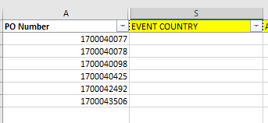
3.1.25 Preparation of NAM CSR report. Populate Global Template columns  *Step applicable for all Iterations (1,2,3) | Populate column ‘AstraZeneca Engagement Owner’ from Global Template:  Note: Do not remove the filter from column ‘PO Reportability’  - Vlookup the ‘Purchasing Document Number’ column from CSR report in the file ‘PO Dictionary_MASTER’ in column T (‘AstraZeneca Engagement Owner’) |  | 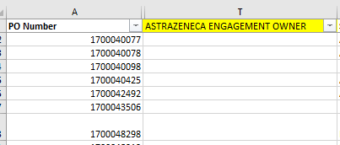
3.1.26 Preparation of NAM CSR report. Populate Global Template columns  *Step applicable for all Iterations (1,2,3) | Populate column ‘Study Code’ from Global Template:  Note: Do not remove the filter from column ‘PO Reportability’  - Vlookup the ‘Purchasing Document Number’ column from CSR report in the file ‘PO Dictionary_MASTER’ in column U (‘Study Code’) |  | 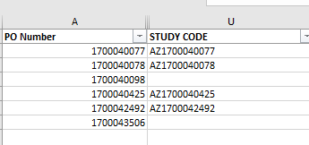
3.1.27 Preparation of NAM CSR report. Populate Global Template columns  *Step applicable for all Iterations (1,2,3) | Populate column ‘Comments’ from Global Template:  Note: Do not remove the filter from column ‘PO Reportability’  - Vlookup the ‘Purchasing Document Number’ column from CSR report in the file ‘PO Dictionary_MASTER’ in column V (‘Comments’)  - Remove all filters |  | 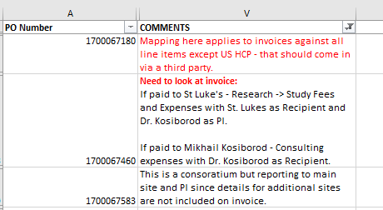
3.1.28 Preparation of NAM CSR report. Populate Global Template columns  *Step applicable for all Iterations as described in the step | Populate column ‘GL Reportability’ from Global Template:  - Go to shared path folder using link \\seskcifssvm01\GPT_RPA\Dictionaries to download and open the ‘GL Dictionary_MASTER’ file  - Vlookup the ‘GL Account’ number column from CSR report into the ‘GL Dictionary_MASTER’ file  IF file is prepared for Iteration 1(AMERICAS)  THEN the vlookup will be performed in column D Iteration 1 - US Recipient  IF file is prepared for Iteration 2 (EMEA)  THEN the vlookup will be performed in column C Iteration 2 - EMEA Recipient  IF file is prepared for Iteration 3 (ASIAPAC)  THEN the vlookup will be performed in column E Iteration 3 - ASP Recipient  Updated the columns names as per the GL Dictionary  in 08/07/2019  NOTE: Do not remove the #N/A returns |  | 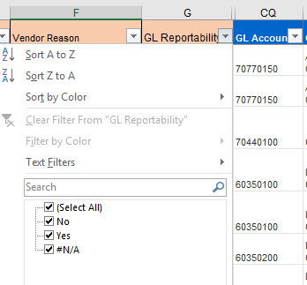  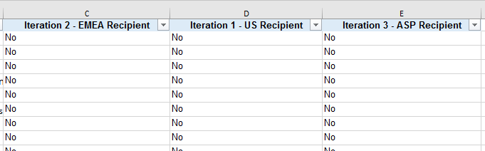
3.1.29 Preparation of NAM CSR report. Populate Global Template columns  *Step applicable for all Iterations as described in the step | Populate column ‘Vendor Reportability’ from Global Template:  - Go to shared path folder using link \\seskcifssvm01\GPT_RPA\Dictionaries to download and open the ‘Vendor Dictionary_MASTER’ file  - Vlookup the ‘Vendor ID’ column from CSR report into the ‘Vendor Dictionary_MASTER’ files using column ‘Vendor Code’  IF file is prepared for Iteration 1(AMERICAS)  THEN the vlookup will be performed in column F ‘Iteration 1 - US Recipients’  IF file is prepared for Iteration 2 (EMEA)  THEN the vlookup will be performed in column E ‘Iteration 2 - EMEA Recipients’  IF file is prepared for Iteration 3 (ASIAPAC)  THEN the vlookup will be performed in column G ‘Iteration 3 - ASP Recipients’  Updated the columns position and names as per the Vendor Dictionary in 08/07/2019 |  | 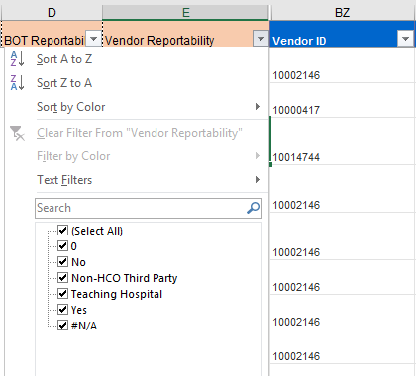  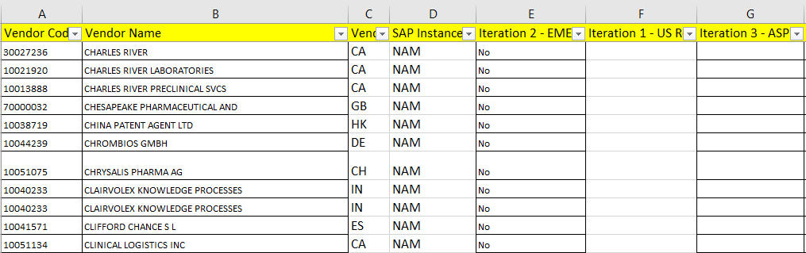
3.1.29b  Preparation of NAM CSR report. Populate Global Template columns  *Step applicable for all Iterations as described in the step | Populate column ‘Vendor Reportability’ from Global Template:  - Go to column ‘Vendor Reportability’ from Global Template and filter on ‘#N/A’ values  - Vlookup the ‘Name 1’ column from CSR report into the ‘Vendor Dictionary_MASTER’ files using column B ‘Vendor Name’  IF file is prepared for Iteration 1(AMERICAS)  THEN the vlookup will be performed in column F ‘Iteration 1 - US Recipients’  IF file is prepared for Iteration 2 (EMEA)  THEN the vlookup will be performed in column E ‘Iteration 2 - EMEA Recipients’  IF file is prepared for Iteration 3 (ASIAPAC)  THEN the vlookup will be performed in column G ‘Iteration 3 - ASP Recipients’  Updated the columns position and names as per the Vendor Dictionary in 08/07/2019 | Step added by Megan after review in21st of June
3.1.30 Preparation of NAM CSR report. Populate Global Template columns  *Step applicable for all Iterations (1,2,3) | Populate column ‘Vendor Reason’ from Global Template:  - Remove all filters  - Vlookup the ‘Vendor ID’ column from CSR report into the ‘Vendor Dictionary_MASTER’ file using column ‘VENDOR CODE’ in column A and pull back ‘ Vendor Reason/Description’ and put in Vendor Reason column  Megan updated ‘Name 2’ column with ‘Vendor id’ in 21.06.2019 |  | 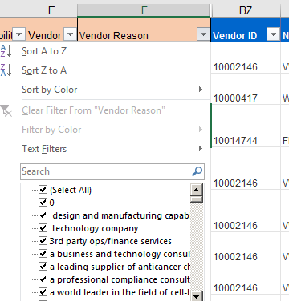  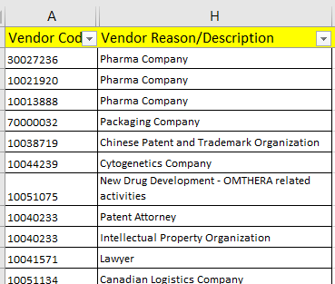
3.1.31 Preparation of NAM CSR report. Populate Global Template columns.  Steps 1 to 12 in this sections are applicable only for Iteration 1.  Steps 13 to 31 in this section are applicable for all Iterations 1,2,3 | Populate column ‘BOT Reportability Determination’ from Global Template:  - Go to column ‘NAM - IS_VWP’ from Global Template and filter on ‘Yes’  - Fill in with ‘NR-VWP’ into the column B ‘BOT Reportability Determination’ from Global Template for the filtered data  - Remove all filters *updated in 14.06.2019  - Go to column ‘NAM - IS_Grant’ from Global Template and filter on ‘Yes’  - Fill in with ‘NR-Grant’ into the column B ‘BOT Reportability Determination’ from Global Template for the filtered data for the blank cells (do not overwrite)  - Remove all filters *updated in 14.06.2019  - Go to column ‘NAM -IS_Contribution’ from Global Template and filter on ‘Yes’  - Fill in with ‘NR-Contribution’ into the column B ‘BOT Reportability Determination’ from Global Template for the filtered data for the blank cells (do not overwrite)  - Remover all filters  - Go to column ‘NAM - TH Match?’ from Global Template and filter on the ‘Yes’ values. Corrected in 02.07.2019  - Fill in with ‘R-TH’ into the column B ‘BOT Reportability Determination’ from Global Template for the filtered data for the blank cells (do not overwrite)  - Remove all filters updated in 14.06.2019  - Go to column ‘PO Excluded due to Type’ from Global Template and filter on the ‘Yes’ values  - Fill in with ‘NR- PO Type’ into the column B ‘BOT Reportability Determination’ from Global Template for the filtered data but only for the blank cells (do not overwrite)  - Remove all filters  - Go to column ‘PO Reportability’ from Global Template and filter on the ‘Yes’ values  - Fill in with ‘R- PO Dictionary’ into the column B ‘BOT Reportability Determination’ from Global Template for the filtered data but only for the blank cells (do not overwrite)  - Remove all filters  - Go to column ‘PO Reportability’ from Global Template and filter on the ‘NO’ values  - Fill in with ‘NR- PO Dictionary’ into the column B ‘BOT Reportability Determination’ from Global Template for the filtered data but only for the blank cells (do not overwrite)  - Remove all filters  - Go to column ‘GL Reportability’ from Global Template and filter on the ‘No’ Values  - Fill in with ‘NR- GL’ into the column B ‘BOT Reportability Determination’ from Global Template for the filtered data but only for the blank cells (do not overwrite)  - Remove filters  - Go to column ‘GL Reportability’ from Global Template and filter on the ‘Yes’ and #N/A updated in 09.07.2019  - Then go to column Vendor Reportability from Global Template and filter on ‘Yes’, #N/A, 0 and ‘Teaching Hospital’ updated in 09.07.2019  - Fill in the column B ‘BOT Reportability Determination’ from Global Template with ‘R-Vendor and GL = Y or blank’ but only for the blank cells (do not overwrite)  - Remove filters  - Go to column ‘Vendor Reportability’ from Global Template and filter on ‘No’ or ‘Non-HCO Third Party’  - Fill in with ‘NR-Vendor’ in the column B ‘BOT Reportability Determination’ from Global Template but only for the blank cells (do not overwrite)  - Remove all filters |  | 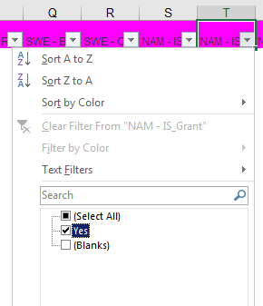  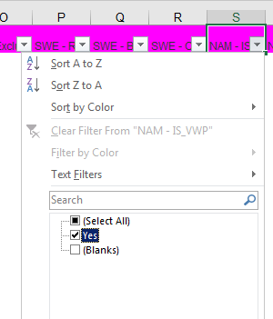  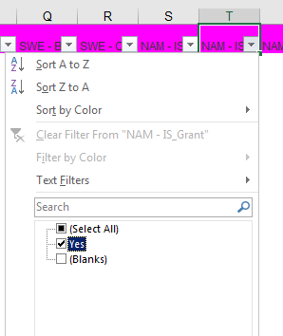  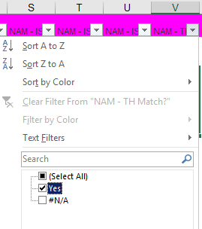  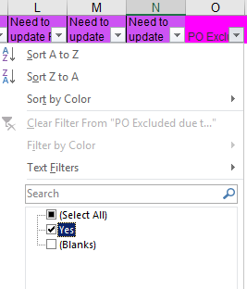  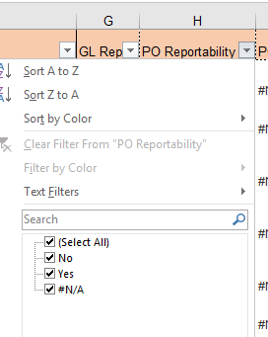  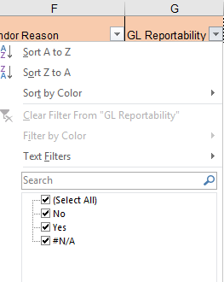  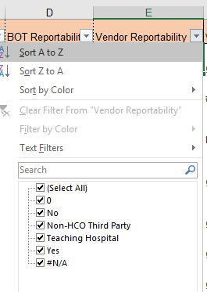  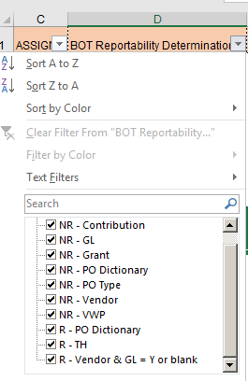
3.1.32 Preparation of NAM CSR report. Populate Global Template columns.  Step applicable for all Iterations (1,2,3) | Populate column A ’Assignment’ from Global Template:  - Go to column ‘BOT Reportability Determination’ from Global Template and filter on the fields starting with ‘R’ (reportable)  - Then go to column A ’Assignment’ from Global Template and fill in the filtered cell with ‘Assign’  - Remove all filters |  | 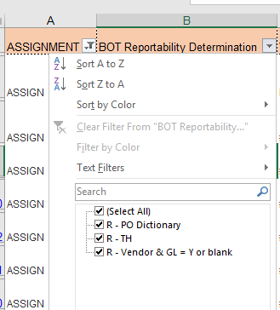
3.1.33 Preparation of NAM CSR report. Copy-paste content from CSR report under Global Template.  Step applicable for all Iterations (1,2,3) | Copy-paste the information from CSR report columns into the template columns for the filtered (‘Assign’) rows only  NOTE: Information may be available in these columns from the PO Dictionary, do not overwrite. Copy-Pate the data only for the blank cells.  - Go to column ’Assignment’ and filter on the ‘Assign’ field  - Then copy paste the content from CSR report column Vendor Search Term2 into Global Template column RECIPIENT IDENTIFIER  - Copy paste the content from CSR report column Name 1 into Global Template column RECIPIENT NAME  - Copy paste the content from CSR report column Vendor Address Line Item 1 into Global Template column RECIPIENT ADDRESS LINE 1  - Copy paste the content from CSR report column Vendor City into Global Template column RECIPIENT CITY  - Copy paste the content from CSR report column Vendor Postal Code into Global Template column RECIPIENT POSTAL CODE  - Copy paste the content from CSR report column Clearing Date into Global Template column PAYMENT DATE  - Copy paste the content from CSR report column Signed Amount into Global Template column PAYMENT AMOUNT  - Copy paste the content from CSR report column Currency Key into Global Template column PAYMENT CURRENCY  - Copy paste the content from CSR report column Reference Document Number into Global Template column SUPPLIER INVOICE NUMBER  - Copy paste the content from CSR report column WBS Element into Global Template column STUDY CODE  - Copy paste the content from CSR report column Document Number into Global Template column SAP DOCUMENT NUMBER  - Copy paste the content from CSR report column Purchasing Document Number into Global Template column PURCHASE ORDER NUMBER |  | 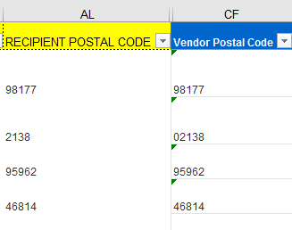  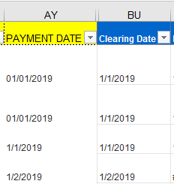  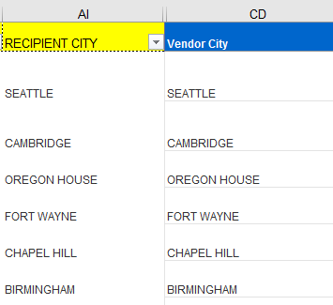  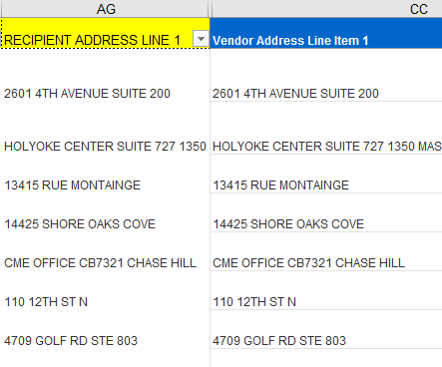  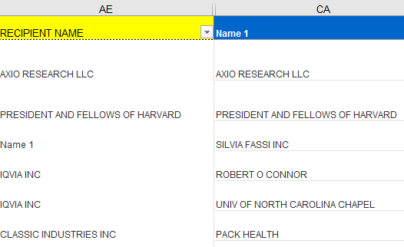  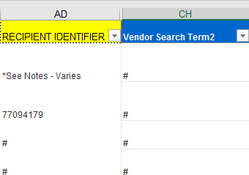
3.1.34 Preparation of NAM CSR report. Populate Global Template columns  *Step applicable for Iteration 1 ONLY | Populate column RECIPIENT STATE from Global Template  NOTE: Do not remove the filter from ‘Assign’ when processing the next steps. The files will be also saved having the filer in the ‘Assign’ fields. Updated this note in 26th of June  - Go to the Shared Network Path \\seskcifssvm01\GPT_RPA\Dictionaries and open file ‘DropDownLOVs_25June2019’  - Go to column ‘Vendor Region’ from CSR report and vlookup the regions in the file ‘DropDownLOVs_25June2019’ in worksheet ‘Recipient State Mapping’ column B  Added the mapping worksheets and column name in 18/06/2019. Step updated in 26.06.2019 to include the mapping tables location in the Shred Network Path file ‘‘DropDownLOVs_25June2019’ |  | 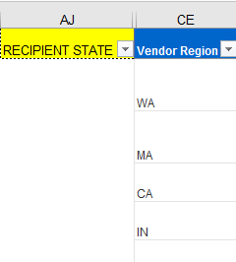  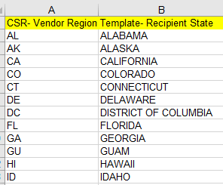
3.1.35 Preparation of NAM CSR report. Populate Global Template columns. Step applicable for all Iterations (1,2,3) | Populate column RECIPIENT COUNTRY from Global Template:  - Go to the Shared Network Path \\seskcifssvm01\GPT_RPA\Dictionaries and open file ‘DropDownLOVs_25June2019’  - Go to column ‘Vendor Country Code’ from CSR report and vlookup the regions in the file ‘DropDownLOVs_25June2019’ in worksheet ‘Recipient Country Mapping’ column B ‘Template- Recipient Country’  Added the mapping worksheets and column name in 18/06/2019. Step updated in 26.06.2019 to include the mapping tables location in the Shared Network Path file ‘‘DropDownLOVs_25June2019’ |  | 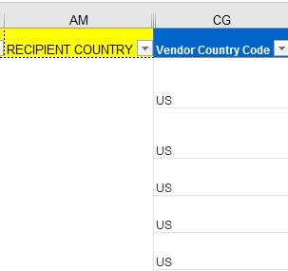  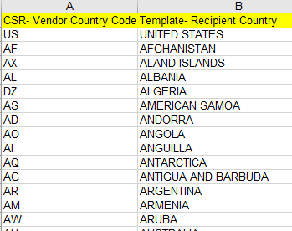
3.1.36 Preparation of NAM CSR report. Populate Global Template columns. Step applicable for all Iterations (1,2,3) | Populate column RFERENCE NUMBER from Global Template:  Concatenate CSR Fields columns: Invoice Line Item & Document Number & Company Code & Fiscal Year  Note: Must convert Document Number to Number format before performing concatenation so do not have a zero before the actual number – added by Megan in 21st of June  NOTE: Do not convert the ‘Invoice Line Item’ fields to number – added in 16.07.2019 |  | 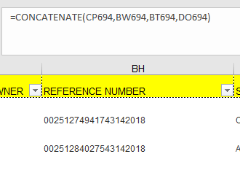
3.1.37 Preparation of NAM CSR report. Populate Global Template columns. Step applicable for all Iterations (1,2,3) | Populate column RECORD COMPANY from Global Template:  - Go to the Shared Network Path \\seskcifssvm01\GPT_RPA\Dictionaries and open file ‘DropDownLOVs_25June2019’  - Go to CSR column ‘Company Code’ from CSR report and vlookup the code in the file ‘DropDownLOVs_25June2019’ in worksheet ‘Record Company Mapping’ in column B ‘Record Company’  Added the mapping worksheets and column name in 18/06/2019. Step updated in 26.06.2019 to include the mapping tables location in the Shared Network Path file ‘DropDownLOVs_25June2019’ |  | 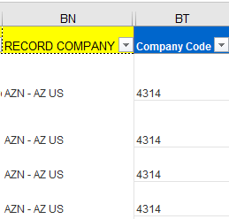  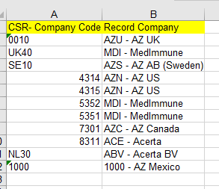
3.1.38 Preparation of NAM CSR report. Populate Global Template columns. Step applicable for all Iterations (1,2,3) | Populate column DATA SOURCE from Global Template:  - Go to the Shared Network Path \\seskcifssvm01\GPT_RPA\Dictionaries and open file ‘DropDownLOVs_25June2019’  - Go to CSR column ‘System ID’ from CSR report and vlookup the code in the file ‘DropDownLOVs_25June2019’ in worksheet ‘Data Source Mapping’ in column B ‘Data Source’  Added the mapping worksheets and column name in 18/06/2019  - Then go to CSR column ‘Reference Document Number’ and filter on the values that ‘Begins with ‘AZIE’ or ‘AZHE’ and override in the Global Template column DATA SOURCE with words ‘EPAY’  Step added by Megan in 21st of June  Step updated in 26.06.2019 to include the mapping tables location in the Shred Network Path file ‘DropDownLOVs_25June2019’ |  | 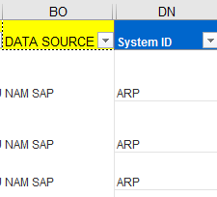  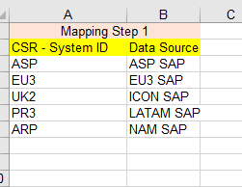
3.1.39 Preparation of NAM CSR report. Populate Global Template columns. Step applicable for all Iterations (1,2,3) | Populate column FUNCTION from Global Template:  - Got to Shared Network Path \\seskcifssvm01\GPT_RPA\Dictionaries and open ‘Management Unit Dictionary_MASTER’  - Go to column ‘Management Unit’ from CSR report and vlookup management unit code in the worksheet ‘Dictionary’ in column Function (B) |  | 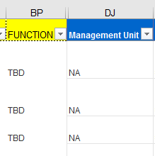  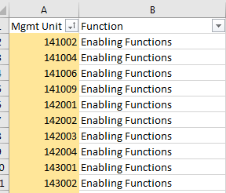
3.1.40 Preparation of NAM CSR report. Create Drop down list. Step applicable for all Iterations (1,2,3) | Create dropdown list for the blank rows on Global Template column SPEND CATEGORY containing:  Advisory Board  Congress  Grants and Contributions/Donations  Investigator Meeting  Licensing  Other Research Meeting  Research  Speaker Program  Sponsorship  Unblinded Market Research  Teaching Hospital Payment  Consulting  Research - Pre Clinical  NOTE: The dropdown list is maintained in the worksheet ‘All LOVs’ within the Global Template |  | 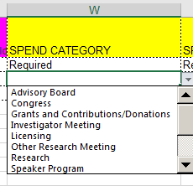
3.1.41 Preparation of NAM CSR report. Create Drop down list. Step applicable for all Iterations (1,2,3) | Create dropdown list for the blank rows on Global Template column SPEND SUBCATEGORY containing:  501c3 Contribution/Donation  Fees  Registration Fees  Reprint  Research Collaboration Payments  Study Drug and Supplies  Study Fees and Expenses  Transportation  Direct Payments  Meals  Lodging  Licensing/Royalty Fee  NOTE: The dropdown list is maintained in the worksheet ‘All LOVs’ within the Global Template |  | 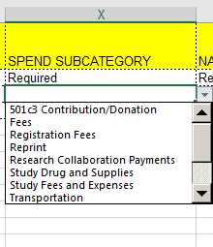
3.1.42 Preparation of NAM CSR report. Create Drop down list. Step applicable for all Iterations (1,2,3) | Create dropdown list for the blank rows on Global Template column NATURE OF PAYMENT containing:  Cash/Reimbursed  In-Kind/Non-Reimbursed  NOTE: The dropdown list is maintained in the worksheet ‘All LOVs’ within the Global Template |  | 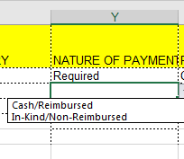
3.1.43 Preparation of NAM CSR report. Create Drop down list. Step applicable for all Iterations (1,2,3) | Create dropdown list for the blank rows on Global Template column PRODUCT containing:  ACCOLATE;ARIMIDEX;ATACAND;BEVESPI;AEROSPHERE;BRILINTA;BYDUREON;BYETTA;CALQUENCE; CAPRELSA;CASODEX;CRESTOR;DALIRESP;DUTOPROL;ENTOCORT;EPANOVA;FARXIGA;FASENRA;FASLODEX;FLUMIST;IMFINZI;IRESSA;KOMBIGLYZE; LOKELMA; LUMOXITI;LYNPARZA;MERREM IV;MOVANTIK;MYALEPT;NEXIUM; NON-COVERED PRODUCT; NONE; ONGLYZA; ONGLYZA; PRILOSEC; PULMICORT RESPULES; QTERN; QUETIAPINE FUM; RHINOCORT; SEROQUEL; SYMBICORT; SYMLIN PEN; SYNAGIS; TAGRISSO; TENORETIC; TENORMIN; TOPROL; TUDORZA; VIMOVO; XIGDUO; ZAFIRLUKAST; ZESTORETIC; ZESTRIL; ZOLADEX; ZOMIG; ZURAMPIC  NOTE: The dropdown list is maintained in the worksheet ‘All LOVs’ within the Global Template |  | 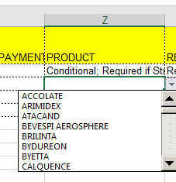
3.1.44 Preparation of NAM CSR report. Create Drop down list. Step applicable for all Iterations (1,2,3) | Create dropdown list for the blank rows on Global Template column RECIPIENT TYPE containing:  HCP  HCO  NOTE: The dropdown list is maintained in the worksheet ‘All LOVs’ within the Global Template |  | 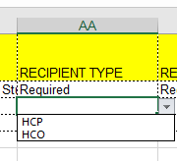
3.1.45 Preparation of NAM CSR report. Create Drop down list. Step applicable for all Iterations (1,2,3) | Create dropdown list for the blank rows on Global Template column RECIPIENT IDENTIFICATION TYPE containing: AZ, NPI, GUID  NOTE: The dropdown list is maintained in the worksheet ‘All LOVs’ within the Global Template |  | 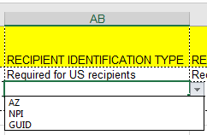
3.1.46 Preparation of NAM CSR report. Create Drop down list. Step applicable for all Iterations (1,2,3) | Create dropdown list for the blank rows on Global Template column RECIPIENT LICENSE TYPE containing:  Administrator, Advanced Practice Nurse (APN), Certified Registered Nurse Anaesthetist, Dental Assistant, Dental Prosthetist, Dentist, Doctor of Optometry (OD), Doctor of Osteopathy (DO), Licensed Practical Nurse (LPN), Medical Assistant, Medical Doctor (MD), Midwife, MPH, Non Licensed, Nurse, Nurse Practitioner (NP), Office Staff / Administrators, Optician, Optician Assistant, Other, Pramedical, Paramedical Assistant, PharmD, PhD, Physical Therapist, Physician, Physician Assistant (PA), Registered Nurse (RN), Researcher/Scientist, Veterinarian, Veterinarian Assistant  NOTE: The dropdown list is maintained in the worksheet ‘All LOVs’ within the Global Template |  | 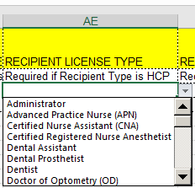
3.1.47 Preparation of NAM CSR report. Create Drop down list. Step applicable for all Iterations (1,2,3) | Create dropdown list for the blank rows on Global Template column RECIPIENT STATE containing:  ALABAMA, ALASKA, CALIFORNIA, COLORADO, CONNECTICUT, DELAWARE, DISTRICT OF COLUMBIA, FLORIDA, GEORGIA, GUAM, HAWAII, IDAHO, ILLINOIS, INDIANE, IOWA, KANSAS, KENTUCKY, LOUISIANA, MAINE, MARSHALL ISLANDS, MARYLAND, MASSACHUSETTS, MICHIGAN, MICRONESIA, MILITARY ATLANTIC, MILITARIC EUROPE, MILITARY PACIFIC, MINNESOTA, MISSISSIPPI, MISSOURI, MONTANA, NEBRASKA, NEVADA, NEW HAMPSHIRE, NEW JERSEY, NEW MEXICO, NEW YORK, NORTH CAROLINA, NORTH DAKOTA, NORTH MARINA, ISLANDSM OHIOM OKLAHOMA, OREGOB, PALUA, PENNSYLVANIA, PUERTO RICO, RHODE ISLAND, SOUTH CAROLINA, SOUTH DAKOTA, TENNESSEE, TEXAS, UTAH, VERMONT, VIRGIN ISLANDS, VIRGINIA, WASHINGTON, WEST VIRGINIA, WISCONSIN, WYOMING  NOTE: The dropdown list is maintained in the worksheet ‘All LOVs’ within the Global Template |  | 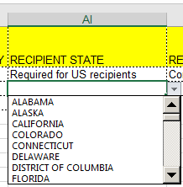
3.1.48 Preparation of NAM CSR report. Create Drop down list. Step applicable for all Iterations (1,2,3) | Create dropdown list for the blank rows on Global Template column PI IDENTIFICATION TYPE containing: AZ, NPI, GUID  NOTE: The dropdown list is maintained in the worksheet ‘All LOVs’ within the Global Template |  | 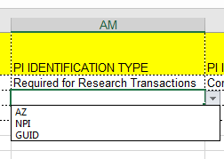
3.1.49 Preparation of NAM CSR report. Create Drop down list. Step applicable for all Iterations (1,2,3) | Create dropdown lists for the blank rows on Global Template columns  - Column: ‘Assessment Determination’:  Reportable; Not Reportable; UNCERTAIN  - Column: ‘Need to update PO Dictionary?’:  YES; NO  - Column ‘Need to update vendor dictionary?’:  YES; NO  - Column: ‘Need to update GL Dictionary?’:  YES; NO  NOTE: The dropdown list is maintained in the worksheet ‘All LOVs’ within the Global Template |  | 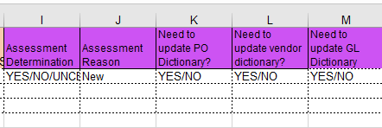
3.1.50 Preparation of NAM CSR report. Create Drop down list. Step applicable for all Iterations (1,2,3) | Covert the populate Global Template fields  - Convert all the formulas within the report to values  - Convert fields from columns ‘PURCHASE ORDER NUMBER’ and ‘SUPPLIER INVOICE NUMBER’ to text
3.1.51 Save and upload file in the Shared Path folder. Files will be saved base on the Iteration as described. | Save and upload file in the Shared Path  - Save file for Iteration 1 as ‘NAM_AMERICAS_Month_Year_CSR_Assignments’ and upload it to AMERICAS shared path folder using link \\seskcifssvm01\GPT_RPA\InvoiceValidation\Process\AMERICAS\Input Folder  - Save file for Iteration 2 as NAM_EUROPE_Month_Year_CSR_Assignments and upload it to EMEA shared path folder using link \\seskcifssvm01\GPT_RPA\InvoiceValidation\Process\EMEA\Input Folder  - Save file for Iteration 3 as NAM_ROW_Month_Year_CSR_Assignments and upload it to ASIAPAC shared path folder using link \\seskcifssvm01\GPT_RPA\InvoiceValidation\Process\ASIAPAC\Input Folder |  | 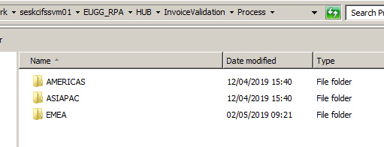  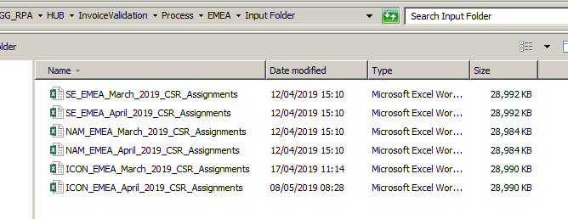
3.1.52 Prepare the Sweden CSR report. Use Global Template  *Step applicable for all Iterations (1,2,3) | Prepare the Sweden CSR report for Iteration 1, 2 and 3: Use Global Template  - Download and open the CSR report containing Sweden data for the 3 iterations from Shared Network Path:  SE_ MonthYear_Americas_Iteration_1  SE_ MonthYear_Europe_Iteration_2  SE_ MonthYear_ROW_Iteration_3  - Check if the CSR columns that will be used in the process are available. Column names that bot will check: ‘Vendor Tax ID 2’, ‘Payment Method Supplement’, ‘Vendor Text’, ‘Name 1’, ‘Signed Amount’, ‘GL Account’, ‘Purchasing Document Number’, ‘Vendor ID’, ‘Name 2’, ‘Vendor Search Term2’, ‘Vendor Address Line Item 1’, ‘Vendor City’, ‘Vendor Postal Code’, ‘Clearing Date’, ‘Signed Amount’, ‘Currency Key’, ‘Reference Document Number’, ‘WBS Element’, ‘Document Number’, ‘Vendor Region’, ‘Vendor Country Code’, ‘Invoice Line Item’, ‘Company Code’, ‘Fiscal Year’, ‘System ID’, ‘Management Unit’, ‘SAP PO Type’,’Cost Center’, ‘Business Area’  IF any of these columns are not available  THEN robot will send notification email to Global Transparency Team with ‘Columns [names] are not available in the CSR data report [name]’ and move to the next report  - Convert the column ‘GL Account’, ‘Document Number’, ’Cost Center’, Management Unit’, Vendor ID’, ‘Purchasing Document Number’ to number format by highlighting each whole column and executing “text to columns” function – updated in 17.07.2019  - Use the Global Template saved in Robot internal Memory (My Docs) to copy-paste the CSR Sweden data into the template at the end of the pre-populated column names starting column BS  - Leave one blank row between the header and the report content
3.1.53 Preparation of SWEDEN CSR report. Populate the Global Template columns. *Step applicable for all Iterations (1,2,3) | Populate Global Template column ‘SWE - CC begins with 1*?’:  - Go to CSR report column ‘Cost Center’ and apply filter on the values that begin with ‘000001’  - Then go back to the Global Template column ‘SWE - CC begins with 1*?’ and fill in ‘Yes’ for the filtered values  - Remove the filter |  | 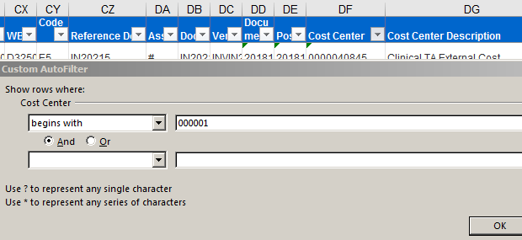
3.1.54 Preparation of SWEDEN CSR report. Populate the Global Template columns. *Step applicable for all Iterations (1,2,3) | Populate Global Template column ‘SWE - Business Area = Z005?:  - Go to CSR report column ‘Business Area’ and filter on Z005  - Then go back to Global Template column ‘SWE - Business Area = Z005?’ and fill in ‘’Yes’ for the filtered values  - Remove the filter |  | 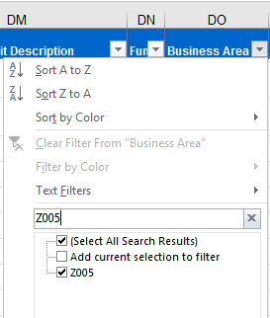
3.1.55 Preparation of SWEDEN CSR report. Populate the Global Template columns. *Step applicable for all Iterations (1,2,3) | Populate Global Template column ‘SWE - Ref contains Tax ?’:  - Go to CSR report column ‘Reference Document Number’ and apply filter on the values that ‘contain’ the word ‘TAX’  - Go back to the Global Template column and fill in ‘Yes’ for the filtered values  - Remove the filter |  | 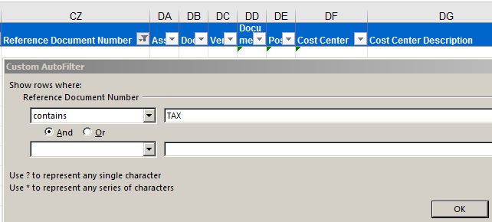
3.1.56 Preparation of SWEDEN CSR report. Populate the Global Template columns. *Step applicable for all Iterations (1,2,3) | Populate Global Template column ‘PO Excluded due to type?’:  - Go to CSR column ‘SAP PO Type’ and filter on YLMS (Ops Locally Mngd Ser), YNB (Ops), YSNC (PO Collaboration Ord), YSMI (scheduling agreement)  NOTE: Robot should filter on the values that begin with YLMS, YNB, YSNC, YSMI - added in 17.07.2019  - Go back to the Global Template column and fill in ‘Yes’ for the filtered values  - Remove the filter  NOTE: The filtering criteria may not all be available in the list. Filter on the available fields. | IF the filtering criteria is not available in the list  THEN ignore the step and move to the next one | 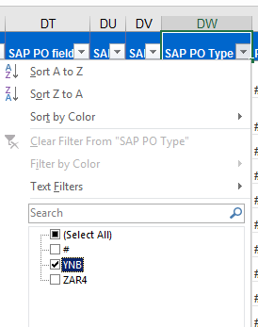
3.1.57 Preparation of SWEDEN CSR report. Populate the Global Template columns. *Step applicable for all Iterations (1,2,3) | Populate Global Template column REFERENCE NUMBER:  - Concatenate CSR Fields: Invoice Line Item & Document Number & Company Code & Fiscal Year  Note: Will need to change format of Document Number to Number to ensure no leading zero!  NOTE: Do not convert the ‘Invoice Line Item’ fields to number – added in 16.07.2019
3.1.58 Preparation of SWEDEN CSR report. Populate the Global Template columns. *Step applicable for Iteration 2 ONLY | Populate Global Template column ‘Loaded in ASPEN?’:  - Go to the Shared Path folder \\seskcifssvm01\GPT_RPA\Dictionaries and open the ASPEN Dictionary – ‘Adhoc Report-Cube_SWE_SOAR_MonthYear’  - VLOOKUP the Unique id from column REFERENCE NUMBER from Global Template in ASPEN dictionary ‘Source System Activity ID Field’ and pull back ‘Reportability Indicator’ |  | 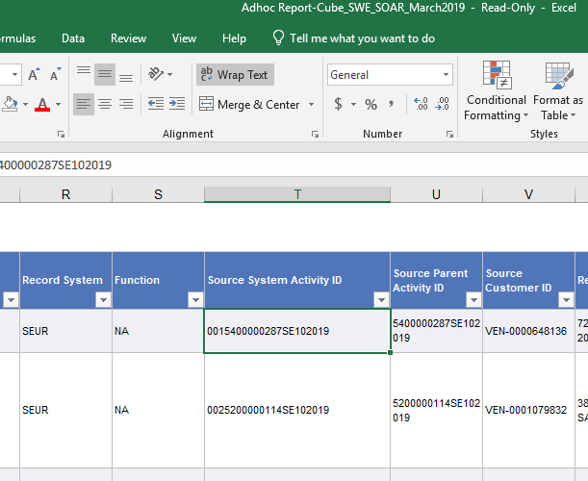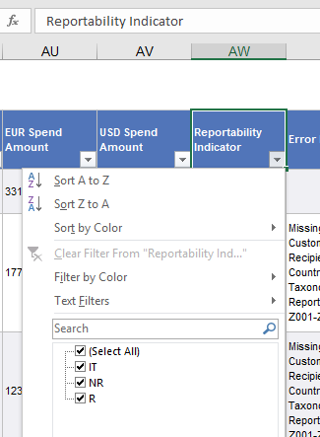
3.1.59 Preparation of SWEDEN CSR report. Populate the Global Template columns. *Step applicable for all Iterations (1,2,3) | Populate column ‘PO Reportability’ from Global Template:  - Go to shared path folder using link \\seskcifssvm01\GPT_RPA\Dictionaries to download and open the ‘PO Dictionary_MASTER’  - Go back to the Global Template data column ‘PO Reportability’ and vlookup the ‘Purchasing Document Number’ column from CSR report content in the file ‘PO Dictionary_MASTER’ in column B ( ‘Reportability’)  NOTE: Do not remove the #N/A returns. |  | 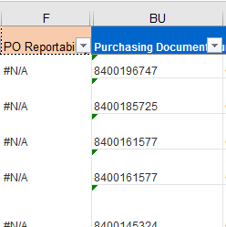
3.1.60 Preparation of SWEDEN CSR report. Populate the Global Template columns. *Step applicable for all Iterations (1,2,3) | Populate column ‘PO Reason’ from Global Template:  - VLOOKUP the ‘Purchasing Document Number’ from CSR report column in the ‘PO Dictionary_MASTER’ in column C ( ‘Reason’)  Updated in 09.07.2019 |  | 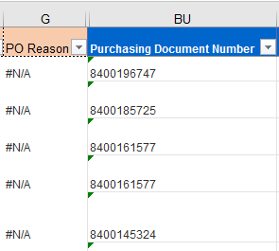
3.1.61 Preparation of SWEDEN CSR report. Populate the Global Template columns. *Step applicable for all Iterations (1,2,3) | Populate column ‘Spend Category’ from Global Template:  - Go to column ‘PO Reportability’ from Global Template and filter on ‘Yes’ – added in 09.07.2019  - Vlookup the ‘Purchasing Document Number’ column from CSR report in the file ‘PO Dictionary_MASTER’ in column D (‘Spend Category’)  Repeat the Vlookup process using ‘Purchasing Document Number’ and ‘PO Dictionary_MASTER’ for columns ‘Spend Subcategory’, Nature of Payment’, ‘Product’, ‘Recipient’, ‘Recipient identification Type’, ‘Recipient ID’, ‘Recipient Name’, ‘PI Identification Type’, ‘PI Identifier’, ‘PI Name’, ‘Description of meeting/event’, ‘Event City’, ‘Event State’, ‘Event Country’, ‘AstraZeneca Engagement Owner’, ‘Study Code’, ‘Comments’.  NOTE: Process steps captured already in the Design Document for NAM report 3.1.11 – 3.1.27 |  | 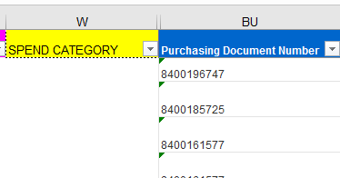
3.1.62 Preparation of SWEDEN CSR report. Populate the Global Template columns. *Step applicable for all Iterations (1,2,3) | Populate column ‘GL Reportability’ from Global Template:  - Covert the ‘GL Account number’ column from CSR report to number  - Go to shared path folder using link \\seskcifssvm01\GPT_RPA\Dictionaries to download and open the ‘GL Dictionary_MASTER’ file  IF file is prepared for Iteration 1(AMERICAS)  THEN the vlookup will be performed in column D Iteration 1 - US Recipient  IF file is prepared for Iteration 2 (EMEA)  THEN the vlookup will be performed in column C Iteration 2 - EMEA Recipient  IF file is prepared for Iteration 3 (ASIAPAC)  THEN the vlookup will be performed in column E Iteration 3 - ASP Recipient  Updated the columns names as per the GL Dictionary  in 08/07/2019  NOTE: Do not remove the #N/A returns |  | 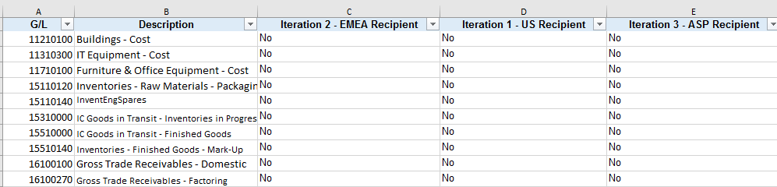
3.1.63 Preparation of SWEDEN CSR report. Populate the Global Template columns. *Step applicable for all Iterations (1,2,3) | Populate column ‘Vendor Reportability’ from Global Template:  - Covert the ‘Vendor ID’ column from CSR report to number  - Go to shared path folder using link \\seskcifssvm01\GPT_RPA\Dictionaries to download and open the ‘Vendor Dictionary_MASTER’ file  - Vlookup the ‘Vendor ID’ column from CSR report into the ‘Vendor Dictionary_MASTER’ files using column ‘Vendor Code’  IF file is prepared for Iteration 1(AMERICAS)  THEN the vlookup will be performed in column F ‘Iteration 1 - US Recipients’  IF file is prepared for Iteration 2 (EMEA)  THEN the vlookup will be performed in column E ‘Iteration 2 - EMEA Recipients’  IF file is prepared for Iteration 3 (ASIAPAC)  THEN the vlookup will be performed in column G ‘Iteration 3 - ASP Recipients’  - Updated the columns position and names as per the Vendor Dictionary in 08/07/2019  NOTE: Do not remove the #N/A returns  - Go to column ‘Vendor Reportability’ from Global Template and filter on ‘#N/A’ values  - VLOOKUP the ‘Name 1’ column from CSR report into the ‘Vendor Dictionary_MASTER’ files using column ‘Vendor Name’ based upon iterations defined above |  | 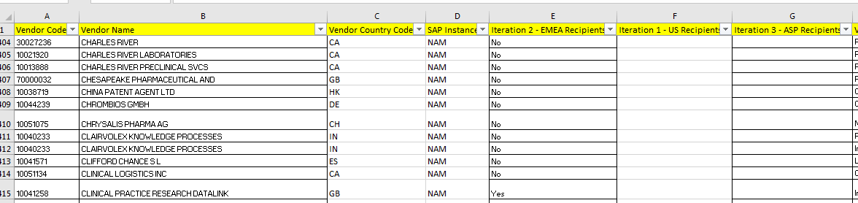
3.1.64 Preparation of SWEDEN CSR report. Populate the Global Template columns. *Step applicable for all Iterations (1,2,3) | Populate column ‘Vendor Reason’ from Global Template:  - Remove all filters  - VLOOKUP the ‘Vendor ID’ column from CSR report into the ‘Vendor Dictionary_MASTER’ file using column ‘VENDOR CODE’ in column A and pull back ‘ Vendor Reason/Description’ and put in Vendor Reason column
3.1.65 Preparation of SWEDEN CSR report. Populate the Global Template columns. *Step applicable for all Iterations (1,2,3) | Populate Global Template column ‘BOT Reportability Determination’  - Go to Global Template column ‘Loaded in ASPEN?’ and filter on ‘R or IT’  - Then go to column ‘BOT Reportability Determination’ and fill in ‘NR – Found in ASPEN’ for the filtered values  - Remove the filters  - Go to column ‘SWE - CC begins with 1*?’ and filter on ‘Yes’  - Then go to column ‘BOT Reportability Determination’ and fill in ‘NR – MC’ for the filtered values but only for the blank cells  - Remove the filters  - Go to column ‘Business Area = Z005?’ and filter on ‘Yes’  - Then go to column ‘BOT Reportability Determination’ and fill in ‘NR – MC’ for the filtered values but only for the blank cells (do not override already populated fields)  - Remove the filters  - Go to column ‘SWE - Ref contains Tax ?’ and filter on ‘Yes’  - Then go to column ‘BOT Reportability Determination’ and fill in ‘NR – Tax’ for the filtered values but only for the blank cells  - Remove the filters  - Go to column ‘PO Excluded due to Type’ and filter on ‘Yes’  - Then go to column ‘BOT Reportability Determination’ and fill in ‘NR – PO Type’ for the filtered values but only for the blank cells  - Remove all filters  - Go to column ‘PO Reportability’ and filter on ‘Yes’  - Then go to column column ‘BOT Reportability Determination’ and fill in ‘R – PO Dictionary’ for the filtered values but only for the blank cells  - Remove all filters  - Go to column ‘PO Reportability’ and filter on ‘No’  - Then go to column ‘BOT Reportability Determination’ and fill in ‘NR – PO Dictionary’ for the blank cells only  - Remove all filters  - Go to column ‘GL Reportability’ and filter on ‘No’  - Then go to column ‘BOT Reportability Determination’ and fill in ‘NR – GL’ for the filtered values but only for the blank cells  - Remove all filters  - Go to column ‘GL Reportability’ and filter on ‘YES and ‘#N/A’ – updated in 09.07.2019  - Go to column ‘Vendor Reportability’ and filter on ‘YES’, 0, Teaching Hospitals and ‘#N/A’ updated in 09.07.2019  - Then go to column ‘BOT Reportability Determination’ and fill in ‘R - Vendor & GL’ for the filtered values but only for the blank cells  - Remove all filters  - Go to column ‘Vendor Reportability’ and filter on ‘No or ‘Non-HCO Third Party’  - Then go to column ‘BOT Reportability Determination’ and fill in ‘NR – Vendor’ for the filtered values but only for the blank cells.  - Remove all filters |  | 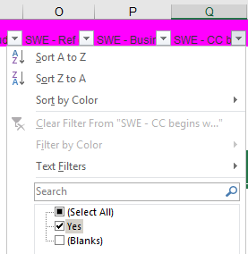  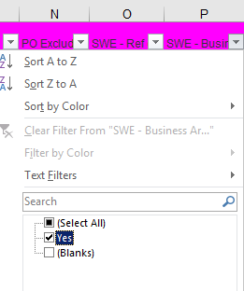  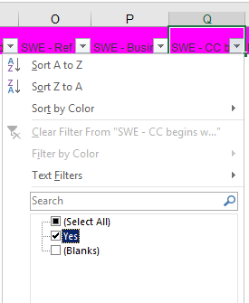  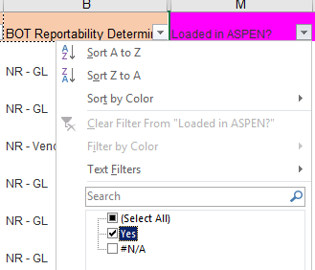
3.1.66 Preparation of SWEDEN CSR report. Populate the Global Template columns. *Step applicable for all Iterations (1,2,3) | Populate column ‘ASSIGNMENT’ from Global Template:  - Go to column ‘BOT Reportability Determination’ an filter on the fields starting with R (reportable)  - Fill in ‘Assign’ for the filtered values in column ‘ASSIGNMENT’  - Remove all filters |  | 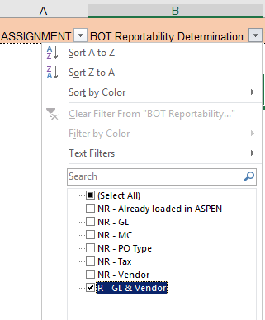  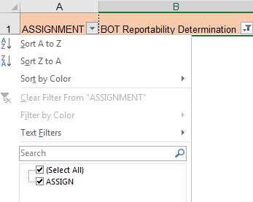
3.1.67 Preparation of SWEDEN CSR report. Copy-paste the CSR data into the Global template. *Step applicable for all Iterations (1,2,3) | Copy-paste the information from CSR report columns into the template columns for the filtered (‘Assign’) rows only. Do not overwrite  - Go to column ‘Assignment’ and filter on the ‘Assign’ fields only  - Then copy paste the content from CSR report column Vendor Search Term2 into Global Template column RECIPIENT IDENTIFIER for the blank fields only  - Copy paste the content from CSR report column Name 1 into Global Template column RECIPIENT NAME for the blank fields only  - Copy paste the content from CSR report column Vendor Address Line Item 1 into Global Template column RECIPIENT ADDRESS LINE 1 for the blank fields only  - Copy paste the content from CSR report column Vendor City into Global Template column RECIPIENT CITY for the blank fields only  - Copy paste the content from CSR report column Vendor Postal Code into Global Template column RECIPIENT POSTAL CODE for the blank fields only  - Copy paste the content from CSR report column Clearing Date into Global Template column PAYMENT DATE for the blank fields only  - Copy paste the content from CSR report column Signed Amount into Global Template column PAYMENT AMOUNT for the blank fields only  - Copy paste the content from CSR report column Currency Key into Global Template column PAYMENT CURRENCY for the blank fields only  - Copy paste the content from CSR report column Reference Document Number into Global Template column SUPPLIER INVOICE NUMBER for the blank fields only  - Copy paste the content from CSR report column WBS Element into Global Template column STUDY CODE for the blank fields only  - Copy paste the content from CSR report column Document Number into Global Template column SAP DOCUMENT NUMBER for the blank fields only  - Copy paste the content from CSR report column Purchasing Document Number into Global Template column PURCHASE ORDER NUMBER for the blank fields only
3.1.68 Preparation of SWEDEN CSR report. Populate Global Template columns. *Step applicable for Iteration 1 ONLY | Populate column RECIPIENT STATE from Global Template  NOTE: Do not remove the filter from ‘Assign’  - Go to the Shared Network Path \\seskcifssvm01\GPT_RPA\Dictionaries and open file ‘DropDownLOVs_25June2019’  - Go to column ‘Vendor Region’ from CSR report and vlookup the regions in the file ‘DropDownLOVs_25June2019’ in worksheet ‘Recipient State Mapping’ column B  - Step updated in 27.06.2019 to include the mapping tables location in the Shared Network Path file ‘DropDownLOVs_25June2019’
3.1.69 Preparation of SWEDEN CSR report. Populate Global Template columns. *Step applicable for all Iterations (1,2,3) | Populate column RECIPIENT COUNTRY from Global Template:  - Go to the Shared Network Path \\seskcifssvm01\GPT_RPA\Dictionaries and open file ‘DropDownLOVs_25June2019’  - Go to column ‘Vendor Country Code’ from CSR report and vlookup the regions in the file ‘DropDownLOVs_25June2019’ in worksheet ‘Recipient Country Mapping’ column B ‘Template- Recipient Country’  Step updated in 27.06.2019 to include the mapping tables location in the Shared Network Path file ‘DropDownLOVs_25June2019’
3.1.70 Preparation of SWEDEN CSR report. Populate Global Template columns. *Step applicable for all Iterations (1,2,3) | Populate column RECORD COMPANY from Global Template:  - Go to the Shared Network Path \\seskcifssvm01\GPT_RPA\Dictionaries and open file ‘DropDownLOVs_25June2019’  - Go to CSR column ‘Company Code’ from CSR report and vlookup the code in the file ‘DropDownLOVs_25June2019’ in worksheet ‘Record Company Mapping’ in column B ‘Record Company’  - Step updated in 27.06.2019 to include the mapping tables location in the Shared Network Path file ‘DropDownLOVs_25June2019’
3.1.71 Preparation of SWEDEN CSR report. Populate Global Template columns. *Step applicable for all Iterations (1,2,3) | Populate column DATA SOURCE from Global Template:  - Go to the Shared Network Path \\seskcifssvm01\GPT_RPA\Dictionaries and open file ‘DropDownLOVs_25June2019’  - Go to CSR column ‘System ID’ from CSR report and vlookup the code in the file ‘DropDownLOVs_25June2019’ in worksheet ‘Data Source Mapping’ in column B ‘Data Source’  - Then go to CSR column ‘Reference Document Number’ and filter on the values that ‘Begins with ‘EPAY’ and override in the Global Template column DATA SOURCE with words ‘EPAY’  - Step updated in 27.06.2019 to include the mapping tables location in the Shared Network Path file ‘DropDownLOVs_25June2019’
3.1.72 Preparation of SWEDEN CSR report. Populate Global Template columns. *Step applicable for all Iterations (1,2,3) | Populate column FUNCTION from Global Template:  - Go to Shared Network Path \\seskcifssvm01\GPT_RPA\Dictionaries and open ‘Management Unit Dictionary_MASTER’  - Go to column ‘Management Unit’ from CSR report and vlookup management unit code in the worksheet ‘Dictionary’ in column Function (B)
3.1.73 Preparation of SWEDEN CSR report. Create Drop down list. *Step applicable for all Iterations (1,2,3) | Create dropdown list for the blank rows on Global Template column SPEND CATEGORY containing:  Advisory Board  Congress  Grants and Contributions/Donations  Investigator Meeting  Licensing  Other Research Meeting  Research  Speaker Program  Sponsorship  Unblinded Market Research  Teaching Hospital Payment  Consulting  Research - Pre Clinical  NOTE: The dropdown list is maintained in the worksheet ‘All LOVs’ within the Global Template
3.1.74 Preparation of SWEDEN CSR report. Create Drop down list. *Step applicable for all Iterations (1,2,3) | Create dropdown list for the blank rows on Global Template column SPEND SUBCATEGORY containing:  501c3 Contribution/Donation  Fees  Registration Fees  Reprint  Research Collaboration Payments  Study Drug and Supplies  Study Fees and Expenses  Transportation  Direct Payments  Meals  Lodging  Licensing/Royalty Fee  NOTE: The dropdown list is maintained in the worksheet ‘All LOVs’ within the Global Template
3.1.75 Preparation of SWEDEN CSR report. Create Drop down list. *Step applicable for all Iterations (1,2,3) | Create dropdown list for the blank rows on Global Template column NATURE OF PAYMENT containing:  Cash/Reimbursed  In-Kind/Non-Reimbursed  NOTE: The dropdown list is maintained in the worksheet ‘All LOVs’ within the Global Template
3.1.76 Preparation of SWEDEN CSR report. Create Drop down list. *Step applicable for all Iterations (1,2,3) | Create dropdown list for the blank rows on Global Template column PRODUCT containing:  ACCOLATE;ARIMIDEX;ATACAND;BEVESPI;AEROSPHERE;BRILINTA;BYDUREON;BYETTA;CALQUENCE; CAPRELSA;CASODEX;CRESTOR;DALIRESP;DUTOPROL;ENTOCORT;EPANOVA;FARXIGA;FASENRA;FASLODEX;FLUMIST;IMFINZI;IRESSA;KOMBIGLYZE; LOKELMA; LUMOXITI;LYNPARZA;MERREM IV;MOVANTIK;MYALEPT;NEXIUM; NON-COVERED, PRODUCT; NONE; ONGLYZA; ONGLYZA; PRILOSEC; PULMICORT RESPULES; QTERN; QUETIAPINE FUM; RHINOCORT; SEROQUEL; SYMBICORT; SYMLIN PEN; SYNAGIS; TAGRISSO; TENORETIC; TENORMIN; TOPROL; TUDORZA; VIMOVO; XIGDUO; ZAFIRLUKAST; ZESTORETIC; ZESTRIL; ZOLADEX; ZOMIG; ZURAMPIC  NOTE: The dropdown list is maintained in the worksheet ‘All LOVs’ within the Global Template
3.1.77 Preparation of SWEDEN CSR report. Create Drop down list. *Step applicable for all Iterations (1,2,3) | Create dropdown list for the blank rows on Global Template column RECIPIENT TYPE containing:  HCP  HCO  NOTE: The dropdown list is maintained in the worksheet ‘All LOVs’ within the Global Template
3.1.78 Preparation of SWEDEN CSR report. Create Drop down list. *Step applicable for all Iterations (1,2,3) | Create dropdown list for the blank rows on Global Template column RECIPIENT IDENTIFICATION TYPE containing:  NOTE: The dropdown list is maintained in the worksheet ‘All LOVs’ within the Global Template
  AZ
  NPI
  GUID
3.1.79 Preparation of SWEDEN CSR report. Create Drop down list. *Step applicable for all Iterations (1,2,3) | Create dropdown list for the blank rows on Global Template column RECIPIENT LICENSE TYPE containing:  Administrator, Advanced Practice Nurse (APN), Certified Registered Nurse Anaesthetist, Dental Assistant, Dental Prosthetist, Dentist, Doctor of Optometry (OD), Doctor of Osteopathy (DO), Licensed Practical Nurse (LPN), Medical Assistant, Medical Doctor (MD), Midwife, MPH, Non Licensed, Nurse, Nurse Practitioner (NP), Office Staff / Administrators, Optician, Optician Assistant, Other, Paramedical, Paramedical Assistant, PharmD, PhD, Physical Therapist, Physician, Physician Assistant (PA), Registered Nurse (RN), Researcher/Scientist, Veterinarian, Veterinarian Assistant  NOTE: The dropdown list is maintained in the worksheet ‘All LOVs’ within the Global Template
3.1.80 Preparation of SWEDEN CSR report. Create Drop down list. *Step applicable for all Iteration 1 ONLY | Create dropdown list for the blank rows on Global Template column RECIPIENT STATE containing:  ALABAMA, ALASKA, CALIFORNIA, COLORADO, CONNECTICUT, DELAWARE, DISTRICT OF COLUMBIA, FLORIDA, GEORGIA, GUAM, HAWAII, IDAHO, ILLINOIS, INDIANE, IOWA, KANSAS, KENTUCKY, LOUISIANA, MAINE, MARSHALL ISLANDS, MARYLAND, MASSACHUSETTS, MICHIGAN, MICRONESIA, MILITARY ATLANTIC, MILITARIC EUROPE, MILITARY PACIFIC, MINNESOTA, MISSISSIPPI, MISSOURI, MONTANA, NEBRASKA, NEVADA, NEW HAMPSHIRE, NEW JERSEY, NEW MEXICO, NEW YORK, NORTH CAROLINA, NORTH DAKOTA, NORTH MARINA, ISLANDSM OHIOM OKLAHOMA, OREGOB, PALUA, PENNSYLVANIA, PUERTO RICO, RHODE ISLAND, SOUTH CAROLINA, SOUTH DAKOTA, TENNESSEE, TEXAS, UTAH, VERMONT, VIRGIN ISLANDS, VIRGINIA, WASHINGTON, WEST VIRGINIA, WISCONSIN, WYOMING  NOTE: The dropdown list is maintained in the worksheet ‘All LOVs’ within the Global Template
3.1.81 Preparation of SWEDEN CSR report. Create Drop down list. *Step applicable for all Iterations (1,2,3) | Create dropdown list for the blank rows on Global Template column PI IDENTIFICATION TYPE containing:  NOTE: The dropdown list is maintained in the worksheet ‘All LOVs’ within the Global Template
  AZ
  NPI
  GUID
3.1.82 Preparation of SWEDEN CSR report. Create Drop down list. *Step applicable for all Iterations (1,2,3) | Create dropdown lists for the blank rows on Global Template columns  - Column: ‘Assessment Determination’:  REPORTABLE; NOT REPORTABLE; UNCERTAIN  - Column: ‘Need to update PO Dictionary?’:  YES; NO  - Column ‘Need to update vendor dictionary?’:  YES; NO  - Column: ‘Need to update GL Dictionary?’:  YES; NO  NOTE: The dropdown list is maintained in the worksheet ‘All LOVs’ within the Global Template
3.1.83 Preparation of SWEDEN CSR report. Create Drop down list. *Step applicable for all Iterations (1,2,3) | Covert the populated Global Template fields  - Convert all the formulas within the report to values  - Convert fields from columns ‘PURCHASE ORDER NUMBER’ and ‘SUPPLIER INVOICE NUMBER’ to text
3.1.84 Save and upload files in the shared path folder | - Save file as ‘SE_AMERICAS_Month_Year_CSR_Assignments’ and upload it to AMERICAS shared path folder using link \\seskcifssvm01\GPT_RPA\InvoiceValidation\Process\AMERICAS\Input Folder  - Save files as ‘SE_EUROPE_Month_Year_CSR_Assignments and upload it to EMEA shared path folder using link \\seskcifssvm01\GPT_RPA\InvoiceValidation\Process\EMEA\Input Folder  - Save file as SE_ROW_Month_Year_CSR_Assignments and upload it to ASIAPAC shared path folder using link \\seskcifssvm01\GPT_RPA\InvoiceValidation\Process\ASIAPAC\Input Folder
3.1.85 Preparation of ICON CSR report. Copy-paste the CSR data into Global Template. *Step applicable for all Iterations (1,2,3) | Prepare the ICON CSR report for Iteration 1, 2 and 3: Use Global Template  - Download and open the CSR report containing ICON data for the 3 iterations  ICON_MonthYear_Americas_Iteration_1  ICON_ MonthYear_Europe_Iteration_2  ICON_ MonthYear_ROW_Iteration_3  - Check if the CSR columns that will be used in the process are available. Column names that bot will check: ‘Vendor Tax ID 2’, ‘Payment Method Supplement’, ‘Vendor Text’, ‘Name 1’, ‘Signed Amount’, ‘GL Account’, ‘Purchasing Document Number’, ‘Vendor ID’, ‘Name 2’, ‘Vendor Search Term2’, ‘Vendor Address Line Item 1’, ‘Vendor City’, ‘Vendor Postal Code’, ‘Clearing Date’, ‘Signed Amount’, ‘Currency Key’, ‘Reference Document Number’, ‘WBS Element’, ‘Document Number’, ‘Vendor Region’, ‘Vendor Country Code’, ‘Invoice Line Item’, ‘Company Code’, ‘Fiscal Year’, ‘System ID’, ‘Management Unit’, ‘SAP PO Type’,’Cost Center’, ‘Business Area’  IF any of these columns are not available  THEN robots will send notification email to Global Transparency Team with ‘Columns [names] are not available in the CSR data report [name]’ and move to the next report  - Convert the column ‘GL Account’, ‘Document Number’, ’Cost Center’, Management Unit’, Vendor ID’, ‘Purchasing Document Number’ to number format by highlighting each whole column and executing “text to columns” function  - Use the Global Template saved in Robot internal Memory (My Docs) to copy-paste the CSR Sweden data into the template at the end of the pre-populated column names starting column BS  - Leave one blank row between the header and the report content
3.1.86 Preparation of ICON CSR report. *Step applicable only for Iteration 1 | Populate column ‘NAM – TH Match?’ in the Global Template  - Go to shared path folder using link \\seskcifssvm01\GPT_RPA\Dictionaries to download and open the ‘ ‘2019_Teaching_Hospital_List_MASTER’ file  - Search in the dictionary using CSR column ‘Vendor Tax ID 2’ and the EIN number in the dictionary ‘2019_Teaching_Hospital_List_MASTER’ and bring in the content within column Hub_Vlookup (Q) in the ‘NAM – TH Match?’  NOTE: The column ‘NAM – TH Match?’ will be populated with ‘Yes’ and ‘N/A’. Leave #N/A for any non-matches
3.1.87 Preparation of ICON CSR report. *Step applicable for all Iterations (1,2,3) | Populate Global Template column ‘SWE - Ref contains Tax ?’:  - Go to CSR report column ‘Reference Document Number’ and apply filter on the values that ‘contain’ the word ‘TAX’  - Go back to the Global Template column and fill in ‘Yes’ for the filtered values  - Remove the filter
3.1.88 Preparation of ICON CSR report. *Step applicable for all Iterations (1,2,3) | Populate Global Template column ‘PO Excluded due to type?’:  - Go to CSR column ‘SAP PO Type’ and filter on ‘NB’, ‘ZTHD’, ‘ZTOL’, ‘ZSMI’ or ‘ZT76’  - Go back to the Global Template column and fill in ‘Yes’ for the filtered values  - Remove the filter  NOTE: The filtering criteria may not all be available in the list. Filter on the available fields.
3.1.89 Preparation of ICON CSR report. *Step applicable for all Iterations (1,2,3) | Populate Global Template column REFERENCE NUMBER:  Concatenate CSR Fields: Invoice Line Item & Document Number & Company Code & Fiscal Year  Note: Must convert Doc No. to Number Format prior to executing concatenate  NOTE: Do not convert the ‘Invoice Line Item’ fields to number – added in 16.07.2019
3.1.90 Preparation of ICON CSR report. *Step applicable for Iteration 2 | Populate Global Template column ‘Loaded into ASPEN?’  - Go to the Shared Path folder using link \\seskcifssvm01\GPT_RPA\Dictionaries and open the ASPEN_ICON Dictionary -> Adhoc Report-Cube_ICON_SOAR_Jan_May_2019  - VLOOKUP the unique id from column REFERENCE NUMBER from Global Template in ASPEN_ICON dictionary in worksheet ‘Adhoc Report’ in the ‘Source System Activity ID’ column (AJ) and pull back Reportability Indicator (AW)
3.1.91 Preparation of ICON CSR report. *Step applicable for all Iterations (1,2,3) | VLOOKUP in PO Dictionary Master to populate the column ‘PO Reportability’, ‘PO Reason’, Spend Category’, ‘Spend Subcategory’, Nature of Payment’, ‘Product’, ‘Recipient’, ‘Recipient identification Type’, ‘Recipient ID’, ‘Recipient Name’, ‘PI Identification Type’, ‘PI Identifier’, ‘PI Name’, ‘Description of meeting/event’, ‘Event City’, ‘Event State’, ‘Event Country’, ‘AstraZeneca Engagement Owner’, ‘Study Code’, ‘Comments’.  - Follow the process steps captured in the Design Document for NAM report 3.1.8 – 3.1.27
3.1.92 Preparation of ICON CSR report. *Step applicable for all Iterations (1,2,3) | Populate column ‘GL Reportability’ from Global Template:  - Covert the ‘GL Account number’ column from CSR report to number  - Go to shared path folder using link \\seskcifssvm01\GPT_RPA\Dictionaries to download and open the ‘GL Dictionary’ file  IF file is prepared for Iteration 1(AMERICAS)  THEN the vlookup will be performed in column D Iteration 1 - US Recipient  IF file is prepared for Iteration 2 (EMEA)  THEN the vlookup will be performed in column C Iteration 2 - EMEA Recipient  IF file is prepared for Iteration 3 (ASIAPAC)  THEN the vlookup will be performed in column E Iteration 3 - ASP Recipient  Updated the columns names as per the GL Dictionary  in 08/07/2019  NOTE: Do not remove the #N/A returns |  | 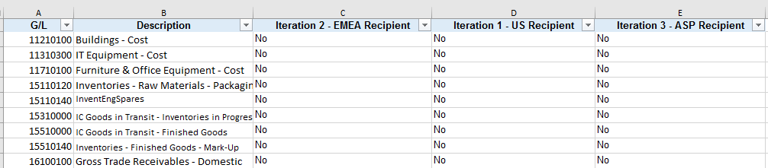
3.1.93 Preparation of ICON CSR report. *Step applicable for all Iterations (1,2,3) | Populate column ‘Vendor Reportability’ from Global Template:  - Covert the ‘Vendor ID’ column from CSR report to number  - Go to shared path folder using link \\seskcifssvm01\GPT_RPA\Dictionaries to download and open the ‘Vendor Dictionary_MASTER’ file  - Vlookup the ‘Vendor ID’ column from CSR report into the ‘Vendor Dictionary_MASTER’ files using column ‘Vendor Code’  IF file is prepared for Iteration 1(AMERICAS)  THEN the vlookup will be performed in column F ‘Iteration 1 - US Recipients’  IF file is prepared for Iteration 2 (EMEA)  THEN the vlookup will be performed in column E ‘Iteration 2 - EMEA Recipients’  IF file is prepared for Iteration 3 (ASIAPAC)  THEN the vlookup will be performed in column G ‘Iteration 3 - ASP Recipients’  - Updated the columns position and names as per the Vendor Dictionary in 08/07/2019  NOTE: Do not remove the #N/A returns  - Go to column ‘Vendor Reportability’ from Global Template and filter on ‘#N/A’ values  - Vlookup the ‘Name 1’ column from CSR report into the ‘Vendor Dictionary_MASTER’ files using column ‘Vendor Name’ based upon iterations defined above  - Remove filters
3.1.94 Preparation of ICON CSR report. *Step applicable for all Iterations (1,2,3) | Populate column ‘Vendor Reason’ from Global Template:  - VLOOKUP the ‘Vendor ID’ column from CSR report into the ‘Vendor Dictionary_MASTER’ file using column ‘VENDOR CODE’ in column A and pull back ‘ Vendor Reason/Description’ and put in Vendor Reason column
3.1.95 Preparation of ICON CSR report. *Steps 1 to 3 are applicable for Iteration 2 only  *Steps 4 to 24 are applicable for all Iterations (1,2,3) | Populate column ‘Bot Reportability Determination’ from Global Template:  - Go to Global Template column ‘Loaded in ASPEN?’ and filter on ‘R or IT’  - Then go to column ‘BOT Reportability Determination’ and fill in ‘NR – Found in ASPEN’ for the filtered values  - Remove the filters  - Go to column ‘SWE - Ref contains Tax ?’ and filter on ‘Yes’  - Then go to column ‘BOT Reportability Determination’ and fill in ‘NR – Tax’ for the filtered values but only for the blank cells  - Remove the filters  - Go to column ‘PO Excluded due to Type’ and filter on ‘Yes’  - Then go to column ‘BOT Reportability Determination’ and fill in ‘NR – PO Type’ for the filtered values but only for the blank cells  - Remove all filters  - Go to column ‘PO Reportability’ and filter on ‘Yes’  - Then go to column ‘BOT Reportability Determination’ and fill in ‘R – PO Dictionary’ for the filtered values but only for the blank cells  - Remove all filters  - Go to column ‘PO Reportability’ and filter on ‘No’  - Then go to column ‘BOT Reportability Determination’ and fill in ‘NR – PO Dictionary’ for the blank cells only  - Remove all filters  - Go to column ‘GL Reportability’ and filter on ‘No’  - Then go to column ‘BOT Reportability Determination’ and fill in ‘NR – GL’ for the filtered values but only for the blank cells  - Remove all filters  - Go to column ‘GL Reportability’ and filter on ‘YES and #N/A – updated in 09.07.2019  - Go to column ‘Vendor Reportability’ and filter on ‘YES and #N/A – updated in 09.07.2019  - Then go to column ‘BOT Reportability Determination’ and fill in ‘R - Vendor & GL’ for the filtered values but only for the blank cells  - Remove all filters  - Go to column ‘Vendor Reportability’ and filter on ‘No or ‘Non-HCO Third Party’  - Then go to column ‘BOT Reportability Determination’ and fill in ‘NR – Vendor’ for the filtered values but only for the blank cells  - Remove all filters
3.1.96 Preparation of ICON CSR report. *Step applicable for all Iterations (1,2,3) | Populate column ‘ASSIGNMENT’ from Global Template:  - Go to column ‘BOT Reportability Determination’ an filter on the fields containing R (reportable)  - Fill in ‘Assign’ for the filtered values in column ‘ASSIGNMENT’  - Remove all filters  - Filter on the ‘Assign’ rows to complete the next steps
3.1.97 Preparation of ICON CSR report. Follow the same steps as for SWE CSR reports. *Step applicability is described in the referred section (3.1.67 to 3.1.83) | Robot will follow the same steps as for SWE CSR data preparation starting with step 3.1.67 to 3.1.83 which includes:  - Copy paste the data from CSR report under the template for the blank rows only but keeping the ‘Assign’ filer  - Vlookup data in the mapping documents/tables in the Shared Network Path  - Create Dropdown lists  - Convert data to text
3.1.98 Save and upload ICON files to the Shared Path location. *Step applicable for all Iterations (1,2,3) | - Save file as ‘ICON_AMERICAS_Month_Year_CSR_Assignments’ and upload it to AMERICAS shared path folder using link \\seskcifssvm01\GPT_RPA\InvoiceValidation\Process\AMERICAS\Input Folder  - Save files as ‘ICON_EUROPE_Month_Year_CSR_Assignments and upload it to EMEA shared path folder using link \\seskcifssvm01\GPT_RPA\InvoiceValidation\Process\EMEA\Input Folder  - Save file as ICON_ROW_Month_Year_CSR_Assignments and upload it to ASIAPAC shared path folder using link \\seskcifssvm01\GPT_RPA\InvoiceValidation\Process\ASIAPAC\Input Folder

3.2 Exception Handling

# | Process Description | Business rule / exceptions | Screenshot of Step
3.2.1 | When not all input files are available in the Shared Network Path | IF: Files are not available on the shared path for the previous month  THEN: Robot will stop the process and send an email notification to Global-Payment-Transparency@astrazeneca.com, radoslaw.orski@astrazeneca.com, Megan.Dalaya@astrazeneca.com, and Christine.Fernandes1@astrazeneca.com informing that files are missing
3.2.2 | When all 9 input files are not available in the Shared Network Path | IF: All 9 input files are not available on the shared path for the previous month  THEN: Robot will start the process with the available files and send an email notification to Global-Payment-Transparency@astrazeneca.com, radoslaw.orski@astrazeneca.com, Megan.Dalaya@astrazeneca.com, and Christine.Fernandes1@astrazeneca.com with the name of the missing reports
3.2.3 | When the columns used in the process are missing from the CSR reports | IF any of these columns are not available  THEN robot will stop the process and send notification email to Global-Payment-Transparency@astrazeneca.com, radoslaw.orski@astrazeneca.com, Megan.Dalaya@astrazeneca.com, and Christine.Fernandes1@astrazeneca.com with ‘Columns [names] are not available in the CSR data report [name]’ and move to the next report
3.2.4 | When the values to be filtered are missing from the row data | IF the values to be filtered are not available  THEN ignore the step and move to the next one that would not be dependent on that particular step.
3.2.5 | When one or part of the filtering criteria is missing from the row data but others are available | IF one or part the values to be filtered are not available  THEN robot will filter on the available criteria and proceed as per the current design
3.2.6 | When the dictionaries/mapping tables used in the process are missing from the Shared Network Path | IF the dictionaries/mapping tables used in the process are missing from the Shared Network Path  THEN robot will stop the process and send an email notification to Global-Payment-Transparency@astrazeneca.com, radoslaw.orski@astrazeneca.com, Megan.Dalaya@astrazeneca.com, and Christine.Fernandes1@astrazeneca.com with the name of the missing dictionary/mapping table
3.2.7 | When Marco errors occur | IF errors occur to the Marco  THEN the robot will stop the process and send an email notification to Global-Payment-Transparency@astrazeneca.com, radoslaw.orski@astrazeneca.com, Megan.Dalaya@astrazeneca.com, and Christine.Fernandes1@astrazeneca.com and move to the next available file

3.3. Re-usable Components
For BoT Analytics it is available in PROD Control Room / My Tasks / Shared_Taskbots /

4. Target applications and roles
The target applications the Solution will interface with are described below.

Microsoft Outlook
Application Name | Microsoft Outlook
Process Steps in scope for Application | Send/Receive emails
Application / System Owner
Validated system
Environments available
Purpose
Version
Internal or External | Internal
URL
Relevant licensing considerations
Single Sign-On | Yes
Business Criticality Classification
TSO
Support Hours
Role and/or Access
Credential rules, policies and
encryption certificates

Shared Path
Application Name | Shared Path
Process Steps in scope for Application | Upload/Download files
Application / System Owner
Validated system
Environments available
Purpose
Version
Internal or External | Internal
URL
Relevant licensing considerations
Single Sign-On | Yes
Business Criticality Classification
TSO
Support Hours
Role and/or Access
Credential rules, policies and
encryption certificates

Microsoft Excel
Application Name | Microsoft Excel
Process Steps in scope for Application
Application / System Owner
Validated system
Environments available
Purpose | To receive and use the data for the process. If application is unavailable, robot will not have the required data for the process
Version
Internal or External
URL
Relevant licensing considerations
Single Sign-On
Business Criticality Classification
TSO
Support Hours
Role and/or Access
Credential rules, policies and  encryption certificates | <Please detail the credential rules and policies that will apply for the application(s) to be used. Determine if any encryption certificates are required for any credentials to be used.>

5. Solution Design
This section describes the technical design of the automated solution.

5.1. Data Flow – Solution Overview

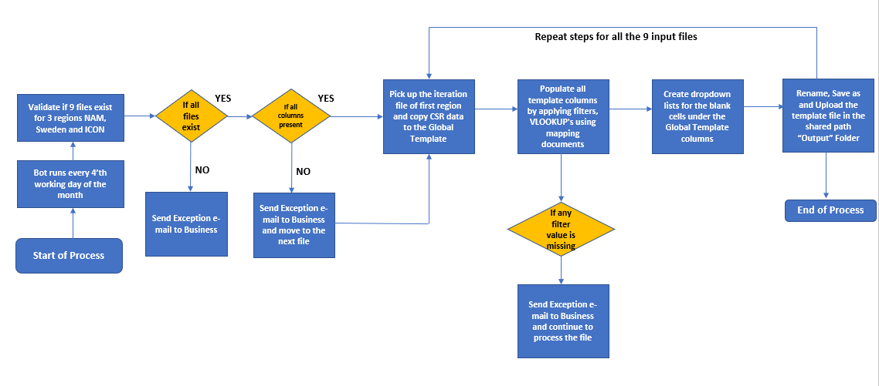

5.2. Data Flow - Solution Components

Ref. | Object Type | Object Name | Purpose
1 | Input data | Excel | Extract data from SOAR excel report into Global Template excel
2 | Validate and Filter Data | Excel Macro | To perform filters and vlook-ups to data
3 | Send Notification to business | Outlook | BoT will inform business on exceptions and success

6. Data Management and Reporting
This section describes how data created by the solution will be managed

6.1. Overview
- There are 3 types of Iterations 1,2 and 3 for 3 regions Sweden, NAM and UK where the Bot picks files based on their names, from the shared path.

- When file contains NAM data: Bot will use the Global Template saved in Internal Memory

- Bot will copy-paste the NAM CSR data into the template at the end of the pre-populate columns header and will VLOOKUP data in the Global Template using the PO/Vendor Dictionaries and Teaching Hospital list saved in the Shared Path folder

- Bot will apply filters and populate Template columns to sort the reportable transactions

- Bot will copy the information from the CSR report columns under the Global Template columns and create dropdown lists for blank cells.

- Bot then saves and uploads the file to the respective region's output folder.

- The same process is repeated for all the 3 iteration files of 3 regions.A total of 9 output files are generated and saved in the shared path by the bot

6.2 Reporting Requirements

- Input to the bot is in the form of excel files and all necessary headers are to be present for successful run.
- After processing the Global Template with the help of Mapping documents and Input SOAR files, the bot will store 3 Iteration files for every region in the shared path. Final Status mail will be triggered to denote process completion.

6.3. Storage
Input and Output files needed for bot are present in the below shared path location:
\\seskcifssvm01\GPT_RPA

6.4. Privacy
- No personal data/credentials are used or saved anywhere in the process.

6.5. Security
- The Bot won’t store any information like report in local machine.
- The application login credentials will be retrieved from credential vault and it is not stored anywhere
- Only the Business and BoT has the Access for shared path.

6.6. Preservation
N/A

7. Solution Configuration
This section describes the configuration details of the technical Solution.

7.1. System Access and Credentials
Shared Path Access \\seskcifssvm01\GPT_RPA

7.2. Configuration Schedule
- BoT will be only triggered manually based on business requirement.

7.3. Component Configuration
- SEUIT_021_Pumbaa_Main_000
- SEUIT_021_Pumbaa_Healthchecker_001

7.4. Configuration Testing
- Unit testing will be performed by Configurator
- UAT is performed by Process Business Expert
7.5 Bot Analytics
For this process, Bot analytics applies in terms of capturing the presence of the 9 input files, Status of success or failure accordingly and the error log if any, for the files processed.

8. Process and Functional Risk Assessment

8.1. Risk Assessment
This section considers what risk scenarios could be realistically considered for system functions, or groups of process steps.

Ref. | Risk Description | Process Steps Impacted | Likelihood to occur | Impact | Likelihood of detection | Initial Risk Rating | Mitigation / Action Taken | Final Risk Rating
1 | Unable to access shared path | 3.1.1 | L | H | H | H | Contact support and tasks to be handled manually by GPT team | L

9. Business Continuity
This section describes the business continuity approach in the events of workforce (physical or virtual) unavailability, systems unavailability, or capacity constraints.

9.1. Physical workforce unavailability
- Email sent to SME if there are any issues with the input files and final status
- Exception Email will be sent to support team in case of shared drive issue

9.2. Virtual workforce unavailability
- Email sent to SME to say that there will be a delay, so the work will have to be done manually – use this for any contact with the team managing the robot (email)

9.3. Target application unavailability
- N/A

9.4. Excessive workload

- None

10. Maintenance Activity
S. No | Activity | Frequency of this Activity
1 | BoT PRID Renewal | N/A
2 | VM PRID Renewal | Once in 6 Months
3 | NPA Accounts Inventory | Business Requirements Whenever needed
4 | BoT Dependency Application in VM | N/A
5 | Office 365 Licence Setup & Renewal | Initial Setup & In case of Failure
6 | VM Reboot Schedule Maintenance | Monthly Once
7 | IE & Java compatibility setup | N/A
8 | MS Access Engine 2007 Setup | N/A
9 | Script Repository Maintenance [Bit Bucket] | At Every CHG in Prod for Code alone
10 | Dot Net Framework 4.5 | N/A
11 | Shared Network Drive | At initial setup to Build of VM
12 | Shared Mailbox Access | N/A

i. Business Glossary
Acronyms and terms used throughout this document are described below.
Acronym or Term | Synonym(s) | Full Description
VW | PAC, Robot, Bot | Virtual Worker
HW |  | Human Worker
PDD |  | Process Design Document
SDD |  | Solution Design Document
BP |  | Blue Prism
VM | VDI | Virtual Machine
VDI | VM | Virtual Desktop Interface
RPA | PA | Robotic Process Automation
SSO |  | Single Sign-On

ii. Attachments
The following attachments relate to this document.
Attachment | Description
NA

