# Amazon Sales Report

Prepared in the partial ful-fillment of the Data Analytics in **InnoByte Service** Internship Program



Under the Guidance of

Mrs. Sonali Agarwal

Talent Acquistion Team (InnoByte)

Submitted by

I.Purna Chandra Rao-22PA1A4549

FROM:

VISHNU INSTITUTE OF TECHNOLOGY(VIT)

**Problem Statement**

Analyze and Provide Insights on Amazon Sales Report

**Problem Description**

The provided dataset contains information about sales transactions on Amazon, including details such as order ID, date, status, fulfilment method, sales channel, product category, size, quantity, amount, shipping details, and more. The objective is to conduct a comprehensive analysis of the data and extract actionable insights to support business decision-making.

Datasets[: Amazon Sales Dataset](https://drive.google.com/file/d/1YrjYKtS1WHmINL6eafRsrDzrZaw2_WvX/view)

**Pre-Processing Steps:**

1. **Data Transformation:**
   * Used Power BI Desktop to transform the data.
   * Set the first row as column headers.
2. **Handling Duplicates:**
   * Checked for duplicates in the Order ID column and removed them.
3. **Data Quality Checks:**
   * Used Show Whitespace, Column Quality, and Column Distribution to analyze errors, empty values, and valid percentages in the data.
4. **Data Type Detection:**
   * Used auto data type detection in the Transform tab to ensure correct column types.
5. **Replacing Empty Values:**
   * Replaced empty values in numerical columns with 0.
   * Replaced empty values in categorical columns with nan**.**
6. **Column Deletion:**
   * Deleted two entirely empty columns: [New] and [PendingS].
7. **Date Column Issue:**
   * The Date column was incorrectly detected as an Indian data type. You solved this by right-clicking on the column and using Change Type > Using Locale to change the locale from "English India" to "English United States," which enabled Power BI to correctly recognize the column as a date.
8. **Correcting the Amount Column:**
   * Detected that the Amount column was incorrect due to the presence of cancelled product amounts. Used a DAX formula to create a new column [Correct Amount].
9. **Calculations Using DAX:**
   * Calculated the average amount per product/category.
   * Calculated cancellation rate.
   * Calculated success rate.
   * Calculated MoM% (Month over Month Percentage) using the [Correct Amount] column.

**Reports:**

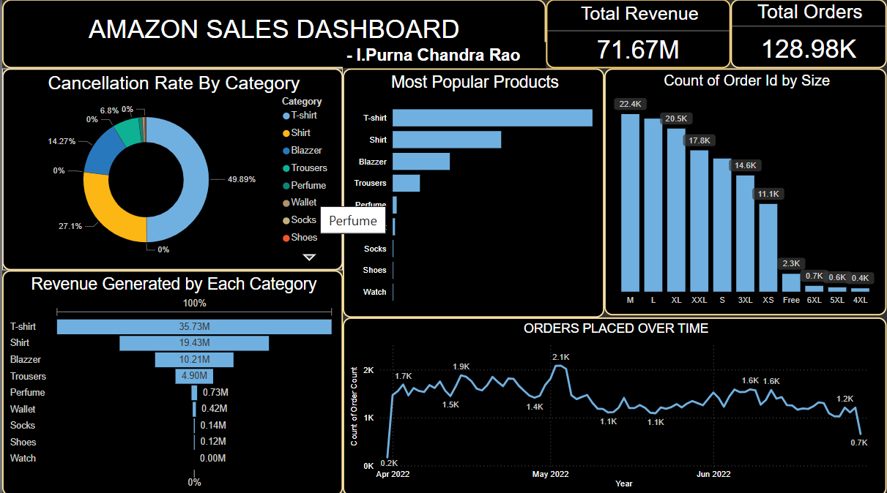

**Amazon Sales Dashboard Analysis**

**Performance Metrics:**

* Total Revenue: The business generated an impressive revenue of 71.67M, showcasing strong sales.
* Total Orders: A high volume of 128.98K orders indicates a healthy customer base and product demand.

**Cancellation Rate Insights:**

* T-shirts (49.89%) and Shirts (27.1%) account for the majority of cancellations, representing a potential issue with customer satisfaction, product quality, or delivery timelines for these items.
* Some categories, such as Perfume, Wallet, Socks, and Shoes, show no cancellations, indicating better customer reliability for these products.

**Revenue Breakdown by Category:**

**Top Revenue Categories:**

* T-shirts are the biggest revenue driver (35.73M) and likely a core focus for the business.
* Shirts and Blazers follow with 19.43M and 10.21M, respectively.
* Low Revenue Categories:
* Categories like Shoes, Wallet, Socks, Perfume, and Watch contribute marginal revenue, suggesting lower demand or limited inventory.

**Most Popular Products:**

* T-shirts dominate as the most popular product, followed by Shirts and Blazers.
* Items like Socks, Shoes, and Wallets see lower popularity, which aligns with their low revenue contribution.

**Order Sizes Distribution:**

* M, L, and XL sizes dominate orders, collectively accounting for over 60% of total orders.
* XS, Free Size, and larger sizes (5XL, 6XL) have minimal demand, highlighting the need for a better focus on medium and large sizes.

**Orders Over Time:**

* Peak Periods: Orders peaked in May 2022 (2.1K orders), indicating this could be a high sales season.
* Decline: A gradual decline in order volume after May suggests a need for re-engagement campaigns or addressing potential seasonal factors.

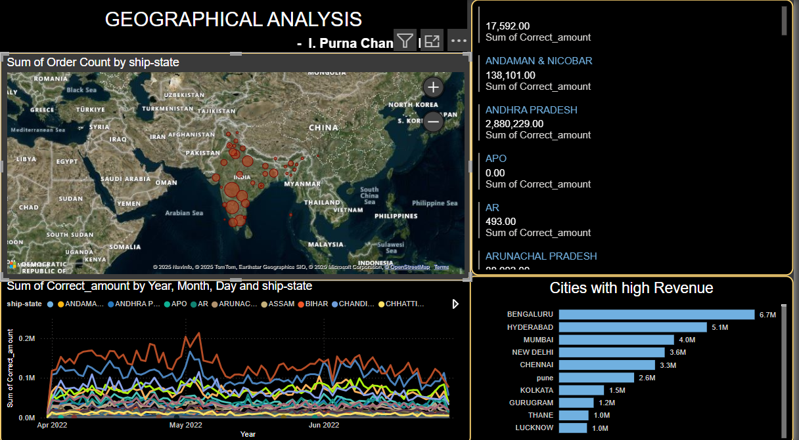

**Geographical Analysis Dashboard Insights**

**Regional Revenue Trends:**

* **Top States:** Andhra Pradesh (28.80M) leads the revenue chart, with significant contributions from other regions like Bengaluru (6.7M) and Hyderabad (5.1M).
* **Underperforming Regions:** States like APO, AR, Arunachal Pradesh, and Andaman & Nicobar Islands show minimal revenue. These regions might be underserved or lack a strong customer base.
* City-Level Revenue Distribution:

**Top Cities:**

* Bengaluru, Hyderabad, and Mumbai are major revenue hubs, accounting for significant business activity.

**Emerging Cities:**

* Cities like Kolkata, Gurugram, and Lucknow show potential but contribute relatively less.

**Time-Based Sales Trends:**

**Fluctuations:**

* Sales activity sees consistent fluctuations across all regions, with noticeable peaks in May 2022, reinforcing this period as a high-demand phase.

**Opportunities:**

* Aligning promotional efforts with such high-demand periods could amplify revenue further.

**Visual Highlights:**

* The geographical map pinpoints major order volumes in southern and metropolitan regions.
* Sparse activity in northeastern states and islands could indicate logistical challenges or untapped potential.

**Recommendations for Business Growth**

**Product Improvements:**

* Analyze reasons for the high cancellation rates of T-shirts and Shirts (e.g., fit issues, quality, or delivery delays) and address them to enhance customer satisfaction.
* Invest in marketing and promotions for low-revenue categories (Shoes, Perfume, and Socks) to boost their visibility and sales.

**Regional Focus:**

* Leverage high-revenue regions like Andhra Pradesh, Bengaluru, and Hyderabad with targeted campaigns.
* Develop strategies to penetrate low-revenue states through discounts, faster shipping, or regional-specific products.

**Time-Based Campaigns:**

* Schedule campaigns, discounts, or new product launches during peak periods like May, to maximize impact.
* Study post-May declines to mitigate future drops in sales through customer retention programs.

**Size Optimization:**

* Focus inventory management on medium and large sizes (M, L, XL) to meet customer demand and reduce excess stock of less popular sizes.

**City-Level Targeting:**

* Expand operations in emerging cities like Kolkata, Gurugram, and Lucknow, which show growth potential.
* Boost local advertising and logistics infrastructure to capture untapped markets.