­

2019

**Submited By**

**ALOK BEHERA SOUMYARANJAN MAHALIK**

**ASHUTOSH GHADEI PURNA CHANDRA MANSINGH**

**ON CONSUMER INTENTION PREDICTION USING TWITTER**

BSC-ITM

PROJECT REPORT

**A**

**PROJECT REPORT**

**ON**

**CONSUMER INTENTION PREDICTION USING TWITTER**



**Group Members:**

**Alok Behera Ashutosh Ghadei**

**REGD: 37UITM166003 REGD:37UITM166006**

**Soumyaranjan Mahalik Purna Chandra Mansingh**

**REGD:37UITM166043 REGD:37UITM166029**

M4/46, Acharya Vihar Jaydev Vihar Road, Acharya Vihar, Near Iffco State Office, Jayadev Vihar, Bhubaneswar, Odisha 751013

**DECLARATION**

This is declare that the project entitled CONSUMER INTENTION PREDICTION USING TWITTER is a bonafied work carried out by us for the partial fulfillment of the degree of Bachelor of Information Technology and Management, Lakshya Institute of Technology, Bhubaneswar during the session of 2016-2019. The interpretations drawn in the project are own and not drawn from any other sources. The materials issued in this project are duly acknowledged.

Alok Behera (37UITM166003)

Ashutosh Ghadei (37UITM166006)

Soumyaranjan Mahalik (37UITM166043)

Purna Chandra Mansingh (37UITM166029)

**CERTIFICATE**

Certified that the project work intitled “INTENTION PREDICTION USING TWITTER” is a bonafied work carried out by Alok Behera (37UITM166003), Ashutosh Ghadei (37UITM166006), Soumyaranjan Mahalik (37UITM166043), Purna Chandra Mansingh (37UITM166029) in partial fulfillment of the requirements for the award of the degree of Bachelor of Information Technology and Management, Lakshya Institutte Technology, Bhubaneswar during the year of 2019. It is certified that all the corrections/suggestion indicated for internal assessment have been incorporated in the report. The project report has been approved as it satisfies the academic requirements in respect of work prescribed for the Bachelor of Information Technology and Management

**PRINCIPAL**

**Lakshya Institute of Technology**

**Bhubaneswar**

**ABSTRACT**

Recently, there has been a significant rise in the ecommerce industry and more specifically in people buying products online. There has been a lot of research being done on figuring out the buying patterns of a user and more importantly the factors which determine whether the user will buy the product or not. In this study, we will be researching on whether it is possible to identify and predict the purchase intention of a user for a product and target that user towards the product with a personalized advertisement or a deal. Further, we wish to develop a software that will help the businesses identify potential customers for their products by estimating their purchase intention in measurable terms from their tweets and user profile data on twitter. After applying various text analytical models to tweets data, we have found that it is indeed possible to predict if a user have shown purchase intention towards a product or not, and after doing some analysis we have found that people who had initially shown purchase intention towards the product have in most cases also bought the product.

**INTRODUCTION:**

Our project is a web application that predicts the likelihood/certainty that a customer will buy a product that he is interested in based on his social media posts such as Twitter tweets and user profile data. This will help the company/business target a particular customer more efficiently and boost their sales.

First, we search for Twitter tweets of potential customers wanting to buy a product. And based on those tweets we estimate/predict the likelihood that the customer will buy the product. We then make a model by gathering tweets from users who have already expressed intention to buy the product using their tweet history and if possible, their web search history as well and then training the text analytical model based on those tweets. Using the model, we input potential customers who have tweeted about the product but have not bought it. And based on the training data the model estimates a prediction/likelihood of whether the customer will buy it or not. We have limited the scope of our data to only mobile phones. Our model predicts the consumer intention for the latest upcoming mobile phones. We have tested it on the latest iPhone X variants and our model has provided promising results with accuracies of up to 80% considering that we have limited annotated data.

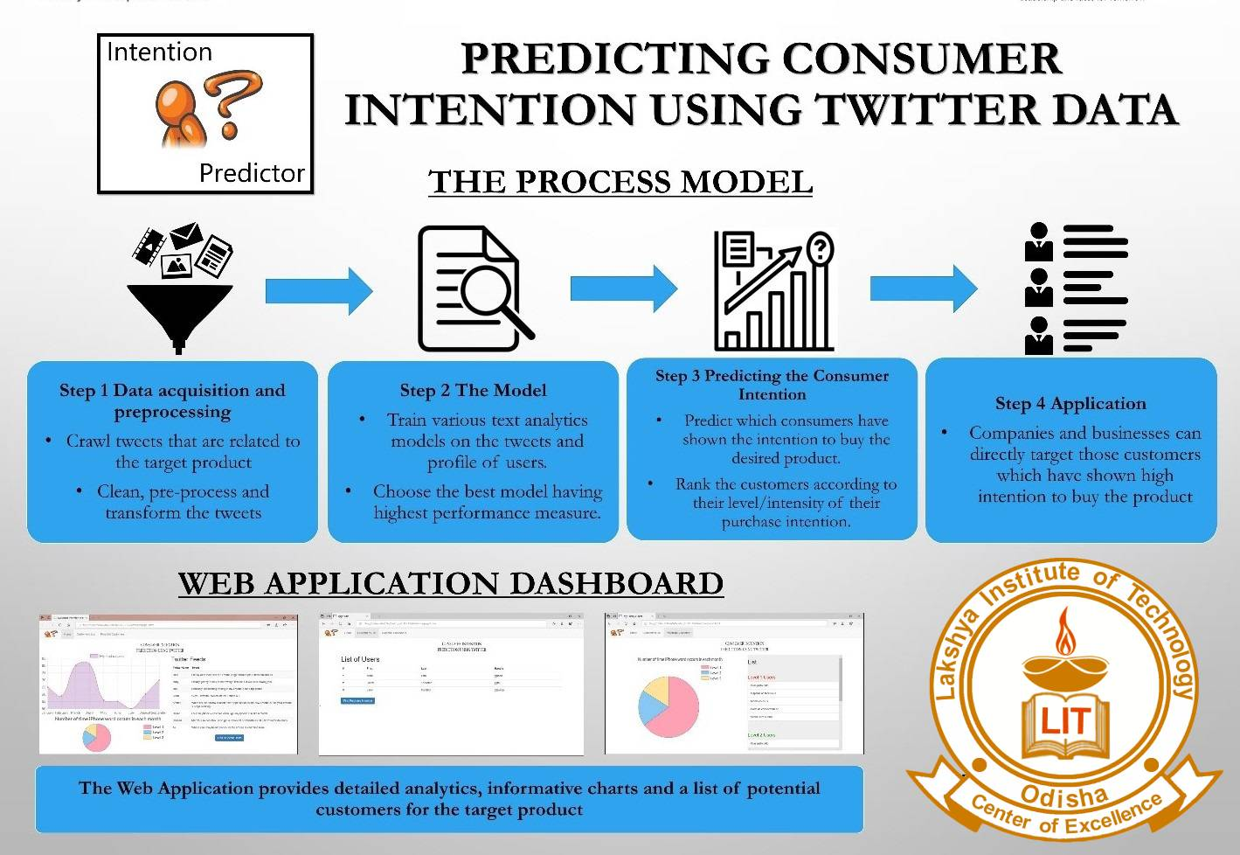

**High Level Design:**

1. **Rationale and sources of your project idea**

Currently we have many recommendation systems available which recommend different products to the user, most of which are not efficient. No such effective model for businesses to identify potential customers. Further, there have been several research studies for analyzing the insights of online consumers buying behavior. However, only a few have addressed the customers buying intention for products.

We want to develop an application that will help the businesses identify potential customers for their products by estimating their purchase intention in measurable terms from their tweets and user profile data on twitter. In a way we can say that Purchase Intention detection task is close to the task of identifying wishes in product reviews.

1. **Logical structure**

i. Web Application

We have developed a web application so that users can easily access our application. A web application also provides portability, speed and is easy to use. It also does not require much hardware to be setup on the user’s end.

ii. Dashboard screen

We have developed a dashboard which shows the relevant statistics according to the dataset of the product which the user can use to evaluate the results and check the trend for the product.

iii. Upload annotated dataset function

The user will press the upload annotated dataset button through which he will be asked to upload the dataset he wants to test for his product and find the relevant customers from that dataset. The output will be in a form of a pie chart and a table showing the different level of customers and the scores assigned to each customer.

iv. Analysis function

When the user presses the analysis button, he will be taken to the screen which will show the detailed analysis of our dataset that we have built containing word clouds, positive vs negative tweets and the most used words for that product.

1. **Background**

We aim to analyze the tweets related to a product and identify the purchase intention in it. In this way we can rank the tweets which have high purchase intention and report the name of the person who tweeted as potential customer of product.

We will make a model by gathering tweets from users who have already expressed intention to buy the product and see their tweet history and if possible, their web search history as well. Using this model, we will input potential customers who have tweeted about the product but have not bought it yet! And based on the training data the model will estimate a prediction/likelihood of whether the customer will buy it or not.

1. **Hardware / Software tradeoffs :**

Hardware is always preferred over software and in some cases, hardware is regarded as highly optimized form of software.

Since we have focused on developing a machine learning algorithm and deploy it on a website, we must have sophisticated hardware on the server end but if a user is using the website that it is not necessary that the user have a sophisticated and high-end laptop.

We have developed our program on Python and deployed it on the Django Framework, so the software requirement isn’t as high. Anyone with a basic python shell can run the code.

1. **Relationship with available past projects or standards e,g. IEEE, ANSI, ISO and etc.**

There have been several research studies for analyzing the insights of online consumers buying behavior. However, only a few have addressed the customers buying intention for products. Studies on identification of wishes from texts, specifically Ramanand et al. (Ramanand, Bhavsar, and Pedanekar 2010) consider the task of identifying ‘buy’ wishes from product reviews. These wishes include suggestions for a product or a desire to buy a product. They used linguistic rules to detect these two kinds of wishes. Although rule-based approaches for identifying the wishes are effective, but their coverage is not satisfactory, and they can’t be extended easily. Purchase Intention detection task is close to the task of identifying wishes in product reviews. Here we don’t use the rule-based approach, but we present a machine learning approach with generic features extracted from the tweets.

Past studies have shown that it is possible to apply Natural Language Processing (NLP) and Named Entity Recognition (NER) to tweets (Li et al., 2012) (Liu et al., 2011). However, applying NER to tweets is very difficult because people often use abbreviations or (deliberate) misspelled words and grammatical errors in tweets. Nonetheless, Finin et al. (2010) tried to annotate named entities in tweets using crowdsourcing. Other studies used these techniques to apply sentiment analysis to tweets. The first studies used product or movie reviews because these reviews are either positive or negative. Wang et al. (2011) and Anta et al. (2013) analyzed the sentiment of tweets filtered on a certain hashtag (keywords or phrases starting with the symbol that denote the main topic of a tweet). These studies merely analyze the sentiment of a tweet about a product after the author has bought it. We will however be extracting features from tweets to find whether the user has shown purchase intention towards the product or not.

More recently, research articles like Identifying Purchase Intentions by Extracting Information from Tweets ( February 8, 2017, RADBOUD U NIVERSITY NIJMEGEN) and Tweetalyst: Using Twitter Data to Analyze Consumer Decision Process (The Berkeley Institute of Design) investigate if an artificial intelligence approach can predict (from existing user created content on twitter) if someone is a potential customer for a specific company or product and identify users at different stages of the decision process of buying a given product. Further looking at research reports like The Impact of Social Network Marketing on Consumer Purchase Intention in Pakistan: Consumer Engagement as a Mediator (Asian Journal of Business and Accounting 10(1), 2017) give us an insight of the impact of social network marketing on consumer purchase intention and how it is affected by the mediating role of consumer engagement. Based on UGT theory (Uses and Gratification Theory).

Some preprocessing techniques commanly used for twitter data are the sentiment140 API (Sentiment140 allows you to discover the sentiment of a brand, product, or topic on Twitter), the TweetNLP library (a tokenizer, a part-of-speech tagger, hierarchical word clusters, and a dependency parser for tweets), unigrams, bigrams and stemming. There are also some dictionary-based approaches such as using the textBlob library (TextBlob is a Python (2 and 3) library for processing textual data. It provides a consistent API for diving into common natural language processing (NLP) tasks such as part-of-speech tagging, noun phrase extraction, sentiment analysis, and more).

The common machine learning algorithms that are used for text analysis are Linear Regression, Random Forest, Naive Bayes and Support Vector Machine. We will be looking at these models later in detail.

1. **Patents, copyright and trademarks :**

We have not used any copyright software or patents or trademarks. Python is an open source library as well as Django and therefore we have no such requirement.

**SOFTWARE / HARDWARE DESIGN:**

1. **Overview**

We aim to analyze the tweets related to a product and identify the purchase intention in it. In this way we can rank the tweets which have high purchase intention and report the name of the person who tweeted as potential customer of product.

We will make a model by gathering tweets from users who have already expressed intention to buy the product and see their tweet history and if possible, their web search history as well. Using this model, we will input potential customers who have tweeted about the product but have not bought it yet! And based on the training data the model will estimate a prediction/likelihood of whether the customer will buy it or not.

1. **Program Details**
   1. **Overview :**

The approach that we have implemented is to label the tweets text as having Purchase Intention and Not having Purchase intention. We have annotated about 3000 tweets from Twitter using our own web crawler. After preprocessing the tweets, we are left with about 1300 tweets for training data and remaining for testing. We defined definition of Purchase Intention as object that is having action word like (buy, want, desire) associated with it. We have manually annotated the data by reading each tweet and label them as purchase intention and non-purchase intention tweet. We have used this table as a reference to label the tweets:

Criteria for Labelling of tweets

|  |  |  |
| --- | --- | --- |
|  | Tweet | Class |
| 1 | Comparing iphone x with other phone and telling other phone are better? | No PI |
| 2 | Talking about good features of iphone x? | PI |
| 3 | Talking about negative features of iphone x? | No PI |
| 4 | liked video on Youtube about iphone x? | PI |

Each tweet was read by 3 people and final class was decided by maximum voting.

Next, we preprocessed the tweets using these techniques:

1. **LOWERCASE**

So, we started our groundwork by converting our text into lower case, to get case uniformity.

final_data_frame["text"] = final_data_frame["text"].apply(

lambda x: " ".join(x.lower() for x in x.split())

)

1. **REMOVE PUNC**

Then we passed that lower case text to punctuations and special characters removal function. Text may contain unwanted special characters, spaces, tabs and etcetera which has no significant use in text classification.

final_data_frame["text"] = final_data_frame["text"].str.replace( "[^\w\s]", "")

1. **STOPWORD`S REMOVAL**

Text also contains useless words which are routine part of the sentence and grammar but do not contribute to the meaning of the sentence. Likes of “the”, “a”, “an”, “in” and etcetera are the words mentioned above. So we do not need these words, and it is better to remove these.

stop = stopwords.words("english")

final_data_frame["text"] = final_data_frame["text"].apply(

lambda x: " ".join(x for x in x.split() if x not in stop) )

1. **COMMON WORD REMOVAL**

Then there also lots of repetitive words which from their recurrence do not contribute to the meaning in the sentence. This can also be the result of mistake as the data we are analyzing is an informal data where formal sentence norms are not taken into consideration.

freq = pd.Series(

" ".join(final_data_frame["text"]).split()).value_counts()[:10]

freq = list(freq.index)

final_data_frame["text"] = final_data_frame["text"].apply(

lambda x: " ".join(x for x in x.split() if x not in freq)

)

1. **RARE WORDS REMOVAL**

We also removed some rare words like names, brand words (not iphone x), left out html tags etc. These are unique words which do not contribute much to interpretation in the model.

rare = pd.Series(

" ".join(final_data_frame["text"]).split()).value_counts()[-10:]

rare = list(rare.index)

final_data_frame["text"] = final_data_frame["text"].apply(

lambda x: " ".join(x for x in x.split() if x not in rare)

)

1. **SPELLING CORRECTION**

Social media data is full of spelling mistakes. And it is our job to get rid of these mistakes and give our model the correct word as an input.

final_data_frame["text"][:5].apply(lambda x: str(TextBlob(x).correct()))

1. **STEMMING**

Then we stemmed the words to their root. Stemming works like by cutting the end or beginning of the word, considering the common prefixes or suffixes that can be found in that word. For our purpose, we used Porters Stemmer, which is available with NLTK.

st = PorterStemmer()

final_data_frame["text"][:5].apply(

lambda x: " ".join([st.stem(word) for word in x.split()])

)

1. **LEMMATIZATION**

Then we also performed lemmatization on our text. This analysis is performed in morphological order. A word is traced back to its lemma, and lemma is returned as the output.

final_data_frame["text"] = final_data_frame["text"].apply(

lambda x: " ".join([Word(word).lemmatize() for word in x.split()])

)

Next, we made 3 types of document vectors:

Before constructing document vectors, we have constructed a set of unique words on which we will base our document vectors.

1. **TF**

First is the term frequency document vector. We have stored text and its labeled class in dataframe final_df. And we have constructed a new dataframe with columns as the words and document count as the rows. So, individual frequency of words in a document count is recorded.

1. **IDF**

It is a weighting method to retrieve information from the document. Term frequency and inverse document frequency scores calculated and then product of TF*IDF is called TF-IDF.

IDF is important in finding how relevant a word is. Normally words like ‘is’, ‘the’, ‘and’ etc. have greater TF. So IDF calculated a weight to tell how important least occurring words are.

1. **TF-IDF with textblob library**

With the help of textblob library we calculated sentiments of individual word and then multiplied the sentiment score with TF and TF-IDF of that word.

Once the corpus was ready, we then used different text analytical models to test which one gave the best results. We used the following models:

1. **Support Vector Machine (SVM)**

Simply put, SVM is a supervised machine learning algorithm which does complex transformation on the data. And then it tries to separate data on classes we have defined on our data.

1. **Naive Bayes**

Naive Bayes methods are a set of supervised learning algorithms based on applying Bayes’ theorem with the “naive” assumption of conditional independence between every pair of features given the value of the class variable.

1. **Logistic Regression**

Logistic regression is the appropriate regression analysis to conduct when the dependent variable is dichotomous (binary). Like all regression analyses, the logistic regression is a predictive analysis. Logistic regression is used to describe data and to explain the relationship between one dependent binary variable and one or more nominal, ordinal, interval or ratio-level independent variables.

1. **Decision Tree**

Decision Trees are a non-parametric supervised learning method used for classification and regression. The goal is to create a model that predicts the value of a target variable by learning simple decision rules inferred from the data features.

1. **Neural Network**

It is deep learning machine algorithm, which is arranged in a layer of neuron. There is an input layer, output layer and hidden layers of neurons. Neuron network is adaptive as neurons in these layers learn from their initial input and subsequent runs.

* 1. **User interface**

1. Firstly, the user will open the DASHBOARD and see the status of the product through charts and the relevant tweets for the product in a list.
2. Secondly, the user will press the UPLOAD ANNOTATED DATASET button through which he will be asked to upload the dataset he wants to test for his product and find the relevant customers from that dataset. The output will be in a form of a pie chart and a table showing the different level of customers and the scores assigned to each customer.
3. Thirdly, when the user presses the ANALYSIS button, he will be taken to the screen which will show the detailed analysis of our dataset that we have built containing word clouds, positive vs negative tweets and the most used words for that product.



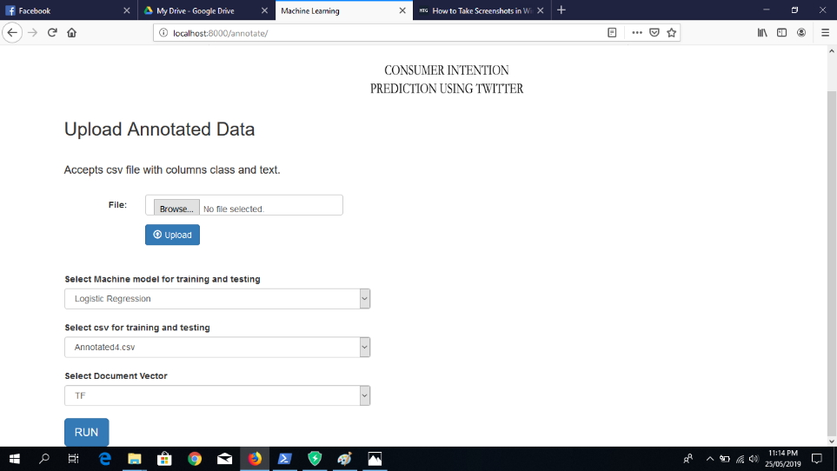

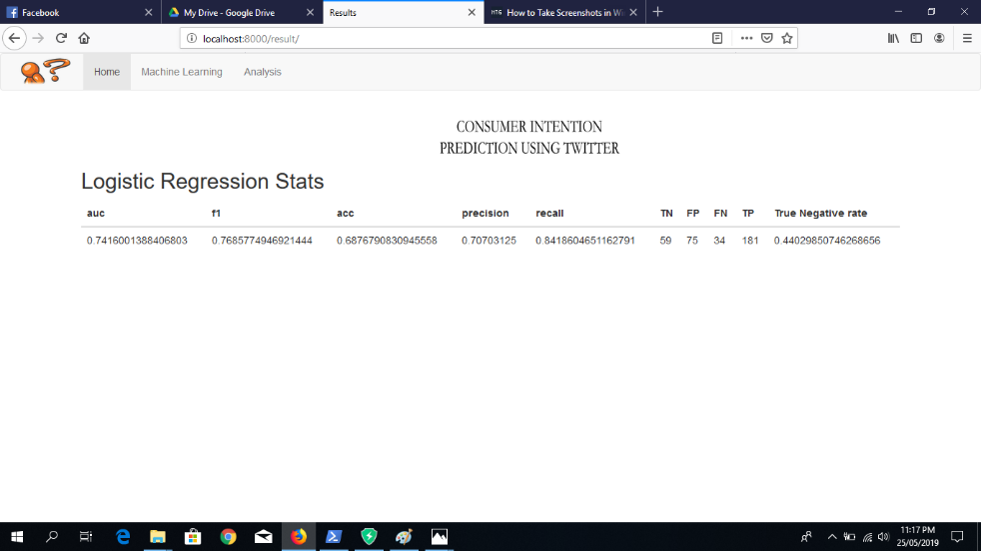

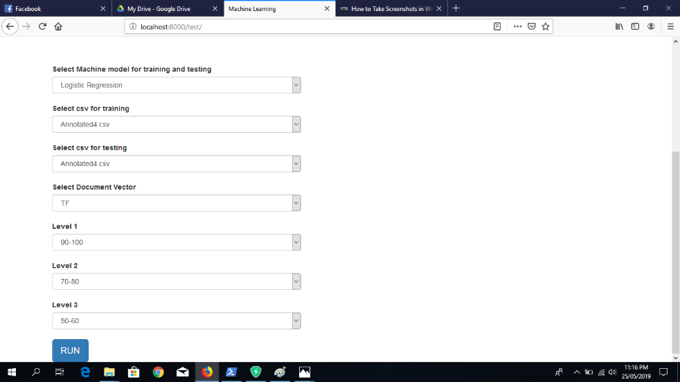

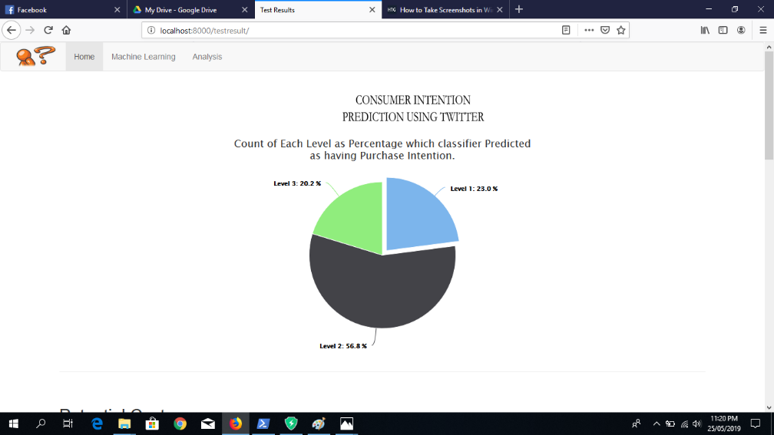

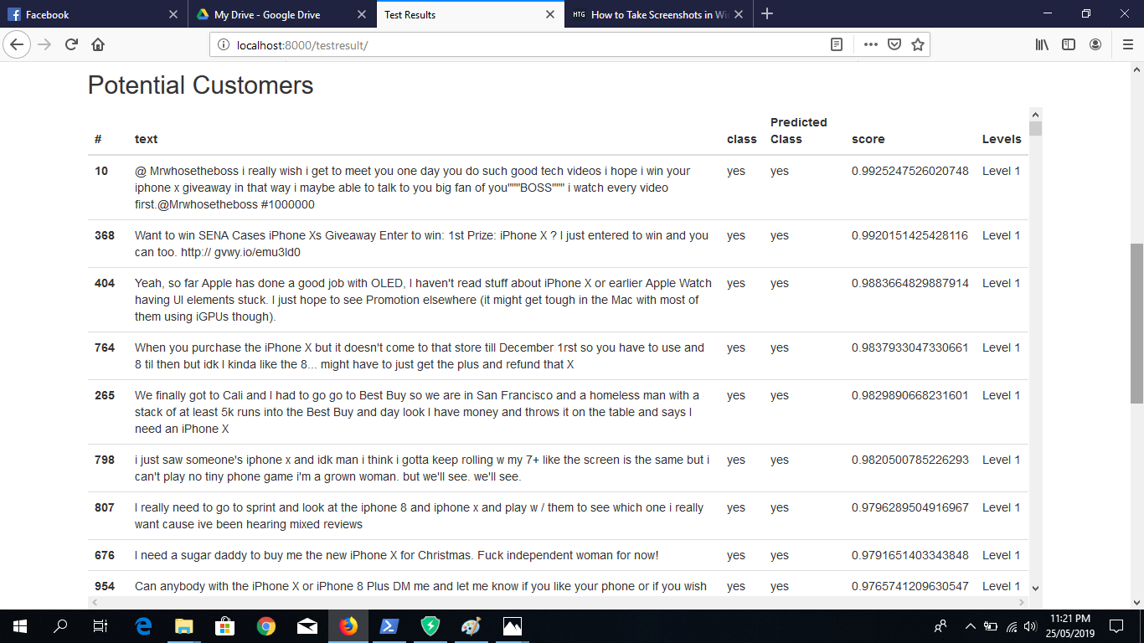

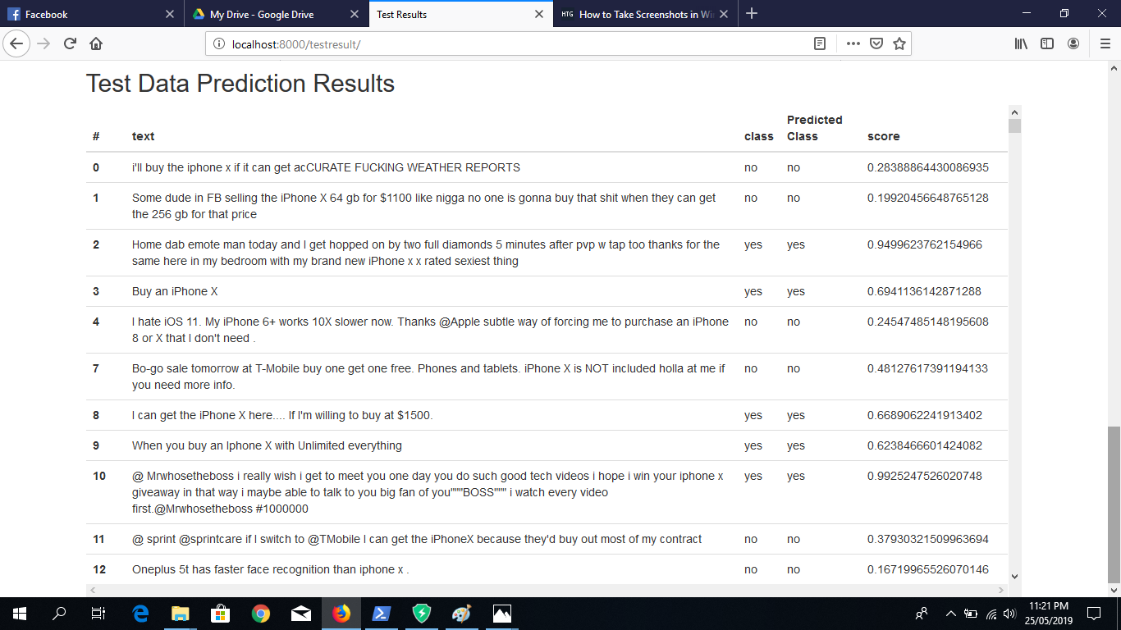

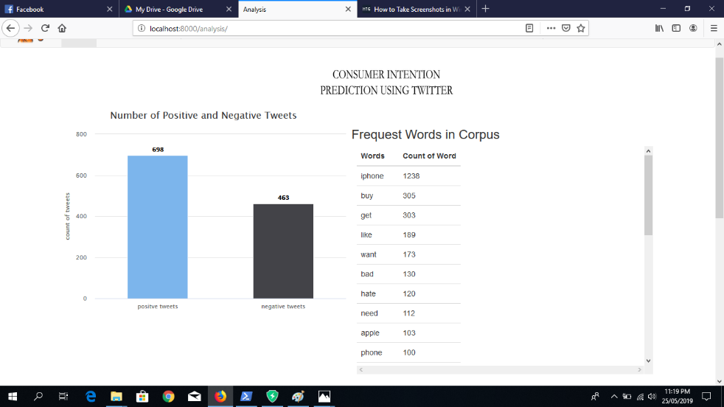

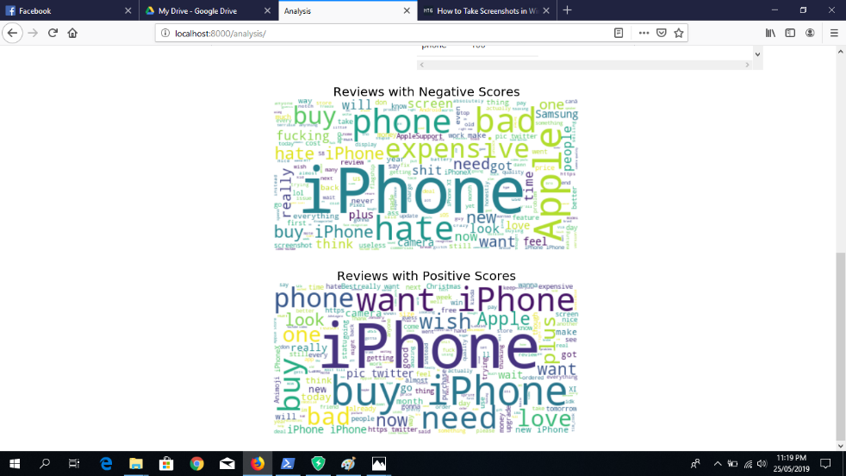

* 1. **Errors**

Initially we encountered some errors in running the python environment and setting up a separate virtual environment for our project. However, we were soon able to overcome this by reading up on the documentation and following tutorials.

We also encountered some errors running the Django framework. Setting up a sperate virtual environment and installing the missing dependencies later fixed this problem.

We also faced some issues in integrating the python code with the website because it was our first time configuring a back-end server to run code scripts and sending the output to the html page and getting it to display correctly.

* 1. **Trails and** **tests**

We have tested the model accuracy by confusion matrix (Accuracy, Precision, Recall, F-Measure). Further we have also considered the True Negative Rate, The True Positive Rate and the shape of the ROC curve for more insights. This will give us a percentage of accuracy achieved by our model.

For our application development, we opted to use unit testing in which individual units of source code, were tested to determine if they are fit to use. Then, we ran integration testing where the individual source was merged and tested as group.

We also tested the usability of our website by carrying out the tasks and functions of the website in different scenarios and checking if they successfully completed.

1. **Hardware Details**
   1. **Overview**

Since our project is purely software based and we have developed a web application as a final deliverable we did not have any hardware requirements.

We tested all the algorithms and the web application on multiple *for daily use laptops* and the functions and outputs were all displaying correctly.

* 1. User interface hardware

Our user interface hardware would be the laptop and so the web application includes graphical controls, which the user can select using a mouse or keyboard.

* 1. **Things that did not work**

Since our project is purely a software-based web application we did not have to test any hardware but rather just checked on multiple laptops if the website was functioning properly.

* 1. **Trails and tests**

We assessed the non-functional requirements of the website by evaluating the security, scalability and flexibility of the website in terms of users who use it and for the admins who will monitor the website.

We also tested the usability of our website by carrying out the tasks and functions of the website in different scenarios and checking if they successfully completed.

**RESULTS:**

Since we are using a machine learning (artificial intelligence) based approach we needed to set an accuracy standard for our model and evaluate the results by matching the desired standard.

To evaluate our models, we used the following techniques:

1. Confusion Matrix

2. Accuracy

3. Precision

4. Recall

5. F-Measure

Further we have also considered the True Negative Rate, The True Positive Rate and the shape of the ROC curve for more insights.

After evaluating our model here are the following results that we have gotten:

For our first attempt this is the results that we got:

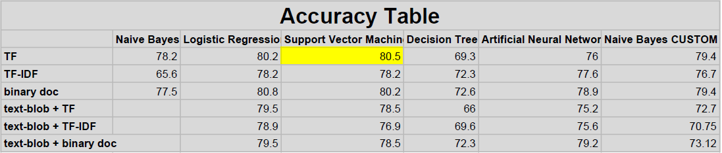

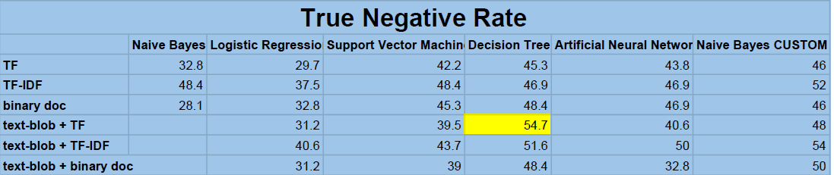

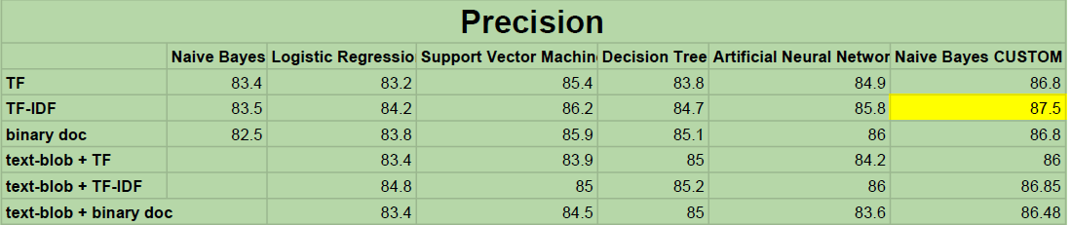

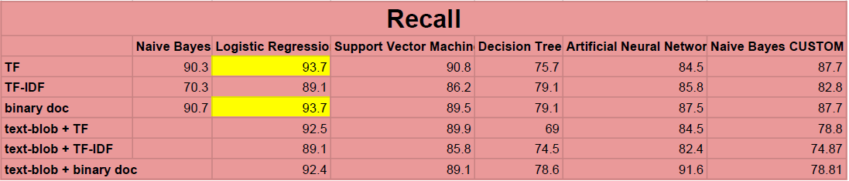

For our second attempt after reorganizing the data preprocessing steps and adding some customized steps specific to our data, we got these results:

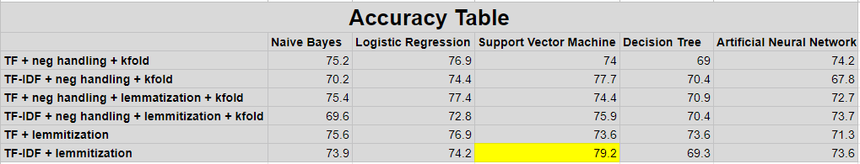

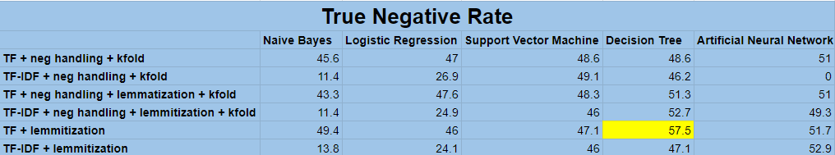

**CONCLUSIONS:**

Our results were quite promising since we had created our own dataset and were building the model from scratch. We had to create our own dataset because there does not exist a publicly available dataset for purchase intention based on twitter tweets.

The 2 major problems that we faced were:

1. The imbalance class problem: Since our dataset was manually annotated by us, we had about 2000 positive tweets and 1200 negative tweets. Due to this we were getting a very low True Negative Rate and our model was not accurately predicting the negative class.
2. Limited annotated data: Since we had to manual annotate each tweet in the dataset and this process takes a lot of time, we were only able to annotate about 3200 tweets.

Looking at the other researches that are done in the similar field, our project also stands apart since we have implemented 5 different models and after evaluating them, we choose the best one customized to the product data.

We were not able to get more than 80% accuracy because of the two problems highlighted above. To achieve even 80% accuracy with an imbalance class data and such a small dataset is a victory.

After showing the website to a few potential clients we have received positive remarks about our product and people seem interest in this new approach to customer identification and targeted marketing.

.

**APPENDIX:**

**Appendix 1: Equations**

1. Naïve Bayes Algorithm

Bayes theorem provides a way of calculating the posterior probability, P(c|x), from P(c), P(x), and P(x|c). Naive Bayes classifier assume that the effect of the value of a predictor (x) on a given class (c) is independent of the values of other predictors. This assumption is called class conditional independence.

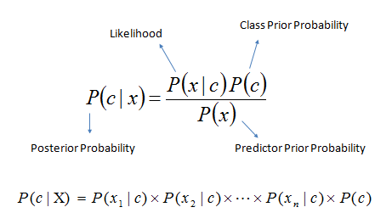

* *P*(*c|x*) is the posterior probability of *class* (*target*) given *predictor* (*attribute*).
* *P*(*c*) is the prior probability of *class*.
* *P*(*x|c*) is the likelihood which is the probability of *predictor* given *class*.
* *P*(*x*) is the prior probability of *predictor*.

1. **Support Vector Machine:**

Support Vector Machines are based on the concept of decision planes that define decision boundaries. A decision plane is one that separates between a set of objects having different class memberships.

For this type of SVM, training involves the minimization of the error function:

http://www.statsoft.com/textbook/graphics/SVMIntro4.gif

subject to the constraints:

http://www.statsoft.com/textbook/graphics/SVMIntro5.gif

where C is the capacity constant, w is the vector of coefficients, b is a constant, and http://www.statsoft.com/textbook/image2.gif represents parameters for handling nonseparable data (inputs). The index i labels the N training cases. Note that http://www.statsoft.com/textbook/graphics/SVMIntro7.gif represents the class labels and xi represents the independent variables. The kernel http://www.statsoft.com/textbook/graphics/SVMIntro15c.gif is used to transform data from the input (independent) to the feature space. It should be noted that the larger the C, the more the error is penalized. Thus, C should be chosen with care to avoid over fitting.

1. **Logistic Regression**

Logistic regression predicts the probability of an outcome that can only have two values (i.e. a dichotomy). The prediction is based on the use of one or several predictors (numerical and categorical).

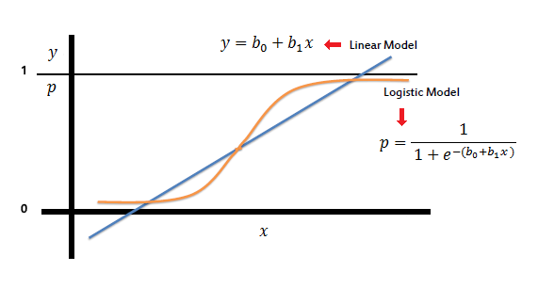

In the logistic regression the constant (*b0*) moves the curve left and right and the slope (*b1*) defines the steepness of the curve. By simple transformation, the logistic regression equation can be written in terms of an odds ratio.

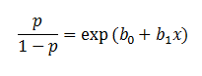

Finally, taking the natural log of both sides, we can write the equation in terms of log-odds (logit) which is a linear function of the predictors. The coefficient (*b1*) is the amount the logit (log-odds) changes with a one unit change in *x*.

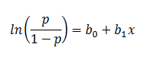

As mentioned before, logistic regression can handle any number of numerical and/or categorical variables.

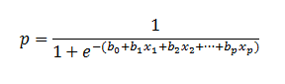

1. **Decision tree**

Decision tree builds classification or regression models in the form of a tree structure. It breaks down a dataset into smaller and smaller subsets while at the same time an associated decision tree is incrementally developed.

To build a decision tree, we need to calculate two types of entropy using frequency tables as follows:

* 1. Entropy using the frequency table of one attribute:

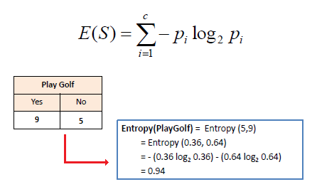

* 1. Entropy using the frequency table of two attributes:

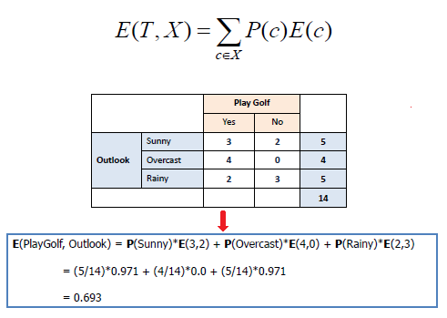

Constructing a decision tree is all about finding attribute that returns the highest information gain (i.e., the most homogeneous branches).

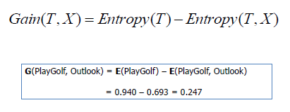

1. **Neural Network**

Backpropagation algorithms are a family of methods used to efficiently train artificial neural networks (ANNs) following a gradient descent approach that exploits the chain rule. The main feature of backpropagation is its iterative, recursive and efficient method for calculating the weights updates to improve in the network until it is able to perform the task for which it is being trained.

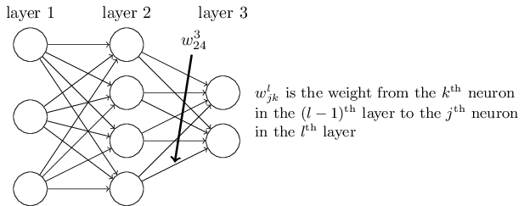

**Appendix 2: Code**

1. **Code for models**

def output_to_results(*pathData*):

final_data_frame, data_frame_undefined = extract(pathData)

final_data_frame["text"] = final_data_frame["text"].apply(

lambda *x*: " ".join(x.lower() *for* x *in* x.split())

)

final_data_frame["text"] = final_data_frame["text"].str.replace(

"[^\w\s]", "")

stop = stopwords.words("english")

final_data_frame["text"] = final_data_frame["text"].apply(

lambda *x*: " ".join(x *for* x *in* x.split() *if* x *not* *in* stop)

)

freq = pd.Series(

" ".join(final_data_frame["text"]).split()).value_counts()[:10]

freq = list(freq.index)

final_data_frame["text"] = final_data_frame["text"].apply(

lambda *x*: " ".join(x *for* x *in* x.split() *if* x *not* *in* freq)

)

rare = pd.Series(

" ".join(final_data_frame["text"]).split()).value_counts()[-10:]

rare = list(rare.index)

final_data_frame["text"] = final_data_frame["text"].apply(

lambda *x*: " ".join(x *for* x *in* x.split() *if* x *not* *in* rare)

)

final_data_frame["text"][:5].apply(lambda *x*: str(TextBlob(x).correct()))

st = PorterStemmer()

final_data_frame["text"][:5].apply(

lambda *x*: " ".join([st.stem(word) *for* word in x.split()])

)

final_data_frame["text"] = final_data_frame["text"].apply(

lambda *x*: " ".join([Word(word).lemmatize() *for* word in x.split()])

)

corpus = []

*for* text in final_data_frame["text"]:

corpus.append(text)

final_data_frame.rename(*columns*={"class": "class_label"}, *inplace*=True)

Class_Label = {"yes": 1, "no": 0}

final_data_frame.class_label = [

Class_Label[item] *for* item in final_data_frame.class_label

]

final_data_frame.rename(*columns*={"class_label": "class"}, *inplace*=True)

count_vectorizer = CountVectorizer()

count_vectorized_data = count_vectorizer.fit_transform(corpus)

tfidf_vectorizer = TfidfVectorizer()

tfidf_vectorized_data = tfidf_vectorizer.fit_transform(corpus)

vectorized_data = tfidf_vectorized_data

X_train, X_test, Y_train, Y_test = train_test_split(

vectorized_data, final_data_frame["class"], *test_size*=0.3, *random_state*=0

)

SVM = svm.SVC(*probability*=True, *C*=1.0,

*kernel*="linear", *degree*=3, *gamma*="auto")

SVM.fit(X_train, Y_train)

Naive = naive_bayes.MultinomialNB()

Naive.fit(X_train, Y_train)

logisticReg = linear_model.LogisticRegression(*C*=1.0)

logisticReg.fit(X_train, Y_train)

dtc = DecisionTreeClassifier(*min_samples_split*=7, *random_state*=252)

dtc.fit(X_train, Y_train)

neural_network = MLPClassifier(

*solver*="lbfgs", *alpha*=1e-5, *hidden_layer_sizes*=(5, 2), *random_state*=1

)

neural_network.fit(X_train, Y_train)

stats_SVM = report_results(SVM, X_test, Y_test)

stats_Naive = report_results(Naive, X_test, Y_test)

stats_logistic = report_results(logisticReg, X_test, Y_test)

stats_dtc = report_results(dtc, X_test, Y_test)

stats_neural = report_results(neural_network, X_test, Y_test)

stats = []

stats.append(stats_SVM)

stats.append(stats_Naive)

stats.append(stats_logistic)

stats.append(stats_dtc)

stats.append(stats_neural)

*return* stats

*# output_to_results("data/AnnotatedData3.csv")*

1. **Code for website**

{% extends 'navbar.html' %}

{% block title %}Analysis{% endblock %}

{% block content %}

<script src="https://code.highcharts.com/highcharts.js"></script>

<script src="https://code.highcharts.com/modules/data.js"></script>

<script src="https://code.highcharts.com/modules/exporting.js"></script>

<script src="https://code.highcharts.com/modules/export-data.js"></script>

<script src="https://code.highcharts.com/highcharts.js"></script>

<script src="https://code.highcharts.com/modules/wordcloud.js"></script>

<div id="container" style="min-width: 310px; height: 400px; margin: 0 auto"></div>

<br>

<table id="datatable"></table>

<div id="word-cloud"></div>

var lines = text.split(/[,\. ]+/g),

data = Highcharts.reduce(lines, function (*arr*, *word*) {

var obj = Highcharts.find(arr, function (*obj*) {

return obj.name === word;

});

if (obj) {

obj.weight += 1;

} else {

obj = {

name: word,

weight: 1

};

arr.push(obj);

}

return arr;

}, []);

Highcharts.chart('word-cloud', {

series: [{

type: 'wordcloud',

data: data,

name: 'Occurrences'

}],

title: {

text: 'Wordcloud of Lorem Ipsum'

}

});

</script>

<script>

$(document).ready(function () {

Highcharts.chart('container', {

data: {

table: 'datatable'

},

chart: {

type: 'column'

},

title: {

text: 'Data extracted from a HTML table in the page'

},

yAxis: {

allowDecimals: false,

title: {

text: 'Units'

}

},

tooltip: {

formatter: function () {

return '<b>' + this.series.name + '</b><br/>' +

this.point.y + ' ' + this.point.name.toLowerCase();

}

}

});

});

</script>

{% endblock %}

**Appendix 3: Schematic of your hardware**

We did not require any specialized hardware for building the machine learning model and the website.

**Appendix 4: Software/parts list**

1. Python 3.6
2. Python Django Framework
3. Mongo DB
4. scikit-learn library for Python
5. Internet browser eg Google Chrome
6. A Python code editor

**Appendix 5: Work distribution**

1. Alok Behera: in charge of building and testing the various text analytical models and preparing them to be incorporated in the website.
2. Soumyaranjan Mahalik: in charge of designing the front end website for the whole project.
3. Purna Chandra Mansingh: in charge of developing the back end and providing complete integration.
4. Asutosh Ghadei: in charge of the data gathering and preprocessing task. From scraping the data, to storing it in a database and then applying preprocessing techniques on the data.