* This is a Standard Spring boot application
* dependencies are present in pom.xml
* application.properties contains the configurable folder for JSON and logs.

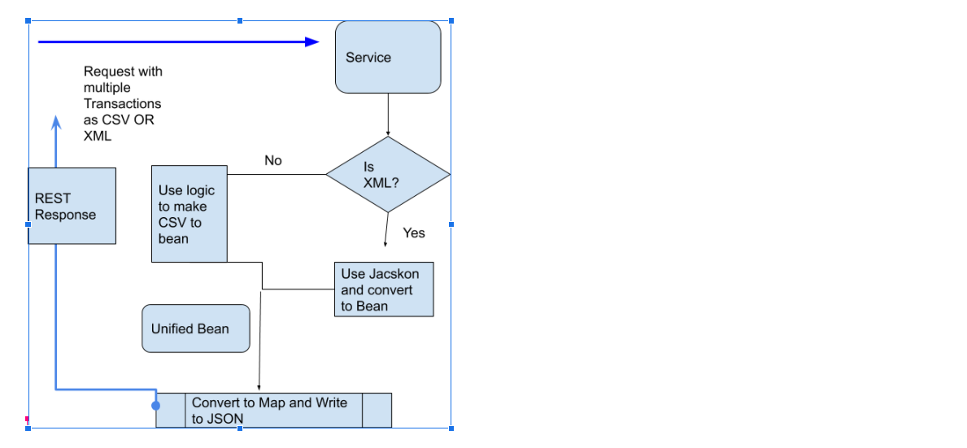

Please find below curl commands to make to API from command prompt,

curl --location --request POST '<http://localhost:8080/memberupload>' \

--header 'Content-Type: multipart/form-data' \

--form 'file=@/C:/Users/username/Desktop/choicecsv.csv'

curl --location --request POST '<http://localhost:8080/memberupload>' \

--header 'Content-Type: multipart/form-data' \

--form 'file=@/C:/Users/username/Desktop/choicexml.xml'