**12. Develop testcases and build a portal for testcases using selenium**

Create an Instance with

* T3.Micro
* 12GB storage
* Add the Inbound rule with Accepting all TCP
* Copy the SSH key
* Download the pem file

Open the Gitbash/Powershell and direct to pem file directory

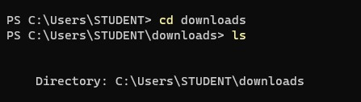

Enter the ssh key in the shell/gitbash

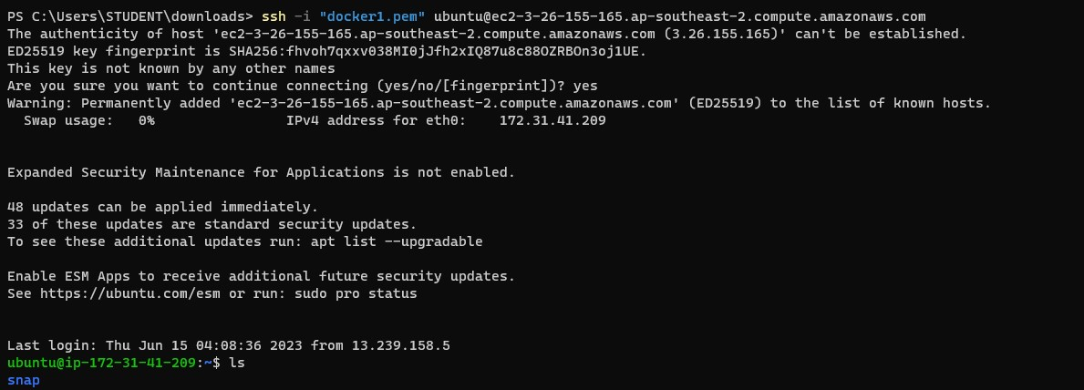

**Move to Root user by the command**

$ sudo su –



**Then install JRE and JDK**

$ sudo apt install default-jre

$ sudo apt install default-jdk

**Install docker with the command**

$ sudo apt install docker

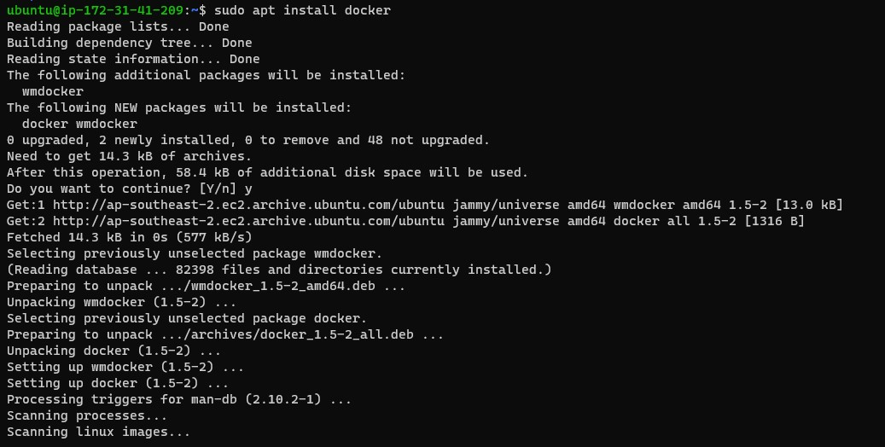

**Install docker compose**

$sudo apt install docker-compose

Create a file docker-compose.yml with the code



**If you cant copy and paste the code visit this and copy from here directly**

https://github.com/purnachand88/DockerSeleniumGrid/blob/main/SetupSeleniumGrid4.yml

|  |
| --- |
| version:"3" |
|  | services: |
|  | HubService: |
|  | image: selenium/hub:4.0.0-rc-2-20210930 |
|  | container_name: seleniumHub |
|  | ports: |
|  | - "4445:4444" |
|  | - "4442:4442" |
|  | - "4443:4443" |
|  |  |
|  | ChromeService: |
|  | image: selenium/node-chrome:4.0.0-rc-2-20210930 |
|  | shm_size: "2gb" |
|  | ports: |
|  | - "5900" |
|  | - "7900" |
|  | environment: |
|  | - SE_EVENT_BUS_HOST=seleniumHub |
|  | - SE_EVENT_BUS_PUBLISH_PORT=4442 |
|  | - SE_EVENT_BUS_SUBSCRIBE_PORT=4443 |
|  | - SE_NODE_MAX_SESSIONS=3 |
|  | depends_on: |
|  | - HubService |
|  |  |
|  | FirefoxService: |
|  | image: selenium/node-firefox:4.0.0-rc-2-20210930 |
|  | shm_size: "2gb" |
|  | ports: |
|  | - "5900" |
|  | - "7900" |
|  | environment: |
|  | - SE_EVENT_BUS_HOST=seleniumHub |
|  | - SE_EVENT_BUS_PUBLISH_PORT=4442 |
|  | - SE_EVENT_BUS_SUBSCRIBE_PORT=4443 |
|  | - SE_NODE_MAX_SESSIONS=2 |
|  | depends_on: |
|  | - HubService |
|  |  |
|  | EdgeService: |
|  | image: selenium/node-edge:4.0.0-rc-2-20210930 |
|  | shm_size: "2gb" |
|  | ports: |
|  | - "5900" |
|  | - "7900" |
|  | environment: |
|  | - SE_EVENT_BUS_HOST=seleniumHub |
|  | - SE_EVENT_BUS_PUBLISH_PORT=4442 |
|  | - SE_EVENT_BUS_SUBSCRIBE_PORT=4443 |
|  | - SE_NODE_MAX_SESSIONS=2 |
|  | depends_on: |
|  | - HubService |

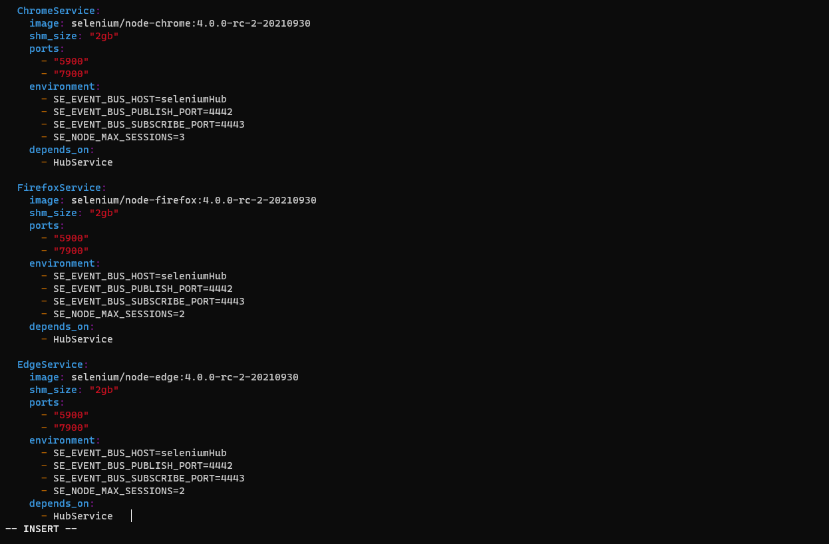

**Then run the file with command**

$ docker-compose up



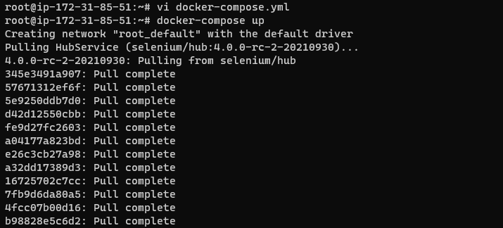

We could see that Selenium grid have been started running \

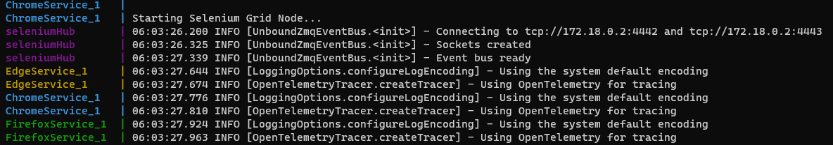

Open another Powershell/gitbash terminal and start the same instance with steps done above

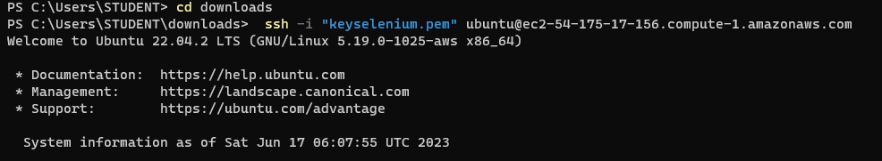

**Go to root user and the enter the command**

$ docker ps –a

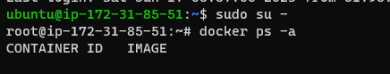

We can see the ports running with their port addresses

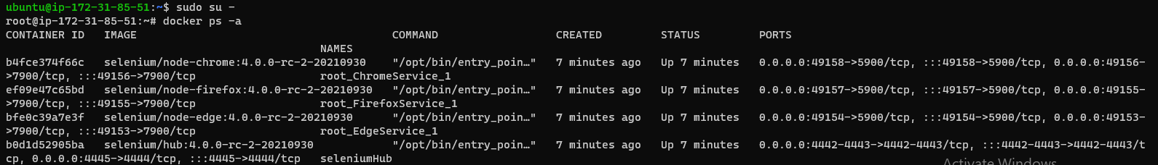

Copy your public ip from the AWS page

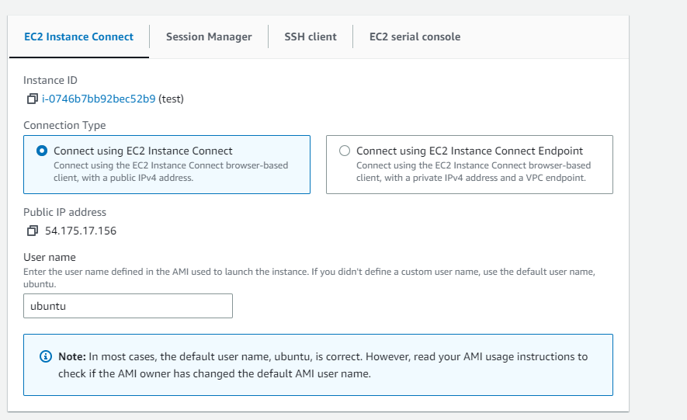

Add the ports that have been running before and enter in browser

54.175.17.156:4445

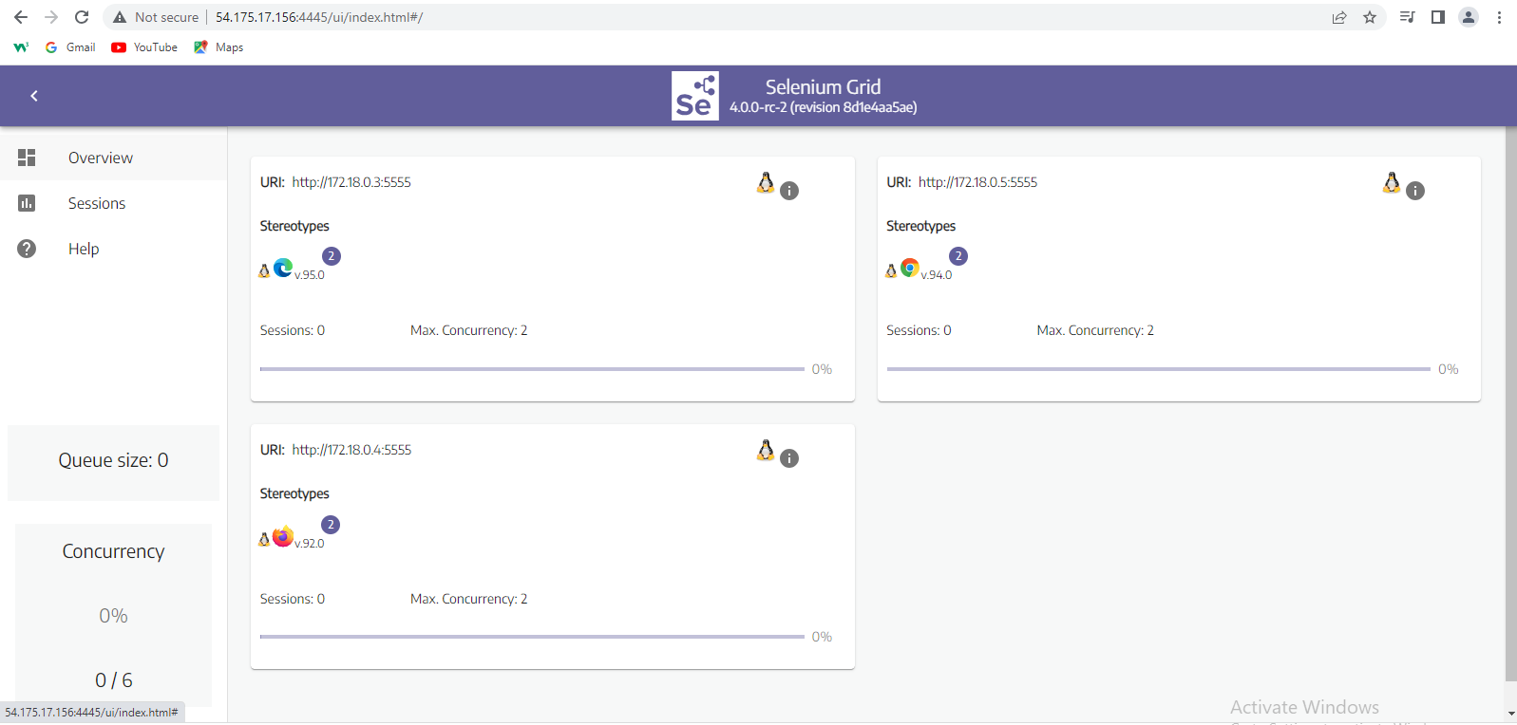

This is the selenium grid which we can find our Testcases status that are going to run and are running.

Then copy the **public ip** again and add the ports that are going to direct us to the **NO VNC portal**

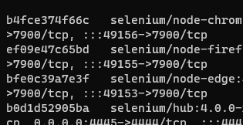

Ports are seen in here and every browser has its own port number

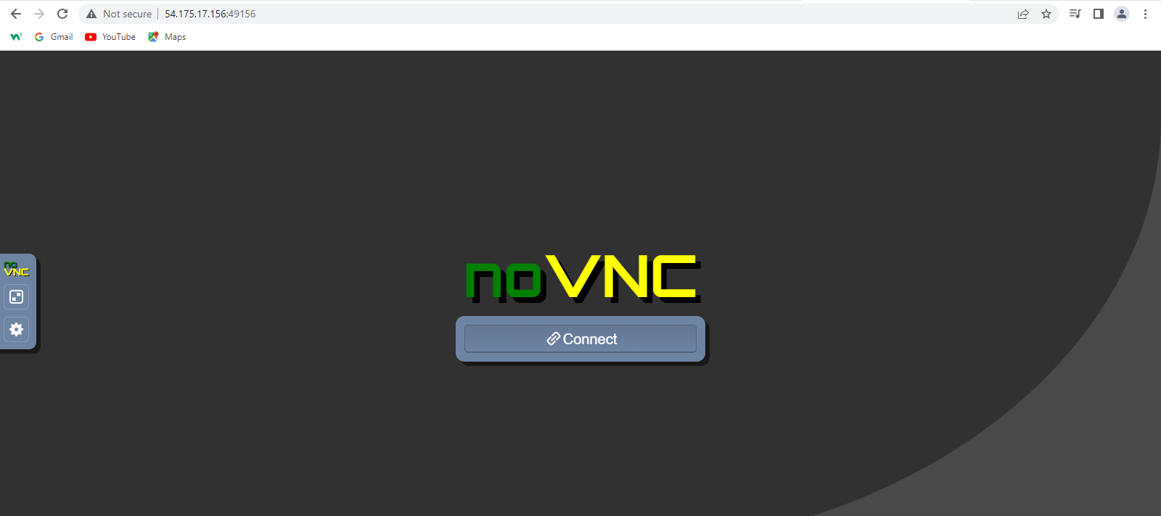

**After connecting then enter the password**

Secret

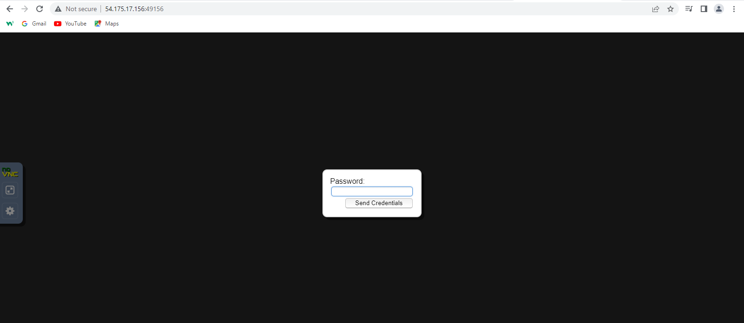

Then the portal will be like this



Here we can monitor the test cases and conclude the result

**Ports for browsers are**

[http://54.175.17.156:**49156**](http://54.175.17.156:49156) - Chrome

[http://54.175.17.156:**49155**](http://54.175.17.156:49155) -Firefox

[http://54.175.17.156:**49153**](http://54.175.17.156:49153) - Edge

To run a test case we have include these port numbers in the java code and then run with a package (not the normal run command )

We can find the test cases redirecting here and executing in NO VNC viewer