A
MINI PROJECT REPORT ON
REAL-TIME STATUS SYSTEM UPDATE IN A PARALLEL BLOCKING QUEUE
Submitted to
UNIVERSITY COLLEGE OF ENGINEERING & TECHNOLOGY
MAHATMA GANDHI UNIVERSITY, NALGONDA
In partial fulfilment of the requirements for the award of the degree of

BACHELOR OF TECHNOLOGY IN
COMPUTER SCIENCE & ENGINEERING
Submitted by

G.DEVENDER 4511-23-733-072

D. ANUSHA 4511-23-733-112

M.DEVIKA 4511-23-733-082
Under the guidance of
Mrs .M . JYOTHI RANI

Assistant Professor(c) Department of CSI

DEPARTMENT OF COMPUTER SCIENCE AND INFORMATICS UNIVERSITY COLLEGE OF ENGINEERING & TECHNOLOGY
MAHATMA GANDHI UNIVERSITY NALGONDA – 508254
MARCH- 2026

DEPARTMENT OF COMPUTER SCIENCE AND INFORMATICS UNIVERSITY COLLEGE OF ENGINEERING &TECHNOLOGY
MAHATMA GANDHI UNIVERSITY

NALGONDA – 508254

CERTIFICATE

Certified that this is a bonafide record of the mini project work entitled “Real-Time Status System Update in a Parallel Blocking Queue” done by G.DEVENDER (4511-23-733-072), D.ANUSHA (4511-23-733-112), M.DEVIKA (4511-23-733-082) submitted to the Faculty of Computer Science and Informatics in partial fulfilment of the requirements for the Degree of Bachelor of Technology in Computer Science and Engineering from Mahatma Gandhi University, Nalgonda during the year 2025-2026.

Project Guide: Department Co-Ordinator:

Mrs .M . JYOTHI RANI DR. M. JAYANTHI
Assistant Professor© Assistant Professor
Dept. of CSI Dept. of CSI

UCET&T, MGU
Nalgonda.
UCET&T, MGU
Nalgonda.

ACKNOWLEDGEMENT
We would like to express our deep gratitude to our project guide Mrs .M . JYOTHI RANI , Assistant Professor (C), Department of Computer Science and Informatics, UCET, MGU, for her guidance with unsurpassed knowledge and immense encouragement.
We are grateful to DR. M. JAYANTHI, Head of the Department, Computer Science and Informatics, for the valuable guidance and for permitting us to carry out this project.
We would like to thank Head of Department and Principal Mrs. CH. SUDHA RANI for her expert guidance and encouragement at various levels of our project.
We thank all Teaching Faculty of Department of Computer Science & informatics, whose suggestions during reviews helped us in accomplishment of our project.
We express our thanks to all those who contributed directly or indirectly for the successful completion of our project work.
With Gratitude,

Our Team,

G.DEVENDER | [4511-23-733-072]
D. ANUSHA | [4511-23-733-112]
M.DEVIKA | [4511-23-733-082]

DECLARATION
We, hereby declare that the Mini Project entitled, “Real-Time Status System Update in a Parallel Blocking Queue” has been carried out by us under the guidance of Mrs .M . JYOTHI RANI Asst. Professor(c), UCE&T, MGU, Nalgonda, in partial fulfilment of the requirements for the award of degree of Bachelor of Technology in Computer Science and Engineering, of the University College of Engineering & Technology, MGU during the academic year 2025-26. The work done in this dissertation report is original and it has not been submitted for any other degree in any university.

(Student Signature)

G.DEVENDER [4511-23-733-072]

D. ANUSHA [4511-23-733-112]

M.DEVIKA [4511-23-733-082]

CONTENTS
ACKNOWLEDGEMENT .........................................................................i
DECLARATION ..................................................................................... ii
ABSTRACT ............................................................................................ iii
CHAPTER 1: INTRODUCTION
1.1 Motivation for Work ..................................... ……………………….1
1.2 Introduction ........................................................................................ 1
1.3 Existing Method ......................................... …………………………2
1.4 Proposed Method ................................................................................ 2
1.5 Problem Definition ..............................................................................3
1.6 Objectives of the Project .................................................................... 3
CHAPTER 2: LITERATURE SURVEY
2.1 Introduction ........................................................................................ 4
2.2 Existing System ................................................................................. 4
CHAPTER 3: THEORETICAL BACKGROUND
3.1 Prediction Model ............................................................................... 5
3.1.1 Machine Learning Algorithms ....................................................... 7
3.1.2 Neural Networks ........................................................................... 14
3.1.3 AI Techniques ............................................................................... 17
CHAPTER 4: PREAMBLE
4.1 System Architecture ....................................................................... 12
CHAPTER 5: SYSTEM REQUIREMENT SPECIFICATION
5.1 System Requirements ................................................................... 13
5.1.1 Hardware Requirements .......................................................... 13
5.1.2 Software Requirements ........................................................... 14
5.2 Functional Requirements ............................................................ 14
5.3 Non-Functional Requirements ................................................... 16
CHAPTER 6: SYSTEM ANALYSIS
6.1 Feasibility Study ........................................................................ 16
6.1.1 Economic Feasibility .............................................................. 16
6.1.2 Technical Feasibility .............................................................. 17
6.1.3 Social Feasibility .................................................................... 17
6.2 Analysis ..................................................................................... 17
6.2.1 Performance Analysis ............................................................ 17
6.2.2 Technical Analysis ................................................................ 18
6.2.3 Economic Analysis ............................................................... 18
CHAPTER 7: SYSTEM DESIGN
7.1 UML Diagrams ........................................................................ 15-16
7.1.1 Use Case Diagram ................................................................ 17
7.1.2 Class Diagram ...................................................................... 18
7.1.3 Sequence Diagram ............................................................... 19
7.1.4 Activity Diagram ................................................................. 20
CHAPTER 8: IMPLEMENTATION
8.1 Sample Code .......................................................................... 21-25
CHAPTER 9: TESTING
9.1 Testing Methodologies .......................................................... 26
9.1.1 White Box Testing ............................................................. 27
9.1.2 Black Box Testing ..................................................................... 27
9.2 Unit Testing .............................................. ………………………28
9.3 System Testing ............................................................................. 28
9.4 Quality Assurance ........................................................................ 28
CHAPTER 10: RESULT & PERFORMANCE ANALYSIS
10.1 Output Snapshots ...................................................................... 29
10.2 Result Analysis ........................................................................ 29
CHAPTER 11: CONCLUSION & FUTURE WORK
11.1 Conclusion .................................................................................. 30
11.2 Future Work ................................................................................ 30
REFERENCES .................................................................................. 31-32

ABSTRACT

This project focuses on maintaining the freshness of information in real-time status update systems using multi-path transmission. In such systems, updates are transmitted from a source to a monitor through multiple parallel servers. Since updates travel through different paths, they may arrive at the destination in a different order, which makes system analysis more challenging. To evaluate the freshness of information, the concept of Age of Information (AoI) is used as a performance metric.
The study considers two types of systems: a homogeneous system, where all servers have identical arrival and service rates, and a heterogeneous system, where servers operate with different service rates. The system behavior is analyzed using the Stochastic Hybrid Systems (SHS) framework, which effectively models both discrete and continuous dynamics of the system.
Mathematical expressions are derived to calculate the average AoI for both types of systems. The results demonstrate that increasing the number of servers significantly improves system performance by reducing AoI. A major improvement is observed when the system transitions from a single-server configuration to a dual-server setup. Overall, the project highlights the effectiveness of parallel server systems in improving data freshness in real-time communication networks.

G.DEVENDER | [4511-23-733-072]
D. ANUSHA | [4511-23-733-112]
M.DEVIKA | [4511-23-733-082]

PREAMBLE

INTRODUCTION

In recent years, the rapid growth of intelligent communication systems such as Internet of Things (IoT), smart transportation, wireless sensor networks, and mobile edge computing has increased the demand for real-time data transmission. In these systems, it is not only important to deliver data quickly, but also to ensure that the information received is fresh and up-to-date.

Traditional performance metrics like delay and throughput are not sufficient to measure the freshness of information. These metrics only indicate how long it takes for data to reach the destination, but they do not reflect whether the data is still relevant at the time of reception. To overcome this limitation, a new metric called Age of Information (AoI) is used. AoI measures the time elapsed since the last received update was generated, thereby providing a better understanding of data freshness.

In real-time systems, updates are generated at a source and transmitted to a monitor through communication channels. If the system uses only a single server, updates may experience delays due to congestion, leading to outdated information. To improve performance, multiple servers can be used to transmit updates simultaneously through parallel paths.

This project focuses on a real-time status update system using a parallel blocking queue model, where multiple servers process updates in parallel without any buffering. The system ensures that only fresh updates are transmitted, thereby improving the overall efficiency and timeliness of information delivery.

EXISTING SYSTEM
In existing communication systems, data transmission is typically performed using single-server queue models such as M/M/1. In these systems, updates are processed sequentially, which leads to increased waiting time and delay, especially when the arrival rate of updates is high.
Most existing systems rely on traditional performance metrics such as delay and throughput, which do not accurately capture the freshness of data. As a result, even if data is delivered quickly, it may still be outdated and not useful for real-time applications.
Additionally, existing systems often include buffers where incoming updates are stored when the server is busy. While buffering helps prevent data loss, it also increases waiting time and leads to the transmission of outdated information.

Limitations of Existing System:
- High delay due to single-server processing
- Data becomes outdated before reaching the destination
- Inefficient handling of real-time updates
- Limited scalability
- Increased waiting time due to buffering
- Poor performance under high traffic conditions
These limitations make traditional systems unsuitable for applications that require high data freshness and real-time performance

PROPOSED SYSTEM
To overcome the limitations of existing systems, the proposed system introduces a parallel blocking queue model for real-time status updates. In this system, multiple servers are used to process updates simultaneously, allowing faster transmission and improved data freshness.
The system operates without a buffer, meaning that if all servers are busy, incoming updates are discarded instead of being stored. This approach ensures that only fresh updates are processed and delivered to the monitor.
Updates are generated randomly at the source and assigned to any available server. Each server processes one update at a time, and upon completion, the update is delivered to the monitor. Since multiple servers operate in parallel, the system significantly reduces delay and improves performance.
Key Features of Proposed System:
- Multiple parallel servers for processing updates
- Bufferless (blocking) queue system
- Immediate processing of updates if servers are available
- Discarding of updates when all servers are busy
- Improved data freshness using AoI
Advantages:
- Reduced delay
- Improved freshness of information
- Efficient utilization of resources
- Better scalability
- Suitable for real-time applications

PROBLEM STATEMENT

In modern communication systems, maintaining the freshness of information is a major challenge. Traditional systems primarily focus on minimizing delay but fail to ensure that the delivered data is up-to-date, which may lead to outdated information being used for decision-making and result in inefficient outcomes. Single-server systems introduce significant delays when the system becomes overloaded, causing updates to wait in queues before being processed. Additionally, buffering mechanisms store older updates, which further reduces the freshness of data. In multi-server systems, although parallel transmission improves processing speed, it can lead to out-of-order delivery of updates, making it difficult to accurately identify the most recent information. Therefore, there is a need for an efficient system that minimizes delay, ensures data freshness, handles multiple updates effectively, and reduces the impact of outdated information. This project addresses these challenges by designing a parallel blocking queue system that improves the timeliness and freshness of data.

OBJECTIVES OF THE PROJECT

The main objective of this project is to design a real-time status update system using a parallel server model that ensures efficient transmission of updates. The project aims to improve the freshness of information by utilizing the Age of Information (AoI) metric as a key performance indicator. It also focuses on reducing delay in data transmission by enabling parallel processing of updates through multiple servers. In addition, the system performance is analyzed using queueing theory to understand the behavior of updates under different conditions. The project further compares the performance of single-server and multi-server systems to evaluate their effectiveness. It also studies the impact of increasing the number of servers on overall system performance and data freshness. Finally, the objective is to develop a scalable and efficient communication system that can be applied to real-time applications.

LITERATURE SURVEYS
The study of real-time status update systems has gained significant importance due to the increasing demand for fresh and timely information in applications such as Internet of Things (IoT), intelligent transportation, and wireless communication systems. Traditional performance metrics like delay and throughput are not sufficient to measure data freshness, which led to the introduction of Age of Information (AoI) as a key metric. Early research focused on single-server queue models, which were simple but resulted in higher delay and outdated information. To improve performance, multi-server and multi-path transmission systems were introduced, allowing updates to be processed and transmitted simultaneously. These systems improve data freshness but also introduce challenges such as out-of-order packet delivery and increased system complexity.
Recent studies have focused on optimizing system performance by improving update generation rates, service mechanisms, and scheduling strategies. Different approaches such as preemptive and non-preemptive queue models, packet management techniques, and server selection methods have been explored to reduce AoI. Non-preemptive systems are considered more suitable for practical applications due to their simplicity and lower computational complexity. It has also been observed that increasing the number of servers significantly improves performance, especially when moving from a single-server to a dual-server system. However, beyond a certain point, adding more servers provides limited improvement, emphasizing the need for efficient system design and proper resource utilization.
Drawbacks of Existing Literature:
· Many existing methods are based on single-server models, leading to higher delay and poor data freshness.
· Some approaches use fixed system parameters, which may not adapt well to changing network conditions.
· Multi-server systems introduce out-of-order packet arrivals, increasing system complexity.
· Traditional models may not efficiently handle high traffic or dynamic update generation rates.
· Some techniques are computationally complex and difficult to implement in real-time systems.
· Existing methods may not fully utilize parallel processing capabilities effectively.

THEORETICAL BACKGROUND

Real-time communication systems have become an essential component of modern technology due to their wide range of applications in Internet of Things (IoT), intelligent transportation systems, wireless sensor networks, and edge computing. In such systems, it is not only important to deliver data quickly, but also to ensure that the information received is fresh and up-to-date. Traditional performance metrics such as delay and throughput are not sufficient to evaluate the freshness of information, as they do not reflect how recent the data is at the time of reception. To address this limitation, the concept of Age of Information (AoI) is introduced, which measures the time elapsed since the most recent update received at the destination was generated.
Real-Time_Status_Update_System_…
To effectively analyze and improve data freshness, various mathematical models and analytical techniques have been developed. Among these, queueing theory plays a significant role in modeling the behavior of real-time systems. In this project, a parallel blocking queue model is used, where multiple servers process updates simultaneously without maintaining any waiting buffer. This ensures that outdated updates are not stored in the system, thereby improving the overall freshness of information. The theoretical background of this project focuses on key concepts such as Age of Information, queueing models, stochastic hybrid systems, and parallel server architectures.

3.1 AGE OF INFORMATION
Age of Information (AoI) is a fundamental metric used to evaluate the freshness of data in real-time communication systems. It is defined as the time difference between the current time and the generation time of the most recently received update. Unlike traditional delay metrics, AoI continuously increases over time when no new updates are received and drops instantly when a fresh update reaches the destination. This dynamic behavior makes AoI a more accurate representation of data freshness.
The average AoI is commonly used to measure system performance over a long period. A lower value of AoI indicates that the system is capable of delivering fresh updates more frequently, while a higher AoI suggests that the information at the receiver is becoming outdated. Therefore, minimizing AoI is a key objective in the design of real-time update systems.

3.1.1 UPDATE GENERATION PROCESS
In real-time systems, updates are generated at the source in a random manner depending on the occurrence of events. This process is typically modeled using a Poisson distribution, which represents the probability of updates arriving over time. The randomness of update generation reflects real-world scenarios where events such as sensor readings, environmental changes, or system updates occur unpredictably.
The rate at which updates are generated, known as the arrival rate, has a significant impact on system performance. If updates are generated too frequently, the system may become overloaded, leading to increased data loss. On the other hand, if updates are generated too slowly, the information at the receiver may become outdated. Therefore, maintaining an optimal update generation rate is essential for achieving better data freshness.

3.1.2 QUEUEING MODEL
Queueing theory is used to model the flow of updates in real-time systems. In this project, the system is represented using an M/M/n/n queue model, where both the arrival and service processes follow exponential distributions, and the system consists of multiple servers with no waiting buffer. This type of system is also known as a blocking queue system.
In this model, when an update arrives, it is immediately assigned to an available server. If all servers are busy, the update is discarded instead of being stored in a queue. This approach ensures that only the most recent updates are processed, thereby improving data freshness. Although this may lead to some data loss, it is acceptable in real-time systems where outdated information is less useful than fresh data.

3.1.3 PARALLEL SERVER SYSTEM
A parallel server system consists of multiple servers that operate simultaneously to process incoming updates. Each server handles one update at a time, and updates are assigned to any available server. This parallel processing significantly reduces the time required to deliver updates, thereby improving system performance.
However, the use of multiple servers introduces certain challenges. Since updates are processed independently by different servers, they may arrive at the destination in a different order than they were generated. This out-of-order delivery makes it difficult to track the most recent update and analyze the system accurately. Despite this challenge, parallel server systems provide a significant improvement in data freshness compared to single-server systems.

3.2 STOCHASTIC HYBRID SYSTEM
Stochastic Hybrid Systems (SHS) provide a powerful framework for analyzing systems that involve both discrete and continuous processes. In real-time update systems, the discrete component represents the state of the system, such as the number of updates being processed, while the continuous component represents the evolution of Age of Information over time.
The SHS approach combines these two components to model the behavior of the system more accurately. It allows the analysis of complex scenarios where updates arrive randomly and are processed by multiple servers. Using SHS, it is possible to derive mathematical expressions for average AoI and evaluate system performance under different conditions.

3.3 SYSTEM PERFORMANCE ANALYSIS
The performance of a real-time update system depends on several factors, including the arrival rate of updates, the service rate of servers, and the number of servers in the system. Increasing the number of servers generally leads to a reduction in AoI, as updates can be processed more quickly. However, beyond a certain point, adding more servers does not significantly improve performance, indicating that there is an optimal number of servers for efficient system operation.
Balancing these parameters is essential for achieving better performance and ensuring that the system delivers fresh and timely information.

3.4 SYSTEM ARCHITECTURE
The proposed system follows a structured architecture designed to efficiently process real-time updates. The process begins with the generation of updates at the source, which are then transmitted to available servers. Each server processes the assigned update independently and delivers it to the monitor. The monitor continuously tracks the received updates and calculates the Age of Information to evaluate data freshness.
This architecture ensures that updates are processed efficiently without unnecessary delays, thereby improving the overall performance of the system. By combining parallel processing with a blocking queue mechanism, the system effectively maintains fresh and up-to-date information.

SYSTEM REQUIREMENTS

INTRODUCTION
The System Requirement Specification (SRS) defines the complete set of requirements that the proposed real-time status update system must satisfy. It provides a clear description of the system’s functional capabilities, hardware and software requirements, and operational constraints. The SRS acts as a formal agreement between the developers and users regarding how the system should behave and perform.
This document specifies the requirements needed to design and implement a real-time status update system using a parallel blocking queue model. It outlines the necessary tools, system resources, and functionalities required to ensure efficient processing and delivery of updates. The SRS also serves as a reference for system design, development, testing, and implementation phases.

4.2 SOFTWARE REQUIREMENTS
Software requirements define the programming tools, platforms, and libraries required for developing and running the system efficiently. These components ensure smooth execution of simulations, mathematical analysis, and performance evaluation of the system.
The proposed system can be implemented using Python (version 3.7 or higher) due to its simplicity and strong support for scientific computing. Development can be carried out using environments such as Jupyter Notebook, VS Code, or Spyder IDE. The system can operate on commonly used operating systems such as Windows or Linux.
For computation and analysis, libraries such as NumPy and SciPy are required for handling mathematical operations. Visualization tools like Matplotlib can be used to display graphs related to Age of Information and system performance. Optional libraries such as Pandas may be used for handling data, while Anaconda distribution can be used to manage the development environment efficiently.

4.3 HARDWARE REQUIREMENTS
Hardware requirements specify the physical resources needed to run the system effectively. The system does not require highly advanced hardware but should have sufficient processing capability to handle simulations and calculations.
A system with an Intel Core i5 processor or higher is recommended for efficient execution. A minimum of 8 GB RAM is required to handle computations smoothly, while higher memory may improve performance for large-scale simulations. At least 20 GB of free disk space is needed for storing program files and outputs.
A standard display monitor is sufficient for visualizing results, and basic input devices such as a keyboard and mouse are required for system interaction. A GPU is optional and may be used to accelerate processing if advanced simulations are performed.

4.4 FUNCTIONAL REQUIREMENTS
Functional requirements describe the operations that the system must perform to achieve its objectives. The system is designed to simulate and analyze real-time update transmission using a parallel server model.
The system must be capable of generating updates at the source based on a defined arrival rate. It should assign updates to available servers and process them independently. If all servers are busy, the system must discard incoming updates, following the blocking queue mechanism.
The system should compute the Age of Information continuously and track how it changes over time. It must also analyze system performance by evaluating how parameters such as arrival rate, service rate, and number of servers affect AoI.
Additionally, the system should display results in the form of graphs or numerical outputs and allow storage of simulation results for further analysis. The system should also support multiple configurations to compare different scenarios.

4.5 NON-FUNCTIONAL REQUIREMENTS
Non-functional requirements define the quality attributes and performance expectations of the system. These requirements ensure that the system operates efficiently and reliably under different conditions.
The system should provide fast execution with minimal processing delay. It must produce accurate results for AoI calculations and system performance analysis. The system should be scalable, allowing it to handle different numbers of servers and varying input parameters.
Reliability is an important factor, and the system should produce consistent results when executed multiple times under similar conditions. The system should also be user-friendly, with a simple interface for running simulations and viewing results. Maintainability is also important, and the system should be designed in a modular way so that it can be easily updated or modified.

4.5.1 PRODUCT REQUIREMENTS
Product requirements describe the features and capabilities that the proposed system must provide. The system should be able to simulate a real-time status update environment using multiple servers and evaluate the freshness of information using Age of Information.
The system must accept input parameters such as arrival rate, service rate, and number of servers. It should perform update generation, server allocation, and processing of updates automatically. The system should compute AoI and analyze how it changes with different system configurations.
The system should also provide clear output results in graphical or numerical form and allow users to compare performance under different conditions. The product should be efficient, reliable, and capable of handling real-time simulation scenarios.

4.5.2 ORGANIZATIONAL REQUIREMENTS
Organizational requirements define the standards and guidelines that must be followed during the development of the system. The project should follow proper software engineering principles to ensure quality and reliability.
All stages of development, including design, coding, testing, and documentation, should be carried out systematically. Proper documentation of system architecture, algorithms, and implementation details must be maintained for future reference.
The system should follow coding standards to ensure readability and maintainability. Version control practices should be used to track changes during development. The project must also adhere to ethical and legal standards related to software usage and data handling.
Proper testing and validation should be conducted before final implementation to ensure that the system performs correctly under various conditions.

SYSTEM ANALYSIS
System analysis is a crucial phase in the development of any software project. It involves studying the existing system, identifying its limitations, and understanding the requirements of the proposed system. The main objective of system analysis is to design an improved solution that enhances performance, efficiency, and reliability.
In this project, system analysis focuses on understanding how real-time status update systems operate and how the freshness of information can be improved using a parallel blocking queue model. The analysis examines how updates are generated, processed, and delivered through multiple servers, and how the Age of Information (AoI) can be minimized. By analyzing these aspects, the system can be designed to ensure efficient processing of updates and improved data freshness.
The analysis also considers technical and operational requirements needed for implementing the system. It helps in identifying suitable tools, system configurations, and performance parameters. The results obtained from this analysis serve as a foundation for designing and implementing an efficient real-time update system.
5.1 FEASIBILITY STUDY
Feasibility study is an important step in system analysis that evaluates whether the proposed system can be developed successfully within the available resources and constraints. It helps in determining whether the system is practical, cost-effective, and beneficial.
In this project, feasibility is analyzed in terms of economic, technical, and social aspects. These factors help in understanding whether the system can be implemented efficiently and whether it will be useful for real-time applications. Conducting feasibility analysis at an early stage helps in identifying potential challenges and reducing risks during development.
5.2 ECONOMICAL FEASIBILITY
Economic feasibility evaluates the cost required for developing and implementing the proposed system. The real-time status update system is mainly based on software simulation and mathematical modeling, which significantly reduces the overall cost.
The system uses open-source tools such as Python and scientific libraries, which eliminates the need for expensive software licenses. It does not require specialized hardware, and a standard computer system is sufficient for implementation. Therefore, the overall cost involved in developing and running the system is minimal.
Compared to other complex communication systems that require advanced infrastructure, the proposed system provides a cost-effective solution. Hence, the economic feasibility of the system is considered highly favorable.
5.3 TECHNICAL FEASIBILITY
Technical feasibility determines whether the required technology and technical knowledge are available to implement the proposed system. The technologies used in this project, such as queueing theory, parallel server models, and stochastic analysis, are well established and widely used in research and practical applications.
The system can be implemented using programming languages like Python along with libraries such as NumPy and Matplotlib. These tools provide efficient support for mathematical computation and performance analysis.
The system does not require advanced hardware and can be executed on a standard computing environment. Since the concepts used in this project are already validated and widely studied, the technical feasibility of the system is considered achievable.
5.4 SOCIAL FEASIBILITY
Social feasibility evaluates the acceptance and usefulness of the proposed system among users. The real-time status update system is designed to improve data freshness and efficiency in communication systems, making it highly useful for modern applications.
The system can be used by students, researchers, and professionals to analyze and understand real-time communication models. It provides a simple and effective approach to studying system performance and data freshness.
Since the system improves efficiency and simplifies analysis, it is expected to be positively accepted by users. It also contributes to academic research and practical applications in communication systems.

5.5 ANALYSIS
System analysis involves evaluating the performance, technical aspects, and economic factors of the proposed system before implementation. It helps in determining whether the system can meet its objectives efficiently.
In this project, the analysis focuses on understanding how the parallel blocking queue model improves data freshness compared to traditional systems. It also evaluates how different parameters such as arrival rate, service rate, and number of servers affect system performance.
The analysis ensures that the system can operate efficiently under different conditions and provides reliable results.
5.5.1 PERFORMANCE ANALYSIS
Performance analysis evaluates how efficiently the system processes updates and maintains data freshness. The system should be able to handle multiple updates simultaneously and deliver them with minimal delay.
The performance of the system depends on factors such as update arrival rate, service rate of servers, and number of servers. Increasing the number of servers generally improves performance by reducing AoI.
Efficient algorithms and proper system design help in achieving better performance and accurate results.
5.5.2 TECHNICAL ANALYSIS
Technical analysis focuses on the technologies used for implementing the system. The project uses well-established concepts such as queueing models and stochastic analysis, which are supported by modern programming tools.
The implementation can be carried out using Python and its associated libraries, which provide efficient support for simulation and analysis. These tools are widely used and well documented, making the system easy to develop and maintain.

5.5.3 ECONOMICAL ANALYSIS
Economical analysis evaluates the cost efficiency of the system. The use of open-source tools and standard computing resources ensures that the overall cost of development and implementation is very low.
The system does not require expensive infrastructure or specialized hardware, making it affordable and practical. Therefore, the project is economically feasible and suitable for academic and research purposes.

6. DESIGN
System design is an important phase in the development of the proposed real-time status update system. It provides a clear representation of how updates are generated at the source, assigned to parallel servers, processed, and delivered to the monitor. The design of the proposed system is based on a parallel blocking queue model in which multiple servers work simultaneously to improve the freshness of information at the destination. The main objective of this design is to reduce delay and maintain a low Age of Information (AoI) by ensuring that only the most relevant and fresh updates are processed. The paper models the network as a single queue with multiple servers, each behaving as a non-preemptive M/M/1/1 server, with new arrivals discarded whenever all servers are occupied.
In the proposed system, updates are generated from a single source according to a random arrival process. These updates are immediately sent to the system and assigned to any idle server. Each server processes one update at a time and forwards it to the monitor after service completion. Since the queue is bufferless, no waiting mechanism is provided. If all servers are busy, the arriving update is blocked and discarded. This design is especially suitable for real-time systems because outdated updates are less useful than fresh updates. The monitor continuously tracks the freshness of the received information using the AoI metric. The SHS-based analytical model in the paper combines discrete state changes with continuous age evolution, which makes it suitable for describing this real-time status update behavior.
6.1 UML DIAGRAMS
Unified Modeling Language (UML) diagrams are used to represent the structure and behavior of the proposed system in a visual form. These diagrams help in understanding the overall working of the real-time status update system, the interaction between system entities, the order of operations, and the workflow followed during update processing. In this project, UML diagrams are used to explain the design of the parallel blocking queue system in a clear and systematic manner. The major diagrams included are the Use Case Diagram, Sequence Diagram, and Activity Diagram. These diagrams together provide a complete understanding of the functioning of the proposed system. This kind of chapter structure is also consistent with the design-section style seen in your pasted template file for UML-based report writing.

6.1.1 USE CASE DIAGRAM
The Use Case Diagram represents the interaction between the external actors and the proposed real-time status update system. It provides a high-level view of the functionalities performed by the system and the role of the actor in initiating these operations. In the proposed model, the main actor is the Source/User, which generates updates and interacts with the system. The system then performs operations such as update generation, queue admission, server allocation, processing through parallel servers, blocking of updates when all servers are busy, and finally delivery of fresh updates to the monitor.
In this system, the actor initiates the update transmission process. Once an update is generated, the system checks the availability of servers. If a server is idle, the update is assigned for service. If all servers are already occupied, the arriving update is discarded according to the blocking queue mechanism. After service completion, the processed update is delivered to the monitor, where the Age of Information is refreshed if the received update is the freshest one. Thus, the use case diagram clearly explains the interaction between the actor and the system functionalities related to freshness-oriented update delivery.
The use case representation is suitable for this project because it summarizes the major operations of the system without going into internal implementation details. It helps the reader understand what the system does, who interacts with it, and what responses are generated by the system under different conditions.
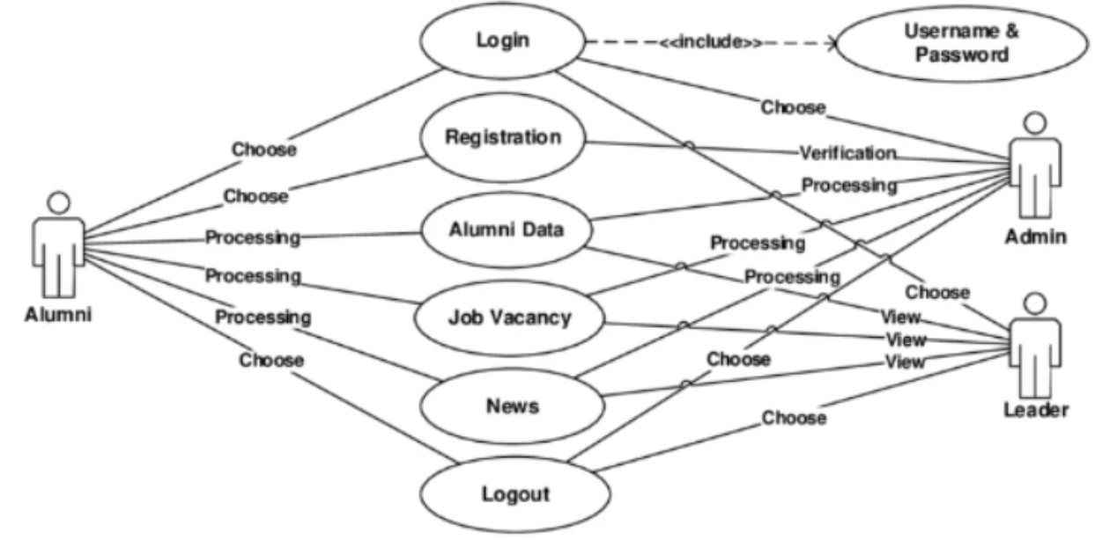
Fig. 6.1 Use Case Diagram of the proposed real-time status update system showing the interaction between the actor and the system functions.
6.1.2 SEQUENCE DIAGRAM
The Sequence Diagram represents the time-ordered interaction between the main components of the proposed system. It shows how the source, bufferless queue, parallel servers, and monitor communicate with each other during the execution of the real-time update process. This diagram is useful for understanding the exact sequence in which updates are generated, processed, and delivered.
The process begins when the source generates a fresh update. The update is then sent to the bufferless queue. The queue checks whether any server is available at that particular instant. If at least one server is free, the update is assigned to one of the idle servers. The selected server starts processing the update according to the service rate. Once the service is completed, the update is transmitted to the monitor. The monitor then checks whether the received update is fresher than the previously received one. If it is fresher, the AoI is reduced accordingly.
If all servers are busy at the time of update arrival, the queue blocks the incoming update and discards it immediately. No waiting or storage takes place in the system. This sequence matches the behavior described in the paper, where arrivals are admitted only to idle servers and discarded otherwise, while the monitor’s age evolves depending on update delivery and freshness.
The sequence diagram helps in visualizing message flow and the chronological order of operations among different system components. It gives a detailed understanding of the interaction logic of the proposed parallel blocking queue system.
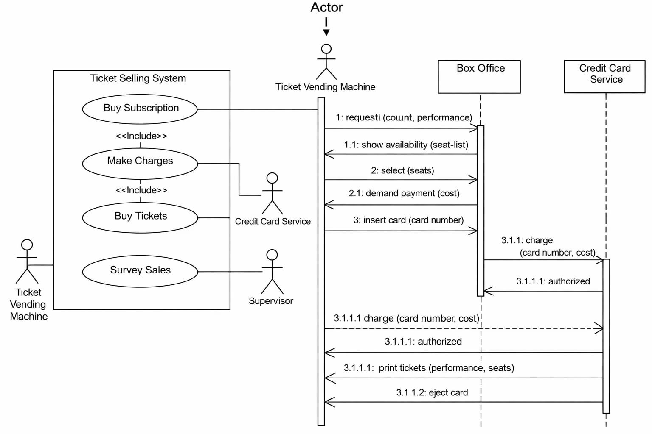
Fig. 6.2 Sequence Diagram of the proposed real-time status update system showing the flow of updates between source, queue, servers, and monitor.
6.1.3 ACTIVITY DIAGRAM
The Activity Diagram represents the workflow of the proposed real-time status update system. It explains how the system moves from one activity to another starting from update generation and ending with monitor refresh or update discard. It is useful for understanding the decision-making process inside the system and the overall operational flow.
The workflow begins with the generation of a status update at the source. After generation, the update is sent to the queue admission stage. At this point, the system checks whether a server is available. If the condition is true, the update is assigned to an idle server for processing. After service completion, the update is delivered to the monitor, and the Age of Information is updated. If the update is fresher than previous updates, the monitor refreshes its information state.
If the server availability condition is false, meaning all servers are busy, the system discards the update. The process then continues with the next arriving update. This clearly reflects the blocking behavior of the system, where fresh updates are prioritized and old waiting packets are avoided. The activity diagram therefore provides a simple and effective representation of the full working procedure of the proposed design.
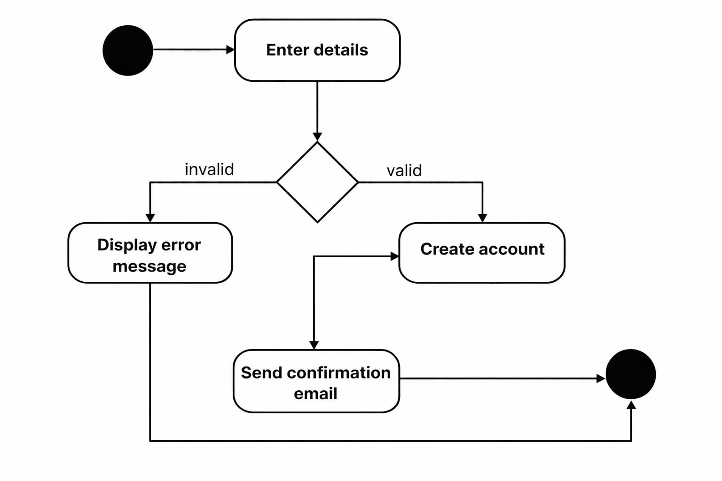
Fig. 6.3 Activity Diagram of the proposed real-time status update system showing the workflow from update generation to delivery or discard.
6.2 DESIGN SUMMARY
The system design of the proposed real-time status update system is centered on parallel processing, bufferless queue operation, and freshness-aware delivery. The source continuously generates updates, the queue admits them only when servers are free, and the monitor evaluates freshness using the Age of Information metric. By using parallel servers, the system improves timeliness and reduces stale information. The use case, sequence, and activity diagrams together provide a complete visual explanation of system interaction, execution order, and workflow. Hence, the design confirms that the proposed parallel blocking queue model is suitable for real-time communication systems where timely delivery of fresh information is more important than storing outdated updates.

7.IMPLEMENTATION

7.1 SAMPLE CODE

import numpy as np

import matplotlib.pyplot as plt

from collections import deque

def generate_update(lam):

Generates update arrival time using exponential distribution

inter_arrival_time = np.random.exponential(1/lam)

return inter_arrival_time

class UpdateQueue:

def __init__(self):

self.queue = deque()

def add_update(self, update_time):

self.queue.append(update_time)

def get_update(self):

if len(self.queue) > 0:

return self.queue.popleft()

return None

def is_empty(self):

return len(self.queue) == 0

class ParallelServers:

def __init__(self, n_servers, mu):

self.n_servers = n_servers

self.mu = mu

self.busy_until = np.zeros(n_servers)

def process_update(self, current_time, update_time):

idle_servers = np.where(self.busy_until <= current_time)[0]

if len(idle_servers) > 0:

server_id = idle_servers[0]

service_time = np.random.exponential(1/self.mu)

completion_time = current_time + service_time

self.busy_until[server_id] = completion_time

return completion_time, update_time

return None, None

class Monitor:

def __init__(self):

self.last_update_time = 0

self.aoi_values = []

self.time_values = []

def update(self, current_time, generated_time):

self.last_update_time = generated_time

aoi = current_time - self.last_update_time

self.aoi_values.append(aoi)

self.time_values.append(current_time)

def average_aoi(self):

return np.mean(self.aoi_values) if len(self.aoi_values) > 0 else 0

def simulate_system(n_servers=2, lam=1, mu=1, total_time=1000):

queue = UpdateQueue()

servers = ParallelServers(n_servers, mu)

monitor = Monitor()

time = 0

while time < total_time:

arrival = generate_update(lam)

time += arrival

queue.add_update(time)

if not queue.is_empty():

update_time = queue.get_update()

completion_time, generated_time = servers.process_update(time, update_time)

if completion_time is not None:

monitor.update(completion_time, generated_time)

return monitor

lambda_values = np.linspace(0.5,5,10)

avg_aoi = []

for lam in lambda_values:

monitor = simulate_system(n_servers=2, lam=lam, mu=1)

avg_aoi.append(monitor.average_aoi())

plt.plot(lambda_values, avg_aoi)

plt.xlabel("Arrival Rate (λ)")

plt.ylabel("Average AoI")

plt.title("Age of Information vs Arrival Rate")

plt.show()

8.TESTING

8.1 TESTING METHODOLOGIES
Various testing methods and techniques were applied to ensure the accuracy, reliability, and performance of the real-time status update system based on the parallel blocking queue model. The testing process focused on validating each stage of the system, including update generation, server allocation, processing of updates, and computation of Age of Information (AoI). Both internal system behavior and output results were verified to ensure that the system correctly maintains data freshness under different conditions.
Testing was carried out in multiple stages. Initially, individual components such as update generation logic, server processing mechanism, and AoI calculation were tested separately to verify their correctness. Intermediate values such as update arrival times, service completion times, and AoI variation were analyzed to ensure accurate implementation. System-level testing was then performed by simulating different scenarios with varying arrival rates, service rates, and number of servers to evaluate overall performance.
The testing methodology included both white box testing, which examines the internal logic and implementation, and black box testing, which evaluates system performance based on input-output behavior. These approaches ensure that the system functions correctly both at the module level and at the complete system level.
Pasted text

8.1.1 WHITE BOX TESTING
White box testing was applied to verify the internal logic and implementation of the real-time status update system. This testing focused on analyzing the correctness of algorithms used for update generation, server allocation, service processing, and AoI computation.
During testing, the update generation mechanism was validated to ensure that updates follow the expected random distribution based on the defined arrival rate. The server allocation logic was tested to confirm that updates are assigned only to available servers and that updates are correctly discarded when all servers are busy.
The service mechanism was also examined to verify that each server processes updates independently and reduces service time correctly. Additionally, the AoI calculation was tested to ensure that it increases continuously over time and drops correctly when a new update is delivered to the monitor.
Advantages in this context:
White box testing ensures the correctness of internal computations and system logic. It helps verify that the mathematical implementation of AoI and queue behavior is accurate.
Disadvantages:
White box testing requires a deep understanding of system logic and mathematical modeling. Testing all possible system states can also be time-consuming.

8.1.2 BLACK BOX TESTING
Black box testing was performed to evaluate the system based on input-output behavior without analyzing internal implementation details. In this testing approach, different input parameters such as arrival rate, service rate, and number of servers were provided to the system.
The output results, including AoI graphs and performance metrics, were analyzed to verify whether the system behaves as expected. For example, when the number of servers increases, the AoI should decrease, indicating improved data freshness.
Different simulation scenarios were tested to ensure that the system responds correctly under various conditions. The outputs were visually inspected and compared with expected behavior to confirm system accuracy.

8.2 UNIT TESTING
Unit testing was performed to verify the functionality of individual components of the system. Each module was tested independently before integrating it into the complete system.
The update generation module was tested to ensure that updates are generated correctly based on the defined arrival rate. The server processing module was tested to verify that updates are assigned and processed correctly. The AoI calculation module was tested to confirm that the system accurately computes the Age of Information over time.
By testing each component separately, errors were identified and corrected at an early stage, ensuring that the integrated system performs accurately and efficiently.

8.3 SYSTEM TESTING
System testing was conducted to evaluate the overall performance of the real-time status update system. In this stage, the complete system was tested from update generation to final AoI computation and result visualization.
Different simulation scenarios were used to test the system under various conditions. The system was able to process updates correctly, assign them to servers, and compute AoI values without errors. The results showed that the system behaves as expected, with AoI decreasing when more servers are available.
System testing also confirmed that the system produces consistent and reliable results across multiple runs. This indicates that the system is stable and suitable for analyzing real-time update systems.

8.4 QUALITY ASSURANCE
Quality assurance ensures that the system operates accurately and reliably under different conditions. It involves verifying that all components function correctly and that the system produces consistent results.
Key quality assurance measures include ensuring correct implementation of update generation, accurate computation of AoI, and proper handling of server allocation. The system was tested repeatedly to confirm that it produces consistent outputs for the same input parameters.
The system was also evaluated for performance and stability to ensure that it runs efficiently without errors during simulation.
QUALITY FACTORS
The quality of the system is evaluated based on several important factors. Accuracy is ensured by correctly computing AoI and system performance metrics. Reliability is achieved by producing consistent results across multiple simulations. Efficiency is maintained by processing updates quickly without excessive computation time.
Robustness ensures that the system performs correctly under different conditions and parameter values. Maintainability is achieved by designing the system in a modular way, making it easy to update or modify. Usability ensures that the system is easy to understand and operate for users.

9. RESULT & ANALYSIS
The real-time status update system based on the parallel blocking queue model was implemented and evaluated using different simulation parameters such as arrival rate, service rate, and number of servers. The objective was to analyze how effectively the system maintains data freshness by minimizing the Age of Information (AoI).
The system was tested under different conditions by varying system parameters and observing the behavior of AoI over time. The results show that AoI increases continuously when no update is received and drops sharply whenever a new update is successfully delivered to the monitor. This behavior confirms the correctness of the implemented system in tracking real-time data freshness.
The simulation results also indicate that the use of multiple servers significantly improves performance. When the number of servers increases, the system is able to process more updates simultaneously, which reduces delay and improves the freshness of information. A major improvement is observed when moving from a single-server system to a multi-server system.
However, beyond a certain number of servers, the improvement in AoI becomes marginal. This shows that system performance depends on optimal resource utilization. Additionally, higher arrival rates may lead to more discarded updates when all servers are busy, which affects overall efficiency.

10. CONCLUSION & FUTURE SCOPE
The real-time status update system using a parallel blocking queue model was successfully implemented and analyzed. The system processes updates generated from a source and transmits them through multiple parallel servers to a monitor, where the freshness of information is evaluated using the Age of Information (AoI) metric.
The parallel server architecture significantly improves system performance by reducing delay and ensuring timely delivery of updates. The blocking queue mechanism prevents the storage of outdated updates by discarding incoming updates when all servers are busy. This ensures that only fresh and relevant information is delivered to the monitor.
The experimental results show that the system effectively reduces AoI and improves data freshness compared to traditional single-server systems. The generated output graphs clearly demonstrate how AoI varies over time and how increasing the number of servers enhances system performance. Overall, the project proves that the parallel blocking queue model is an efficient and reliable approach for real-time communication systems where data freshness is critical.
FUTURE SCOPE
▪ The system can be extended to support dynamic server allocation for adaptive performance optimization.
▪ The model can be integrated with machine learning techniques to predict optimal system parameters and improve efficiency.
▪ The system can be applied in Internet of Things (IoT) and smart city applications for real-time monitoring and control.
▪ Further optimization can be performed to reduce computational complexity and improve processing speed.
▪ The model can be extended to handle heterogeneous servers with different service rates for more realistic scenarios.
▪ The system can be enhanced to include network delay, packet loss, and transmission errors for advanced communication analysis.

REFERENCES
- Z. Chen, Y. Gu, and Q. Yang, “Real-Time Status Update System in a Parallel Blocking Queue,” IEEE, 2025.
- S. Kaul, R. Yates, and M. Gruteser, “Real-time status: How often should one update?” IEEE INFOCOM, 2012.
- R. D. Yates and S. Kaul, “The Age of Information: Real-time status updating by multiple sources,” IEEE Transactions on Information Theory, 2019.
- M. Costa, M. Codreanu, and A. Ephremides, “On the Age of Information in status update systems with packet management,” IEEE Transactions on Information Theory, 2016.
- Y. Sun, E. Uysal-Biyikoglu, R. D. Yates, C. Koksal, and N. Shroff, “Update or wait: How to keep your data fresh,” IEEE Transactions on Information Theory, 2017.
- A. M. Bedewy, Y. Sun, and N. B. Shroff, “Optimizing data freshness, throughput, and delay in multi-server information-update systems,” IEEE ISIT, 2016.
- A. Kosta, N. Pappas, and V. Angelakis, “Age of Information: A new concept, metric, and tool,” Foundations and Trends in Networking, 2017.
- J. P. Hespanha, “Stochastic Hybrid Systems: Application to communication networks,” Springer, 2006.
- L. Kleinrock, Queueing Systems, Volume 1: Theory, Wiley, 1975.
- D. Gross and C. M. Harris, Fundamentals of Queueing Theory, Wiley, 2008.
- R. G. Gallager, Discrete Stochastic Processes, Springer, 1996.
- D. Bertsekas and R. Gallager, Data Networks, 2nd Edition, Prentice Hall, 1992.
- H. Takagi, Queueing Analysis: A Foundation of Performance Evaluation, North-Holland, 1991.
- E. Altman and T. Jiménez, “Novel delayed information schemes in network systems,” IEEE CDC, 2006.

- A. Ephremides, “Queueing theory and its applications in communication networks,” IEEE Communications Magazine, 1994.
- P. Billingsley, Probability and Measure, Wiley, 1995.
- S. M. Ross, Introduction to Probability Models, Academic Press, 2014.
- F. Baccelli and P. Brémaud, Elements of Queueing Theory, Springer, 2003.
- J. Walrand, An Introduction to Queueing Networks, Prentice Hall, 1988.
- M. J. Neely, Stochastic Network Optimization, Morgan & Claypool, 2010.
- Y. Polyanskiy and Y. Wu, “Information theory for real-time communication systems,” IEEE, 2016.
- N. Lu and X. Shen, “Performance analysis of multi-server communication systems,” IEEE Transactions on Communications, 2015.

