Retail Sales Data Engineering and Business Intelligence Project

1. Project Overview
Objective:
Build an end-to-end retail sales analytics solution by implementing a data pipeline that performs ingestion, cleaning, transformation, validation, and loading of retail transaction data. The processed data is then used in Power BI for business insights.
Business Problem:
Raw retail data contains missing values, duplicate records, inconsistent product information, PII data, and data quality issues. The goal is to create a clean, analytics-ready dataset for reporting and decision making.
2. Solution Architecture
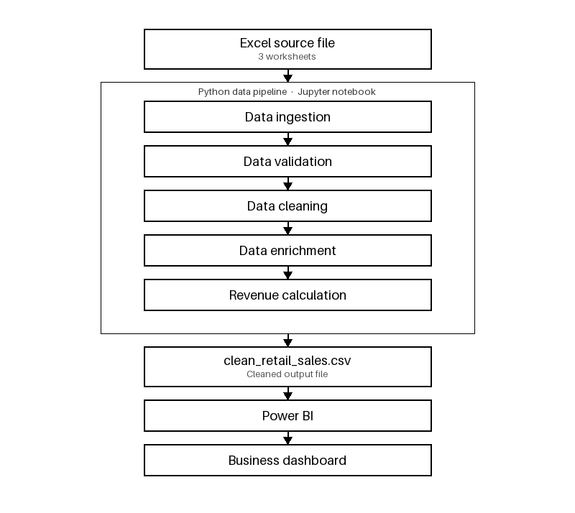

3. Data Flow
DFD Level 0
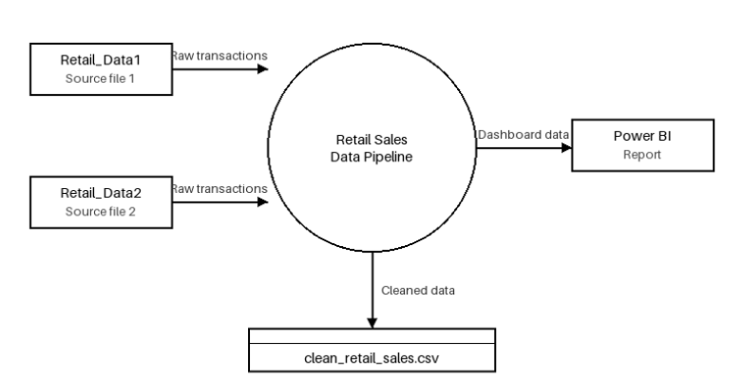
DFD Level 1
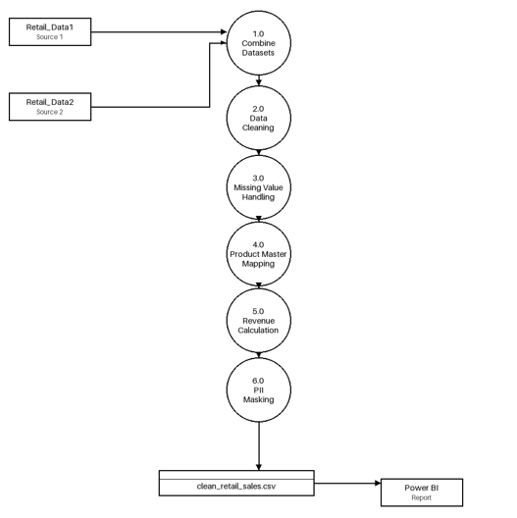

4. Dataset Description
Source file contains:
1. retail_data1 – Retail transactions
2. retail_data2 – Additional retail transactions
3. product_details – Product master table
Key fields:
transaction_id, customer_id, customer_name, email, phone, product_id,
product_name, category, quantity, price, discount, city,
payment_method, payment_status, transaction_date

5. Assumptions
1. Product master data is the trusted source.
2. Product prices from product_details are accurate.
3. Revenue is calculated after discounts.
4. Transaction IDs are unique.
5. Email and phone are PII fields.
6. Missing product details can be derived using product_id.

6. Data Cleaning Strategy
• Missing value handling using product master mappings.
• Duplicate record removal.
• Data type standardization.
• Product information standardization.
• PII masking for email and phone numbers.

7. Transformation Logic
Product Master Mapping:
product_name, category and price are mapped from product_details using product_id.
Revenue Formula:
Revenue = Price × Quantity × (1 – Discount/100)
PII Masking:
Emails and phone numbers are masked before publishing the curated dataset.

8. Data Validation
Validation checks:
• Null validation
• Duplicate validation
• Revenue validation
• Record count validation
Expected record count after combining:
8494 rows

9. Final Curated Dataset
Output File:
clean_retail_sales.csv
Key Columns:
transaction_id, customer_id, customer_name, product_id, product_name,
category, quantity, price, discount, city, payment_method,
payment_status, transaction_date, revenue, masked_email, masked_phone

10. Power BI Data Model
Fact Table:
clean_retail_sales
Measures:
• Total Revenue
• Total Orders
• Total Customers
• Total Quantity Sold
• Average Order Value

11. Power BI Dashboard Design
Page 1 – Executive Summary
• KPI Cards
• Revenue Trend
• Revenue by Category
• Revenue by City
• Slicers
Page 2 – Revenue Analysis
• Revenue Trend
• Revenue by Payment Method
• Revenue by City
• Revenue by Payment Status
Page 3 – Product Performance
• Top 10 Products
• Bottom 10 Products
• Quantity Sold by Product
• Product Performance Table
Page 4 – Category Trends & Regional Insights
• Revenue by Category
• Quantity by Category
• Category Revenue by City
• Matrix Visual (City vs Category)

12. Key Business Insights
• Monitor overall revenue performance.
• Identify top-performing products.
• Analyze category-wise trends.
• Compare city-wise revenue.
• Understand payment preferences.
• Track revenue growth over time.

13. Technologies Used
Python, Pandas, Jupyter Notebook/Kaggle, CSV, Power BI, Microsoft Word, GitHub

14. Conclusion
The project demonstrates an end-to-end data engineering and business intelligence workflow. Raw retail data was transformed into a clean analytics-ready dataset and used to build interactive Power BI dashboards for revenue, product, category, and regional analysis.

