|  |  |  |  |  |  |  |
| --- | --- | --- | --- | --- | --- | --- |
| **S.No** | **Attribute** | **Range** | **Scale** | **Consequences / Methods** | | |
| 1. | **LB** FHR baseline (beats per minute) | 106 - 160 | Discrete | Decrease: Fetal asphyxia and acidosis and subsequent distress in newborn during labor period. Among these maternal fever, fetal immaturity, fetal sleep, fetal tachycardia, and drug administration to the mother. | | Increase: Hyperthyroidism secondary to thyroid stimulating antibodies, fever associated with systemic infections and substance abuse. |
| 2. | **AC** # of accelerations per second | 0 - 26 | Discrete | Decrease: Leads to decelerations like early, late and variable decelerations. | | |
| 3. | **FM** # of foetal movement per second | 0 - 564 | Discrete | Decrease: Baby’s growth slows down or problem with baby’s placenta or with uterus. | Increase: Leads to stillbirth or umbilical cord wrapping around baby’s neck. | |
| 4. | **UC** # of uterine contractions per second | 0 – 23 | Discrete | When a certain level of oxytocin flowing in your blood. This can be very normal, like labor, when your body and your baby's brain release oxytocin to stimulate contractions for labor. | | |
| 5. | **ASTV** Percentage of time abnormal short-term variability | 12 – 87 | Continuous | Low fetal heart rate short term variation is predictive for hypoxia during the antenatal period. | | |
| 6. | **ALTV** Percentage of time with abnormal long-term variability | 0 – 91 | Continuous |
| 7. | **mSTV** Mean value of short-term variability | 0.2 – 7 | Continuous |
| 8. | **mLTV** Mean value of long-term variability | 0 – 50.7 | Continuous |
| 9. | **DL** # of light decelerations per second | 0 – 16 | Discrete | Early decelerations are normal. Late and variable decelerations can sign as baby isn’t doing well.  Variable decelerations have no fixed time relationship to uterine contractions. Therefore, the pattern of decelerations changes from one contraction to another. Variable decelerations are usually caused by compression of the umbilical cord and do not indicate the presence of fetal distress. | | |
| 10. | **DS** # of severe decelerations per second | 0 – 1 | Discrete |
| 11. | **DP** # of prolongued decelerations per second | 0 – 4 | Discrete |
| 12. | **Width** Width of FHR histogram | 3 - 180 | Continuous | Decrease in width signs slow heart rate. | | |
| 13. | **Min** Minimum of FHR histogram | 50 -159 | Continuous | Minimum record in client fetal heart rate | | |
| 14. | **Max** Maximum of FHR histogram | 122 - 238 | Continuous | Maximum record in client fetal heart rate | | |
| 15. | **Nmax** # of histogram peaks | 0 - 18 | Discrete | Count of highest peaks in FHR | | |
| 16. | **Nzeros** # of histogram zeros | 0 - 10 | Discrete | Count of zero records in FHR | | |
| 17. | **Mode** Histogram mode | 60 – 187 | Continuous | Calculating Mode | | |
| 18. | **Mean** Histogram mean | 73 – 182 | Continuous | Calculating Mean | | |
| 19. | **Median** Histogram median | 77 – 186 | Continuous | Calculating Medain | | |
| 20. | **Variance** Histogram variance | 0 – 269 | Continuous | Calculating Variance | | |
| 21. | **Tendency** Histogram tendency 1=Left asymmetric, 0= Asymmetric, 1=Right asymmetric | (-1) - 1 | Nominal | Tendency predicts the client. | | |

**Data Pre-Processing on UCI Machine Learning Repository CTG Dataset**

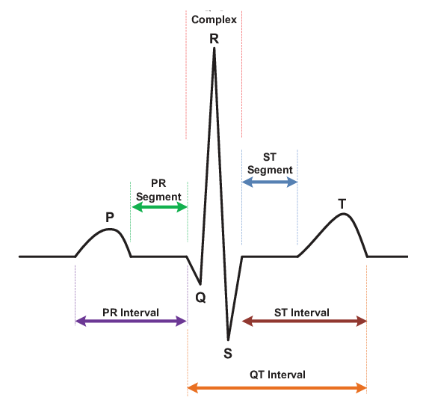**ECG:**

ECG

**PR Interval:** It is a period measured in milliseconds, from the beginning of the P wave until the beginning of the [QRS complex](https://en.wikipedia.org/wiki/QRS_complex) . It is normally between 120 and 200 ms in duration.

* A long PR interval (of over 200 ms) indicates a slowing of conduction between the atria and ventricles known as [first degree heart block](https://en.wikipedia.org/wiki/First_degree_heart_block).
* A short PR interval (of less than 120ms) may be associated with a [Pre-excitation syndromes](https://en.wikipedia.org/wiki/Pre-excitation_syndrome).
* A variable PR interval may indicate other types of [heart block](https://en.wikipedia.org/wiki/Heart_block).

**QRS Complex:** The QRS complex is the combination of three of the graphical deflections seen on a typical [electrocardiogram](https://en.wikipedia.org/wiki/Electrocardiography). Measure of the QRS interval start at the end of the PR interval to the end of the S wave. Normally this interval is 0.08 to 0.10 seconds. When the duration is longer it is considered a wide QRS complex.

* Represents the depolarization of [interventricular septum](https://en.wikipedia.org/wiki/Interventricular_septum) occur when the electrical signal passes through stunned or scarred [heart muscle](https://en.wikipedia.org/wiki/Myocardium). This defines the deflection amplitude of 25% or more of the subsequent R wave, or being > 0.04 s (40 ms) in width and > 2 mm in amplitude.

**QT Interval:** The QT interval is a measurement made on an [electrocardiogram](https://en.wikipedia.org/wiki/Electrocardiography) used to assess some of the electrical properties of the [heart](https://en.wikipedia.org/wiki/Heart). It is calculated as the time from the start of the [Q wave](https://en.wikipedia.org/wiki/QRS_complex) to the end of the [T wave](https://en.wikipedia.org/wiki/T_wave).  An abnormally long or abnormally short QT interval is associated with an increased risk of developing [abnormal heart rhythms](https://en.wikipedia.org/wiki/Heart_arrhythmia) and [sudden cardiac death](https://en.wikipedia.org/wiki/Cardiac_arrest).